Trump Administration Proposes to Cut Food Stamp Eligibility for 3.1 Million Americans
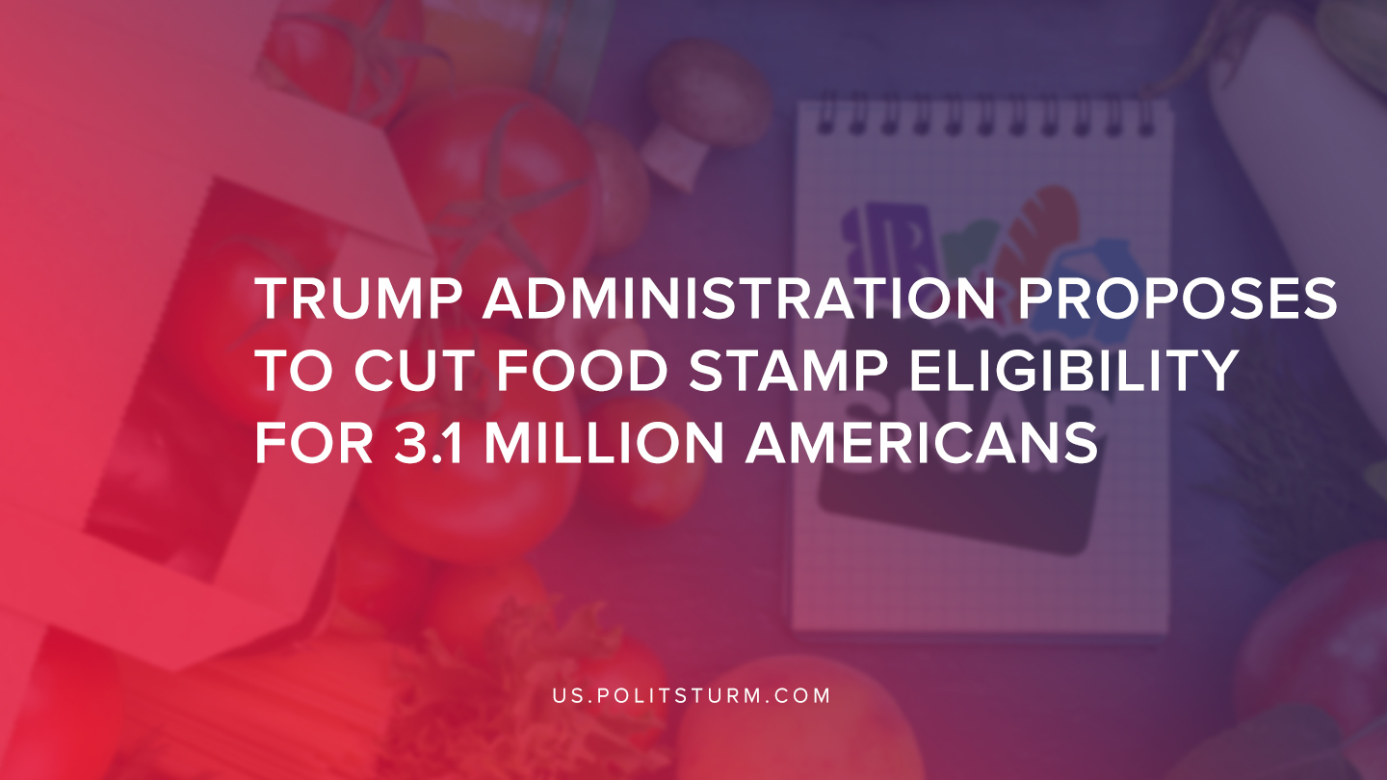

Original article
2019-07-24
1 min read

The United States Department of Agriculture (USDA) announced Tuesday that it will be limiting the eligibility for the Supplemental Nutritional Assistance Program (SNAP), more commonly referred to as food-stamps.
The proposed rule would eliminate 3.1 million people from being eligible for nutritional assistance. Nationally, 68% of SNAP recipients are in families. More than 44% of recipients are in working families.
The administration has justified the move as an effort to promote “self-sufficiency” and has implied that the systems has been subject to systematic abuse.
“For too long, this loophole has been used to effectively bypass important eligibility guidelines. Too often, states have misused this flexibility without restraint,” said U.S. Secretary of Agriculture Sonny Perdue. “The American people expect their government to be fair, efficient, and to have integrity – just as they do in their own homes, businesses, and communities. That is why we are changing the rules, preventing abuse of a critical safety net system, so those who need food assistance the most are the only ones who receive it.”
While the stated reason or the proposal is to reduce waste, fraud and increase government accountability, there is a clear class dynamic at play that must be investigated. Statistics have demonstrated a large percentage of working families and children are reliant on these programs. 1 in 6 American children lives with hunger, and this move by the Trump administration will reduce eligibility thus exacerbating the problem.
The USDA, which by its own stated purpose is supposed to “reduce food insecurity and promote nutritious diets among the American people” is acting to exacerbate hunger among working people and children. The reason for this is because the American government represents the dictatorship of the bourgeoisie, the owners of capital. This is just another example of the Trump administration cutting aid to workers while simultaneously increasing aid to the bourgeoisie through tax cuts.
Sources:
1, 2, 3

Original article

