Trump Administration Helped Meatpacking Executives Block Pandemic Worker Protections
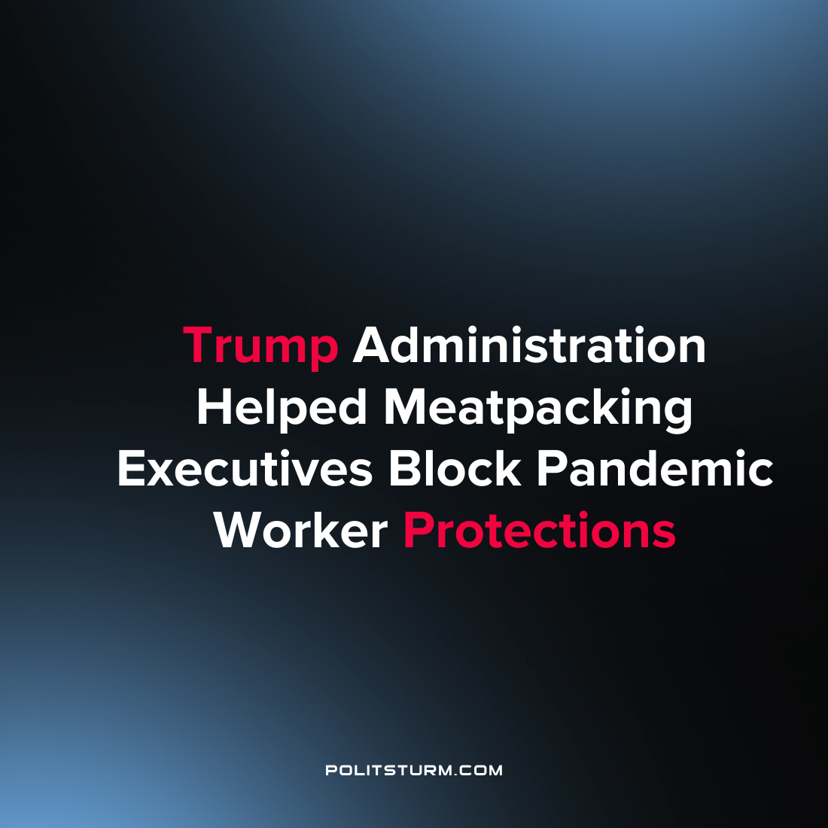

Original article
2022-05-11
1 min read

A new staff report by the Select Subcommittee on the Coronavirus Pandemic details the close connection between the Trump administration and meatpacking executives at the onset of the pandemic.
The report details how meatpacking executives were aware of the risks that the pandemic posed to its workforce and how the executives dismissed these concerns to maximize profits.
For example, during the onset of the pandemic Smithfield CEO Ken Sullivan publicly warned that closing the Smithfield plants would be “pushing our country perilously close to the edge in terms of our nation’s meat supply” when in fact there was no shortage.
Industry officials also received support from the United States Department of Agriculture (USDA) during this time to dissuade workers from staying home or quitting when there were limited safety precautions in place to protect the workers. For example, when positive COVID tests were creating pressure for plant shutdowns an industry representative made the following comment:

“Plants are being closed. Health depts. are making decisions (Greeley [Colorado]), governors are making surprise decisions (Sioux Falls [South Dakota]), health departments are showing up unannounced at plants (Waterloo IA), and the media reporting is going to create more attention from health departments and governors in other communities IMO. It seems to be cascading and our friends at USDA and the VP’s office are not able to stop it.”

The report lays bare the fundamental truth that the U.S. government serves the interests of the capitalist class, not the workers. The collusion between industry and government is not an anomaly but reflects the fact that we live in a class society and the current government represents the interests of the capitalist class who is interested in the maximization of profits. It is imperative that Marxist-Leninists understand and convey that while the U.S. government claims to represent “the People”, it is merely a class government serving the interests of the rich oligarchs and this report just serves as further evidence of this fact.

Source: 1

Original article

