Trump Administration Declares Teachers Essential Workers
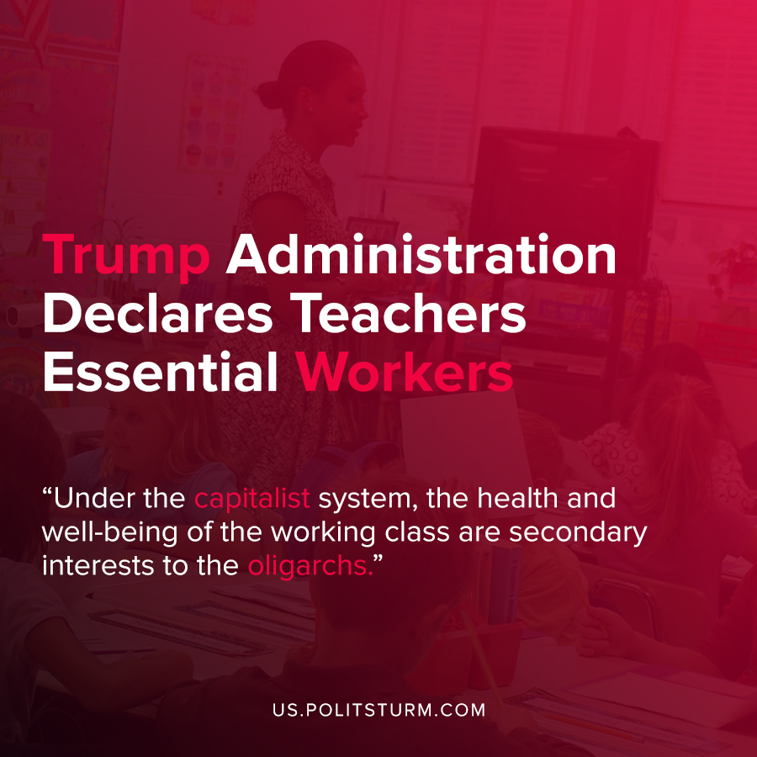

Original article
2020-08-22
1 min read

The Department of Homeland Security issued new guidance on which American workers are considered essential workers. In the newest guidance, issued on Tuesday, August 18th 2020, teachers were included in the list of critical essential infrastructure workers who are able to work during the pandemic.
The move comes amidst the Trump administration’s continued efforts to re-open America’s schools as quickly as possible. While the Trump administration has stated that they are in favor of “safely” re-opening, it must be noted that they were in favor of safely reopening the economy which has led to the deaths of over 170,000 Americans.
Teachers unions have come out strongly in opposition to the new guidance, such as the National Education Association.
“The Trump administration’s threats to designate teachers as ‘essential workers’ has no legal merit and is more of a rhetorical gambit to give President Trump and those governors who are disregarding the advice and guidance from public health experts an excuse to force educators into unsafe schools”, said NEA president Lily Eskelsen Garcia.
The Trump administration simply uses false rhetoric to declare conditions “safe” and minimizes the risks and concerns of the workers.
Under the capitalist system, the health and well-being of the working class are secondary interests to the oligarchs. As such, only the dictatorship of the proletariat can truly serve the interests of the workers and not needlessly risk their lives for their own economic and political purposes.
Sources: 1 , 2 , 3

Original article

