Trump Administration Announces Restrictive Immigration Rule
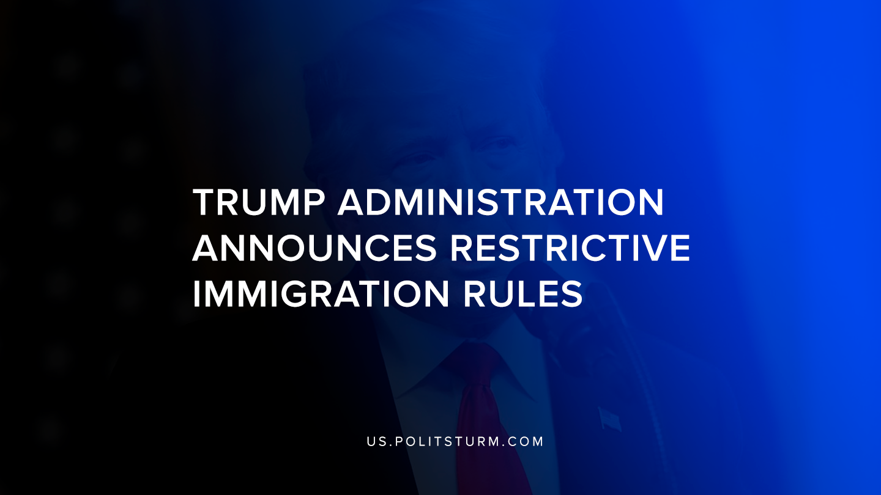

Original article
2019-08-14
1 min read

A statement was released from the White House detailing the Trump administration’s new rule regarding immigration. The rule would prevent immigrants from entering the country if they are likely to become a “public charge”. This rule seeks to limit those who have received public benefits over a certain threshold from entering the country.
It would also prevent other immigrants from adjusting their immigration status.
The stated rationale behind the move is to promote “self-sufficiency” for immigrants and to limit the use of public benefits that could be used by “vulnerable Americans”.
The Trump administration is appealing to the rule of law and the longstanding history of enforcing laws against immigrants. The rule defends its credibility and legitimacy by rationalizing that the United States has used being a public charge as a criterion for inadmissibility for more than 100 years.
The Trump administration so often appeals to the law and its enforcement because the laws in capitalism represent the interests of the bourgeoisie. Capitalism is the dictatorship of the bourgeoisie, therefore it should come as no surprise that the law itself arises out of and reinforces nationalistic tendencies and this new rule is not an exception.
Sources: 1, 2

Original article

