Train Drivers in the UK Accept New Pay Offer After 2 Years of Strike Action
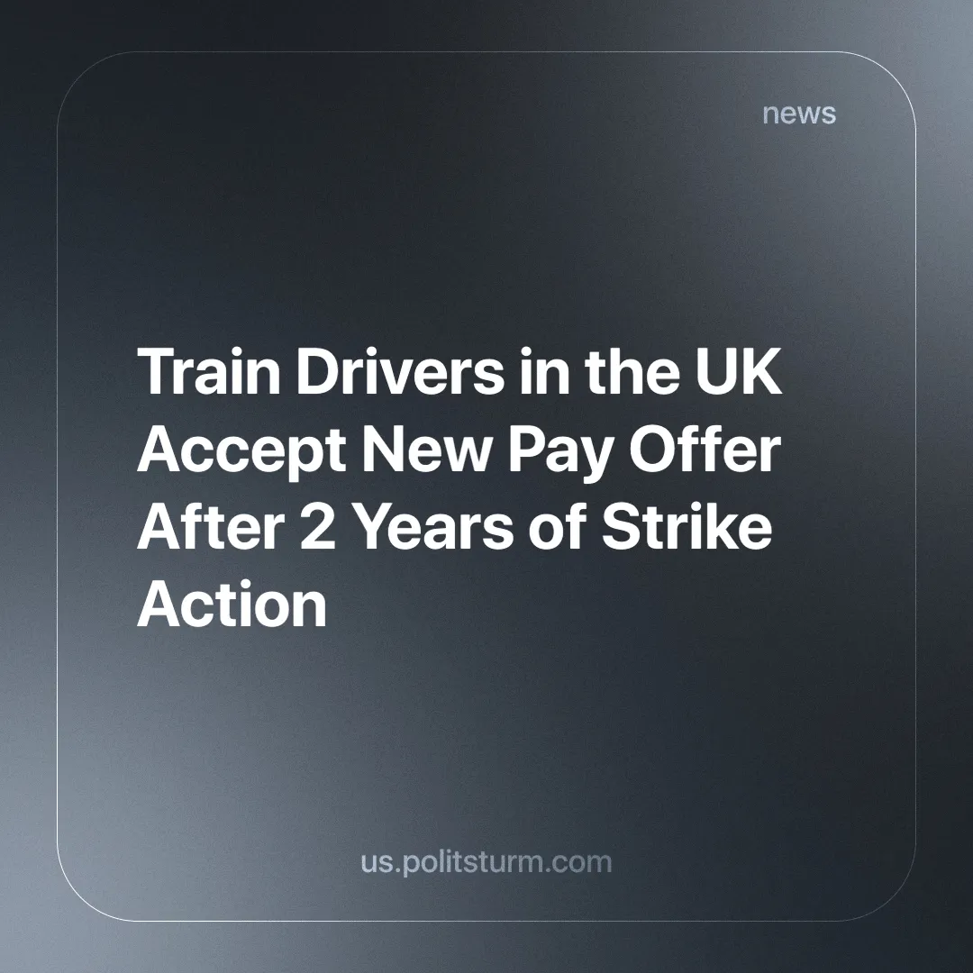

Original article
2024-09-23
4 min read

With a turnout of 88.5%, 96.6% of members of the Aslef union voted to accept a new pay deal. The struggle has been ongoing since June 2022, as train drivers have not received a pay rise since 2019, resulting in a real terms pay cut.
Train drivers will now receive a 5% pay rise backdated to 2022-23, a 4.75% rise in 23-24 and a 4.5% rise in 24-25. The RMT, a separate union for other rail workers, told the BBC it had also received a new offer of 4.75% for 2023/24 and 4.5% for 2024/25 [1].
There has been a total of 18 days of strike action in the last two years in Britain and it has been the longest train drivers' strike in history according to the Aslef General Secretary.
Aslef general secretary Mick Whelan said the main issue wasn't pay, but the 55 proposed changes to terms and conditions such as changes to ways of working, for example to training and rosters. These changes were argued to be necessary to make the railway function more reliably and save money, however, what this really means is more work for the same pay. All these proposed changes have been dropped in the new deal.
Labour also promised earlier this year to nationalise all the country's railways (except freight companies) within five years [2], because of how inefficient and expensive the private rail providers have made train travel. Whether this happens or not remains to be seen. Under capitalism, however, it will still be done for the interests of the capitalists. A nationalised company belongs to the government, but if the government is run by capital and formed by capitalists, then said company continues to work for capitalists. The HS2 debacle last year demonstrates clearly that the parasite state can be just as corrupt and inefficient with railways as private corporations [3].
These train drivers have fought and won a battle against worsening working conditions and for better pay. Train drivers have a higher-than-average salary due to their strikes, and can serve as an example to workers in other fields.
The Labour Party, seeking to end years of disruption and hoping to increase its popularity, has made a small concession to the workers. The capitalist class (whom Labour represents, but with a more pro-worker rhetoric as compared to the Conservatives), are allowing this to happen because the strikes had already cost railway companies £850 million and so it would cost less to accept the pay rise. In addition, the Labour Party wants to position itself as a "friend" of the workers' movement. Unlike the previously ruling Conservatives, who openly admitted to refusing the rail workers a pay deal for political reasons.
Trade union membership in Britain peaked in 1979 (13.2 million) and has been falling ever since, although the rate of decline has slowed in recent years [4].
However, with the rising cost of living, it is likely that we will see more trade union action in the future. They serve as an important training ground for workers and raise their political awareness as well as a tool for workers to struggle against their immiseration within the legality of the capitalist system.
"Despite all these sufferings, brought on by strikes, the workers of neighbouring factories gain renewed courage when they see that their comrades have engaged themselves in struggle. “People who endure so much to bend one single bourgeois will be able to break the power of the whole bourgeoisie,” said one great teacher of socialism, Engels, speaking of the strikes of the English workers. It is often enough for one factory to strike, for strikes to begin immediately in a large number of factories." – V.I. Lenin. Lenin Collected Works, Progress Publishers: Moscow,1964, Volume 4, page 315
As important as this victory was, and as important as trade union struggles are, they alone cannot solve the problem. Trade unionism can only temporarily limit the degree of exploitation of workers. It is limited to fighting for better wages and working conditions. However, through inflation, for example, the costs of necessities rise and the workers have to spend more of their wages on them. Therefore unless there is a union struggle every year, the workers' share of the social wealth continuously decreases.
The capitalists, after a defeat or a concession, will always try to roll back what little progress the workers have made once they have regained their strength as they rely on hired labour to exist (and the less they pay labour the more they pocket). Therefore, if the struggle does not seek to end the existence of the capitalists as a class (as the workers do not need the capitalists to exist), it will eventually lose what little it has gained.
Trade unionism without the leadership of a communist party - an organisation made up of the most theoretically advanced workers with the aim of ending exploitation and achieving socialism - is simply an economic movement of the workers and is very limited in what it can achieve.
A Communist Party has a thorough understanding of Marxist-Leninist theory. This theory is an essential weapon of the working class, guiding its decision-making and struggle against the exploiting class and toward socialism. It gives the workers an insight into their societal relations and the real interests that stem from there.
Under the leadership of a communist party, the usefulness of trade unions is greatly increased. They can coordinate and work towards political goals. It is in this situation that trade unions begin to realise their true potential.
At present, there are no genuinely communist parties in Britain or the rest of the world capable of leading the workers' struggle in this way.
Do you want to help work towards the creation of a truly communist party? Join Politsturm.
Sources:
[1] BBC — Train drivers accept pay deal to end strike action — 18/09/2024
[2] BBC — Labour pledges to renationalise most rail services within five years — 25/04/2024
[3] CityAM – ‘Breathtaking’ HS2 failure slammed after whistleblowers allege cover-up – 25/10/2023
[4] UK Department for Business and Trade — Trade Union Membership, UK 1995-2023: Statistical Bulletin — 29/05/2024

Original article

