Toxic Chemicals Are Increasingly Present in the Human Body
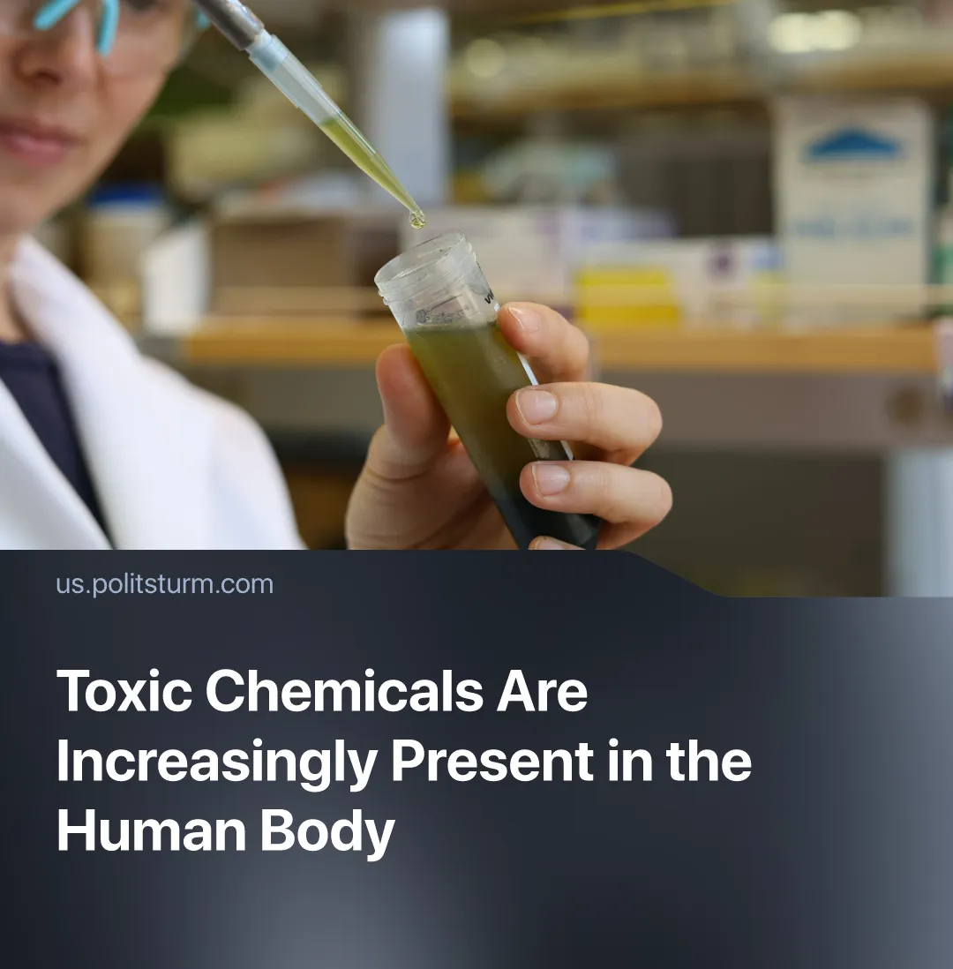

Original article
2026-09-07
1 min read

Toxic "forever chemicals" are now found in 99% of human blood samples. The US, EU, and the Netherlands have all weakened regulations on them after lobbying by industrial groups.
Details. A Dutch government body reported that every breast milk sample it tested contained unnatural “forever chemicals”, with 1 in 5 women having dangerous amounts in their breast milk. The same health institute stated that these chemicals can negatively impact the immune system, as well as the development of the unborn child. These chemicals can increase the risks of certain cancers, cause low birth weight, and reduce fertility.
▶ “Forever chemicals”, also known as PFAS, are man-made chemicals that accumulate in the human body or environment. They have been used in industry and consumer products since the 1940s because of their useful properties and low cost. Nowadays, PFAS are found in excessive amounts nearly everywhere: in drinking water, food packaging, personal care products, and even in soil and water near waste sites and factories.
▶ PFAS are poisoning people worldwide. Despite scientists’ warnings, capitalist governments are failing to protect us. Although “forever chemicals” were found in the blood of 99% of tested Americans, the USA recently repealed its PFAS regulations for drinking water. The EU scaled back on its proposed PFAS ban, after heavy lobbying by German industrial groups. The Dutch government has also loosened its own restrictions on PFAS contamination, arguing that stricter rules would disrupt the construction industry.
▶ Capitalism structurally produces this outcome. No individual capitalist has a profit incentive to control the environmental consequences of their production, these costs are externalised onto workers. PFAS enters water supplies through industrial processes controlled by the capitalist class, whose influence over legislators ensures they remain lightly regulated.
Context. The capitalist system has mismanaged several recent public crises. In 2020, the USA was not ready for Covid-19 and suffered over a million deaths due to it. Likewise, this year’s hantavirus outbreak could have been avoided – the vaccine was nearly ready a decade earlier, but was cancelled when researchers ran out of funding.

Original article

