Toxic Algal Blooms Poison the Largest Lake in the UK
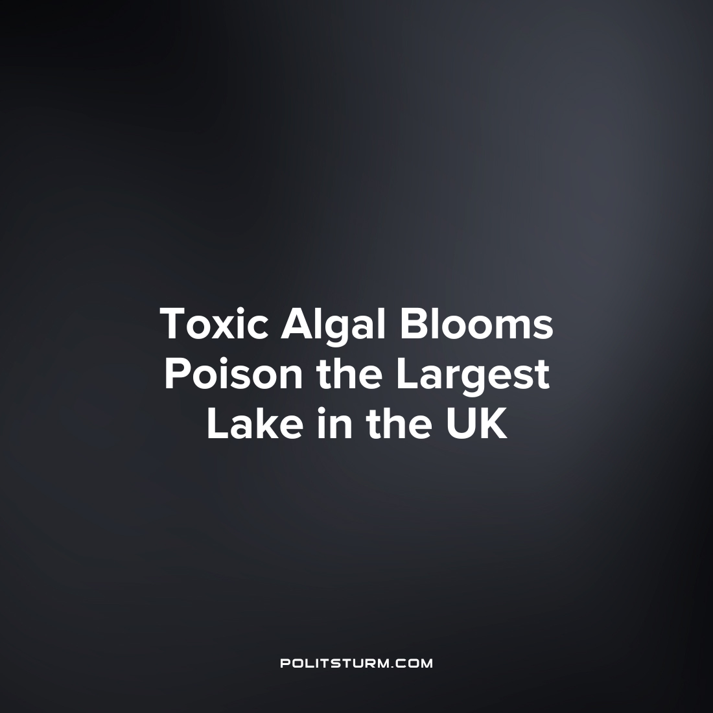

Original article
2023-09-17
2 min read

Lough Neagh, the largest lake in the UK, is being contaminated by toxic algae. This Northern Irish Lake succumbing to toxic algae has unleashed a dire environmental crisis. Fish populations are plummeting, and the growth of toxic algae is rendering the lake a noxious and un-swimmable expanse. The root cause of this catastrophe lies in the relentless dumping of fertilizers into the lake resulting in eutrophication. Eutrophication is a process by which a body of water becomes progressively enriched with minerals and nutrients, namely phosphorous and nitrogen, which thereby stimulates the growth of algae. This tragic situation not only imperils the livelihoods of local residents who depend on the lake for sustenance (it is the source of 40% of Northern Ireland’s drinking water), as well as economic life but also poses a severe threat to the wildlife that calls Lough Neagh home.
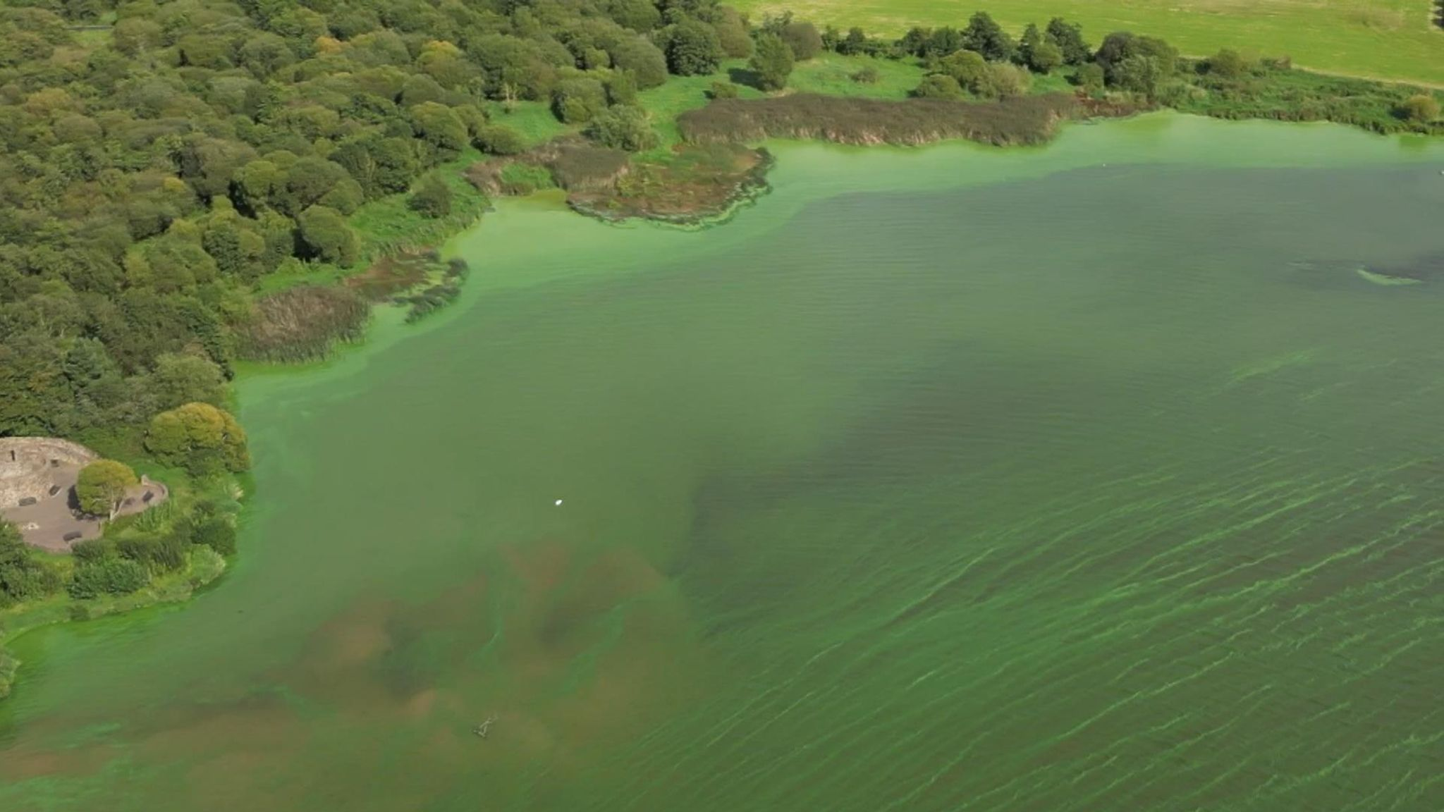
The pollution of Lough Neagh
The poisoning of Lough Neagh exemplifies the devastating consequences of capitalist exploitation of natural resources. Under capitalism, industries driven by the profit motive often engage in reckless pollution, as the imperative to accumulate capital reigns supreme. It is simply more profitable for the agricultural capitalists not to worry about fertilizer runoff and save on this “unnecessary” expenditure. This event serves as a poignant reminder that capitalism prioritises profit over environmental preservation and the well-being of working-class communities, reflecting its callous disregard for its two sources of value (nature and the working-class). It’s a short-sighted system not driven by conscious collective human activity but by the eldritch ebbs and flows of the world market, and the intermittent competition and collusion between the largest monopolies that hold all the sway.
The lake is owned by a private limited company (The Shaftesbury estate) which is owned by a Lord, while the National Trust, various local councils and charities own the area around the lake, especially the rivers where water flows in and out of it. In light of this crisis, the Belfast city council has called for the ownership of the Lake to be nationalised, however, this is a woefully inadequate solution. Marxist-Leninist theory reveals to us that the state is not some neutral arbiter of interests within society, but a tool and bludgeon of the ruling class of society; it is the instrument by which their interests are dictated over the rest of society. So, while the state remains in the hands of the capitalists, not only will it enable them to continue exploiting workers and wrecking our planet, but it will also outright assist them. This is confirmed by the fact that much of the land surrounding the lake (where the fertilizer runoff comes from) is already state-owned. Instead, we must embrace a socialist model guided by Marxist-Leninist theory, where the dictatorship of the interests of capital is replaced by the dictatorship of the interests of the working class, by which we lay the groundwork for a future where production is for human use, rather than for profit.
Sources: 1, 2

Original article

