Top Hedge Fund Managers Made $3 Million Per Day
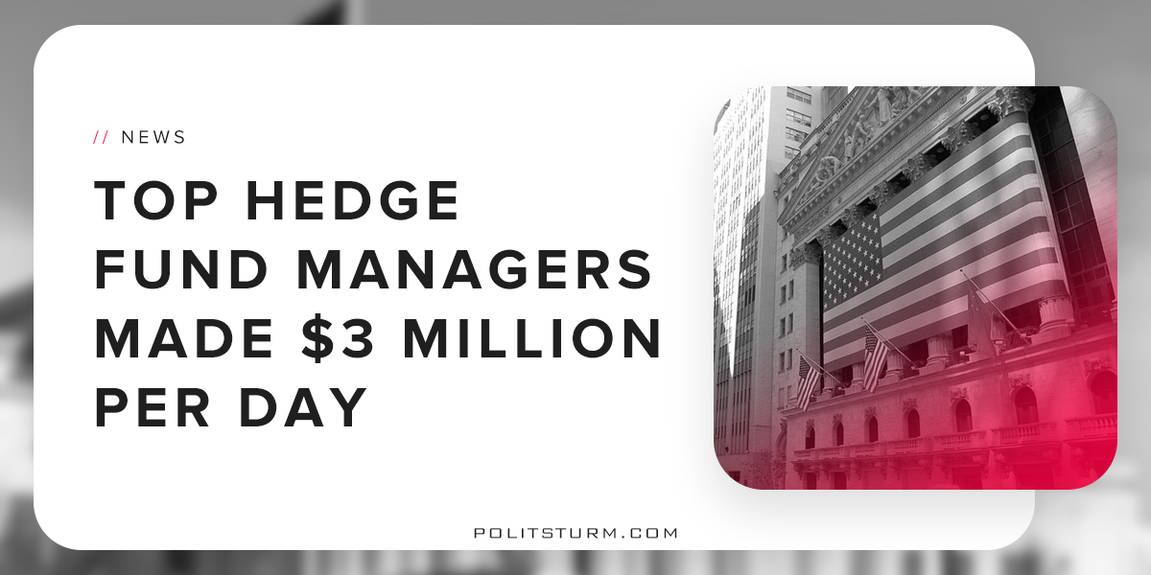

Original article
2018-06-03
2 min read

The top hedge fund managers certainly made ungodly sums of money from the booming stock market in 2017. The top managers made twice as much money in one hour as the average American makes in a year.
The goal of the hedge fund manager is to make the maximum amount of profit from investments. At a fundamental level, money is invested in stocks, bonds, and various other financial “instruments”. These hedge funds can have tens of billions of dollars under management and the manager receives a fee (typically 2%) for buying and selling for the funds investors. This is how these top fund managers are able to make over a billion dollars per year.
The question as to where the profit comes from is of no concern to the billionaire oligarchs. The truth is that these earnings come from the unpaid labor of the working class. The gross income inequality simply reflects the fact that the working class is being robbed blind by capitalist class.
The term ‘income inequality’ describes the difference in income between the working class and the capitalist class. The capitalist class, like these hedge fund managers, are able to reap huge profits and therefore they can make millions of dollars per day.
The working class, by contrast, is the class that is not doing as well. The capitalist system, including the laws and regulations of government, are designed to serve the interests of the rich. Hedge funds are regulated under the Investment Advisers Act of 1940 and they are regulated by the Securities and Exchange Commission.
The funds are quite literally designed to make massive profits for a small number of oligarchs, namely the major investors. It would be impossible to create a hedge fund that is equitable for the mass of workers since it is premised on the exploitation of workers by design.
The government only serves the interests of the capitalist class and therefore serves as the dictatorship of the bourgeoisie. It is both utopian and unrealistic to imagine that income inequality and the contradictions of capitalism can be resolved from within the framework of bourgeois government. Only a government for and by the working people, the dictatorship of the proletariat, can resolve the dire contradictions of capitalism.

https://www.cnbc.com/2018/05/30/these-hedge-fund-managers-made-more-than-3-million-a-day-last-year.html
https://www.irs.gov/pub/int_practice_units/jti_c_05_01_04_01.pdf

Original article

