The Worldview of Dialectical Materialism
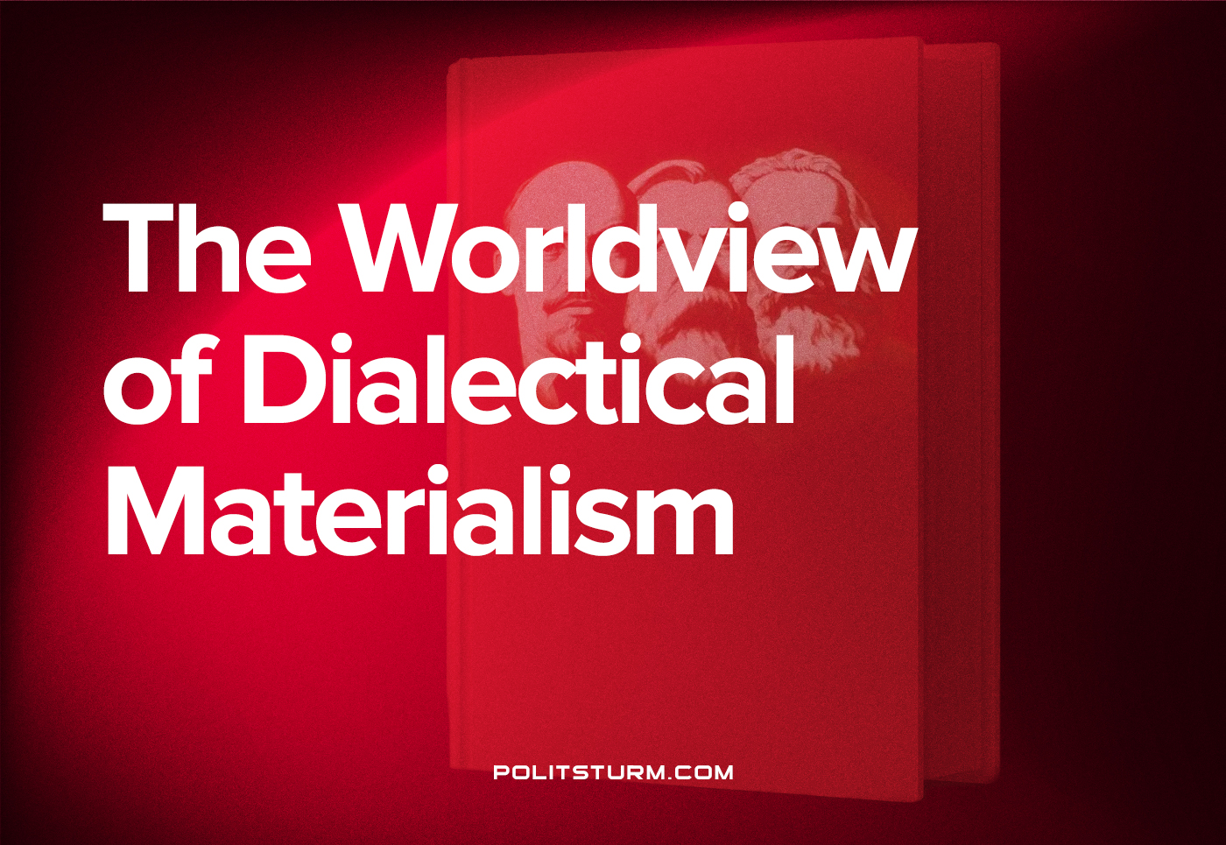

Original article
2022-06-11
6 min read

Dialectical materialism is a scientific worldview, as it stems from the achievements of science, is a theoretical generalization of sciences and puts science at the priority. At the same time, this is the Marxist worldview, which represents the most general view of reality (nature and society). Dialectical materialism is the basis of Marxism.

“The materialistic outlook on nature,” says Engels, “means no more than simply conceiving nature just as it exists, without any foreign admixture.”
(F. Engels. Dialectics of Nature)
The dialectical-materialist worldview is based on the following provisions:
First, is the reality and objectivity of the world. Marxist materialism proceeds from the fact that the surrounding reality really exists and is material in nature, that the diverse phenomena in the world represent different types of moving matter, and that the world itself develops according to the laws of the movement of matter. Moreover, matter is not only a substance that can be touched or seen, but also various types of energy (kinetic, thermal, and so on), relationships between people – all this is also matter, since it objectively exists.

“Matter is a philosophical category denoting the objective reality which is given to man by his sensations, and which is copied, photographed and reflected by our sensations, while existing independently of them.”
(V.I. Lenin, Materialism and Empirio-criticism)
Secondly, the primacy of objective reality. Matter, the objective world is the source of our sensations, ideas and consciousness. Whereas our consciousness and all ideas, theories are secondary, they reflect matter. It is not the spirit in the form of God or the human mind that generates matter, but matter, through the organ of thinking – the brain – creates spirit, consciousness.
This means that at first there was only an objective material world, and then, in the process of its development, a subjective human consciousness appeared, which is confirmed by modern science.
The very life of society, its being is also primary, and its spiritual life is secondary, derivative. The material life of society is an objective reality that exists independently of the will of people, and the spiritual life of society is a reflection of this objective reality, a reflection of being. This means that the source of the formation of the spiritual life of society, the origin of social ideas and theories must be sought in the conditions of the material life of society, and not in the ideas and theories themselves, which only reflect material existence.
What are the conditions for the material life of society, such are its ideas, theories, political views, political institutions.
Thirdly, is universal interconnection. Dialectics considers nature and society not as an accumulation of objects and phenomena independent of each other, but as a single whole, where objects and phenomena are organically connected with each other, depending on each other and determined by each other.
There are different world connections and relations: direct and indirect, generic, functional, cause-and-effect, Spatio-temporal, but not a single thing is isolated and autonomous, does not live by itself. Every object and every thought exists in a certain context, under certain conditions and surrounded by other things, other thoughts, in connection with them.
Fourth, is universal variability. There is nothing static and unchanging in the world, everything in nature and society is in constant motion, it appears and disappears.
All matter in the world is in one or more forms of motion at every moment, be it mechanical motion, thermal motion, electric current, chemical decomposition and combination, or organic life. A part of matter can be at rest only with respect to certain forms of motion, for example, a body can be in mechanical equilibrium, but its atoms still perform chemical processes and oscillate. Matter without motion is just as inconceivable as motion without matter.
Everything is changing. The universe, space, every planet and galaxy, people and their social relations. Social phenomena are also changeable and also temporary.
A particular case of movement (change) is development.

“…dialectics does not regard the process of development as a simple process of growth, where quantitative changes do not lead to qualitative changes, but as a development which passes from insignificant and imperceptible quantitative changes to open’ fundamental changes’ to qualitative changes; a development in which the qualitative changes occur not gradually, but rapidly and abruptly, taking the form of a leap from one state to another; they occur not accidentally but as the natural result of an accumulation of imperceptible and gradual quantitative changes… the process of development from the lower to the higher takes place not as a harmonious unfolding of phenomena, but as a disclosure of the contradictions inherent in things and phenomena, as a “struggle” of opposite tendencies which operate on the basis of these contradictions.”
(J. V. Stalin. Dialectical and Historical Materialism)
Thus, the dialectical concept of development is distinguished by an abrupt transition from one qualitative state to another, continuity and consistency, as well as contradictions as the engine of development.
Fifth, is the comprehensibility of the world. There is nothing that would not yield to our knowledge and theoretical understanding. Everything is accessible to human thought, can be known and put at the service of the people, and for correct and reliable knowledge it is necessary to be consistent with how the world works.
If matter is primary, then one must not only interpret phenomena through objective causes and start from objective laws, but also start from the very subject of study, and not from bare schemes and patterns.
If everything is interconnected, then you need to take into account the connections, take into account the conditions (and not take things and thoughts out of context). A comprehensive and specific analysis of the subject or situation is needed.
Not a single phenomenon in nature can be understood if taken in an isolated form, without connection with surrounding phenomena, because a phenomenon in any area of ​​nature will turn into nonsense. If the phenomena are considered out of connection with the surrounding conditions, in isolation from them, but it can only be understood and explained if it is considered inextricably linked with the surrounding phenomena, in conditionality from the surrounding phenomena.
If everything changes, then you need to look at things as changing and historical, you need to uncover contradictions and look for the main systemic contradiction, the essential quality for revealing the law. Knowledge also needs to be constantly improved and changed.
If everything is scientifically cognizable, then there are no insurmountable barriers to comprehending reality and obtaining reliable knowledge about the world.

Original article

