The Wagner Rebellion: Aftermath
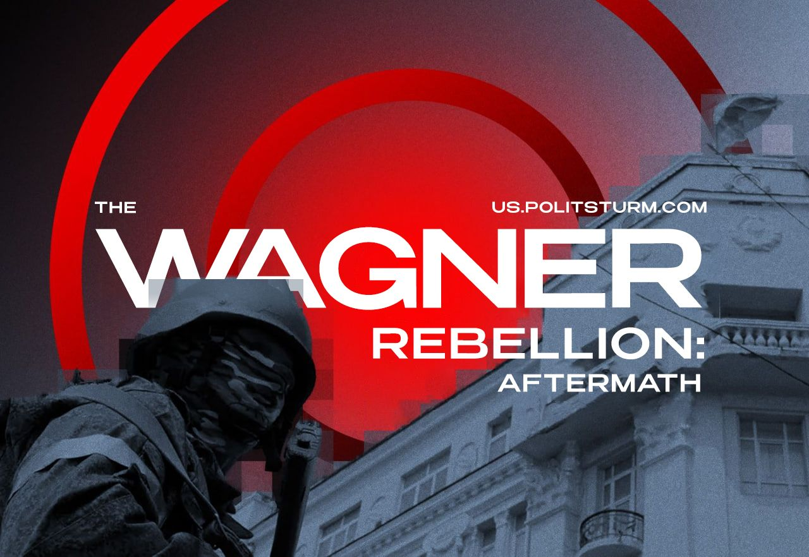

Original article
2023-06-30
6 min read

A week ago, on June 23, 2023, Prigozhin announced his "March of Justice".
Unsupported element
What are the results of the Wagnerites' rebellion?
1. Weakness of the power. Contrary to the statements of state propaganda and officials about national unity, this unity wasn't present among the capitalists.
The ruling class was in the state of panic and confusion, and the state apparatus showed slowness. The power structures, immensely inflated over the past decades, have shown almost complete passivity and lack of resistance, which was proved by the quick "march" of the Wagnerites to Moscow. Understanding the weakness of the state at a time of crisis, the oligarchs preferred to leave the capital and the country.
The split and full-scale struggle of various groups of the ruling class is a real prospect for the development of the domestic political situation in the event of another military and/or political crisis.
2. A blow to Putin's reputation and the image of "stability". It is known that the long-term growth of Prigozhin's influence and strength, as well as the Wagner PMC later on, took place with the consent and approval of Vladimir Putin, who brought Prigozhin closer to himself.
Prigozhin was Putin's right-hand man in the matter of information campaigns and maintained his own "troll factory" and a whole network of propaganda media. PMC "Wagner", which is actively involved in conflicts in Ukraine, Syria, Libya and Africa, was transferred under his control. Moreover, Prigozhin, in fact, bypassing the Federal Penitentiary Service, the Ministry of Defense and the FSB, was allowed to recruit prisoners to the Wagner PMC, which is an unprecedented example in modern Russian history.
The months-long conflict between Prigozhin and the MoD had no reaction from Putin and took place with his actual connivance. An open rebellion by a force created by the state threatened the position of the ruling group of capitalists and the entire political system built by them. In addition, at the tensest moment, information appeared that Putin had left the capital.
Vladimir Putin, as a formal representative and head of the ruling group, was unable to protect its interests and property. At a critical moment, he chose to disappear and disappeared from the information field immediately after a short "address to the nation".
Putin's role as the undisputed political leader of the Russian bourgeoisie has been shaken, along with the image of the "guarantor of stability" portrayed by propaganda, which creates risks for his position as president of the Russian Federation. Similarly, Putin's reputation among the population has also been shaken. All this is of particular importance in view of the presidential elections in Russia in 2024, and with renewed vigor gives new energy to the talks about the "successor".
3. Once again, the entire system of bourgeois law has been crossed out. Firstly, having initiated a criminal case against Prigozhin under Article 279 of the Criminal Code of the Russian Federation for armed rebellion, subsequently the Russian authorities dismissed the case as part of the agreements. Thus, they once again showed the class essence of the existing legal system: laws act when beneficial to the ruling class.
In the shortest possible time, the criminal case was cancelled, a refusal was proclaimed to prosecute the mercenaries participating in the rebellion and to remove responsibility for the seizure of administrative buildings, the destruction of military equipment and the killing of military personnel.
All this dealt a severe blow to the already constantly trampled system of bourgeois legality, and also showed the true essence of bourgeois law.
4. Growth of Prigozhin's "political weight". Having become a great military force, Prigozhin gained significant political weight. Now the head of the Wagner PMC is a serious political force as well and, without a doubt, will participate in domestic political processes. It is possible that his strength can be used by one of the ruling class groups in the case of aggravation of inter-elite conflicts and in an open struggle for power.
5. Reputational losses of Prigozhin. Threatening the position of the Russian bourgeoisie, Prigozhin turned most of the elites against himself and became a dangerous adversary for them. At the same time, it is clear that such an unexpected performance greatly frightened the masses of ordinary citizens.
Appearing before them in the form of an uncontrollable adventurer leading thousands of armed criminal elements to the capital, he brought a certain panic and fear into the minds of the population. Now his "patriotic" demagogy is unlikely to be perceived as before.
6. The reaction of the people. Perhaps the most significant and important point that the events of June 23-24 revealed was the apathy and detached attitude of the population to what is happening. Apart from Rostov, we did not see open and active support from the masses either towards Prigozhin or towards the federal government.
This, better than all kinds of polls and statistics of “public opinion”, demonstrates the true mood of the masses: the passivity and indifference of the working people to what is happening, the lack of active support for both sides.
The majority of Russian citizens showed detachment from the unfolding events and preferred indifferent observation, tried to live their former life. This factor is of great political importance and requires careful study by the Communists.

What's next?
1. Aggravation of the struggle between the capitalists. Despite the fact that the details of the agreements between the Kremlin and Prigozhin are unknown, it is obvious that conflicts among the elites will not stop there.
Moreover, the “Wagner Rebellion” was only the first chord in the upcoming large-scale clash of various groups of capitalists among themselves, who are being pushed to this by the crisis and the increasingly deteriorating situation in the country against the backdrop of the 'SMO'.
2. Tightening the regime. It is to be expected that the authorities will take advantage of the situation to further toughen the regime and control all previously independent groups and organizations. We are talking about the so-called 'voenkory' (military correspondents), and about various associations, such as the Girkin-Strelkov's "Angry Patriots Club".
3. Strengthening communist work. Communists must intensify agitation and propaganda to awaken the class consciousness of the masses and explain to them the causes and nature of what was happening.
It is necessary to intensify the fight against opportunism, both of the left and the right, which has shown a huge threat in a period of aggravation of the political situation.
It is necessary to build up organizational work among the proletariat in order to create a truly communist party.
We are already doing this work. Support and join us.

Original article

