The Struggle of the Less Fortunate Worsens
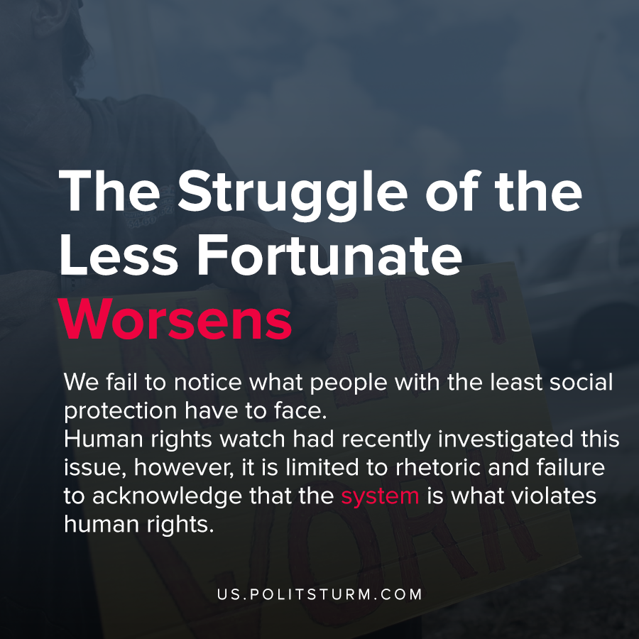

Original article
2020-05-19
1 min read

With the actively worsening conditions of both COVID 19 and the economy, through this struggle, we fail to notice what people with the least social protection have to face. Human rights watch had recently investigated this issue, however, it is limited to rhetoric and failure to acknowledge that the system is what violates human rights.
The capitalist superstructure is limited to placing assumptions within the confines of the system and only critiques within the allowed limits and rarely points out that it is capitalism that is the core of the issue. With the example presented above, we see that regardless of how sentimental any newspaper might sound it fails to fix this issue. With the impending next great depression, we will see ever greater fates doomed to face similar struggles and all they can get is sentimental statements from the bourgeois press.
Socialism within only a few years of existence had once and for all ended this issue, and today we possess the resources to instantaneously allocate the available resources that are already in surplus with excess horses found in both Europe and USA.
https://www.hrw.org/news/2020/05/07/business-usual-isnt-good-enough-worlds-homeless

Original article

