The October Revolution Day
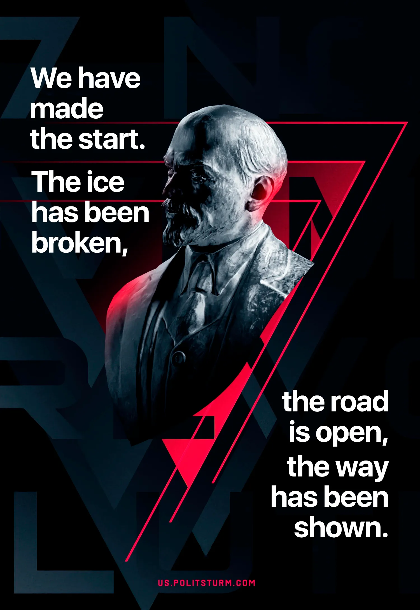

Original article
2025-11-07

"We have made the start. When, at what time, and the proletarians of which nation will complete this process is not important. The ice has been broken; the road is open, the way has been shown". – Vladimir Lenin
Politsturm congratulates all comrades on the anniversary of the October Revolution.

Original article

