The October Revolution: 105th Anniversary
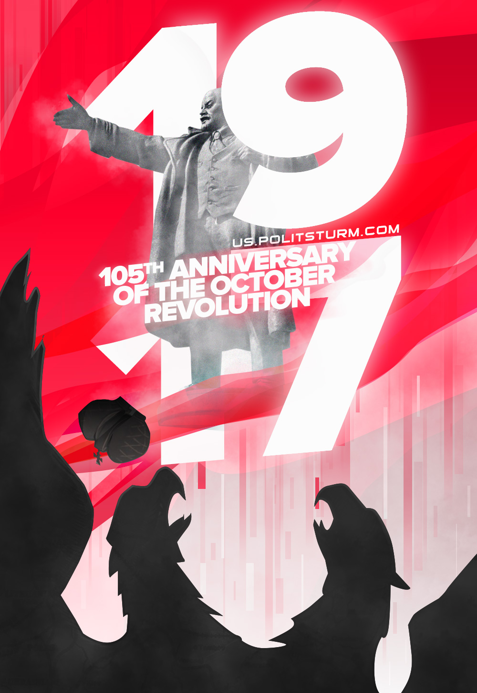

Original article
2022-11-07

The Politsturm team congratulates all comrades on the 105th anniversary of the Great October Socialist Revolution.

Original article

