Soviet Famine 1930–1933: "The Law of Spikelets" Myth Explained
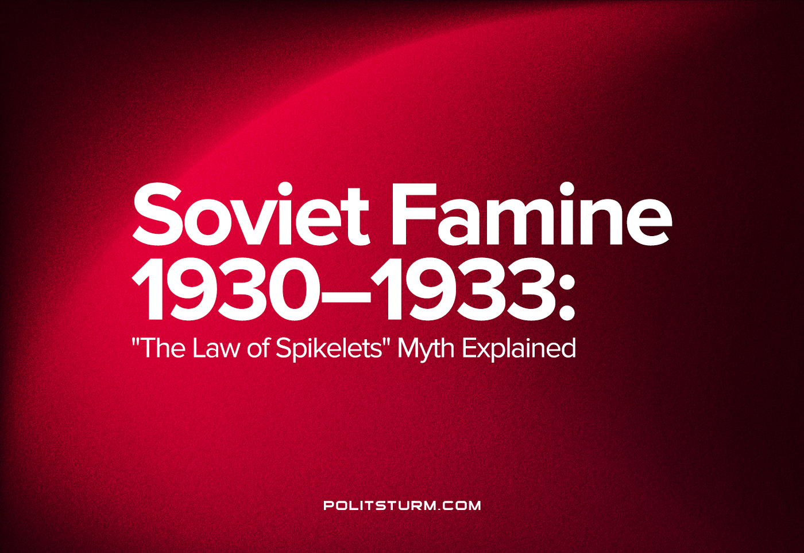

Original article
2022-08-07
19 min read

On August 7th, 1932, the law “On the Protection of Property of State Enterprises, Collective Farms and Cooperatives and the Strengthening of Public Property” was adopted, also known as the “The Law of Spikelets”. Shouts about the “cruelty” and “inhumanity” of this law, which allegedly resulted in many innocent people shot, do not subside to this day. What was this law and why did it pass? How many people were convicted and shot? Let’s try to find the answer.
Over the course of the first five-year plan, collectivization was carried out, which made it possible to switch from small individual farms to large cooperative farms (collective and state farms) equipped with modern agricultural machinery. This transition was accompanied by an intensification of the class struggle in the countryside. Kulaks and counter-revolutionary elements tried to prevent the unification of peasant farms in every possible way. The “Special reference of the SPO OGPU (Secret-Political Detachment of the Joint State Political Directorate) on negative phenomena in collective farm construction on August 7, 1932” contains the following information:
"On the part of people who left collective farms, the occupation and harvesting of crops and hayfields is still presented. These arbitrary actions in some places were organized by kulaks and other counter-revolutionary elements, were accompanied by excesses, armed assaults on collective farmers working in the field, battery, as well as various threats and reprisals against collective farmers and lower representatives of the Soviet apparatus."
"There were facts of a deliberate breakdown of collective agricultural machines, arson of collective farm yards, grain harvest and mowing, committed by quitters in some collective farms to disrupt harvesting. It should be noted that cases of arson of collective farm property have been increasing in some areas in recent days."
"The facts of theft of collective farm grain, expressed in a number of places in cutting ears of wheat, stealing sheaves and threshing them, as well as the theft of grain during threshing deserve special attention. In many cases, these thefts are carried out by individual farmers, quitters from the collective farms and collective farmers who have a small workdays number. A large amount of grain theft takes place in a number of NWK districts, where in some collective farms the sheaf theft reaches 2.4 and 5 hectares (Novouzensky district), and in ASSRNP (Latosh collective farm of Pallasovsky district), collective farmers were cutting wheat heads from an area of ​​10 hectares for two days."
"Grain protection is poorly organized everywhere, and in some collective farms, it is completely absent. It was found that foremen and board members not only do not fight theft, but themselves condone it … while recommending threshing to be done away from guard posts (NVK, Petrovsky district). During the theft of bread, the perpetrators put up a gunfight when guards try to detain them."
At the same time, speculation increased. “… One of the main features of collective farm trade in the present period: collective farm trade is for collective farmers, but not for speculators. Naturally, the kulaks and speculators are trying to use the collective farm trade in their own way and direct it along the capitalist channel … Having bought up significant amounts of imported agricultural products, speculators-resellers tremendously increase prices and then dictate their own prices for products to the market …” – OGPU Circular No. 40435 “On combating speculators-resellers.” The number of thefts increased. In Rostov-on-Don alone, over 6,000 poods of bread, 1,000 poods of sugar, 500 poods of bran and other products were stolen from the Rostprokhlebokombinat system. In the Taganrog branch of Soyuztrans, an organization of former kulaks, traders and criminals, engaged in theft of cargo from the port, was uncovered. According to the OGPU, about 1,500 poods of grain and flour alone were plundered.
This happened during a period of difficult food insecurity in the country. Due to disruptions in the food supply, prices rose. Workers went on strike, demanding monthly rations. This is how this situation is described in the “Special summary of the secret-political department of the OGPU of the USSR on food difficulties for August 1932”:
"There is a critical problem with the supply of basic rationed food products (meat, sugar, fish, cereals). Failure to issue meat, sugar and other products in August was noted in Leningrad, Western Region, Northern Territory, Urals, etc .; in some regions, the ration was not fully issued even for June-July (BSSR, Ukrainian SSR, etc.). According to the IPO, in many regions, rations for August were not issued in full. Interruptions in supply are explained by the systematic non-fulfillment of the delivery plan by the regional organizations; in this regard, inviolable food funds were partially disengaged in the BSSR. The situation is aggravated by the insufficient deployment of self-procurement.
Due to interruptions in the supply of bread and other products in certain cities, the prices of bread and food rose. In some regions of the IPO, the price of a pood of bread on the market has risen to 70-80 rubles.
On the basis of food difficulties, certain groups of workers express fears that “all the grain of the new harvest will be taken by the state, and the workers will remain on the supply through the collective farm bazaars” (enterprises of the Urals, the Ukrainian SSR, etc.). Great discontent of the workers is directed against the employees of the supply and cooperative organizations. There are complaints about shortcomings in distribution, waste of food and self-supply."
Joseph Stalin, speaking before the joint plenum of the Central Committee and the Central Control Commission of the CPSU (b) in January 1933, said the following:
- The former capitalist elements are organizing massive theft and embezzlement on collective farms, state farms and enterprises to undermine public property – the basis of Soviet power.
- Using the private ownership habits of collective farmers – yesterday’s individual peasants – they organize the plundering of cooperative and state property. “In order to organize plundering they play on the private property habits and survivals among the collective farmers, the individual farmers of yesterday who are now members of collective farms. You, as Marxists, should know that in its development man’s consciousness lags behind his actual position. The position of the members of collective farms is that they are no longer individual farmers, but collectivists; but their consciousness is as yet still the old one—that of private property owners. And so, the “have-beens” from the ranks of the exploiting classes play on the private-property habits of the collective farmers in order to organize the plundering of public wealth and thus shake the foundation of the Soviet system, viz., public property.” – says Stalin.
- Theft has already taken on a mass character, and the party does not give it due attention, believing that this is nothing special.
“Recently, theft of goods on railway transport has become more frequent (goods worth tens of millions of rubles were plundered); secondly, the theft of cooperative and collective farm property. Thefts are organized mainly by the kulaks (dispossessed) and other anti-Soviet elements who are trying to undermine our new system. According to the law, these gentlemen are considered ordinary thieves, receive two or three years in prison (formal), but in fact, after 6-8 months they are amnestied. Such a regime for these gentlemen, which cannot be called socialist, only encourages their, in essence, real counter-revolutionary “work.” To endure such a situation is unthinkable. ” – Stalin points out in his letter to L.M. Kaganovich dated July 20, 1932.
Thus, in connection with the aggravated food situation, extremely harsh measures were needed against the theft of cooperative property, public property and speculation. On August 7, 1932, by a joint resolution of the Central Executive Committee and the Council of People’s Commissars of the USSR, the law “On safekeeping property of state enterprises, collective farms and cooperatives and strengthening public (socialist) property” was adopted, commonly known as the “Law of Three Spikelets”:
“During the last period, complaints from workers and collective farmers about the theft (petty larceny) of goods on the railroad and water transport and theft (petty larceny) of cooperative and collective farm property by hooligan and generally anti-social elements have become more frequent. Likewise, complaints of violence and threats from kulak elements against collective farmers who do not want to leave the collective farms and honestly and selflessly work to strengthen the latter have become more frequent."
"The Central Executive Committee and the Council of People’s Commissars of the USSR believe that public property (state, collective farm, cooperative) is the basis of the Soviet system, it is sacred and inviolable, individuals who encroach on public property should be viewed as enemies of the people, and therefore a decisive struggle against plunderers of public property is the primary duty of the organs of Soviet power.
Based on these considerations and meeting the demands of workers and collective farmers, the Central Executive Committee and the Council of People’s Commissars of the USSR decide:
I
1. Make all cargo in rail and water transport equivalent to state property and fully strengthen the protection of this property.
2. Use judicial repressions of the highest degree as measures of social protection against theft of rail and water transport cargo: execution by shooting and confiscation of all property, variable under mitigating circumstances to ten years imprisonment with confiscation of property.
3. Amnesty cannot be granted to criminals sentenced in cases of rail and water transport cargo theft.
II
1. Make all property belonging to collective farms and cooperatives (harvests in the fields, public reserves, livestock, cooperative stock and stores, etc.) equivalent to state property and fully strengthen the protection of this property against theft.
2. Use judicial repressions of the highest degree as measures of social protection against theft of collective farms and collective property: execution by shooting and confiscation of all property, variable under mitigating circumstances to ten years imprisonment with confiscation of all property.
3. Amnesty cannot be granted to criminals sentenced in cases of collective farm and cooperative property theft.
III
1. Conduct decisive battle with all anti-public, kulak-capitalist elements that use violence and threats, or promote the use of violence and threats, against collective farmers, forcing them to leave or purposefully destroy collective farms.
2. Use measures of judicial repressions for protecting collective farms and collective farmers from violence and threats on the part of kulak and other anti-public elements: imprisonment for five to ten years in a concentration camp.
3. Amnesty cannot be granted to criminals sentenced in these cases.
Head, USSR Central Executive Committee, M. Kalinin
Head, Council of Peoples’ Commissars, V. Molotov(Skryabin)
Secretary, USSR Central Executive Committee, А. Yenukidze”
At the same time, the secret “Instructions on the Application of the Decree of the Central Executive Committee and the Council of People’s Commissars of the USSR of August 7, 1932, on the Protection of Property of State Enterprises, Collective Farms and Cooperation and Strengthening Public (Socialist) Property” was issued, which describes how to apply this decree. Here are its snippets:
"Section 1. Crimes falling under the law of August 7.
The law of August 7 should be applied in case of embezzlement of state and public property:
a) industrial (theft of plant and factory property);
b) state farm;
c) state trade organizations;
d) collective farm;
e) cooperative;
f) rail, water and local road transport cargo
Section 2. Categories of thieves and the measure of social protection to be applied to them:
1. In cases of organizations and groups that organized destruction of state, public and cooperative property by arson, explosions and massive damage to property – apply the highest measure of social protection – execution, without indulgence.
2. Regarding kulaks, former traders and other socially alien elements working in the state (industrial and agricultural – state farms) enterprises or institutions, incriminated in the theft of property or embezzlement of large sums of money from these enterprises or institutions, as well as officials of state institutions and enterprises to apply death penalty; in mitigating circumstances (in the case of single and insignificant embezzlements), the death penalty shall be replaced by ten years’ imprisonment.
In case of embezzlement, albeit small, committed by persons of the indicated social categories, but entailing disruption or stoppage of the work of state enterprises (theft of parts of units and machines, deliberate destruction or damage of state farm equipment, etc.) – also apply death penalty.
3. In relations between kulaks, former traders and other socially hostile elements who have infiltrated the supply, trade and cooperation agencies, as well as officials of the distribution network, who are convicted of stealing goods or selling them on the private market and wasting large sums of money, apply the death penalty, and only under mitigating circumstances, in cases of insignificant embezzlement, the death penalty shall be replaced by ten years’ imprisonment.
Subject speculators to the same measure of punishment, although they are not directly involved in theft, but speculate in goods and products, knowing that these goods have been stolen from state institutions and cooperatives.
6. Death penalty is applied to persons convicted of stealing goods in transport, and only under mitigating circumstances (in isolated cases of embezzlement or embezzlement of minor amounts), ten-year imprisonment can be applied.
7. In relation to the kulaks, both infiltrated into the collective farm and those outside the collective farm, organizing or taking part in the theft of collective farm property and grain, death penalty is applied without indulgence.
8. In relation to working individual farmers and collective farmers, who have been convicted of stealing collective farm property and grain, ten-year imprisonment shall be imposed. (and where is the death penalty?)
Under aggravating circumstances, namely: systematic theft of collective farm grain, beets and other agricultural products and livestock, embezzlement by organized groups, embezzlement on a large scale, embezzlement accompanied by violent actions, terrorist acts, arson, etc. – and against collective farmers and individual workers should be subject to the death penalty.
That is, individual farmers and collective farmers had to systematically steal, use violence and commit arson in order to get earn the death penalty.
7. Regarding the chairmen of collective farms and members of the board of directors participating in the theft of state and public property, it is necessary to apply the death penalty and only under mitigating circumstances – ten-year imprisonment.
How severe were these measures? In I. Pykhalov’s article “The Law on Five Spikelets” the following data are given: 3.5% of convicts were sentenced to death, 60.3% were sentenced to 10 years in prison and 36.2% less than 10 years [Botvinnik S. Judiciary struggle for the law of August 7]. Of the latter, 80% of those convicted received sentences not related to imprisonment [Solomon P. Soviet justice under Stalin]. By January 1st, 1933, the general courts in the RSFSR had passed 2,686 death sentences. However, the Supreme Court of the RSFSR reviewed almost half of these sentences. The CEC Presidium made even more excuses. According to the RSFSR People’s Commissar of Justice N.V. Krylenko, on January 1, 1933, the total number of people executed under the law of August 7 on the territory of the RSFSR did not exceed a thousand people.
And even the restriction on the application of Article 51 of the Criminal Code of the RSFSR did not greatly increase the percentage of those shot: from January 1st to May 1st, 1933, 5.4% received the death penalty, 84.5% – 10 years of imprisonment, 10.1% – softer punishments[1, p. 2]. However, this led to the fact that judges began to give 10 years even for petty thefts and accidents. The Soviet prosecutor Vyshinsky cites the following data:
“Three peasants, of whom two, according to the indictment, are kulaks, and according to the certificates they have provided — not kulaks, but middle peasants — took a collective farm boat for a whole day and went fishing. And for this unauthorized use of a collective farm boat, the decree on August 7 was applied, sentenced to very serious punishment. Or another case, when by decree on August 7, a whole family was convicted for eating fish from a river that flowed past the collective farm. Or the third case, when one guy was convicted by decree on August 7 for the fact that at night, as the verdict says, he dabbled in the barn with the girls and thus disturbed the collective farm piglet. The wise judge knew, of course, that the collective farm pig is part of the collective farm property, and the collective farm property is sacred and inviolable. Therefore, this sage reasoned, it is necessary to apply the decree of August 7 and condemn “for disturbance” to 10 years in prison. We have sentences with very serious social protection measures for someone hitting a collective farm piglet with a stone (again, a piglet), causing him some bodily harm: the decree on August 7 was applied as an encroachment on public property."
For example, the bearer Lazutkin, who released the bulls into the street during the harvest, was also sentenced to 10 years in prison; one of the oxen slipped and broke his leg, as a result of which he was slaughtered by the collective farm board decision. Collective farm accountant Alekseenko was sentenced to 10 years in prison for a “negligent attitude to agricultural inventory ”, partially leaving the inventory in the open air after the repair, and it remained unknown whether the inventory became completely or partially unusable. And here is another example, from which, apparently, the classical “three spikelets” came from the collective farmer Ovcharov was sentenced to two years in prison for “picking up a handful of grain and eating due to the fact that he was very hungry and exhausted and did not have the strength to work.”
It would seem that here the anti-Soviet should rejoice because there was evidence that people were still imprisoned “for three spikelets”. However, all these sentences were reviewed almost instantly. “… Every judiciary official was required to prevent the application of the law in cases where its application would lead to discrediting it: in cases of embezzlement in extremely small amounts or in case of an extremely heavy material need of the robber… here we can speak of a“ leftist ”perversion when anyone who committed petty theft was depicted as a class enemy “- writes Vyshinsky in the book “Revolutionary Legality at the Present Stage”. According to the data recorded in a special resolution of the Collegium of the People’s Commissariat of Justice, the number of cancelled sentences in the period from August 7, 1932 to July 1, 1933 ranged from 50 to 60%.
Despite some of the excesses described above, the law paid off. Inveterate plunderers and counter-revolutionary elements were punished. Thus, theft in transport decreased from 9,332 cases throughout the network in August 1932 to 2,514 cases in June 1933. The number of collective farm property thefts also decreased. On May 8, 1933, the Central Committee of the All-Union Communist Party (Bolsheviks) and the Council of People’s Commissars of the USSR issue a joint instruction “On the cessation of the use of mass evictions and acute forms of repression in the countryside.”
“This decree signifies a fundamental change in the entire punitive policy of the judiciary. It requires a shift to mass political and organizational work and emphasizes the need for a more accurate, more precise, more organized strike at the class enemy since the old methods of struggle have outlived themselves and are not suitable in the current situation.
The directive means the end, as a rule, of massive and acute forms of repression in connection with the final victory of the collective farm system in the countryside. New methods in a new situation should be carried out “the policy of revolutionary coercion.”
From now on, the law of August 7, 1932 was to be applied only to the most serious, large-scale facts of theft.
Error loading image
In January 1936, the rehabilitation of those convicted under this law began in accordance with Resolution No. 36/78 of the Central Executive Committee and the Council of People’s Commissars of the USSR dated January 16, 1936 “On checking the cases of persons convicted on the basis of the resolution of the Central Executive Committee and the Council of People’s Commissars of the USSR dated August 7, 1932” On the protection of state property enterprises, collective farms and cooperatives and strengthening public (socialist) property”.
As a result, the number of those convicted of embezzlement of socialist property under the law of August 7, held in forced labour camps, during 1936 decreased almost threefold (see Table 2).
Conclusion: The law of August 7, 1932, unjustly called the “law of three spikelets”, was adopted in response to the current situation in production and agriculture, in response to the massive embezzlement of cooperative and public property, organized by kulaks and other class aliens elements. Contrary to popular belief, relatively few people were shot under this law, and unfair or unnecessarily harsh sentences were overturned. After the food situation stabilized, the law was softened, and then the entire rehabilitation of those convicted under this law followed.

Original article

