The Housing Question Under Capitalism And Socialism
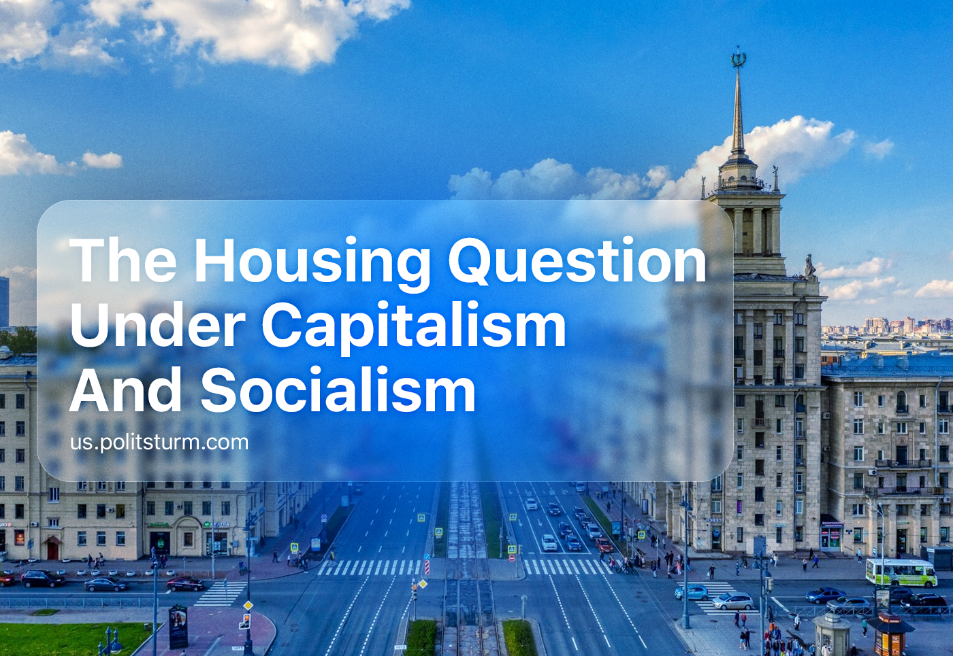

Original article
2024-01-24
20 min read

One of the basic human needs is comfortable and quality housing. Since the beginning of our existence, housing has been a fundamental requirement for survival, providing people with security and the opportunity to rest and recuperate. In order to provide themselves with material benefits throughout their lives, people work together and organize their work under a certain system. In modern society, with its industrial and scientific progress, the majority of the population still does not have this need satisfied.
The reason for this is the connection between the housing issue and the economic system, the organization of labor under capitalism and private ownership of the means of production.

I. Housing as a basic need
Humans, like other living beings, strive to survive in the world around them, in addition, evolutionary progress has allowed us to use our minds to create safer and more comfortable conditions for survival.
If a person does not take care of their primary needs for safety, the availability of food, and keeping in good health, then they will die. Therefore, only when a person is not busy thinking about the lack of food, and does not have to worry about tomorrow, do they begin to study and understand the world around them and satisfy their spiritual, cultural and intellectual needs.
Having comfortable housing is one of the basic needs of a person, without which they cannot thrive and fully satisfy their needs.
The inaccessibility of quality housing due to the high cost of housing and low incomes, unemployment, and limited development opportunities, force people to purchase housing on credit. However, the increase in interest rates on loans forces borrowers to spend a large part of their income on paying off this loan, instead of using these funds to satisfy their other needs.
The low quality of life is further ensured by salary cuts and the withdrawal of part of a person's income through tax systems, inflation and rising prices, paid healthcare, and education.
We should also not forget about the enormous psychological pressure exerted on a person. Finding yourself in an unpredictable economic and financial situation, faced with the threat of losing a job or a sharp reduction in income leads anxiety, stress, and depression to burst into the debtor’s life.
Thus, the desire to satisfy one’s basic needs, without which life in modern society is impossible, in current conditions leads to material and spiritual losses in all other areas of life. What should have become the basis for a quality or at least somewhat bearable life — housing — has become the cause of impoverishment and psychological and mental ill-being.
For these reasons, the housing problem in modern capitalist society is so acute and attracts so much attention.

II. Under capitalism

2.1 Unavailability
From UN data it can be seen that about 15 million people are subject to forced eviction every year, 100 million people have no roof over their heads, and 1.6 billion live in extremely unacceptable conditions. Any such social phenomenon is inextricably linked with the economic situation in society and the country.
Homelessness is a stable phenomenon in capitalism. Private ownership of the means of production inevitably gives rise to unemployment, a reduction in income and social benefits of the population, economic inequality, and exploitation of man by man. This is perfectly shown by statistics on housing prices and average wages in Russia.
In large cities, for example in Moscow, the influx of investment and capital is many times greater than in non-central areas, for example in Novosibirsk, which explains the differences in real estate prices and wages. In the Russian capital city, the average salary in 2021 equaled 71,321 rubles while the secondary market price for housing is 537,800 rubles. per square meter. There is a slightly lower average salary in St. Petersburg; in 2021 it amounted to 60,333 rubles, and the price for 1 sq. meter in the primary market from January 2022 to the 1st quarter in 2022 increased by 21% - to 255,000 rubles. In Ekaterinburg average salary in 2023 is 56,572 rubles, and the price per 1 square meter of living space in October 2022 amounted to 100,275 rubles. The average salary in the Novosibirsk region is equal to 55,377 rubles, and the average price per 1 square meter in this regional capital in October 2022 amounted to 98,100 rubles.
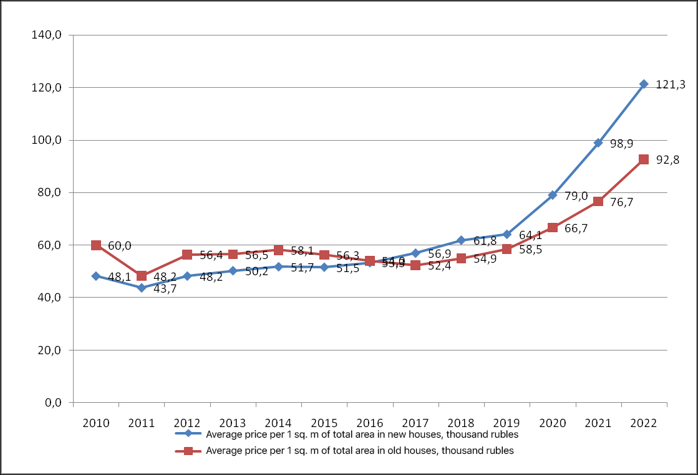
Average price per 1 sq. meter of living space in Russia, according to statistics data from the Central Bank of the Russian Federation.
There is still an idea that such socio-economic problems are characteristic mainly of poor, “underdeveloped” countries like Russia; as if in “developed Western countries” the situation is much better.
Liberal myths about “right” and “wrong” capitalism lead many people to believe that “wrong” capitalism is to blame for Russia’s deplorable economic situation. It seems that Western countries have taken the “right” path, so we need to transfer private property into the hands of the “right” entrepreneurs and the situation will change. But if you look closely, you can see that the situation of Western workers is not much different in this sense.
The situation is deplorable in America, where the average salaries range from 51,000 to 53,500 dollars a year, which is not sufficient to overcome mass poverty in the country. The incomes of about 18.5 million Americans are still below the poverty threshold by two times while another 40 million Americans receive wages below the minimum cost of living.
This is where the problems of the American worker with housing come from. Most US citizens rent apartments without buying them because it is much cheaper. The cost of housing and communal services in the USA ranges from 344.77 to 588.01 dollars per month, while the rent of a one-room apartment ranges from 580 to 3,872 dollars, and for a two-room apartment from 709 to 5,325 dollars.
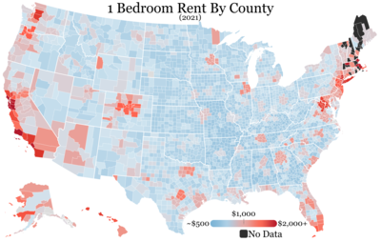
1 bedroom overnight rentals in the USA 2021, according to Wikipedia.
Compared to renting an apartment, buying a personal home has become an expensive privilege. The average price of a home in the USA is $216,000, and sometimes $4 million and even higher (in the areas of New York, San Francisco, Boston, and Los Angeles). Such luxury is unattainable for the average American, who works from 8 to 16 hours per day and 47 hours per week on average.
The high cost of housing and the gradual decline in household incomes inevitably increase the growth of mortgage lending, as it becomes more difficult to purchase apartments without “bank help.” Despite the low mortgage rates in America, the maintenance of the housing itself (taxes on garbage collection, on the real estate itself, on the use of electricity, running water, and the like) costs large sums that an ordinary American cannot always pay, causing the bank to kick him out onto the street. Americans are purchasing new homes less and less.
The renewal of the housing stock is becoming another reason for the increase in the population's debt burden. This is how the authorities get rid of poor areas by demolishing old buildings. New housing near a business center is many times more expensive, so Americans move to small towns or become vagabonds. The approval rate for mortgage loans is also falling, due to the fall in household incomes and an increase in mortgage rates:
“Demand for mortgages in the United States has fallen to its lowest level in a quarter of a century as rates on this type of lending approach 7% per annum. The Mortgage Bankers Association (MBA) index, which measures the number of mortgage applications submitted, fell by 14.2% to 218.7 points, the lowest level since 1997. A year ago, the value of this index was 684.5 points,” writes RBC.
Let's look to the East. The Chinese government reports an 8% reduction in poverty, but upon closer examination, the situation is different.
There are a number of criteria that define a person's status among the poor. For example, the poverty threshold in China is 6.33 yuan per day or 65 rubles per day (equivalent to £0.57 or $0.72 per day). Some earn extra money by repairing old equipment in landfills or trading in the market. The unsanitary conditions characteristic of poor Chinese regions provoke the proliferation of rodents, which can even become food for local residents. Homes in these areas have electricity and running water, but to cover utility bills, the Chinese have to work multiple jobs or overwork. Here the labor market provides generous opportunities to work two shifts.
In any country in the world, cities with a large number of companies have the highest rankings of salaries and also the prices for goods and services. China is no exception. In poorer areas of China, housing prices are much lower than in developed areas.
Thus, buying a home in Urumqi (the average salary is 1,050 yuan) will cost 8,500 yuan. The price of housing is almost 8 times higher than the average salary. In the city of Lhasa (average salary - 6,090 yuan) housing costs about 12,800 yuan. The average salary in Shanghai is 14,800 yuan, and the average housing price is 53,600 yuan. In Beijing (average salary 15,700) you can buy housing at an average price of 59,000, and buying a home in Hong Kong (average salary - 11,524) will cost 138,000, which is already 11 times more than the average salary.
With housing prices like these, the average person in China has no choice but to sign up for an individual housing mortgage. In this “socialist” society, “the people's” finance capitalists have also found ways to further diminish the worker's share of the social wealth. In 2017 the level of consumer loans in China grew by 40%, and Chinese banks, seeing increased demand, raised loan rates to 37%.
If problems arise with timely loan repayments, Chinese banks impose sanctions against borrowers. They operate with the Celestial Empire regulations to punish debtors for the failure to repay loans on time. Within 1 month - a fine, within 1-3 months regular notifications will be received and on-site inspections will be carried out, after 3 months, in addition to all of the above, the bank will closely monitor the movement of funds in all of the client’s accounts and will take the client’s housing as collateral, regardless on the type of loan issued, and after 6 months the bank will go to court. "Due to the loss of trust, debtors must be prepared" for the fact that the courts:
- Can sell the debtor’s home, and instead allocate a small living space to “maintain their living needs”;
- Currently, PRC bailiffs can search for, freeze and confiscate the financial assets of a person charged with non-payment of a debt;
-The debtor will be prohibited from traveling on the highways or using public transport;
-Attempts to cross the border, by any means, will be prevented;
-The debtor is deprived of their pension as one of the types of “fixed income”;
-Can be imprisoned for up to 7 years;
Based on the above, we can draw a definite conclusion that the “housing issue” is not specific to one country or another, but is characteristic of the entire world system of capitalism. At the same time, the reasons for the difficulties are approximately the same everywhere: low wages and, conversely, high housing prices.
In all the countries mentioned, the population, unable to purchase housing, is forced to take out a mortgage loan.
It is worth mentioning what Mortgage Housing Lending is. A mortgage loan is a loan for real estate, issued with a pledge on this property, which until the loan is fully repaid is the property of the bank. The bourgeois media, bank advertisers, and PR people, as well as the government itself, frame a mortgage as an opportunity to purchase long-awaited housing. Banks generally like to talk about themselves as “reliable friends in the search for real estate,” attracting potential clients with various “preferential” programs.
In reality, a mortgage loan is not an opportunity, but an additional burden. It is one of the most important sources of material deprivation.
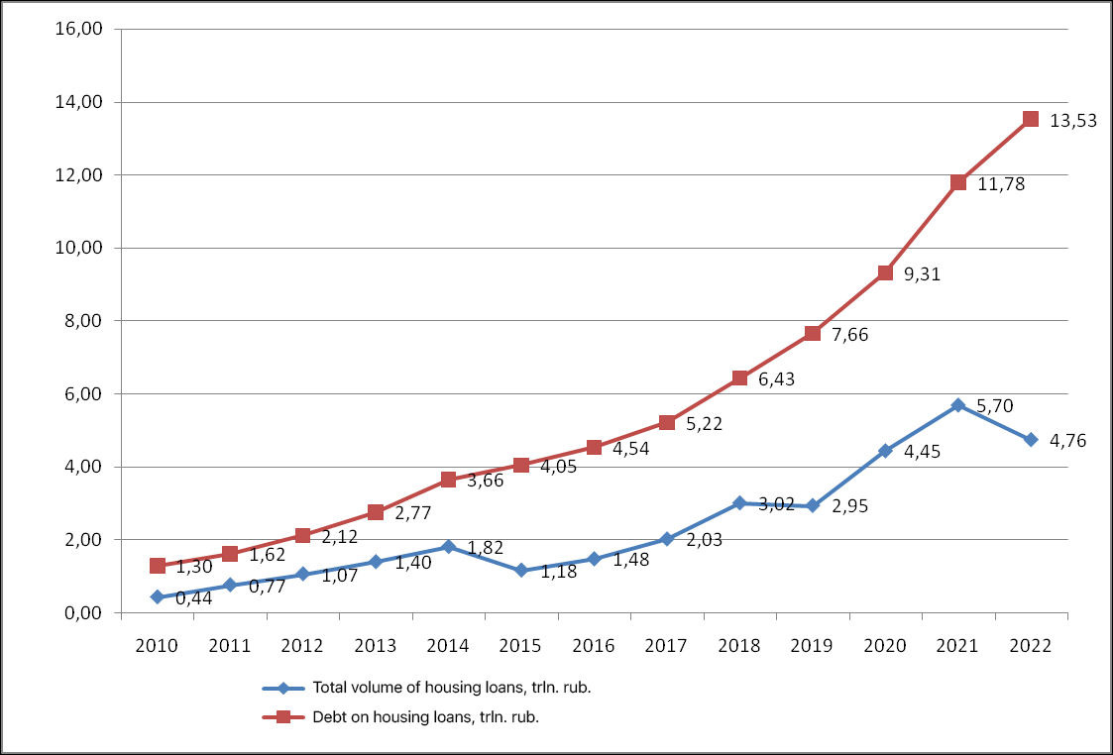
Number of loans provided and debt on them, statistical data from the Central Bank of the Russian Federation
The risk of not repaying a loan, and losing one's housing and livelihood increases with the possibility of losing one's job and stable income during times of economic crisis. Growing nervous stresses lead to increased irritability and chronic anxiety. It depletes the nervous system and undermines a person’s psychological health, which has a bad effect on their well-being and relationships with others. However, the average citizen has no choice, so applying for a mortgage, material deprivation, psychological harm to health, non-payment risk, and loan debt are constant companions of public life.
As the economic situation worsens, the loan interest required to be paid by creditors increases, the income of the population inevitably decreases, and therefore the approval of mortgage lending decreases. In 2021 it decreased to 8-9%, and in 2022 volumes of mortgage approval rates fell by 36%. That is, every third person who applies to a bank for a mortgage is refused. The decline in household incomes occurs against the backdrop of the growing inability to purchase housing, which forces the masses to get into credit bondage. Thus, taking out a loan is inextricably linked with overpayment and the inability to satisfy your other desires and needs until you pay off the loan.

2.2 Scale of construction
Regardless of the difficulties associated with purchasing housing, the construction business is one of the most profitable and rapidly growing industries. The demand for housing, based on its importance in the system of human needs, seldom decreases. In addition, old buildings and houses are gradually deteriorating and need to be replaced with new ones.
“The total revenue of the ten leaders in the ranking in the first quarter of 2022 amounted to 348.1 billion rubles. This is 43.6% more than the amount of revenue of the top ten developers in the Moscow region based on the results of the first quarter of 2021 (242.4 billion rubles),” writes RBC.
Among the leaders in terms of profits are the Donstroy company - 42.6 billion rubles, Samolet - 42.8 billion rubles, and PIK - 131.9 billion rubles. The number of square meters commissioned by Donstroy was 105,282 meters, by Samolet 248,451 meters, and by PIK GC 568,978 meters.
In total, in 2022, approximately 102.7 million square meters of housing, of which – 57.2 million square meters were built by citizens testifies RBC.
The leaders of the American real estate market remain Jacobs Engineering Group, Lennar Corporation, and Fluor Corporation. Fluor Corporation posted earnings of $115 million in the first quarter of 2022. The total revenues of Lennar Corporation increased by 30%, reaching $8.4 billion in 2022, and net profit increased by 59%, to $1.3 billion. As written on the official website of Jacobs Engineering Group, total revenue for 2022 amounted to $14 billion.
The Chinese residential real estate market is divided among China Railway Construction Corp. Ltd (Market cap: 14.9 billion), Sunac China Holdings Ltd (Market cap: 20.7 billion), and China State Construction Engineering (Market cap: 30.7 billion).
No matter what hardships the purchase of housing on credit brings to the population, large capital makes fabulous profits from this. Construction companies are directly interested in the existing lending system. No matter how high the speculative price is set by the market for housing, developers will always be provided with their profits. And only a general economic crisis can lead to the collapse of this sphere, following the fall of the financial market.

2.3. The main contradiction of capitalism
Summarizing all that has been said, we can identify two trends:
Firstly, a huge amount of housing is being built around the world;
Secondly, it turns out to be inaccessible to ordinary people, forcing them to get into credit bondage, rent rooms, or huddle in small studios.
These trends clearly reveal the main contradiction of capitalism - the contradiction between the social nature of labor and the private capitalist nature of appropriating the results of this labor.
To build a modern house, you need a team of engineers, planners, crane operators, and builders, as well as special equipment and machinery. To create this technology and equipment, workers and the means of production they use are necessary. In order to train construction and working personnel, it is necessary to additionally train teachers from technical schools and universities.
For all this, you need to allocate premises and install plumbing, electricity, heating, etc. there. This series can be continued endlessly, despite the fact that we are not yet even talking about the fact that any specialist or ordinary worker must first be born, raised and educated.
Ultimately, the construction of even the smallest house, directly or indirectly, involves the whole of society. This applies to other areas of the economy, not just construction; this expresses the public character of modern production.
However, the members of society who participate in construction cannot use the benefits they themselves create. Instead, they have to buy what they created with their own hands. This happens because the most important thing - the means of production, the tools with which a person builds and produces - are privately owned. For this reason, the result of social, collective labor does not belong to society - it belongs to the owner of the means of production, the capitalist. He, in turn, being the owner of what was built, puts it up for sale and sells it as a product, pursuing the goal not of meeting the needs of society, but of ensuring himself a profit.
“...the product of social labor is appropriated by the individual capitalist. This constitutes the main contradiction, from which flow all the contradictions in which modern society moves and which are revealed with particular clarity in large-scale industry,” - F. Engels, “The Development of Socialism from Utopia to Science.”
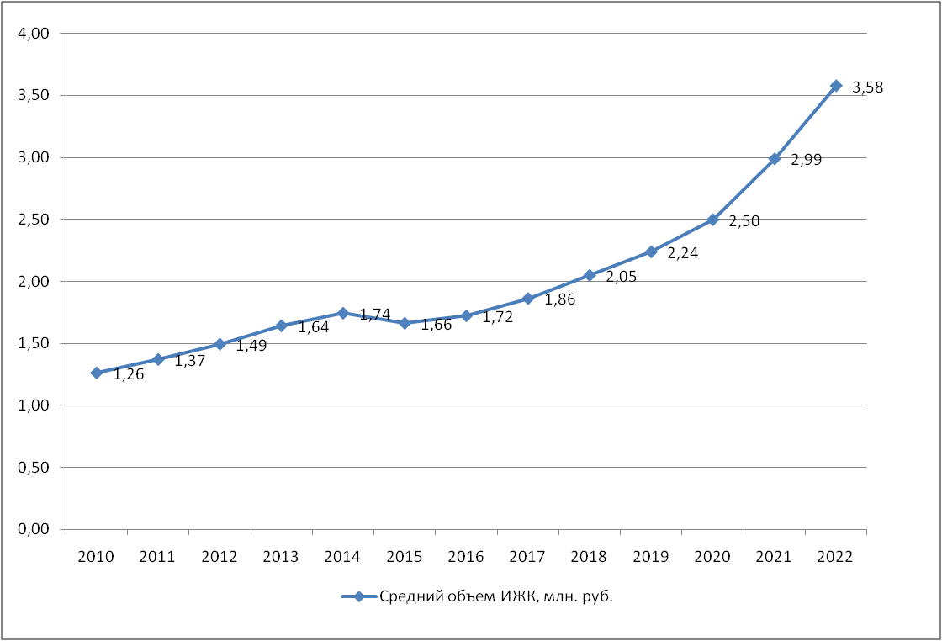
The ratio of issued MHL to their number by statistics from the Central Bank of the Russian Federation.
At the same time, there is a constant decline in the population’s income, so buying a home is becoming increasingly unfeasible and impossible. This is not a “vice” of capitalism, but a systemic feature of it.
Karl Marx discovered this contradiction and identified it as the law of development of capitalist society.

III. Under socialism
The Soviet Union did what no capitalist power could repeat: it defeated unemployment, and poverty and solved the housing problem.
The housing issue in the Soviet Union, although not immediately, was completely resolved. Collective ownership of the means of production and the organization of Soviet power made it possible to distribute resources in the interests of society: workers and peasants who established their own power.
Initially, the scale of construction in the USSR was small. Relatively low rates of construction between 1920 and 1940 are explained primarily by the presence of a sufficient amount of housing inherited from the former Russian Empire. And besides, there was still an undeveloped industrial and technical base. What was previously controlled by officials and large capitalists became the property of the people.
In the 1940s, the country was preoccupied with war and post-war reconstruction. Only then, in the 50s, 60s, and beyond, the pace of housing construction in the USSR increased significantly, fully covering the needs of the population:
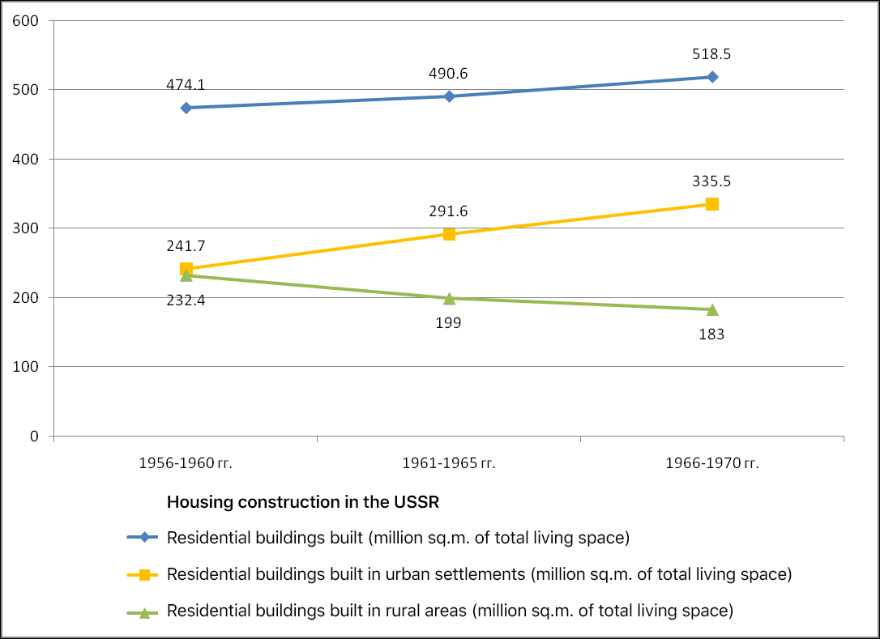
Statistics on the construction of residential buildings in the USSR, website data istmat.org
The graph shows that during the indicated period, urbanization continued in the USSR.
The freedom of social labor from exploitation and the achievements of socialist science made it possible to improve construction technologies.
So, in the construction of the so-called “Khrushchevka” housing complexes, technologies used by modern development companies were: panel construction, connecting these panels by welding, low-rise construction, and so on. The above led to cheaper construction, which helped speed up the pace of housing development.
Thus, the elimination of the contradiction between the collective nature of production and the private nature of its appropriation made it possible to completely solve the housing problem and provide the masses with affordable and convenient housing for their time.

Conclusion
Housing is a basic human need. Its satisfaction allows you to qualitatively satisfy other needs, engage in the realization of your talents, study the world around you, and acquire new skills.
Nowadays, people are faced with the unaffordability of housing, high costs of maintenance, and poor quality construction and furnishing. The reason for this is the capitalist economy. The market has an inherent phenomenon: the contradiction between the social nature of labor and the private nature of the appropriation of its results.
The experience of the Soviet Union has shown that socialism eliminates this contradiction, making it possible to provide the masses with high-quality and comfortable housing, and eliminating homelessness and poverty. There are no other options to clear the path of progress and overcome all the major socio-economic problems of modern society.
Sources
«Statistical collection of the Central Bank of Russia"— from January 30, 2022
Site «Historical Materials»
Visasam—«Level of people below the poverty line in China" - from March 19, 2023
Visasam—«Poverty rate in the US in 2022-2023" - from March 27, 2023
USAPROSTO «Working day in the USA» — from 02 May 2023

Original article

