The Hatred Towards Russians is Rising in Sweden
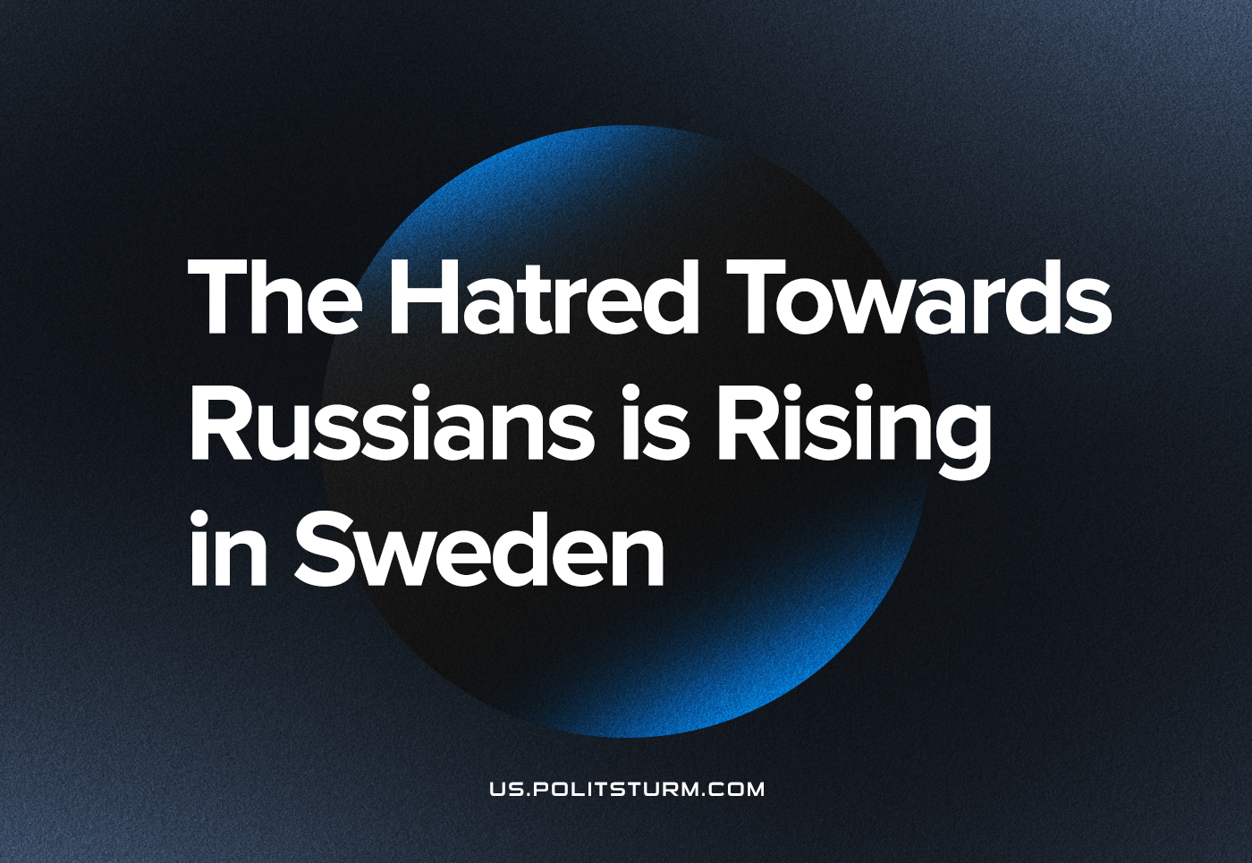

Original article
2023-01-25
6 min read

An uncomfortable atmosphere is manifesting in society, both in Sweden and the rest of the world. It is a hatred towards a certain population. But it is not racist groups behind this, it is politicians from the social democrats to the liberals who feed the fire. This rhetoric is the same as when racists rage against Muslims or other minorities. So what is the difference between social democrats and liberals compared to other racist groups?
The ones exposed to the hatred from the social democrats and the liberals are of Russian nationality, and the examples can be quite strange. Liberals and social democrats now act in the same way as racists who say that Polish or other migrant workers do not belong in the Swedish society. In the former the rhetoric is founded on the idea that the workers because of their nationality are worse than other workers. In the latter case it is presumed to be the Russian citizens’ fault that Putin is in power – in spite of the constant claims that there are no free elections in Russia. Their logic is confusing.
The capitalist economic system needs a scapegoat to exist, and whether that is Muslims, Jews, Romani, etc., or Russians (or any other minority group) that are targeted is irrelevant. It happened in the 1930s with Nazi Germany, and it is happening again. Social media is the worst at targeting the real culprit – the capitalist class – instead of scapegoats.
Oppression of the Russian minority because of imperialist contradictions
The current events are a conflict between two imperialist blocks: Russia and NATO. The Ukrainian regime – not the people – and probably also NATO oppressed the Russian minority in the eastern parts of Ukraine. They had Nazi troops at their disposal. This minority was exposed to illegal arrests, torture, and murder – something that was not covered in the West. Was this an oversight? No, media had been able to cover this oppression just as they cover Russian oppression now. So what is the reason for the neglect of the situation in Donbass and Luhansk under these eight years? Was it to prepare the people of the west for a potential – now real – actions of the Russian Federation?
Nazis in Ukrainian and Russian service
The bourgeoisie in the west have buried their heads in the sand when it comes to condemning the Ukrainian regime for the Nazi units in its army, alternatively tried to sweep it under the rug as none-issue by claiming that the Azov battalion is now a popular army.
The Ukrainian government gave on the 1st of December 2021, just months before the Russian invasion, a gold medal to a Nazi and declared him a national hero. The pretext was that he had been wounded in battle, but nowhere was there an explanation of where and how the Nazi had been wounded.
Even in Russia does Russian Nazis appear openly in state television.
Sanctions on Russia
The west has enforced sanctions on Russia and many countries have also frozen Russian assets. Russian oligarchs complain that they no longer can waddle in the luxury they had grown so accustomed to. But it is not just the Russian oligarchs who are suffering because of the west’s sanctions. Most affected are the common Russian people, the Russian working class, and the people of Russia when the EU enforces export sanctions on iron and steel industries.
This is what Sweden’s EU-minister Hans Dahlgren has to say: “It is another way to put the pressure on Putin. It must become as costly as possible for the Russians, so that they understand that there is a great cost to keep the invasion going”.
And as the Russian capitalists does not want to pay – in spite of sanctions and confiscations of wealth – must the Russian working class pay for it. The Russian capitalists will not suffer. And not just that; they will also accuse the west as the culprit for the deteriorating living conditions of the Russian working class. All this while the Russian bourgeoisie continues to more or less live like before.
Why no sanctions against the US and NATO?
Now that there have been sanctions on Russia, must we ask ourselves why the EU or other countries have not enforced sanctions on the US or NATO. They are waging wars now and then, and should be drowning in sanctions as a result. So why have the EU not seized the US-American oligarchs assets as a result of the US bombing Somalia a couple of hours before the Russian troops engaging? No, the west has accepted the explanation that they are fighting a war against terrorism and Islamic warlords in Africa or the Middle east.
But the west cannot accept that Russia uses the same type of justification when it says it is fighting against Nazi terror groups in Ukraine. Why? Well, here the propaganda of the West plays a part. What the West does is seen as noble and righteous, but what Russia is doing is barbaric and wrong. When a few Islamic terrorists are killed – alongside many civilians – nothing happens. It is looked on with respect and seen as a war for democratic values. But when Nazis in Ukraine get killed – alongside many civilians – we in the West should see it as something terrible.
The causes for wars
The causes for all these wars – yesterdays, todays, and future wars – are NOT a matter of fighting some religious or ideological groups. The US neither wages war against Islamic terrorist groups in Africa nor the Middle east, or any other place in the world. And Russia does not wage “Special Military Operation” against Ukrainian Nazi troops in Ukraine.
The real purpose of these wars is purely imperialistic. None of these countries would sacrifice billions on war if there was nothing to gain. We should take a stand for the people of Ukraine (including minorities in Ukraine such as Russians, Roma, etc) and the people of Russia. The peoples are cannon fodder and squeezed when capitalist countries war against each other.
Then it is also weird how the West is doing what the German Nazis were doing in the 1930s when they would seize Jewish wealth. The Nazis stole art, diamonds, and other things owned by the Jews, and then handed it out to party elites and officers. The Bolsheviks after the revolution seized the wealth owned by their own bourgeoisie and turned it into common property.
I definitely do not think that the West has the same intentions as the Bolsheviks and turning the Russian oligarch’s wealth into common property. Most likely they will just freeze the oligarchs saving and give it back when a liberal or conservative becomes president in Russia – one who is subservient to the liberals and conservatives of the west when they ask of it.
Kerstin Stigsson, Riktpunkt.nu.

Original article

