French Protests Die Down
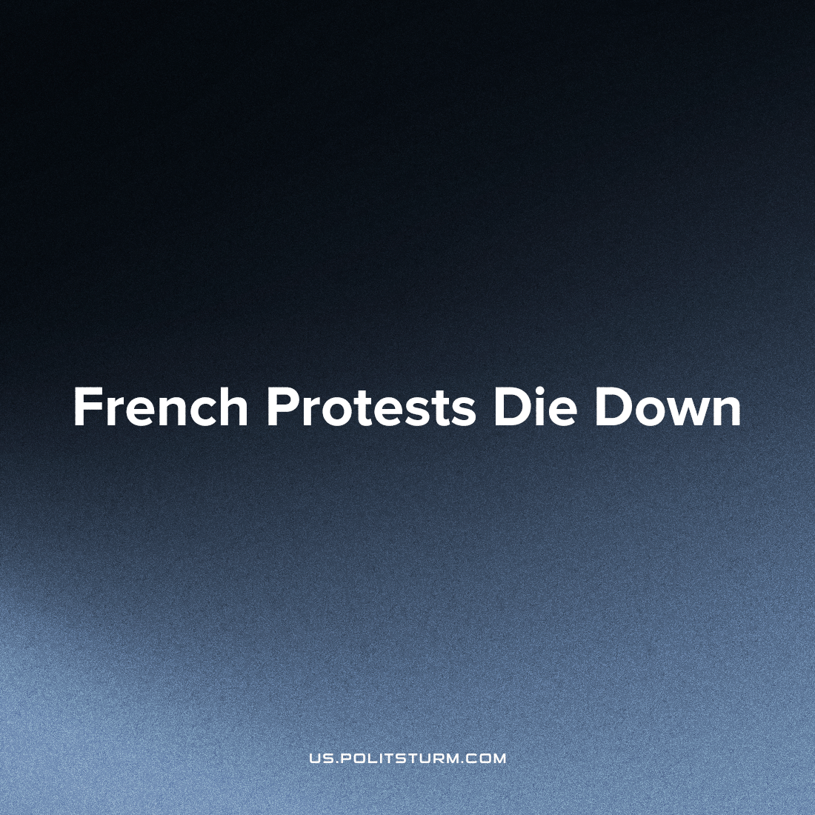

Original article
2023-07-27
3 min read

Massive anti-government protests were expected in France on Bastille Day on July 14. To counter the next wave of popular anger, about 130 thousand policemen and gendarmes were summoned by the government.However, hopes for a massive resistance to the government on Bastille Day did not materialize.
Although there were local riots and clashes with the police, they did not take the form of a large and politically conscious movement. At the end of the day, only 96 people were detained, 225 cars were burned and 51 cases of fireworks use were registered. By French standards, this level of resistance looks rather weak and is inferior even to the indicators earlier in the year.
There was good reason to believe that France's revolutionary national holiday would be the occasion for another wave of mass protests. Since January 2023, the French have organized more than ten nationwide strikes and have regularly protested on the streets against the pension reform that raised the retirement age from 62 to 64. During the most active days, street protests drew more than a million people across the country. These protests also had broad support among the French people: according to polls, almost 70% of the French population supported the protests, and 80% condemned the method of enacting a new law by the president alone in accordance with article 49.3 of the French constitution.
French authorities gave the people further purpose to revolt when a police officer killed 17-year-old Nahel Merzouk during his arrest for lacking a license on June 27th. Riots broke out across France, setting fire to more than 2,500 fires and over 1,350 cars in those days.
Despite the high level of indignation and mobilization of the French people after the murder of a teenager, spontaneous protests did not have a clear ideological focus or clear goals. However, neither "left" parliamentary parties, nor trade unions or other associations have taken responsibility for organizing, coordinating or leading these protests.
Jean-Luc Mélenchon, leader of the Invincible France broad-left coalition, expressed his condolences and outrage over what happened, but called for calm. Mélenchon tweeted on July 30 that “those ‘trade unions’ that call for a civil war must learn to be silent. We have seen what deadly results can come from such talk. The political power must take control of the police. Those who want peace should not add fuel to the fire!”.
Despite his "support" for the people's indignation, Mélenchon and other leaders of the "left" public opinion did not take concrete steps to turn the protests into a real political force. As a result, the riots remained spontaneous and devoid of future political potential.
The absence of a revolutionary political party capable of directing the indignation of the working class in a constructive direction led to the gradual subsidence of popular movements in France. By Bastille Day, only a small manifestation of the former revolutionary energy of the French working people remained.
This development indicates that mass demonstrations and spontaneous riots are not sufficient on their own to achieve significant changes in the political and economic system. It is also necessary to have a conscious political direction. Under the leadership of such a revolutionary force, the working masses will be able to offer crushing resistance to their exploiters and move closer to the realization of socialism.
Sources: DH - “Festivités du 14 juillet : peu d'incidents en France" from July 15, 2023
Le Figaro - "1311 interpellations, 1350 véhicules brûlés... les chiffres de la quatrième nuit d'émeutes après la mort de Nahel" from July 1, 2023
Elabe - "8 Français sur 10 opposés á l'utilisation du 49-3 pour adopter la loi sur la réforme des retraits" from March 15, 2023
Komsomolskaya Pravda – "255 cars were set on fire during the celebration of Bastille Day in France" from July 15, 2023
Twitter posts by Jean-Luc Mélanchon – June 30, 2023

Original article

