The Fall of Karabakh
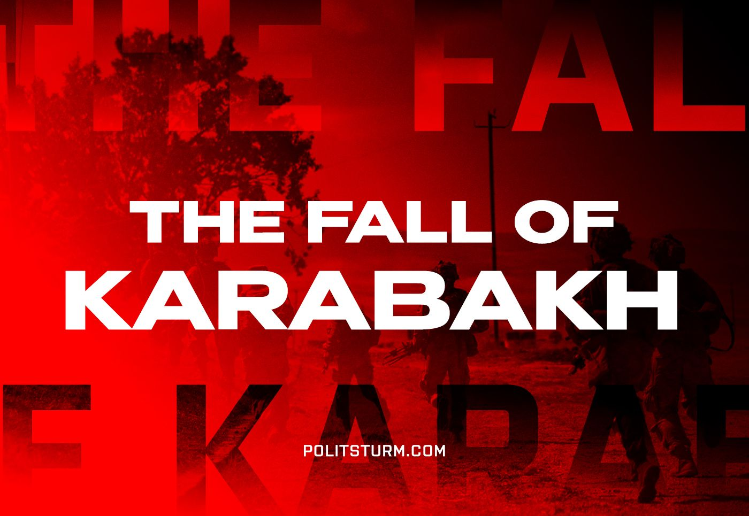

Original article
2023-09-20
8 min read

On September 19, Azerbaijan announced an “anti-terrorist operation” in Nagorno-Karabakh against the unrecognized “Nagorno-Karabakh Republic” (Republic of Artsakh) in order to ensure “the safety of military personnel and the restoration of constitutional order”.
A day later, the NKR government announced the end of resistance and agreement with the demands of Azerbaijan. The agreement to stop “anti-terrorist measures” was reached on the basis of the withdrawal of all armed forces of Armenia and Nagorno-Karabakh, the complete disarmament of the NKR army and the surrender of its weapons and heavy equipment to the Azerbaijani forces. The statement by the Azerbaijani Ministry of Defense emphasizes: “The implementation of these processes is ensured in coordination with Russian peacekeepers”.
What are the results and the consequences of this 'operation'?

The Results of the Conflict
Azerbaijan. Over the past 30 years, Azerbaijan has repeatedly tried to eliminate the unrecognized NKR. During the last major conflict in September-November 2020, Azerbaijan managed to achieve victory and establish control over more than half of the territories as a result of trilateral agreements between Armenia, Azerbaijan and Russia.
At the end of 2022, the blockade of Karabakh began: Azerbaijan closed the Stepanakert-Goris-Berdzor highway, along which the remaining communications of Armenia and the unrecognized republic ran. Information about preparations for hostilities on the part of Azerbaijan appeared several weeks before the start of the next clashes.
For Azerbaijan, the end of the Karabakh conflict is another “small victorious war”, a demonstration of strength to increase the influence of Azerbaijani capital in the region and an opportunity to strengthen support for the ruling bourgeoisie led by Aliyev.
Turkey. Over the past decades, Azerbaijan has actively developed cooperation with Turkey. Turkish capital, which claims to be the largest force in the Black Sea and Transcaucasia, needs unhindered access to Azerbaijani resources.
It is therefore not surprising that representatives of Turkey strongly supported the actions of the Azerbaijani Armed Forces. On September 19, at a session of the UN General Assembly, Turkish President Erdogan said that Karabakh is the territory of Azerbaijan, and Armenia must fulfill its obligations; first of all, to open the Zangezur corridor between Azerbaijan and its exclave Nakhchivan Autonomous Republic.
“We support Azerbaijan in its steps to protect its territorial integrity”, Erdogan said. In turn, Azerbaijani President Ilham Aliyev thanked the Turkish president for his support.
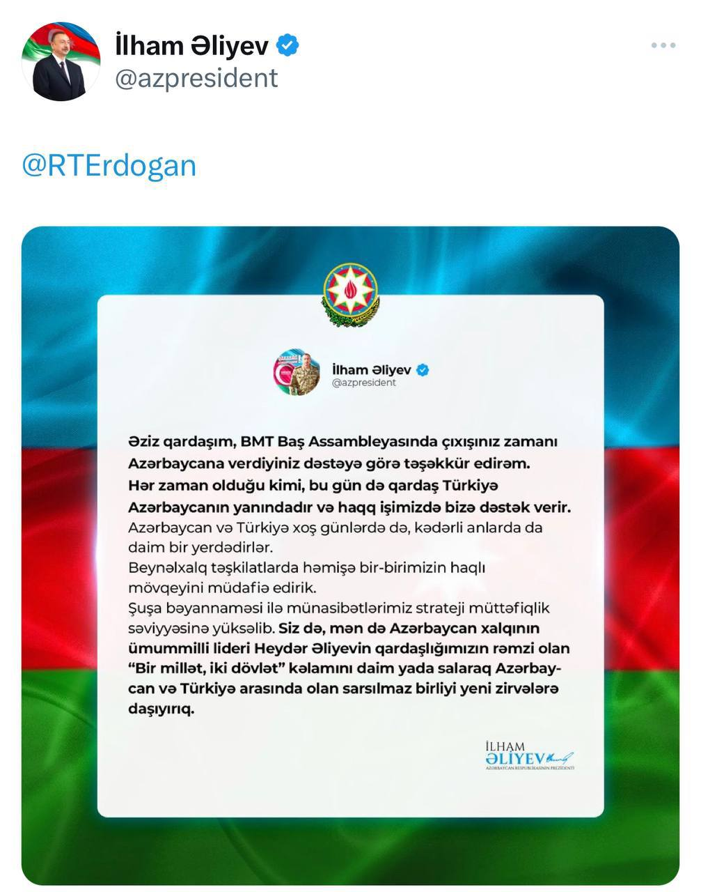
On the same day, a telephone conversation took place between the defense ministers of the two countries, during which Turkish Defense Minister Yashar Guler supported “anti-terrorism measures”.
The Zangezur corridor, access to which opens after the dissolution of the Nagorno-Karabakh Republic, will give Turkish capitalists the opportunity to transit goods from the countries of the region through their territory to Europe and will strengthen its influence not only on Azerbaijan, but also on the entire Transcaucasian region.
Armenia. With the loss of Artsakh, Armenia experiences a loss of political prestige and becomes an even more dependent state.
After the outbreak of hostilities, a spontaneous rally began in the central square in the capital of Armenia, demanding recognition of Artsakh and intervention in the conflict. The protesters expressed their dissatisfaction with the inaction of the authorities. Armenian Prime Minister Nikol Pashinyan addressed the nation, stating that the Armenian authorities condemn Azerbaijan’s invasion of Nagorno-Karabakh, but do not intend to intervene in the conflict: “Azerbaijan is trying to drag Armenia into a full-scale war”.
After the NKR government accepted the Azerbaijani conditions, Pashinyan made another address to the nation. The leader of Armenia tried once again to justify his actions by confronting Azerbaijan’s attempt to drag Armenia into the war and shifted responsibility for the defeat to the leadership of Karabakh and Russia.
Current events will contribute to the growth of chauvinistic and revanchist sentiments in Armenia. Together with the anti-Russian statements of the Armenian leadership over the past months, one should expect a further increase in Armenia’s dependence on stronger imperialist powers and the search for allies among the countries of the European Union.
Russia. The influence of Russian capital in the Transcaucasian region is weakening. Another lack of real assistance to Armenia from Russia has further undermined the authority of the de facto formal CSTO union and the “prestige” of Russian imperialism.
In connection with the events in Karabakh, the leadership of the Russian Federation issued negative messages towards the Armenian leadership. On September 19, Russian Foreign Ministry spokeswoman Maria Zakharova said: “Yerevan’s latest actions create fertile ground for the West’s hostile policy towards Russia... The Russian Federation is not satisfied with Armenia’s statements that anti-Russian steps do not in any way affect bilateral relations”.
Press Secretary of the Russian President, Dmitry Peskov, stated: “Moscow does not accept Armenia’s reproaches regarding Karabakh, they are groundless... de jure we are talking about Baku’s actions on its own territory”.
Dmitry Medvedev published a message on his Telegram channel in which, in an allegorical form, he held Pashinyan responsible for his anti-Russian actions.
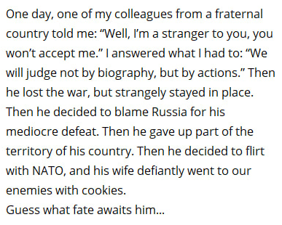
With the loss of Armenia, Russia loses its only ally in the Transcaucasus, which leads to a serious strengthening of Azerbaijan and Turkey, as well as strengthening the interests of the European Union and NATO, of which Turkey is a member.
Iran. Strengthening influence of Azerbaijan and Turkey is extremely unfavorable for Iranian capital, aspiring to leadership in the region, which creates the ground for future conflicts. This is especially important for Iran, since this state includes the provinces of East and West Azerbaijan, as well as Ardabil, inhabited by ethnic Azerbaijanis.

The Consequences of The Conflict
Events in Karabakh will cause another round of nationalist sentiments among all parties to the conflict, and will also give rise to new wars for the next redistribution of territory.
“…Humanity is faced with the alternative of going over to Socialism or of suffering years and even decades of armed struggle between the “great powers for the artificial preservation of capitalism by means of colonies, monopolies, privileges and national oppression of every kind.” – Vladimir Lenin, “Socialism and War”.
The capitalists in power in Armenia and Azerbaijan do not care about the people who died in countless armed clashes: they are only interested in personal gain and the benefit of their bourgeois group.
Who kills each other in modern wars? Workers of different nationalities, intoxicated by the chauvinistic propaganda of their local capitalists. Without proletarian internationalism and solidarity with other workers of the region, including those from Azerbaijan, it will not be possible to create lasting peace and a calm life.

What To Do?
The only way to resist interethnic hostility is socialism. It is indicative that despite the differences between themselves, both sides, as in the case of Ukraine, falsely accuse the communists of creating the preconditions for the conflict in Karabakh. In reality, only the Soviet Union was able to establish a peaceful life between representatives of different nationalities in this region.
For example, when famine broke out in Armenia in May 1920, Azerbaijan helped Armenian workers and peasants by sending food, fuel, money and specialists to restore the national economy. For decades, the peoples of Transcaucasia have built a peaceful life together. And on the contrary: it was with the fall of socialism that a surge in ethnic conflicts became possible.
Only communist parties, armed with Marxist-Leninist theory, can organize the workers of the warring countries as a class and put an end to senseless national wars.
“Either we allow ourselves to be killed in the interests of the imperialist bourgeoisie, or we systematically prepare the majority of the exploited, and ourselves, for seizure – at the price of less sacrifice – of the banks and expropriation of the bourgeoisie in order to put an end to the high cost of living and war.” – Vladimir Lenin, “On the Defence of the Fatherland Issue”.

We are already doing this work. Support and join us.

Original article

