The Export of Capital in the 21st Century as an Instrument of Expansion
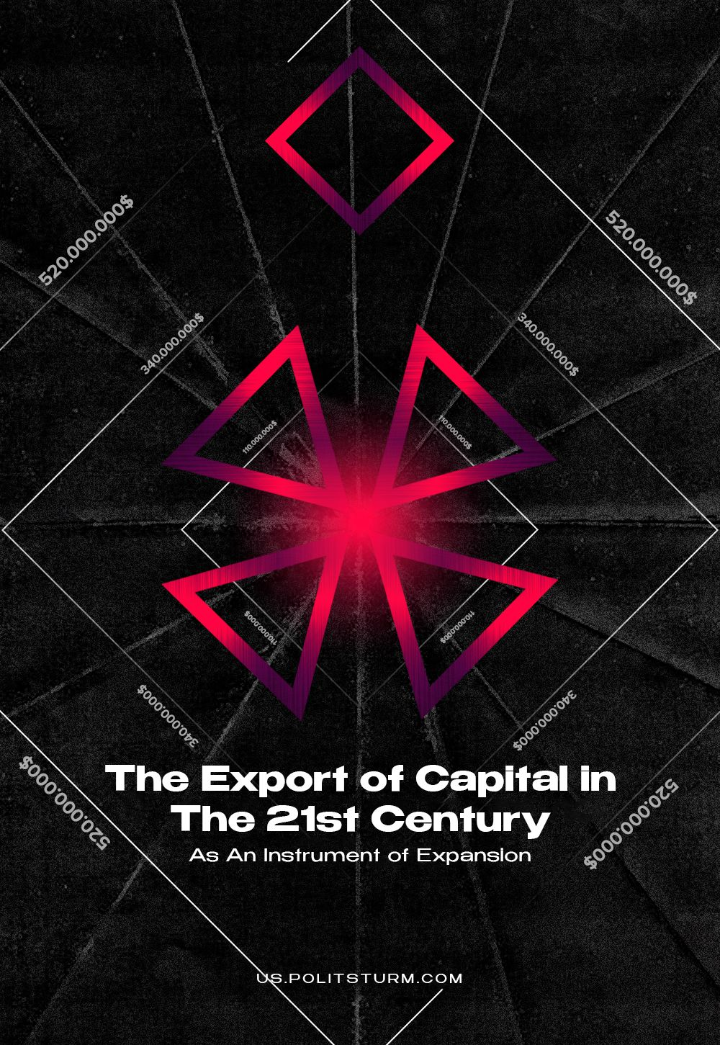

Original article
2023-11-22
21 min read

The imperialism of the 19th and early 20th centuries turned most countries of the world into colonies and semi-colonies to be used as markets, sources of raw materials and almost free labor. In the 21st century, the classical system of colonialism no longer exists, and it is the export of capital that has become the new and, over time, main form of enslavement of weak capitalist nations.
It has become one of the most important laws of the existence of monopolistic capitalism: the domination of finance capital within the most developed countries inevitably leads to the establishment of the domination of a small number of usurious countries over the whole world. At the same time, the struggle for the countries where capital is invested leads to the intertwining of monopolies of different countries and to the aggravation of contradictions and competition between them.
In this material, we will examine the export of capital and its significance under imperialism.

I. What is the Export of Capital?
First of all, it is essential to define capital. Capital encompasses all the resources that the bourgeoisie possesses for producing and selling goods to generate profit.
These resources may include buildings, equipment, machinery, intellectual and physical labor, money, and securities. Capital eventually amasses significant financial wealth and takes control over all sectors of the economy, resulting in the decreased growth of consumption for the proletariat. Capital eventually becomes constrained within its own national state, affecting not only individual companies but entire nations.
In other words, a huge "surplus of capital" is raised: both in the form of goods and money. Therefore, the capitalists must begin to look for countries to export their capital to, in order to use it in other national markets so as to turn a profit, to expand their “sphere of influence” at the expense of the now dependent nation; and to conquer foreign markets.
Thus, it can be said that the export of capital is an investment in foreign markets for greater profits. They place capital abroad mainly for the purpose of self-expansion. By doing so, the capitalist makes a foreign investment.
It is important to note that in the course of history, the global movement of capital emerged after international trade in goods and labor. The process passed through three distinct stages.
First stage - from the beginning of the XVIII to the end of the XIX centuries. This is the "emergent stage of capital export". During this stage, capital exclusively migrated in one direction: from the metropolis to the colonies, and had a limited and sporadic character.
Second stage - from the end of the XIX to the middle of the XX centuries. This period was dubbed the main "stage of capital export" as it involved the transfer of capital between developed countries and also from them to developing countries. The export of capital at this stage becomes characteristically typical and repetitive.
Third stage - from the middle of the XX century to the present date. It has been referred to as the stage of "international capital migration". Both capital export and imports occur among developed, developing, and transitional countries. The latter denotes a group of nations that are moving between different socio-economic positions, occupying an intermediate state between economically advanced and developing nations. Most countries now simultaneously act as both importers and exporters of capital.
Based on the above, the international movement of capital refers to the transfer of capital between different countries in the global economy, irrespective of their socio-economic development, resulting in additional income for their owners.

II. Forms of Capital Exports
There are two main forms of capital exports: entrepreneurial and usurial.
1. The entrepreneurial form is understood as the investment of capital in industry, transportation and other enterprises. It is supposed to create enterprises on the territory of other countries, the costs of which are borne by foreign owners. The purpose of the export of entrepreneurial capital is to gain profit on the basis of the advantages obtained in the country of the invested capital. In this case, the investment is made in two ways: through direct investment and portfolio investment.
Direct investments - are realized through capital investments in foreign enterprises. In fact, direct investments provide full control over the objects of foreign capital investments. The acquired ready-made enterprises become branches of a firm located in another country, which forms the center of an international production corporation.
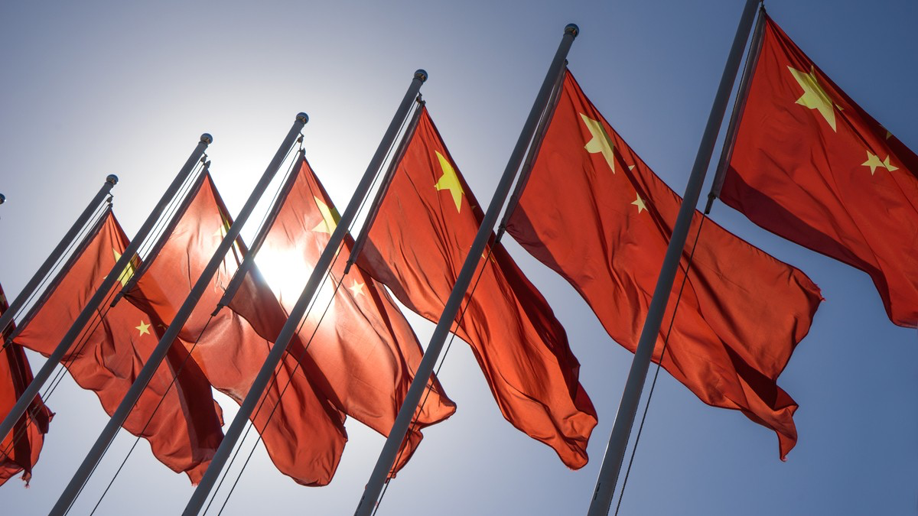
Currently, China is a leader amongst developing countries in Asia in terms of foreign direct investment inflows. With a population of 1.4 billion as of 2021, China is a country that still has huge market potential, which is an important factor for foreign investors. They see the Chinese market as quite large, with huge growth prospects, so many of them invest in China primarily to occupy the market and then to make profits.
Direct investments are largely aimed at import substitution and this strategy is followed by many foreign investors, primarily from the United States. Also, a very significant factor in the growth of foreign direct investment in the PRC is relatively cheap and highly skilled labor. The growth rate of foreign direct investment in China is still faster than the global rate.
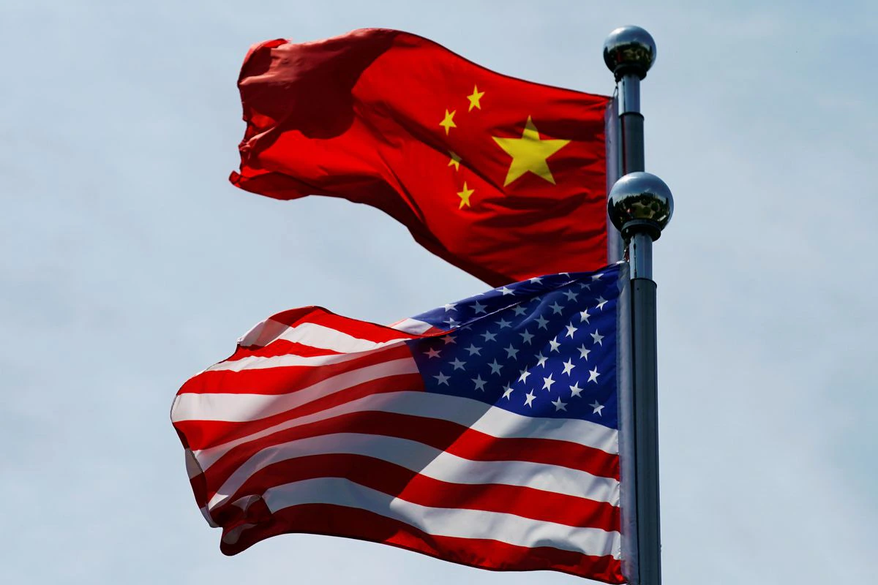
Over the years, there has been a transformation of foreign direct investment by transnational corporations in China. This is manifested in the increasing share of the latest technologies transferred by transnational corporations with the participation of foreign capital. This is demonstrated by the expansion of the network of research centers in the PRC, the active participation of transnational corporations in the training and retraining of personnel, and the growth of capital investment in high-tech rather than labor-intensive industries. Recently, the most advanced technologies of the various parent companies that produce in China, have been applied in China.
Foreign direct investment in service industries has increased significantly since China's accession to the WTO. Currently, China has foreign direct investment from 180 countries, including the United States, Japan, the Republic of Korea, Germany, and the United Kingdom.

Portfolio investment - where the capitalist purchases stocks, bonds and other securities of foreign enterprises. These securities bring them only a certain income, but do not give them the right of control. Export of credit capital is carried out in the form of loans; credits, investments on current and deposit accounts in foreign banks.
A special type of portfolio investment is the participation of foreign capital in joint ventures, where the controlling interest remains with the local state or local private firms. Here foreign capital participates with its financial resources, technology, managerial experience, trademarks, advertising and provision of services in the realization of products.
In return, foreign capital receives the profits according to its share, which it takes out of the country or uses for further investment locally. Foreign owners receive the strongest guarantees of safety and profitability of their investments. In turn, the state authorities of the host country can use external sources of funds and technology more efficiently and rationally in the interest of local capitalists.
The sum of investments out of Russia, made by the Russian Federation was $53.8 billion at the conclusion of 2008, as documented by Rosstat. Additionally, the sum of repaid investments previously dispatched by Russia abroad was $103.2 billion in 2008, marking a 76.3% increase from 2007. The amount of investments repaid indicates the profit or loss of a business, considering the initial investment amount.
2. Loan capital is monetary capital lent on terms of repayment, payment, and urgent use for entrepreneurial purposes.
Export of loan capital contributes to the growth of commodity exchange between countries and makes it possible to attract external financial sources for economic development. Credit relations between states are growing at the highest rates, significantly exceeding the rates of both world trade and the increase in foreign direct investment. Moreover, the international credit market works practically round the clock.
Transfer of significant sums from one country to another in any currency is made instantly through artificial satellites orbiting the Earth and the world network of telecommunications. Depending on the terms for which the loan is granted, it is subdivided into:
- long-term (about 10 years)
- medium-term (2-3 years)
- short-term (3-6 months and up to a year at most).
According to the sources of granting, international loans are in the form of bank loans and commercial credit. Private firms or banks, government agencies and international financial institutions act as lenders. International credit in the global capitalist economy has profound consequences. It has equalized the degree of the application of capital in different countries and contributed to the formation of an average rate of profit within the entire world economy.

Using international credit, the state can accelerate its economic development. The funds of a foreign loan are used to build new enterprises, the products of which are in demand not only within the country but also on the world market. The money in foreign currency received from the export of such goods makes it possible to repay the loan within the stipulated time frame and use part of the enterprise’s profits for other domestic purposes. As a result, the mutual benefit of the creditor and debtor is ensured.
At the same time, international credit can lead to serious economic shocks and sharp contradictions. For example, in the '70s and '80s, the main victims of aggravated conflicts in the international loan capital market were many developing countries. They took loans because of their constantly deteriorating economic situation, participation in the arms race and for other reasons. However, the loans were made without the necessary economic justification, spent inefficiently and often embezzled by the ruling circles of these States.
As a result, many states were unable to fulfill their foreign debt obligations. Interest and amortization in some cases absorb up to half or more of all revenues from exports of goods. In the 1980s, some developing countries were forced to suspend or limit debt repayment. At the same time, new lending to them also declined significantly.
External debt became a serious impediment to further economic development in low- and middle-income countries. And this has led to a serious deterioration in the living conditions of the majority of the population and is used by imperialist states and international financial institutions expressing the interests of creditors to interfere in the internal affairs of debtor countries.

III. Capital Export As An Instrument of Expansion
The export of capital is one of the main instruments of expansion of imperialist states into new markets of the world. It is with its help that TNCs and banks establish control over the factors of production and create global value chains. At the same time, two types of capital exports should be distinguished in terms of their nature and objectives.
Firstly, capital export within imperialist states is when the capital of one imperialist power is invested in the capital of another imperialist power. Thus, for 2018-2021, about 84% of all FDI (foreign direct investment) of developed states comes from mergers and acquisitions, indicating an increase in the speed of concentration of imperialist capital.

The recent takeovers of Tesla Motors by SolarCity in 2016, the merger of Mitsubishi and Renault-Nissan in 2016, and the acquisition of Activision Blizzard by Microsoft in 2022 are vivid examples of this. Through mergers and acquisitions, the world's largest multinational corporations become more competitive and gain access to new technologies and new markets.
Secondly, the export of capital to developing and export-oriented countries. Thus, in 2019, the share of developing countries in global foreign direct investment (FDI) overtook that of developed countries for the first time in a long time and increased to a record 54%. The increase in investment in these countries indicates that capital is being invested in low-wage countries in order to increase the rate of surplus value.
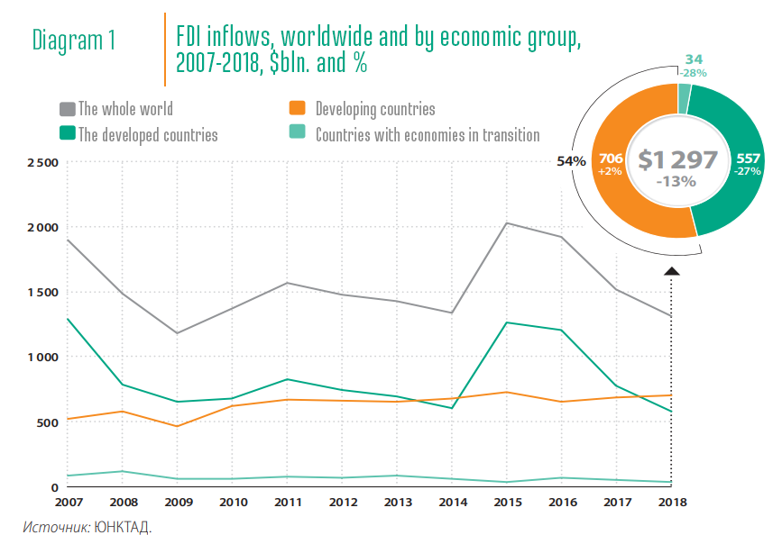
This is exemplified by the transfer of production capacities of imperialist countries to developing countries in places like Africa, Asia and Latin America.
Given the fact that developed and export-oriented countries occupy only an initial link in global value chains, this leads to their economic dependence. Moreover, because the modern economy is characterized by rather strong imbalances in the global division of labour, developing and export-oriented countries tend to be dependent on FDI and public credit in comparison with imperialist countries.
As a rule, FDI in developing and export-oriented countries is not aimed at creating new value added and new technologies, but at extracting resources. Such countries do not create "closed-loop" or self-sufficient economies. On the contrary, the structure of FDI in developing countries indicates that investments are made in extractive and light industries rather than in heavy industries that create means of production (machine tools, machines, robots) and knowledge-intensive areas (IT, telecommunications, biotechnology, aircraft construction, nuclear industry, etc.).
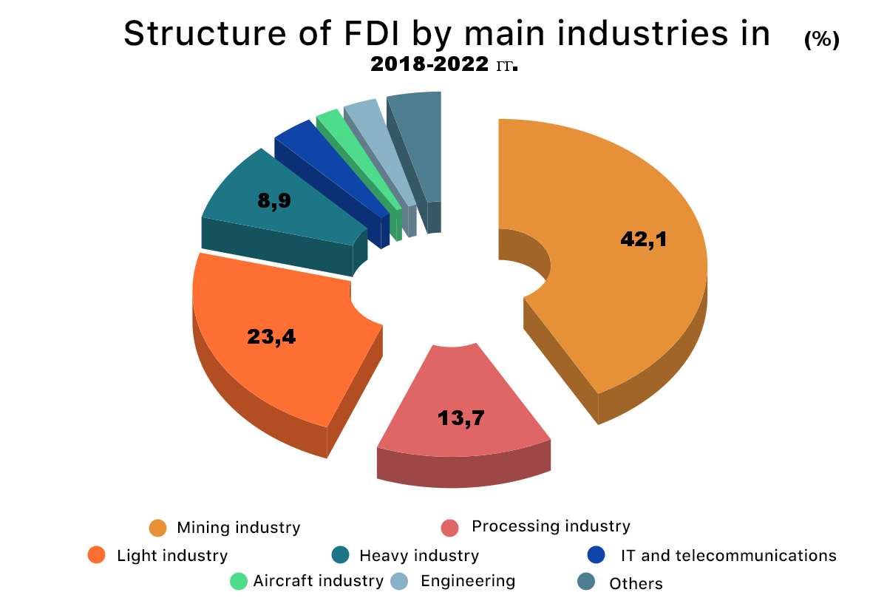
This situation makes developing and export-oriented countries dependent on key investment flows and the global financial situation.
For example, the sharp decline in FDI during the global financial crisis of 2008, according to a number of experts, led to the bankruptcy of about 44% of small businesses and 30% of medium-sized businesses in developing countries alone, causing unemployment for more than 240 million people.
Dependent countries are forced to resort to borrowing from the IMF and national banks. Thus, the famous 10-year Greek debt saga led the Greek economy to collapse.
Multi-billion dollar financial support did not lead to improvement of the situation in the Hellenic economy. Unemployment soared to 27 per cent in 2013 (up to 50 per cent among young people), the population's overdue loans broke all records, and the level of public debt in relation to Greece's GDP exceeded 180 per cent.
Another vivid example of "economic enslavement" is Ukraine, where mistakes in economic policy, a bloated state budget and corruption have led to the country being virtually divided between imperialist powers. In the latter case, "economic enslavement" led not only to the economic subjugation of the country but also to political subjugation, dividing the Ukrainian bourgeoisie into "pro-Western" and "pro-Russian" circles.
The latter circumstance only confirms the thesis that the current conflict in Ukraine is the result of a long-standing competition between the West and the Russian Federation for Ukraine as a market for the application of capital, which has entered a heated phase. According to IMF forecasts, in the worst-case scenario, which envisages the end of the war in Ukraine at the end of 2025, the estimated financing gap will be $240 bn, according to a more optimistic scenario - $115 bn. Ukraine's current government debt as of January 2023 amounted to UAH 4.3 trillion or $116.44 bn, exceeding 80% of GDP.
In recent years, intense competition in the field of direct investment has been taking place between the largest imperialist powers: the United States and China. These countries are competing for markets for their capital in Europe, Asia, Africa and Latin America.
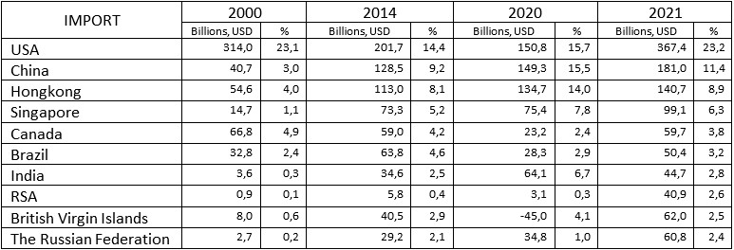
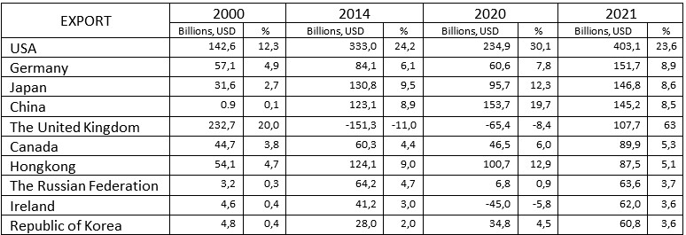
Leading countries in capital exports and imports in the form of FDI and their share in world exports and imports in 2021 compared to previous years, according to UNCTAD data.
The table shows UNCTAD data on the top FDI importing and exporting countries, with the United States, the PRC, and Hong Kong consistently in the top ten.
The PRC has been actively using Hong Kong as its outlet to conduct trade and economic ties with the rest of the world. Therefore, it should be understood that the absolute leaders in FDI exports and imports are actually two international actors - the US and China.
As we can see, the US, China and Hong Kong accounted for 43.5% of global FDI imports and 37.2% of global exports.
China still lags behind the US in capital exports, but the gap has tended to narrow. In 2021, China's total capital exports accounted for 13.6% of world exports, while for the US, the figure was 24.9%. But in terms of capital imports, China was significantly ahead of the US until 2021.
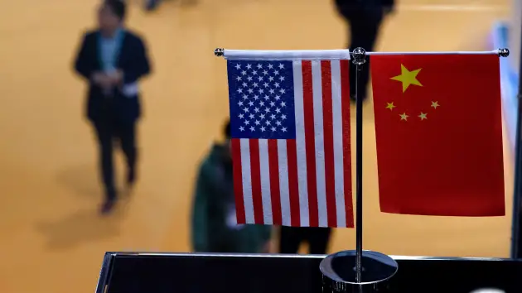
The competition between China and the US is the main contradiction of capital on the current stage of imperialist development. We can observe how it leads to economic confrontation and trade wars between both states. If further aggravated, this competition threatens to escalate into another world war.

IV. China, its Investments and Imperialism
Having traced the directions of direct investments, which China itself carries out on a global scale, we can draw an interesting conclusion. The fact is that the spread of Chinese loan capital to other countries since 2013 has been carried out through lending within the framework of the investment project "One Belt One Road" to develop the economies of countries within the scope of China's interests.
While less developed countries in Africa, Latin America, and Asia initially took loans to build infrastructure, they are now borrowing massively from China to pay off their initial loans, effectively becoming classically dependent on Chinese investors.
In the period 2000-2021, China has provided renegotiated loans. China provided such loans to actually refinance old debts of 22 countries to China for 240 billion dollars, of which 185 billion were provided in the last five years.
That is, China first makes direct investments in exploiting the infrastructure of underdeveloped countries, which allows it to enter new markets with ease. After these countries use up the provided investments, not being able to return them at the declared interest rate, the PRC actually provides these countries with new debts and increases their dependence on itself. Does this ring a bell? This is how the U.S. dominated the economy of the capitalist world in the 20th century and made the dollar the main currency of international settlements.
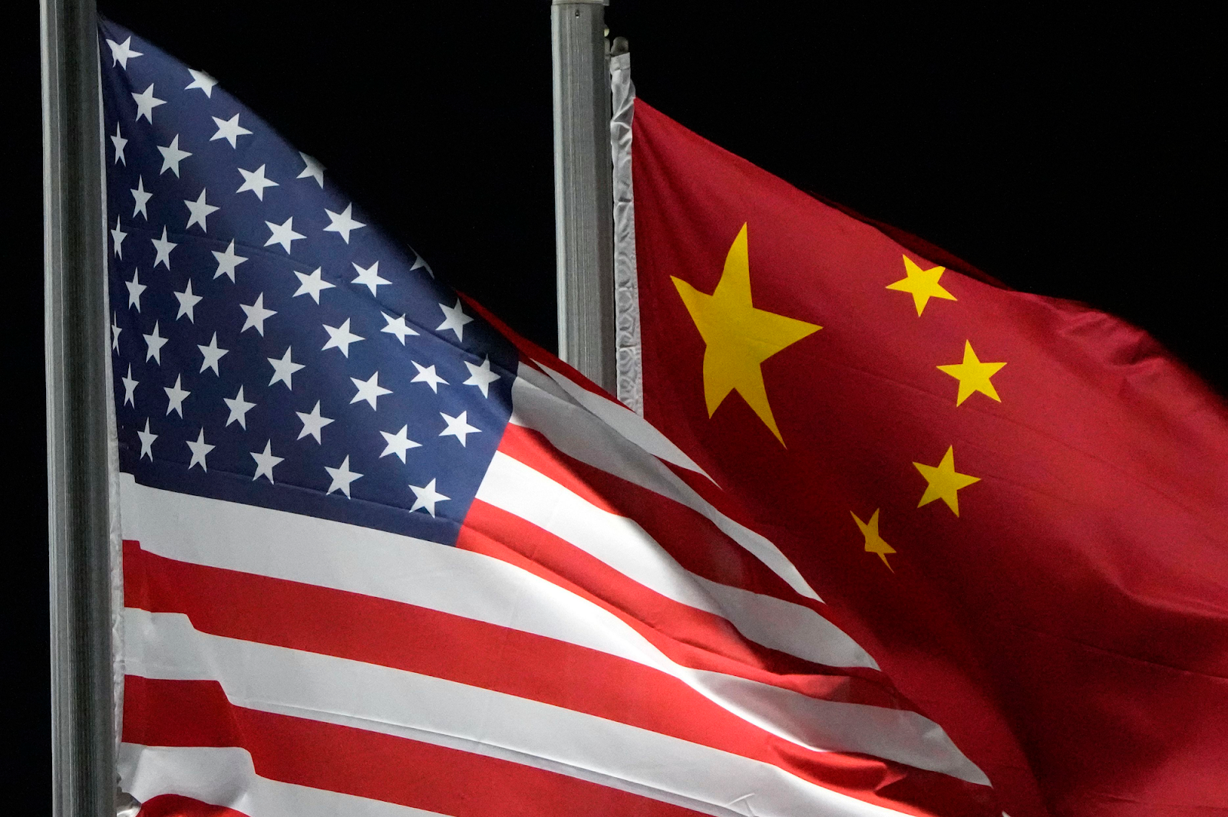
Just like the U.S., now China is actively using currency "swaps" to provide economic assistance to its partners. In simple words, the parties exchange national currencies at a market rate, for example, to finance national importers, if there is a liquidity crisis of a certain currency. A deal is then struck to buy back the provided currency at a more favorable exchange rate for the lender.
Usually such "help" is used by countries with low credit ratings that cannot get loans from the IMF or the World Bank to obtain the necessary amount of currency to also repay their debts. Thus, China is increasing its credit expansion and influence on less developed countries, but the scale of these processes is still smaller compared to the US.
One should also pay attention to the price according to which China provides loans. For example, while the IMF provides loans at an annual rate of about 2%, China's rate is 5%. Since a number of countries are already in a dependent state due to the "One Belt, One Road" project, China has all the necessary levers of coercion. The PRC can consequently expand the circle of its debtor countries, its “sphere of influence” and markets.
In general, the total amount of investments made by Chinese capital within the framework of the "One Belt, One Road" project between 2000 and 2017 reaches almost 900 billion dollars. Most of this money was provided to other countries within the framework of the exact debt relations we have outlined.
China in the 21st century, like the United States in the 20th century and Great Britain in the 19th century, is actively engaged in creating its “sphere of influence” and infrastructure of control over the markets of countries over which Chinese capital seeks to dominate and sell its goods at prices lower than those of national producers.
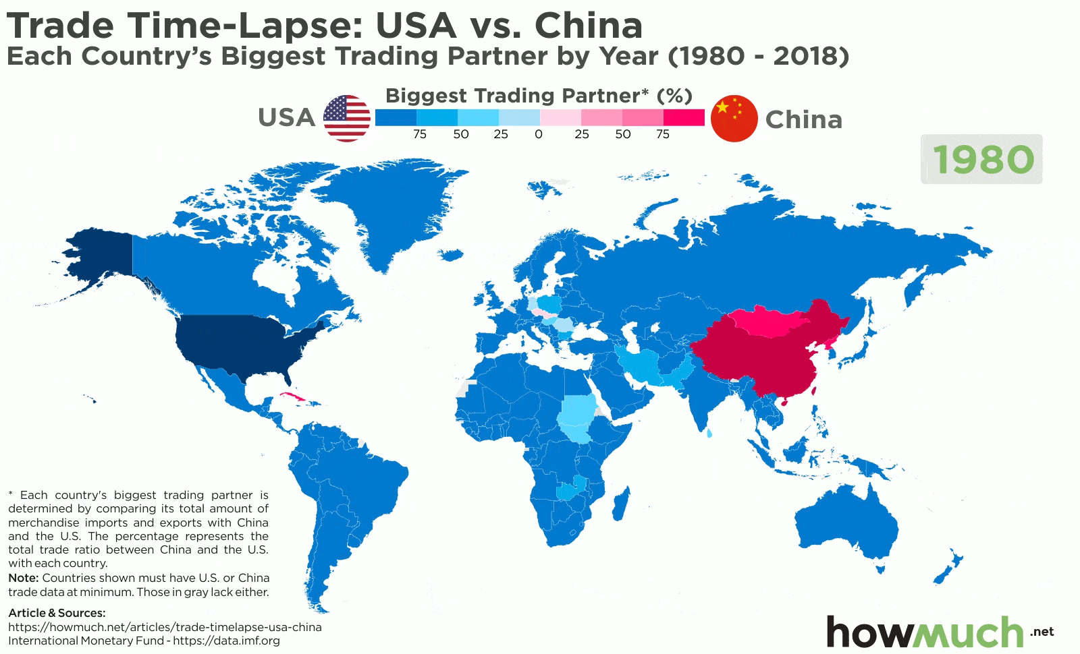
The One Belt, One Road project unites 71 countries with a population of almost 4 billion people, where a quarter of the world's GDP is created.
Such projects enshrine a privileged position for China, which is expressed in the perusal of special Chinese standards, regulations, technical requirements, financing methods, etc. All this leads to the fact that national producers of dependent countries can no longer easily switch to suppliers and contractors from other countries, as this would entail losses and additional costs for retraining workers and implementing new standards.

What's the bottom line?
The export of capital from a country is the process of taking a part of the capital in a given country and moving it in commodity or monetary form to another country in order to make a profit. The main reason for capital migration is its relative excess in a given country; overaccumulation.
By means of exporting capital, monopolies seize key positions in the economy of those countries where it can be applied more efficiently and bring profit, especially if these are developing countries where local capital is scarce and raw materials and labor are extremely cheap.
By covering different countries with a network of investments, the big capital of the imperialist powers subjugates the others, strengthening their position in the world system of imperialism. At the same time, contradictions are accumulating between the imperialist powers themselves, competing for the markets of capital application and striving to strengthen their own position in the system of imperialism.
As we can see, each country now depends on attracting capital investment to strengthen their capital accumulation, home market and consequent position in world imperialism. At the same time, each country is dependent on being able to export capital where it is most profitable. Hence why capital exports flow both away and towards most countries, now, and more so for the countries that are higher in the imperialist system.
After all, it was through British investments that the USA became dominant, and now through American investments, China is becoming dominant.
As the contradictions between the imperialists accumulate, as well as the aggravation of economic crises, their competitive struggle becomes more and more acute, we are slowly reaching the point of open armed confrontation between them.

Original article

