The Essence of the 'American Communist Party'


Original article
2024-08-05
34 min read

On the 21st of July, the Plenary Committee of the so-called American Communist Party (‘ACP’) convened in Chicago, Illinois to sign the declaration of their founding.
They posit themselves as a split of certain chapters of the CPUSA and the PCUSA and criticise the CPUSA for betraying the US working class as the reason for their founding.
Who are the people behind it? Does it differ from its predecessors? What should be the communist position on it?

The Leaders of the ‘ACP’
The most clear idea of the policy and direction of this organisation is provided by the list of its leaders and their history.
The “Plenary Committee” includes several fairly prominent online personalities and streamers, such as “Infrared”, Jackson Hinkle, the “Midwestern Marx Institute”, “Research & Technical Studies Group”, etc.
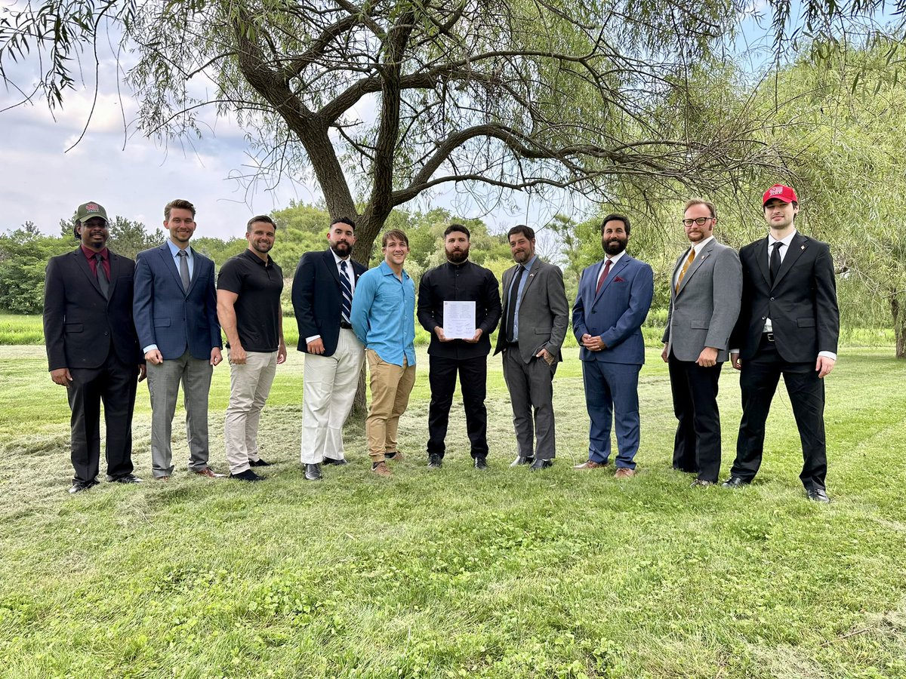
The Plenary Committee of the ‘ACP’

“Infrared” and Jackson Hinkle
“Make America Great Again” (MAGA) was a slogan of the Trump presidential campaign during the 2016 presidential elections in the US. It was used as a part of Trump’s agitation, dedicated to blaming his opponents from the Democratic Party for all the problems of the United States and promising their solution under his presidency. Appealing to a pro-conservative audience, this slogan became popular among the Republican Party’s electorate and their media.
Among the leadership of the ‘ACP’ this current includes “Infrared” YouTube channel organisers, consisting of blogger “Haz”, Henry Ahmad and Grayson Preutz and YouTube blogger Jackson Hinkle, known for his support of Chinese and Russian imperialism together with Trump and the Republican Party.
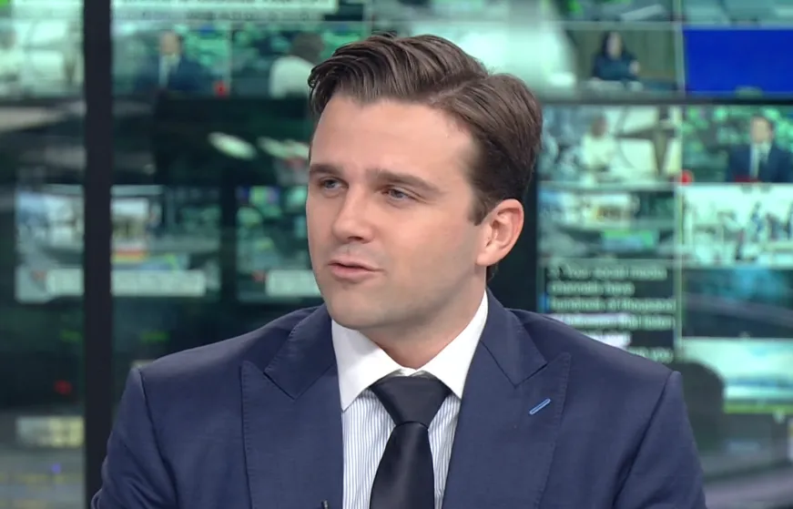
Jackson Hinkle
In an article on the Infrared website the “Executive Chairman of the ACP” who has taken the pseudonym “Haz Al-Din” says:
“The unity of Communism with MAGA is nothing more than the unity of Marxism with the worker’s movement. But this unity will not be accomplished by attempting to enforce the condescending tone-policing of Western Marxists, but by a genuine praxiological encounter between Communist partisans and the people”.
Their idea is that communists have to infiltrate and unite with the supporters of the MAGA slogan since they allegedly oppose capitalism and supposedly compose the broad masses of the American people, the working class in particular.
Is this true? Even a brief analysis contradicts this statement. For example, the table below shows the household income data of US Voters in the 2015 exit polls for the 2016 presidential election.

Source: Edison Research Exit Polls, Census bureau
While income is not an exact reflection of class, it does demonstrate that Trump voters are not significantly different to other US presidential candidate voters.
In fact, the voter base of the Democratic Party runners Clinton and Sanders have less income on average and thereby more likely to be working-class in greater proportion (i.e. their income and means of living are derived from the sale of their labour).
Even more so, the average income of the voters for every single candidate is well over the average median income. American politics have always been the politics for the rich. With a 60.1% turnout in the 2016 elections, the proportion of people disenfranchised by liberal democracy in the US is not insignificant.
“Haz” finds it necessary to say that “Communists do not want to ‘socialize’ people’s actual belongings or even businesses”, in order to calm down the rich audience among MAGA supporters.

“Haz”, “Infrared” leader and the “Executive Chairman of the ACP”
This statement is backed up by Jackson Hinkle: “Communists today in America don’t support the eradication of private property or anything like that. What we support is more growth, more wealth, more businesses for the people”.
While it’s true that the communists have never sought to socialise the essential items of each person, anyone familiar with the basics of Marxist theory knows that communists oppose private property in the means of production:
“The theory of the Communists may be summed up in the single sentence: Abolition of private property.” – Marx and Engels, Manifesto of the Communist Party
“Haz” continues with the claim that the institution of private property will disappear as the productive forces advance:
“Through the course of the actual development of the productive forces, the institution of private property will become superfluous, because productive relations will develop as forms of free association – production will have a substantive human quality based on relations between people, rather than abstractions like money. Communists do not want to force this outcome on people, but allow it to happen. It could not happen at the expense of what the people want, it could only happen as a result of the people’s own historical development”.
This is no different from the theory peddled by the early revisionist social-democrats, Eduard Bernstein and Karl Kautsky. It is essentially claiming that capitalism will “grow” into socialism. In fact, he says outright “We already live under socialism”.
The centralisation of production to an ever greater degree by monopolies paves the way for socialism (the social ownership of production), but it is obviously not socialism itself, nor can it ever be. Class antagonisms and struggle still exist and remain the motive force of history. The proportion of the social wealth appropriated by the capitalists has never been so high.
In order to have actual socialism, those who create the social wealth by means of their own labour (the workers) must expropriate the means of production from the few who expropriate the value the workers create (the capitalists).
“Force is the midwife of every old society pregnant with a new one.” - Marx, Capital Volume One, Chapter Thirty-One.
This way of posing the question of socialism is only helping capitalist propaganda, which denounces monopolies as “corporate communism” and calls for a return to “real capitalism”.
The “Executive Chairman of the ACP” continues:
“In the meantime, what Communists seek is the overthrow of the monopolists, the bankers, big pharma, big agriculture, big tech, and others – which have hijacked the American republic in the name of the ‘sacred institution of private property’. The Communist critique of private property allows for pro-people policies, including lowering taxation, ending government subsidies for the monopolists, and removing red tape – to actually happen, because it places the interests of the people above the interests of money and so-called ‘private property”.
This is the essence of “MAGA communists”: for all the phrase-mongering and polemics they throw about, their politics boils down to low taxation, ending subsidies and limiting state bureaucracy, but not questioning the existence of the monopolies or the capitalist state. It is essentially no different to capitalist propaganda.
Appealing to the dangers of “big corporations” and ideals of the “good old American republic”, they try to gain respect not among the workers, but among the petty and middle bourgeoisie in the first place, who are suffering from the pressure of monopolies.
This is further elaborated and supported by an infographic posted by Hinkle:
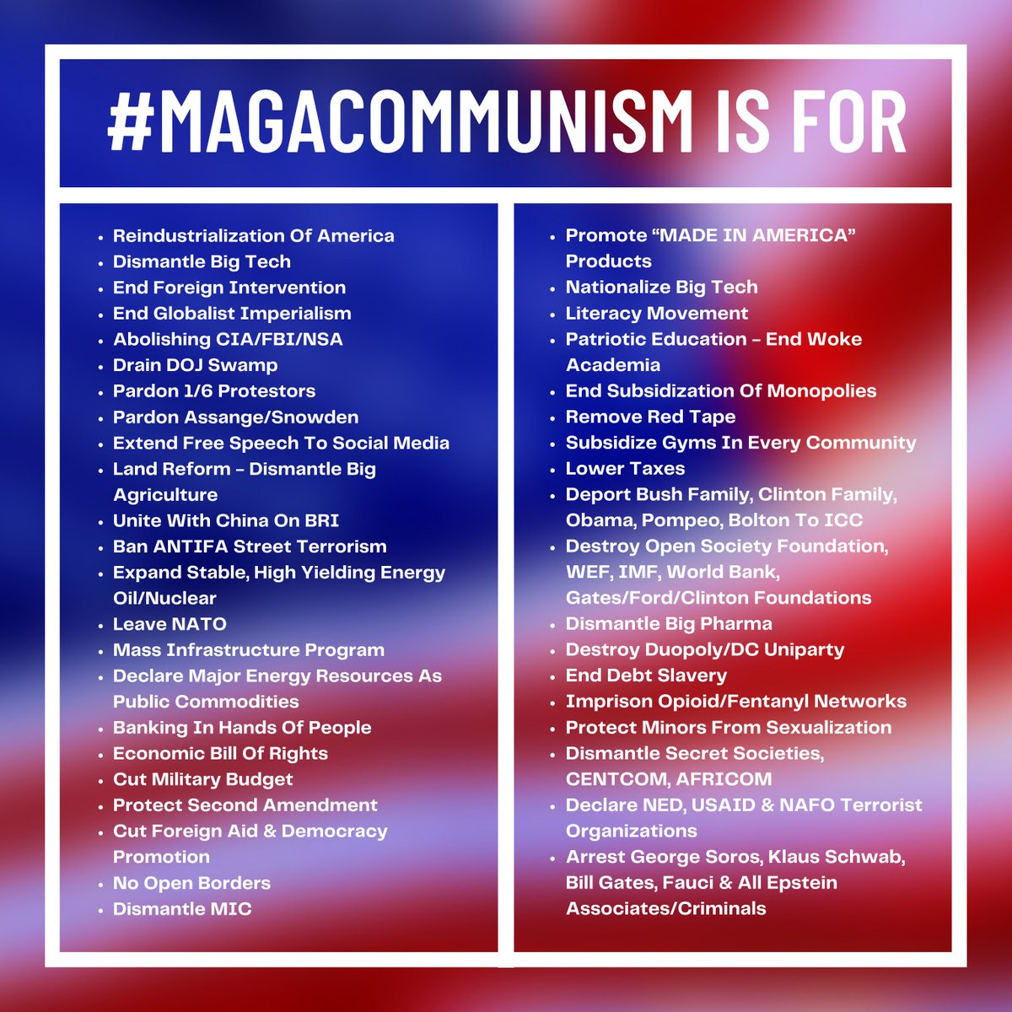
Communism to them is something vague at best or tailing a bourgeois movement at worst, not the conscious transformation of society and social relations to conform with the forces of production. As the famous Bernstein quote goes “The goal is nothing, the movement is everything”, except in this case, “the movement” is not even the worker's movement.
They see Trump's populist, demagogic anti-establishment rhetoric and opportunistically try to hitch onto that bandwagon, unaware that they are mere pawns in the spectacle of bourgeois politics.
It would appear as if these opportunists have no principles at all. However, this is untrue. Opposing the currently dominant wing of the American ruling class, they appeal to Russian and Chinese imperialism.
“Haz” has previously spoken in favour of Russian imperialism in the Russia-Ukraine crisis and denied the existence of Russian imperialism in its entirety. Hinkle has done the same, going as far as converting to Orthodox Christianity and saying “God will liberate Ukraine from the satanists”. The Communist opinion on religious people in their ranks is expressed by Lenin:
“I am for expulsion from the Party of people who take part in religious ceremonies” – Lenin, Letter to the Organising Bureau of the Central Committee, dated May 30, 1919
Similarly, both of these leading “MAGA communists” consider China to be a “socialist and progressive country”, which is very much in line with their denial that socialism requires the abolition of private property on the means of production. In reality, this is the main defining feature of socialism.
“To my mind, the so-called “socialist society” is not anything immutable. Like all other social formations, it should be conceived in a state of constant flux and change. Its crucial difference from the present order consists naturally in production organized on the basis of common ownership by the nation of all means of production.” – F. Engels, Letter to Otto Von Boenigk in Breslau.
In addition, both expound theories of “multipolarity”, that is the striving of Russian and Chinese monopolies to have their place in the sun, alongside the dominant US and EU ones. We have written extensively in the past about the false "anti-imperialism" of this theory in our articles.
“Haz” and Hinkle have appeared in Russian and Chinese media. Hinkle has been directly sponsored by the Russian state.
In the name of “multipolarity”, Hinkle went so far as to say (before the events of October 7th):
“You know who else has a good working relationship with Benjamin Netanyahu? Vladimir Putin has a very good working relationship with Benjamin Netanyahu. I’m actually happier that for the sake of, you know, the multipolar world order that he is in power right now compared to the previous coalition in Israel. Xi Jinping of the Communist Party of China has a good working relationship with Benjamin Netanyahu”.
This is especially ironic, given that Hinkle gained the vast majority of his online following by posting Pro-Palestine content and footage after the October 7 attacks. It further demonstrates how communist principles are utterly alien to these people and their ideology.
In pursuit of “multipolarity” (which has nothing in common with Marxism), they even forge links with the reactionaries that also extoll these theories, such as Aleksander Dugin – the infamous Russian far-right philosopher. “Haz” and Hinkle have met Dugin and have positive opinions of both the man and his theories. Their analysis of imperialist wars consists not in analysing the strivings of monopolies to divide up and re-divide the world, but in establishing unprincipled “alliances” with everyone allegedly opposing “American hegemony”.
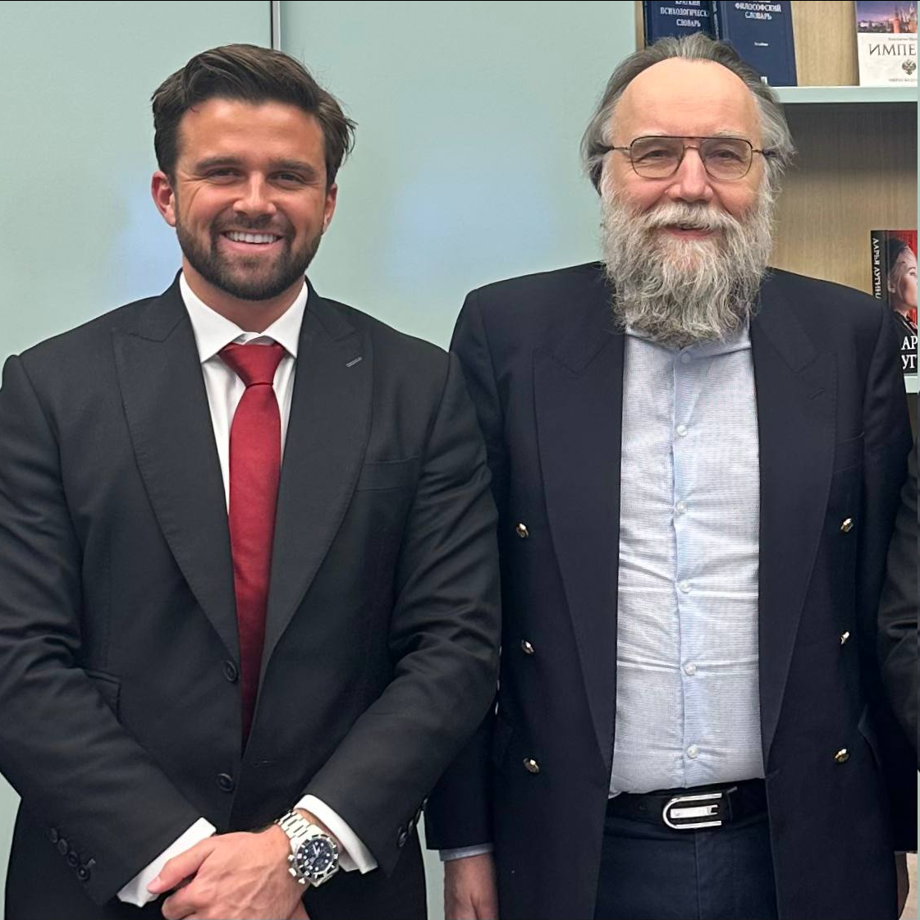
Hinkle and Dugin
According to Dugin, every civilisational state or ethnic group should preserve its own cultural, national, and civilisational identity while also coexisting peacefully with others. The “unipolar” world order led by the US has imposed its civilisation (to him meaning secularism, individualism, liberalism, etc.) too far, and that is the root of the Ukrainian crisis.
This reflects the views of one of Dugin’s inspirations, the “eternal law of human existence” of German reactionary philosopher Heidegger, who was a member of the NSDAP. This ‘law’ suggests that every nation must prioritise and assert itself to maintain its distinct religious, cultural and historical identity.
The “MAGA communist” leaders of ‘ACP’ promote opportunism, tailism and succumb to capitalist ideologists. They don’t oppose American capital at all, they just want it to be led by more competent or ‘better’ capitalists with populist slogans and mix these ideas with their support of Russian and Chinese counterparts.

The “Midwestern Marx Institute”
The “Midwestern Marx Institute” is a publishing press, online store and political journal. Its members on the Plenary Committee are Eddie “Ligma” Smith, Noah Khrachvik, Carlos Garrido and Kyle Pettis.
While they are a separate group from Infrared and Hinkle, they have also spoken out in favour of “MAGA communism”, and hold many of the same principles. One of the main ideas they put forward is a critique of what they describe as the “purity fetish” of the American left. As Garrido puts it:
“This purity fetish, I argue in my work, takes three central forms in the United States:1) Because a bloc of conservative workers are too imperfect or "backward" for the American left, they are considered baskets of deplorables or agents of a "fascist threat."...2) The second form that the purity fetish takes is a continuation of the way it is generally present in the tradition of Western Marxism, which has always rejected actually existing socialism because it does not live up to the ideal of socialism in their heads…3) The third form of the purity fetish is the prevalence of what Georgi Dimitrov called national nihilism: the total rejection of our national past because of its impurities.”
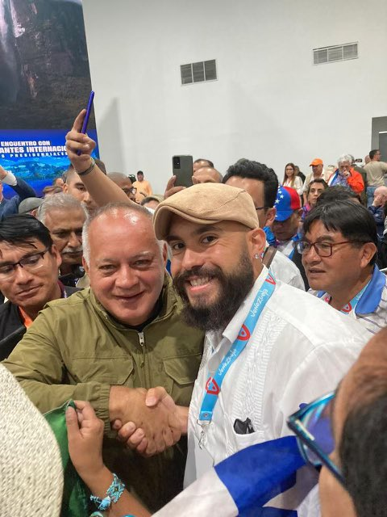
Carlos Garrido, acting as now ‘ACP’ Secretary of Education, meeting a PSUV Venezuelan politician.
Of course, we don’t deny that there is a kernel of truth in this.
Regarding the first point, with the dominance of revisionism and opportunism in the communist movement, many “Marxist” trends have been diluted with left-wing liberalism – groups like the CPUSA openly endorse the Democratic Party.
However, it is abundantly clear, from their praise of “MAGA communism”, that what they are doing is not advocating for the strengthening of Marxism, but its further dilution with right-wing liberalism.
Instead of raising the consciousness of the workers, deluded by bourgeois agitation, to the level of conscious communists, they want to lower themselves, as the CPUSA does, just not to the level of the Democratic Party, but to the level of the Republicans instead.
On the second point, of course, it is also true that many “socialists” in the US (and around the world) believe anti-communist propaganda about the Soviet Union.
However, MWM’s conception of socialism has nothing to do with Marxism, as they also implicitly believe socialism does not mean the social ownership of the means of production (given their support of China and their unity with the “MAGA communists” who outright say so).
In fact, it is so far removed from Marxism that they declare Iran (a reactionary theocratic semi-fascist state) to be an example of socialism and say that, for example, “the structure and function of the Basij [an Islamist militia which includes child soldiers] is almost identical to that of the Communist Party apparatus that existed in the USSR”.
And on the third point, again, there indeed exists an ultra-“left” Maoist tendency in the US that seeks to paint its entire history and population as one reactionary mass.
MWM, however, does not aim to take the aspects of American national culture and history that are compatible with the international workers' struggle for socialism. Instead, they aim to capitulate to the bourgeois nationalism of the MAGA movement, like their “MAGA communist” friends that they have united in a party with.
The slogan of “purity fetish” is used to cover their broad-left sentiments, distortion of Marxism and opportunism and denounce Marxists-Leninists as “sectarians”, just like many right-wing deviationists do across the world.
Dialectical materialism asserts that there is only one truth, grounded in the reality of material existence. Anything that deviates from this truth is an error. The idea of multiple truths is equating truth with falsehood, a tactic often used by liberal ideologies to muddle reality with unfounded nonsense, especially in political rhetoric.
In political practice, this philosophy is embodied in Marxism-Leninism, the science of human social development. It therefore is plentifully clear that their criticism of the “purity fetish” is a cover for their objective to further revise and dilute Marxism. The fight for the “purity” of Marxism is the fight for workers’ interests to be separate and independent from dilution by the interests of other classes.
Adopting ideas that contradict tried and tested scientific theory will inevitably lead to failure. Allowing bourgeois or petty-bourgeois deviations weakens the proletariat and leads it to defeat, playing into the hands of the ruling class. In order to avoid this, we can not and should not plaster over our differences, but ruthlessly expose them and criticise them.
“It is all the more clear what we have to accomplish at present: I am referring to ruthless criticism of all that exists, ruthless both in the sense of not being afraid of the results it arrives at and in the sense of being just as little afraid of conflict with the powers that be.” – Karl Marx, Letter to Ruge, dated September 1843.
In their article praising “MAGA communism”, Eddie Smith says:
“It was Vladimir Lenin who would send party members to the meetings of the fascist and anti-semetic Black Hundreds peasant groups in order to disrupt them and win people away from their reactionary worldview by teaching them Marxism. If it was worth it for Lenin to reach out to fascistic peasants, surely it is worth it for us to reach out to proletarians who voted for Trump over the butcher of Libya Hillary Clinton and genocide Joe Biden.”
Firstly, this is untrue. The Bolshevik party did not send party members to Black Hundred group meetings, they sent party members into Black Hundred controlled trade unions.
“However, when Zubatov, agent of the secret police, organised Black-Hundred workers’ assemblies and workingmen’s societies for the purpose of trapping revolutionaries and combating them, we sent members of our Party to these assemblies and into these societies (I personally remember one of them, Comrade Babushkin, a leading St. Petersburg factory worker, shot by order of the tsar’s generals in 1906). They established contacts with the masses, were able to carry on their agitation, and succeeded in wresting workers from the influence of Zubatov’s agents.” - Lenin, “Left-wing” Communism: An Infantile Disorder, Should Revolutionaries Work in Reactionary Trade Unions?
The distinction is important, as it is clear that MWM views society through the lens of bourgeois politics. We aren’t out to defeat our enemies in the “marketplace of ideas”, by going to fascist or liberal meetings or debating them on live streams, we aim to help the workers see their real relations to the means of production and their interests that stem from there.
This can be done only by consistently fighting for these interests and raising their consciousness. Communists seek to unite the workers under the leadership of a Communist Party. The idea of the MWM and their ‘ACP’ allies, on the contrary, is to stoop as low as possible, to indulge in prejudices themselves, and refuse to struggle against the nationalist and bourgeois-patriotic prejudices about “liberty”, “democracy” and the “American republic” that have been implanted in the USA for centuries.
Secondly, it demonstrates that they clearly have their own “purity fetish” – one that has nothing to do with Marxism. Apparently, the workers misled to vote for Biden are “supporters of genocide”, while the workers misled to vote for Trump (who criticised Biden for not supporting Israel’s war hard enough) are worth reaching out to.
In general, this way of thinking is not new, as it was denounced more than a hundred years ago. In his work “What is to be Done?” Lenin says:
“He who does not deliberately close his eyes cannot fail to see that the new “critical” trend in socialism is nothing more nor less than a new variety of opportunism. And if we judge people, not by the glittering uniforms they do nor by the highsounding appellations they give themselves, but by their actions and by what they actually advocate, it will be clear that “freedom of criticism” means’ freedom for an opportunist trend in Social-Democracy, freedom to convert Social-Democracy into a democratic party of reform, freedom to introduce bourgeois ideas and bourgeois elements into socialism”.
Words about “freedom of criticism” have been replaced by these opportunist ideological descendants with “rejecting the purity fetish”. While the form of this opportunism has changed, the content has not. While classes exist, so do the interests that stem from them, and there are only so many ways of expressing these interests. That is why our modern opportunists reflect those of the past, and why Marx said (in the 18th Brumaire of Louis Bonaparte): “The tradition of all dead generations weighs like a nightmare on the brains of the living”.
To conclude, MWM’s attempts to dilute Marxism with liberalism, and endorsement of Iranian and Chinese capitalism compose a tendency very similar to that of their “MAGA communist” allies. However, the main tendency they both agree with is opportunism. It is therefore unsurprising that “MAGA communists” and MWM decided to unite in one organisation.

“Research & Technical Studies Group”
Rev Laskaris from the “Research & Technical Studies Group” (RTSG) – a research collective that focuses on writing articles about current events, philosophy, history etc. is also part of the ‘ACP’ leadership.
The RTSG is known to defend right-wing reactionaries, such as Iranian Islamists and Alexander Dugin, and promote their views, especially on multipolarity. In addition, they have a few articles defending China.
They have an article on their site that claims the mass protests against the Iranian theocracy in 2022 were fake, as they are in favour of the Islamic Republic. In fact, they go on to praise the influence of Heidegger (the aforementioned Nazi philosopher) in the Iranian revolution in another article:
“Between the failure of both Soviet communism and American capitalism to provide an authentic being and identity to the Iranian people, Shariati juxtaposes the Islamic solution to the predicament of the modern world…It is here where Shariati is most hostile to Western & Soviet Marxism for its explicit atheism, explaining why the communist Tudeh party necessarily fails in Iran…Heidegger offers the most cogent critique of the Western canon from within the Western canon…Above all, Heidegger presents a new way for the rediscovery of civilization; it should therefore come as no surprise that almost all anti-universalist project has their origins in Heidegger, be it the French New Right or Alexander Dugin’s Eurasianism. Heidegger presents a way of cultural affirmation in the face of secular modernity, in which unsurprisingly Dugin, who also a Heideggerian, highlights the rediscovery of civilizational identity…Iranians have been presented with a question: should Iran submit to the West’s liberal world order, or are they entitled to their own independent civilizational reality?”
They say very openly what they represent. They capitulate to bourgeois propaganda about the USSR, deny the universality of class and class interest, claim atheism (and thereby Marxism and dialectical materialism) to be something intrinsically hostile to Iran, and that Iran has an “essential” civilisational identity.
It is no wonder that this ‘collective’ decided to unite in one structure with the aforementioned figures, as they basically share the same views.

PCUSA Renegade
Another notable figure is Christopher Helali – former PCUSA international secretary, who has had a very interesting life. Initially a US Army officer, he trained at Fort Benning (now called Fort Moore, the same site as the infamous School of the Americas) and won several medals for his military service, but then became a conscientious objector in 2015 and resigned.
Originally an anarchist, even interviewing Noam Chomsky in 2013, he was part of the anarchist “Industrial Workers of the World” (IWW). However, information appeared that he stole $4,510 from the IWW acting as the Boston Branch Secretary-Treasurer in 2016. He left for Greece to work with anarchist Syrian refugees and later went on an adventurous tour with the YPG in Syria fighting against ISIS.

Christopher Helali with the YPG
After returning from his tour, he supposedly became a “Marxist-Leninist”. He won a scholarship to study “Marxism” at Huazhong University of Science and Technology in China (as well as completing a Religious studies degree) and joined the PCUSA.
The PCUSA was formed in 2016 due to its founding members’ belief that the CPUSA was no longer fit for purpose. It started off as a centrist organisation (originally against “market socialist” deviations), but gradually shifted into a more openly social-chauvinist and “patriotic socialist” one, supporting Russian and Chinese imperialism.
Helali eventually became their unsuccessful candidate for Congress in 2020 in Vermont (winning 1% of the vote) and later their international secretary, leaving this post seemingly just before the founding of the ‘ACP’. His page on the PCUSA website has been deleted.
He also appeared and spoke at the recent social-chauvinist “World Anti-Imperialist Platform” (WAP) 13 days before the founding of the ‘ACP’, still acting as the PCUSA international secretary. He read out the declaration: “The NATO Imperialist alliance can be defeated if we build the worldwide Axis of Resistance!” (this term is broadly used to describe Iran and its allies in the Middle East – PS).
He has appeared many times on Russian and Chinese news outlets and has written articles for them praising Russian “multipolarity” and Chinese “socialism”. He wrote these articles while still in the PCUSA, which contradicted and still does contract the PCUSA’s own constitution, which denounces “market socialism”.
Helali purportedly played a pivotal role in the organisation's social-chauvinist shift. This very clearly shows an abandonment of discipline and centralisation on the part of the PCUSA, aptly demonstrating why Communists require these things within the party.
Whatever his money troubles leading to his theft of IWW funds, they seem to have been resolved in 2023 when he purchased a building for $350,000, which begs the question where did his change of fortune come from?
It's likely that the capitalist states whose interests he argues for remunerate him for doing so as they do for Hinkle. In fact, working with the WAP, Helali (along with Hinkle) was sponsored by the Russian state in a mission to the UN to pose the question about the Russian administration of Donetsk Oblast.
With such a track record it is no wonder that this person ended up in the ‘ACP’.
Even this brief analysis of the ‘ACP’ leadership shows us that it mostly consists of opportunists, social-chauvinists and adventurers. It can be seen that the Plenary Committee of the ‘ACP’ consists of individuals whose primary principles are support for Russian and Chinese imperialism (or merely just the hope for monetary reward from this), as well as American nationalism.

Does ‘ACP’ Differ from the CPUSA and PCUSA?
Now that we have established who the founding members of the ‘ACP’ are, we understand what views and actions to expect from this organisation. But are they any different to the CPUSA and PCUSA, from which they claim to get their members?
Among the program documents published on the ‘ACP’ website, we can find the “Declaration” and “Information” sections.
The “Declaration” is full of lofty words and loud slogans, mainly directed against the CPUSA. It is supposedly signed by 29 clubs of the CPUSA and 3 of the PCUSA who have now joined them. However, some of these clubs’ accounts have denied association with the ‘ACP’ on social media.
This seems to be the result of one of Infrared’s initiatives that was called “CPUSA 2036”. “Haz” explains that this “...led to my followers flooding the party (while concealing their views to prevent expulsion) on the basis of Infrared's new interpretation of Marxism-Leninism, hoping to restore the party to its former glory by pursuing political independence”.
Infrared followers attempted to do entryism into the CPUSA, failed, were discovered and expelled. The clubs that signed this new ‘ACP’ declaration seem to be these expelled members.
At the end of this “Declaration” there is a long list of claims. Let's look at some of them.
‘ACP’ declares: “They [the CPUSA] have replaced serious Marxist-Leninist education with eclectic seminars given from the liberal perspective, designed primarily to instill allegiance to the Democratic Party”.
But the leaders of this organisation are doing the same thing, only from an “anti-globalist” perspective. The promotion of Dugin, Heidegger, “good old American traditions” and support for Russian and Chinese capitalists is, just the same, a “substitute for serious Marxist-Leninist education”.
The ‘ACP’ then accuses the CPUSA of lacking “freedom of criticism”: “They have unconstitutionally banned principled disagreement and alternate viewpoints contrary to their own, which contradict the democratic centralist principle of freedom of criticism, unity of action”.
We have already analysed the vagueness of this slogan, which is usually used as a cover by opportunists. When it comes to the CPUSA, such accusations are all the more ridiculous, since this organisation is already known to encourage and tolerate various kinds of deviations.
The ‘ACP’ believes that this is not enough and wants even greater theoretical omnivorousness, which is explained in the following accusation: “They have liberally dismissed all interpretations of Marxism-Leninism which reject neoliberal ideology as ‘fascist,’ in order to create the dishonest pretext to silence any criticism of the Party’s fruitless strategy”.
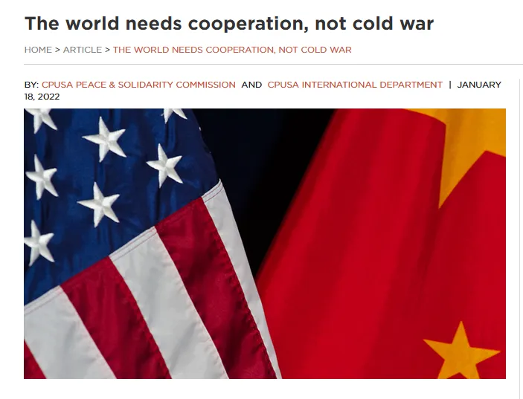
One of CPUSA's materials, defending Chinese opportunists.
The opportunists from the ‘American Communist Party’ are only dissatisfied with the fact that the CPUSA supports only one group of American capital. They would like to have the support of capitalists from the other camp as well.
Accusing the CPUSA of “violating autonomy” also makes Marxist-Leninists laugh since the CPUSA is already known for its extremely decentralised organisational structure.
The ‘ACP’ obviously do not seek to rectify the CPUSA’s errors on a Marxist-Leninist basis. This could be inferred from their founding members' past, but also their declaration and programme. They believe:
“The broad aim of the American Communist Party is the incorporation of technology to both decentralize the scope and scale of practical Party activity, while simultaneously verifying Party alignment in an objective manner. This includes the employment of objective criteria to incentivize the yielding of tangible, practical results on a national scale, and a public ledger containing precise information about the alignment of new Chapters, or dis-alignment of existing ones”.
They want to fix the CPUSA’s decentralisation and disunity with more decentralisation and autonomism. A vanguard party needs a central leadership or “headquarters” to maintain unity. A group of independent organisations that cooperate voluntarily and non-cohesively goes against the core principles of a Leninist organisation.
“The experience of the victorious dictatorship of the proletariat in Russia has clearly shown even to those who are incapable of thinking or have had no occasion to give thought to the matter that absolute centralization and rigorous discipline of the proletariat are an essential condition of victory over the bourgeoisie” – Lenin, “Left-Wing” Communism: An Infantile Disorder, An Essential Condition of the Bolsheviks’ Success
And this is not even mentioning the CPUSA’s plethora of other revisionist theories which the ‘ACP’ fully agrees with (as highlighted by their leaders in the past). We have previously highlighted some of them, but they include: the CPUSA’s support for Chinese imperialism, its embrace of multipolarity, its ideas about market “socialism” (and “socialism” without the eradication of private property), etc.
The ‘ACP’ declaration does highlight real flaws in the CPUSA, such as the transfer of the party archives to New York University, their tailism of the Democratic Party and their liquidation of the party press.
Tailing the Democratic party (especially on the grounds of “anti-fascism”) is utter folly as we previously outlined for their similar strategy during the last mid-term elections. As the situation in the US (and the world) worsens and continues to worsen, more people are leaning on the left.
The CPUSA is no longer a large enough vehicle to contain and neuter the revolutionary sentiment in the US – especially when it advocates voting for the bourgeois party currently in charge. “The survival of democracy and humanity will be on the ballot in November!” – says Juan Lopez, northern California CPUSA chairman and statewide coordinator.
Just like how liberals in bourgeois politics do and historically have paved the way for the fascists, the CPUSA has spent all this time tailing the liberals, and paved the way for another deviation that wants to tail the reactionaries.
In response to the “Declaration”, the CPUSA published a message denying the ‘ACP’s’ claims on Solidnet and saying that “this clique was birthed outside of our ranks“.
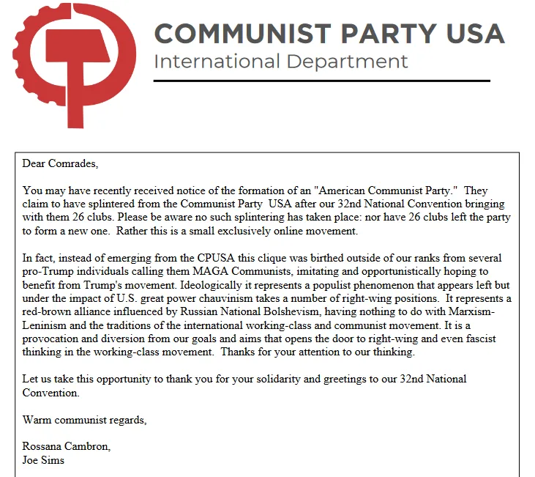
The truth, however, is that it’s the opportunist theory and actions of the CPUSA that made it possible. If this organisation maintained Marxist-Leninist principles and was a real Communist party, this wouldn’t happen.
It is unclear why the CPUSA (and others like it) are even allowed as a “Communist Party” on Solidnet in the first place and raises serious questions about the nature of Solidnet. Whatever the reason, the CPUSA’s message is nothing more than one group of opportunists seeking help against another.
In the end, the main concern that ‘ACP’ has against the CPUSA is that they are not opportunist enough and expresses its ardent desire to become even better at this.
As for the PCUSA, this organisation is far smaller, but also has nothing to do with Marxism-Leninism and cannot be called a Communist Party.
It fostered “patriotic socialism” and social-chauvinist support for foreign imperialists within its ranks. PCUSA is also on the list of signatories of the “Paris Declaration” of WAP.
However, it wasn’t as openly supportive of the “Axis of Resistance”. According to some sources, WAP was supporting a split in the PCUSA because of their position on the Palestine conflict.
In this respect, the ‘ACP’ is more consistent and takes the PCUSA’s opportunist ideas to their logical endpoint. The PCUSA wasn't social-chauvinist enough for the WAP. It's therefore unsurprising that several PCUSA clubs have joined this new organisation.
Overall, we see that ‘ACP’ doesn’t provide anything much different from both the CPUSA and the PCUSA. Their criticism of the CPUSA is meant to attract a left-leaning audience, but in essence, they provide an organisation based on the same principles as the CPUSA.

The Actions of the ‘ACP’
As previously highlighted some of their founding members likely have contracts with Russian and Chinese state media outlets (and others are small businessmen streamers themselves), and should the capitalists of these countries (or indeed a wing of capitalists within the US) see an opportunity in this new party, they will be sure to fund it.
What are the actions of this newly-born organisation? Christopher Helali has already appeared on RT. Hinkle did the same on the Jimmy Dore Show to announce and promote this party.
Garrido has met members of the ruling anti-communist PSUV in Venezuela and showed ‘ACP’ support for Maduro. Jackson Hinkle was invited to speak with Maduro himself.
Helali has also met the social-chauvinist ‘Unified Communist Party of Georgia’ – a half-dead organisation, whose activity mainly consists of putting signatories under social-chauvinist statements. The ‘ACP’ also signed a declaration with the social-chauvinist ‘Communist Party of the Russian Federation’.
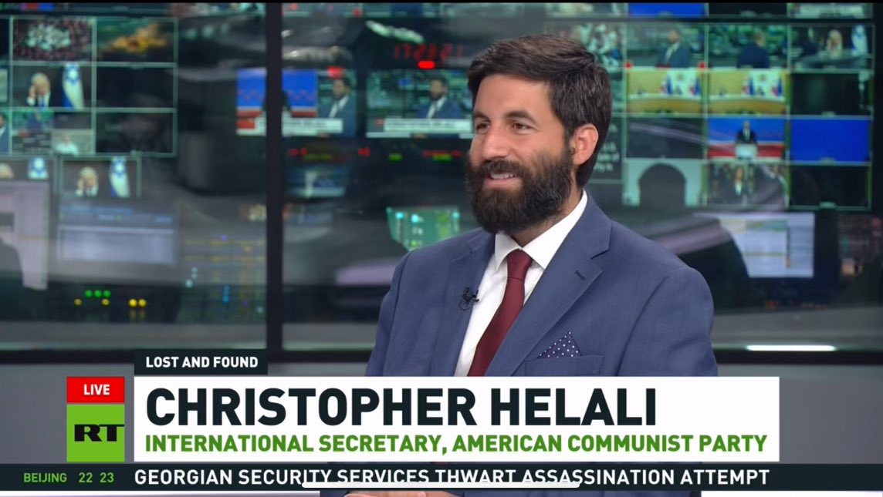
Helali on RT
The line of this organisation clearly follows through on the theoretical views of the leadership of this ‘party’: opportunism, social-chauvinism, tailism and defending the interests of one of the imperialist camps.

How to Create a Communist Party in the USA?
So if the ACP, CPUSA and PCUSA are not Communist parties, what is?
A Communist Party is the most advanced section of the working class, well versed in the most advanced and modern theory that reflects their interests to the fullest extent: Marxism-Leninism.
This organisation is possible only on the basis of Marxist-Leninist theory, acting as a united party-vanguard without any factions, deviations or currents within. It forges strong links to the rest of the working class, through work in trade unions, agitation and propaganda. By consistently and correctly identifying the interests of the workers and fighting for them, the Communist Party must earn its place and authority as the leader of the class.
Such an organisation can not be declared. It’s only forged through fierce struggle against all sorts of deviations, on the basis of everyday work of training communists, communist agitation and establishing connections with the working class. We have previously written an even more in-depth explanation of the “Party of a New Type”.
The main task of the communists in the US is building the Communist Party. The activities of communists must be conducted in this direction.
Together with Marxists-Leninists across the world, our organisation is working on this. Join us in this struggle.

Original article

