The Equal Distribution of Gas Reserves Labeled As "Communism" In Hungary
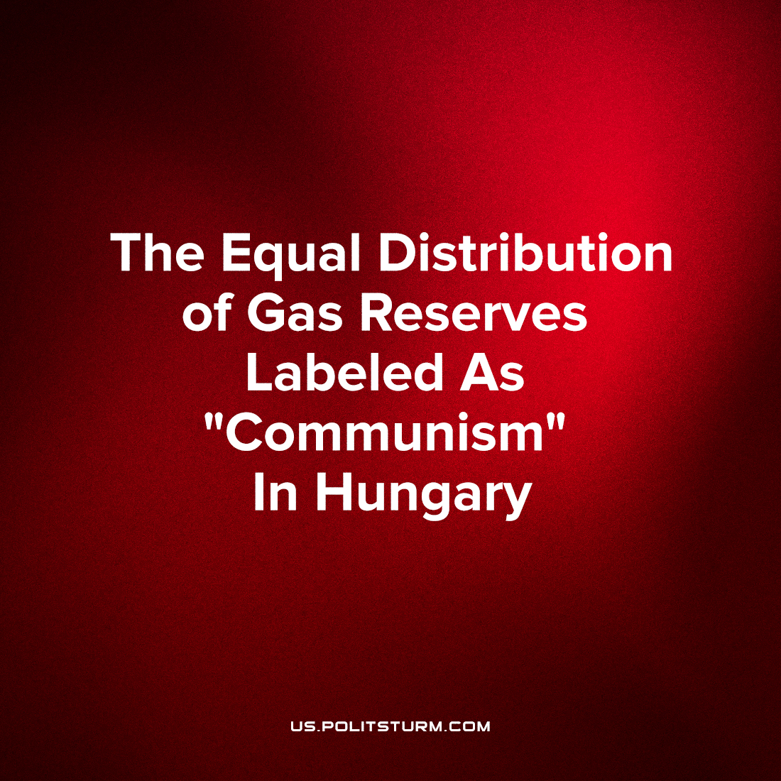

Original article
2022-07-19
1 min read

Gas purchased with the money of Hungarian citizens will be used in Hungary, says the head of the country’s Foreign Ministry, Peter Szijjarto.
The proposal of this chairman of the faction of the European People’s Party in the European Parliament, Manfred Weber, to establish a fair distribution of scarce fuel among EU members, was compared by Mr. Szijjarto with communism:
“Hungarian gas storage facilities will remain owned by Hungary. Gas purchased with Hungarian taxpayers’ money and stored in Hungarian gas storage facilities will be used in Hungary. Weber’s proposal somehow reminds us of communism,”
It would seem that in the friendly alliances of the bourgeoisie, internal disputes still arise. This proves that any such associations are unstable.
As for Szijjarto’s statement, this case is not the first stone thrown in the direction of the Communists. Here is what K. Marx and F. Engels wrote in the “Communist Manifesto”:
“Where is the party in opposition that has not been decried as communistic by its opponents in power? Where is the opposition that has not hurled back the branding reproach of communism, against the more advanced opposition parties, as well as against its reactionary adversaries?”

Original article

