The End of The "Welfare State"


Original article
2024-01-21
30 min read

The last two years saw worsening living standards for many European countries. There is a steady tendency of capitalist governments to gradually reduce and limit the social rights and guarantees of the working class, not only in Europe but all over the world.
All of this goes against the idea of the "social state", or "welfare state", that was promoted after the Second World War, especially in the 1990s and early 2000s. The policy of reforms and concessions to the proletariat has been replaced with the dismantling of the social security system and the attack on the rights of the working class.

I. Establishment and development of the "welfare state" in capitalist countries
The struggle of the workers for their rights and the improvement of their living conditions has taken place throughout the development of society. This struggle started as soon as exploitative relations began to develop under the influence of economic conditions: between the exploiters (who appropriated the results of other people's labor) and the exploited (working) classes.
Feudal, bourgeois, and socialist revolutionary transformations are naturally occurring historical milestones in the course of the development of society. These are driven both by the development of productive forces and by the aspirations of the people to realize their rights and freedoms, and to ensure the best possible standard of living.
At the end of the 19th century, one of the responses of the bourgeoisie to the revolutionary transformations, aimed at containing this growing threat, was the conceiving of the so-called "social state".

The term, introduced by the German economist Lorenzo Von Stein, implies the creation of a state that fairly distributes social benefits among citizens aimed at achieving a decent quality and standard of living for all, smoothing out social inequalities, and helping those in need. In this case, it means predominantly state regulation of the capitalist economy, based primarily on the control of big business and "correct" fiscal policy.
The development of the concept of the welfare state took place during the 20th century, mainly in advanced capitalist countries. In the political sphere, these ideas, primarily promoted by social-democratic forces, were implemented with varying degrees of success within the framework determined by unstable and constantly changing economic factors under capitalism.
We can identify two main stages that economically and politically shaped the implementation of the concept of the "welfare state" in the 20th century.

Stage I
The first stage occurred in the 1920s and marked a brief period of economic growth for the United States, commonly referred to as the "prosperity era" in modern historical literature.
This era was prompted by a noticeable decline in the living conditions of workers following World War I and a substantial increase in unemployment. However, post-war global conditions provided U.S. imperialism with favorable prospects for expanding markets and credit.
American monopolies capitalized on these opportunities by efficiently renewing their capital stock and constructing new plants and factories. The export of capital to other nations stimulated the growth of capitalist enterprises, leading to a marked increase in U.S. industrial production, GDP growth, and reductions in inflation and unemployment rates.
However, the high levels of production in capitalist society inevitably came into conflict with low wages, which could not keep up with the growing inflation. The expansion of wealth, alongside big capital, primarily benefited the middle class (including the petite and middle bourgeoisie and labor aristocracy), as well as the wealthiest segments of society. However, the economic disparity between the wealthiest and poorest members of society continued to widen, and borrowing rates among the population increased rapidly.
The saturation of the market with consumer goods exceeded the purchasing power of citizens, resulting in bankrupcies of businesses and financial institutions, increased unemployment, and ultimately, a severe economic crisis that caused a decline in production and demographic indicators within the country. The period of economic "prosperity" gave way to a period of "great depression."
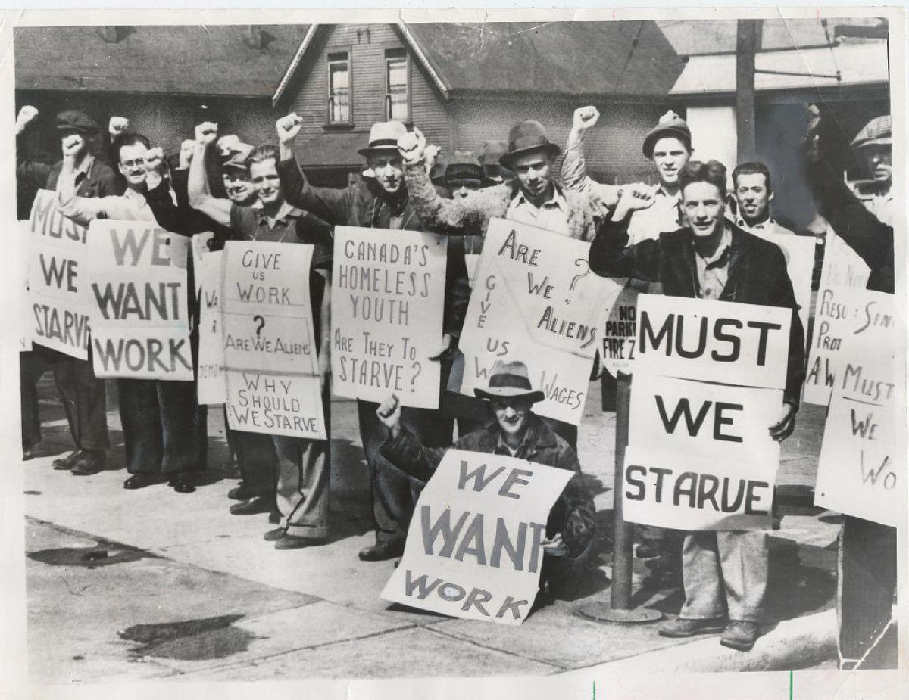
The government had to urgently defuse the situation due to the rapid decline in living standards, impoverishment of the population, growing discontent among citizens, and the growth of labor and communist movements.
After the 1933 U.S. presidential election, Franklin Roosevelt signed the Social Security Act in 1935. The act provided cash benefits for retirees and the unemployed, and a lump-sum death benefit. It also offers aid to low-income families, the blind community, and healthcare services. The cash benefits are funded through taxes on working individuals.
The legislation was prepared and approved with the active participation of Frances Perkins, U.S. Secretary of Labor and a member of the Democratic Party who staunchly advocated for workers' rights. It is worth noting that Perkins contributed to the formation of state policies pertaining to labor unions (despite being distrusted by the union leaders) and played a role in resolving the strike movements. Perkins worked to reconcile the contradictions between the working class and big finance to preserve bourgeois power.
The United States' economic breakthroughs during the "prosperity era" catalyzed prosperity in other European nations.
In Germany, the situation started improving after 1924. Production experienced meteoric growth, resulting in German national income increase in 1929, which was 66% higher compared to 1913. This period is recognized as the "Golden Twenties" in German history.
Wages increased in Britain as the Labour Party took the lead by relying on trade unions and, under the influence of revolutionary events in Russia, advocating for a society based on "public ownership". The first Labour government of 1924 failed to secure Parliament's support and was overthrown by the Conservatives. However, a second Labour government was formed in 1929 and had to deal with the "Great Crisis" that soon followed.
As the economies of several European countries were closely intertwined with the American economy, the economic crisis of the 1930s resulted in a sharp decline in production, bankruptcies of enterprises, increased unemployment, rising prices, and other crisis phenomena, not just in the United States. The Great Depression was a systemic crisis that affected the economic, social, and political landscape in the United States and Western European countries. However, its far-reaching effects impacted almost every country in the world in some way.
Thus, the first phase of the “welfare state” establishment unveiled the inability of the market to regulate itself. Classical liberalism, which advocated for non-intervention of the state in the economy, suffered a setback in the political arena. This phase culminated in the global crisis and the onset of World War II.

Stage II
The second phase of economic recovery in the United States and Western Europe is linked to the post-war period and the decline of European economies following World War II.
As the least affected party, the United States was in the best position, while numerous Western European countries incurred significant material losses during the war, leading to a decline in industrial and agricultural production.
Restoration of the social and economic levels of these countries was done in a twofold way.
On the one hand, the reconstruction of Europe was accomplished through the scope of the Marshall Plan – the U.S. policy that provided extensive economic aid to European nations. The implementation of the Marshall Plan not only increased European countries' dependency on the United States, but it also aided in the removal of communist party representatives from the political field – the U.S. aid was provided to states only under the condition of the expulsion of communists from the governments and policies.
On the other hand, the recovery was driven by domestic social policies, which in some countries were implemented by social democratic parties. The main emphasis was placed on the expansion of state control over the market and the practice of indicative (advisory) planning.
Thus, in Great Britain, a significant role in this was played by the activities of the Labour Party led by K. Attlee, and later by G. Wilson and T. Blair.
Under the Labour government, the English Bank, the coal industry, iron and steel, communication, gas, and electricity were nationalized. The National Insurance, Industrial Safety, and Public Assistance Acts were implemented, replacing previous legislation regarding those in need. The National Health Act was passed, essentially introducing free healthcare to the public and transferring ownership of hospitals, with few exceptions, to the government. There was a significant push to construct inexpensive housing, though this was hindered by subpar building quality.
The post-war economy and industry of France were initially shaped by the Communist Party, but later by the reformist policies of Presidents de Gaulle and Pompidou. These policies struck a certain balance between strict liberalism and social democratic development.
The government functioned as a force for social consolidation and systematic development, elevating the overall social status (including that of the workers), and ultimately sustaining and fortifying the welfare state, rather than mediating unrestricted economic influences. The focus was on nationalization and state-monopolistic regulation. Even though a capitalist economy still formed the foundation of economic management, these measures facilitated the implementation of many social programs, although they could not avert future economic crises.
During the postwar economic recovery in France, significant changes were implemented in labor legislation and social security. Among these changes were: the restoration of the 40-hour work week, the introduction of higher overtime pay, the establishment of two-week paid vacations for workers, and three-week vacations for employees.
The state insurance system was implemented, wages were increased, and pensions and family allowances nearly doubled. Workers were eligible for disability pensions and old-age pensions starting at age 65. Additionally, unemployment benefits, sickness benefits, and pregnancy, childbirth, and child support benefits were established.
After World War II, Italian political and economic relations grew increasingly complex through the struggles of multiple parties. The notable feature of post-war Italy's social and political landscape was the prevalence of strong left-wing parties.
In January 1943, the Italian Communist Party had 15,000 members. The growth of the party resulted from the CPI's great authority during the Resistance era and the spread of socialist ideals after World War II. The general secretary of the CPI, P. Togliatti, played a major role in constructing a "new mass party" that welcomed anyone who subscribed to its political agenda, regardless of their social standing, religious beliefs, and so on. The Italian Socialist Party claimed the second position among leftist parties. Their involvement in the Resistance added to the party's growing prestige. By the end of 1945, it had 700,000 members, which increased to 900,000 in a year.
Until 1948, left-wing and centrist parties (Democrats, Republicans) had a majority in parliament, and right-wing parties (monarchists, fascists) a minority. However, due to the perceived threat of Communist forces coming to power, almost half of the right-wing party votes went to the centrists, particularly the Christian Social Democrats, resulting in their ascent to leadership positions, which weakened the political position of the Communists.
In the '60s and the '70s, the activity of the Chairman of the Italian Council of Ministers, Aldo Moro, who was a representative of the left wing of the Christian Democratic Party, played an important role.
The adopted constitutional laws encompassed various demands for democratic reforms, including the transfer of land to those who cultivate it, as well as nationalization and state control over leading banks and monopolies. The agrarian reform was carried out, which enabled landless and small farmers to acquire more land and expand their land holdings.
All citizens were recognized as having the right to work, the right to participate in the management of enterprises, to weekly rest and to have paid annual leave, to be provided with remuneration commensurate with the quantity and quality of their work. The guarantee of social support and assistance for workers experiencing illness, disability, old age, or unemployment was provided.
Children of all strata were given the right to free and compulsory primary education. Workers' trade union organizations received more rights, and the largest trade union associations had direct links with socialist and communist political parties.
The economic recovery of West Germany (FRG) is intricately linked to the actions of Ludwig Erhard, who embraced liberal political perspectives and put into practice the "socially-oriented" competitive market economy policy. From the mid-1960s onward, social policy for capitalist Germany was under the control of social-democratic parties, guiding it towards greater state regulation and closer collaboration between the government, banks, industry, and trade unions.
The goal of establishing social security in Germany, as a democratic state grounded in bourgeois principles, was not to offer extensive coverage and services for individuals, but rather facilitate conditions for competition that would benefit society.
A comprehensive set of social welfare policies was created based on the principles of providing assistance in sickness, old age, and accidents, as well as offering partial payment for housing, child, and unemployment benefits.
The post-World War II economic boom in the United States is attributed to its extensive foreign economic involvement, which facilitated the export of capital, the capture of markets in other nations, and the consequent inflow of funds. However, bourgeois politicians also had to consider the active trade union movement, which came with increased strike activity as a means of challenging the representatives of big business.
It was against this backdrop that the Employment Act of 1946 was enacted, which significantly reduced the unemployment rate, followed by an increase in the minimum wage, the allocation of funds for low-income family housing, an increase in pensions, and the expansion of welfare benefits.
Furthermore, the country's participation in the Korean War (1950-1953) led to an increase in military contracts, which greatly aided in reducing unemployment. During the 1950s, several social programs were implemented, including medical care and disability insurance. Wages saw a steady increase during this time, and while some Americans experienced an improvement in living standards, approximately 40 million people still lived in poverty.
The presidencies of the following U.S. leaders - J. Kennedy, L. Johnson, R. Nixon - took place against the background of the growing global influence of the USSR in the 1960s, the widespread struggle of black Americans against social discrimination, and the increase in workers' strike activity with more than 2.6 million strikes in 1968 alone.
The government's efforts focused on social welfare, including tax cuts for the non-wealthy, expansion of civil rights for national minorities, and social programs for senior citizens. Additionally, there was an increase in the minimum wage with the retraining of workers for new professions. However, these social reform projects encountered continuous opposition from large corporations resulting in many of the initiatives remaining on paper.
The end of the 1960s saw the onset of an overproduction crisis in the country. The economy contracted while unemployment spiked and consumer goods prices surged. As a result, both the trade union and strike movements gained steam. In 1971, the economic downturn worsened into a depression, which was exacerbated by the global raw materials crisis of 1974-75 (the "oil shock" of 1973), resulting in a decline in US production by over 12% and a subsequent rise in unemployment.
As the situation unfolded, the social expenditures of the state were cut by the authorities. The ceiling on oil and gas prices was eliminated, and Americans' standard of living declined rapidly during this period.
Cuts in social programs provoked protests by workers, and union activity intensified. In September 1981, there was a march in Washington, D.C., that about half a million unemployed and poor people took part. In the same year, there was a major strike of air traffic controllers, who were in favor of higher wages. Under such conditions, in 1983 the authorities had to restore a number of social programs in order to reduce the wave of protests. The retaliatory pressure on the trade union movement led to the fact that the coverage of workers in American industry by trade union organizations almost halved, from 40 to 20.5%.
In the 1990s, the U.S. again experienced an economic recession, accompanied by rising budget deficits, unemployment, and falling living standards for Americans. Political elites solved the problems by raising taxes and cutting tax breaks for the poor.
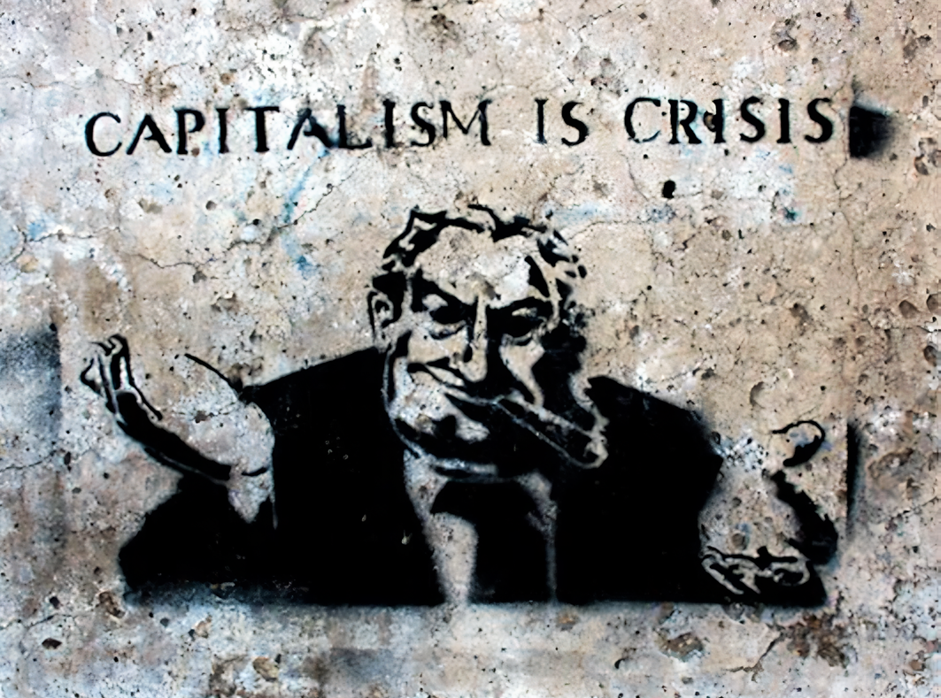
The global financial crisis of 2008 was triggered by the collapse of the U.S. mortgage market in 2007, which caused a sharp decline in production and an increase in unemployment. The crisis, which originated in the United States in the context of globalization, ultimately led to a financial crisis worldwide. Between 2008 and 2012, the country experienced an increase in public debt, a rise in unemployment, a decrease in the population's savings rate, and approximately 15% of the population fell below the poverty line.

II. USSR as a stimulus for the "welfare state" development
In contrast to the countries developing under a capitalist economy, the USSR, formed after the socialist revolution of 1917, provided stable growth of social security. Additionally, the USSR's influence served as a powerful stimulus for the popularity of communist sentiment in capitalist societies. As a result, the bourgeois leadership had to make a more active effort to improve social security measures at home.
The economic and social development of the socialist state hinged on the elimination of private property in the means of production, which also led to the removal of capitalist owners as the class that monopolized ownership of most of the means and benefits.
This formed the foundation for further advancement towards the primary principles of socialism, such as meeting the material and cultural necessities of the populace, promoting the comprehensive development of individual workers, and systematically improving people's lives.
The Soviet social policy system evolved coincidentally with the "welfare state" in the Western world. Many transformations and progressive reforms were introduced in the USSR earlier than in Europe and the United States, and some were borrowed from Western experiences or applied simultaneously with them.
Thus, in December 1917, the Decree "On Sickness Insurance" was adopted. This was a progressive move for the time. The United States did not establish a federal law on maternity leave until 1993, while in Britain, a law on paid maternity leave was not adopted until 1975.
In July 1918, the first centralized free healthcare system in the world was established.
Free primary education was implemented in 1918 and mandated in 1930, resulting in an increase in literacy rates from approximately 30% in 1916 to 90% by 1940. Additionally, on June 6, 1956, the Council of Ministers of the USSR abolished tuition fees for upper secondary schools, technical colleges, and universities.
The pension system in the Soviet Union started with the provision of military personnel. On August 7, 1918, a decree was issued for the pensions of the Red Army soldiers who were incapacitated, as well as their families. The Regulation on Social Security of Workers, which provided disability pensions and unemployment benefits, appeared in the same year. In 1925, long-service pensions (for 25 years of employment) were introduced for public education system employees. In 1932, a general retirement age was established for all citizens, with women retiring at 55 and men at 60. This retirement age remained unchanged until 2019 and was among the lowest in the world.
In March 1930, the USSR closed its last labor exchange and achieved universal employment. Through a specialist distribution system, graduates did not need to seek jobs upon completion of their training, and there was officially no unemployment until 1991.
In the 1950s, mass construction of free housing for citizens began, resulting in a doubling of the average housing provision from 5 to 12 square meters per person by the 1970s.
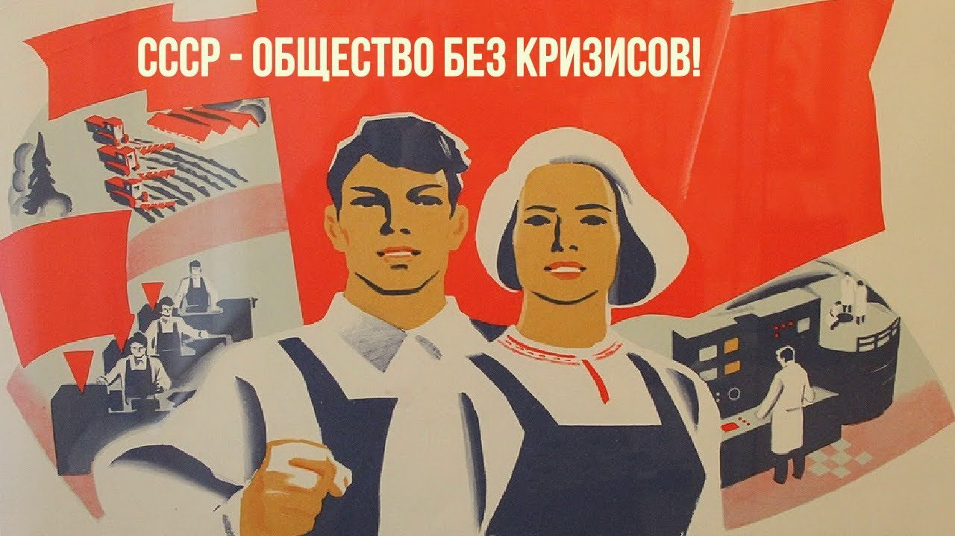
Text on the picture: USSR - society without crisis
The 1977 Constitution of the Soviet Union guaranteed citizens the right to material security when it came to old age, disability, and loss of breadwinners, alongside free education, medical care, and housing.
Despite the steady denunciation of Soviet socialism and anti-communist propaganda, researchers with scientific integrity acknowledge that in the 1970s, the social support provided by the Soviet system was unparalleled in terms of equality, accessibility, and the range of services offered.
The rapid expansion of social security programs in the USSR served as the benchmark and impetus for the development of the "social state" in capitalist countries. The outstanding successes achieved by the Soviet system in the arena of social construction and the subsequent international recognition and popularity of communism objectively posed a continuous threat of inciting revolutionary sentiments in capitalist nations.
The capitalists were compelled to grant substantial concessions to the workers of their nations in order to maintain their power and assets.
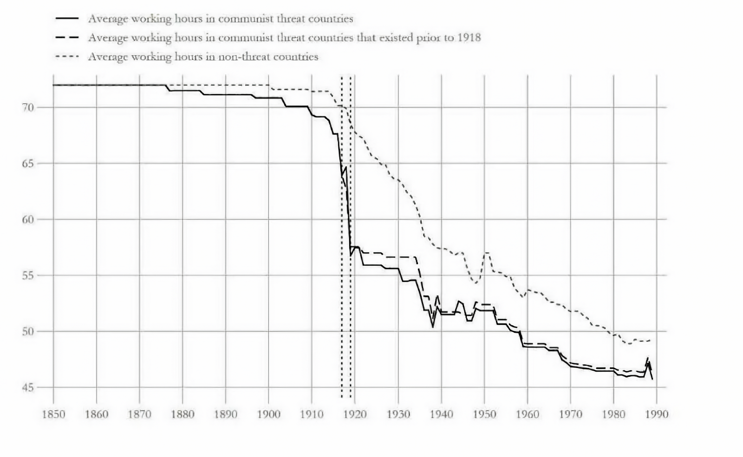
The working day's decline worldwide following 1917. Source: Reforming to Survive: The Bolshevik Origins of Social Policies.

III. Dismantling the "welfare state"
Even during the active decomposition of the USSR in the 1980s and the decline of communist influence worldwide, some capitalist countries' bourgeoisie pursued a policy of reducing social programs and opposing workers' movements.
Thus, the shift towards conservatism in Great Britain, which was attributed to the policies of the famous Prime Minister Margaret Thatcher, resulted in reduced production, numerous workers' union strikes (with their requests being unheeded), an upward trend in unemployment, higher taxes for workers, decreased regional aid, and less social expenditures overall.
During the 1980s, President Ronald Reagan implemented conservative policies that led to a series of challenging economic reforms known as "Reaganomics" in the United States. These reforms aimed to reduce government intervention in the economy and bolster the role of the market. This included a decrease in spending on social programs and programs designed to maintain living standards. Some researchers have suggested that the global crisis of 2008 may have been influenced by the repercussions of these economic reforms.
The downfall of the USSR also resulted in the relinquishment of the requirement to uphold an elevated level of social policy in capitalist countries, which relied on the reputation of the socialist state.
This marked the beginning of a period of actively curtailing social programs, dismantling the "social state", and resulting in more frequent and severe economic crises.
Since the severe crisis of 2008, and potentially as its continuation, according to some economists, there has been a prolonged and increasingly international and national political crisis caused by the regularities of socioeconomic progress of capitalism.
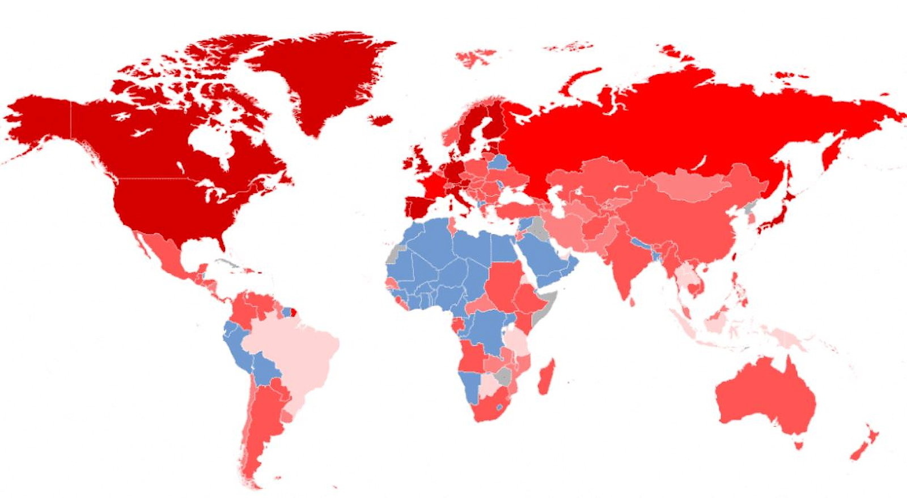
Global Economic Downturn at the close of 2008 (degree of decline is indicated by red color saturation)
Growing global economic instability, inflation, and a production recession are occurring amidst rising international tensions due to the trade war between the US and China, the military conflict in Ukraine, the resulting sanctions policy, falling oil prices, as well as the COVID-19 pandemic. The outbreak of the pandemic has caused an unprecedented crisis in the fields of human resources and healthcare, severely impacting global financial stability.
The economic downturn worldwide principally impacts the living conditions of the proletariat in multiple areas. Due to inadequate financial security and high debts, they are vulnerable to the effects of economic upheavals.
In this context, bourgeois politicians are putting more and more pressure on the workers' movement in order to undermine it. They are increasing taxes and reducing social rights and guarantees, all to maintain a certain degree of stability.
The rights and guarantees that were won through a century of struggle can disappear quickly when the interests of big capital are at stake, setting humanity back to the living and working conditions of earlier stages of capitalism.
Laws that remove restrictions on working hours, legalize child labor, increase the retirement age, reduce social spending, and decrease wage increases are directly or subtly enacted. Of course, all of these measures are presented as urgently necessary due to good intentions or a difficult economic situation caused by crises.
In 2022, a wave of strikes broke out across Europe due to high inflation and the government's inability to increase workers' wages. Since the start of 2023, numerous large-scale strikes have taken place in the United States, Canada, Finland, Germany, Great Britain, Kazakhstan, and Norway. Workers have expressed dissatisfaction with labor conditions and salaries.
Social spending in Russia declined from 7175.2 billion rubles in 2015 to 6018 billion rubles in 2019. Economists worldwide predict a drop in real income attributed to increasing levels of inflation and unemployment.
In France, the 35-hour workweek established in 1998, during the period when social-democratic forces held power, was abolished in 2008.
At the same time, the retirement age is being raised in different countries of the world: 2019 - in Russia, 2023 - in France, since 2012 it has been gradually raised in Germany, and in Austria there are plans to raise it for women. Belgium, Croatia, Denmark, Estonia, Finland, Hungary, Latvia, Lithuania, Romania - all these countries also plan to gradually raise the retirement age.
Bolivia officially permitted child labor in 2014, and Iowa in the U.S. officially permitted it in 2023. Furthermore, the number of child labor violations in the U.S. rose by 70% in 2018. Russia presented a bill in November 2022 to legalize child labor.
Economic crises do not fully encompass the issues of the capitalist economy but rather indicate the impending main crisis of capitalism in its imperialist phase. Capitalism is once again gearing up for another global war as an inevitable result of the intensifying competitive struggle that has reached a global scale.
Such preparation always encompasses not only military but also technical and economic preparations. It is accompanied by increased oppression of workers, and restrictions on their rights and freedoms, promoted under the slogans of necessity and cooperation for the defense of "national unity."
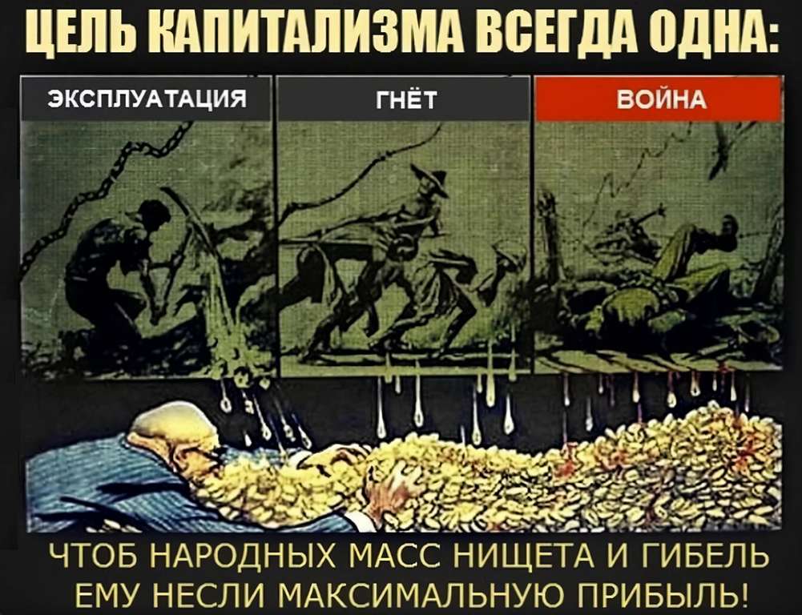
"The goal of capitalism is always the same: Exploitation, Oppression, War. To bring ruin to workers and make them live in poverty, to ensure maximum gains and profitability" Soviet poster-caricature of the Cold War (1953), artist I.M. Semyonov
Capitalist propaganda attempts to eradicate the concept of class division and class struggle from the minds of working individuals. Populist speech endeavors to create a facade of "solidarity" between the laborers and the wealthy elite, the alleged convergence of their interests. However, in reality, there is no common interest between them, as their interests are economically directly opposed, and the well-being of some is always inversely proportional to the well-being of others.
The social-democratic forces of capitalist politics are currently experiencing critical conditions and have displayed their failure and inability to manage the situation. Despite promoting "capitalism with a human face" using social welfare rhetoric, their attempts are unsuccessful due to the framework of the capitalist economy.
These forces seek solutions to socio-political crises while striving to remain within the said economic system. However, the capitalist economy's structural regularities contain contradictions that are insoluble within its framework. First of all, there exists a distinction between the public nature of production and the private nature of appropriation of the resulting products.
In the absence of democratic forces in a capitalist society, and with increasing deprivation and sharpening contradictions. politically radical forces become increasingly prominent. The ultimate manifestation of their influence is the transition from liberal-democracy to fascism.
Fascist policy in this case, like liberal policy, also aims to revoke workers' rights and freedoms, under patriotic slogans at first and later without them, but differs by its method of open terrorist violence against workers to enact these changes at a faster rate. It also involves increasing tax oppression and industrial exploitation, fully subjugating powerless workers under an open dictatorship, and escalating repressive methods to suppress all protests and discontent. The bestial, misanthropic hatred and of capital becomes on open display.

IV. What Is to Be Done?
Сapitalist society, based on the private ownership of the means of production, has achieved significant levels of production capabilities, connecting nations and individuals through global production and economic relationships.
Nevertheless, due to the inherent tendencies directing its evolution, capitalist society is incapable of completely fulfilling the needs of the workforce, even with policies that prioritize social equity.
The interests of workers often clash with those of the wealthy minority who own capital and are supported by the state.
These contradictions fuel the growth of class conflict and ignite class hatred in capitalist society.
The course of historical development in the 20th century has clearly demonstrated that the bourgeoisie's response to the increasing social demands and dissatisfaction of the working class can be divided into two scenarios:
The best-case scenario is a transient enhancement of social policy, derived from the outcomes of military and/or commercial imperialist expansion, which is nevertheless precarious and prone to being undone by the inevitable crises brought about by capitalist economic activity.
In the worst-case scenario, which is inevitable in the context of laws of capitalist development, there can be a worsening of bourgeois dictatorship, which takes on an open terroristic form in both domestic and foreign policies, resulting in a substantial diminishing or loss of social protections and rights.
There can only be one solution to the impasse caused by capitalism: a shift from the current economic formation to a more progressive socialist one.
This imperative requires the elimination of private ownership of the means of production and a restructuring of the state towards the distribution of benefits produced by society in favor of the workers.
The laborers worldwide have no class interest in division or competition on economic or national terms. With advanced technology and production development, prerequisites have emerged for eliminating social stratification and unifying all peoples internationally for the collective benefit - hence the socialist socio-economic system has become even more viable and necessary.
Such an arrangement, in contrast to capitalism, could allow for the systematic achievement of an unparalleled quality of life for all, protection against crises and wars, and the direction of human potential towards creation and the systematic development of society.
Meanwhile, the history of the late 20th and early 21st centuries has demonstrated the futility of hoping that Capitalism can be turned into the "welfare state" through a peaceful reformation and "socially-oriented business".
Firstly, this "welfare" model was a temporary concessionary state of capitalism caused by the rise of the world revolutionary movement and the successful transformation of socialist states.
Secondly, social welfare programs do not eliminate the contradictions of capitalism but rather temporarily mitigate them.
Thirdly, they achieve this through immense economic, commercial, and labor exploitation of the world's poorest countries.
Fourthly, the basis of the "welfare state" lacks stability and is highly changeable; in case the historical situation shifts, capitalists will seek to reduce social policies and dismantle the "welfare state".
An absolute and unreserved triumph of socialism worldwide is the only guarantee that humanity can achieve permanent, progressive, and stable development.
Sources
- Khudokormov A.G. "Economic miracle" in France: Formation and Results of the Dirigisme Model in 1944-1973"
- Zaslavskaya M.D. "Economic History: The Economy of France after World War II"
- Verbets Y.V. "Italy after World War II. Social and economic transformations of the Christian Democratic Party"
- Poddubskaya E.F. "Formation of party system in post-war Italy".
- Basyrova S.G. "The USA in the second half of XX - beginning of XXI centuries".
- Rodovich Y.V. "History of the Modern Times of Europe and America".
- Podolsky V.A. "Development of Social Policy in the USSR: Comparative Analysis with Western Practices".
- Rasmussen M.B., Knutsen K.H. "Reforming to Survive:The Bolshevik Origins of Social Policies"
- Kishore J., North D. "2023: The Global Capitalist Crisis and the Growing Offensive of the International Working Class".
- Promdevelop: "The 2014 Economic Crisis in Russia and the World: Causes and Consequences" dated October 9, 2019, updated October 9, 2019. March 2, 2022.
- Morozov A.Y. "Western countries in the 1920s: on the way to the Great Depression".
- United Russia: "Charles de Gaulle and the Modernization of the Fifth Republic" dated May 6, 2011.
- Zen.ru / The American Life: "On the situation with maternity leave in the United States" dated November 20, 2018.
- Lupenkova N.V. "Educational reforms in Italy: history and experience"
- RIA: "Margaret Thatcher's Ten Most Important Events and Decisions" dated October 11, 2013.

Original article

