The Department of Homeland Security Wants to Control The Activity of Media "Influencers"
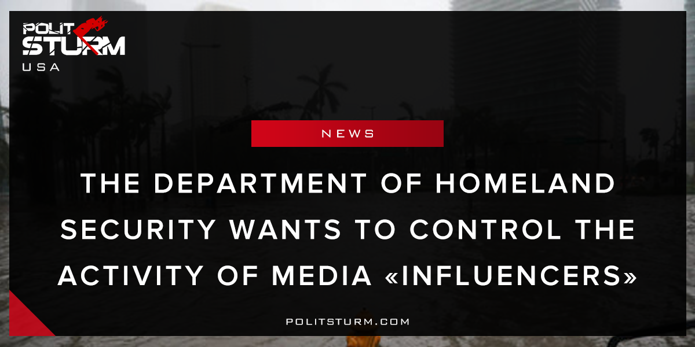

Original article
2018-04-09
1 min read

The Department of Homeland Security is seeking a contractor who can monitor the activity of media “influencers” in a crackdown on supposed fake news circulation in the United States. The contract is intended to identify more than 290,000 news sources written in over 100 different languages.The data is intended to measure the “sentiment” of a particular media source and also to gauge the impact it may have on public opinion. The so-called objective of the campaign is extremely vague, as those monitored include those “related to the Department of Homeland Security or a particular event”. Interestingly, there is no mention of what kind of “particular events” are under consideration or of significance.
Realistically, the capitalist government is attempting to suppress dissent and criticism. Despite all of the democratic rhetoric surrounding “freedom of speech”, this freedom only exists for the capitalist class. Worker criticism of the failing capitalist economic system is simply not acceptable. It is also not in good taste to discuss imperialism , surveillance , or police murder with the oligarchs and their supporters. It is in the sole interest of the propertied class to suppress working class resistance, that is why the government is contracting “media monitoring services”. This action is simply a representation of the class division that exists between the bourgeois government and the mass of working people.
https://www.fbo.gov/index?s=opportunity&mode=form&id=22aa793f75ce05efd160cfa36d7a8acc&tab=core&tabmode=list
https://www.forbes.com/sites/michellefabio/2018/04/06/department-of-homeland-security-compiling-database-of-journalists-and-media-influencers/#303bf7c16121

Original article

