The crisis of “Scandinavian Socialism” in Finland
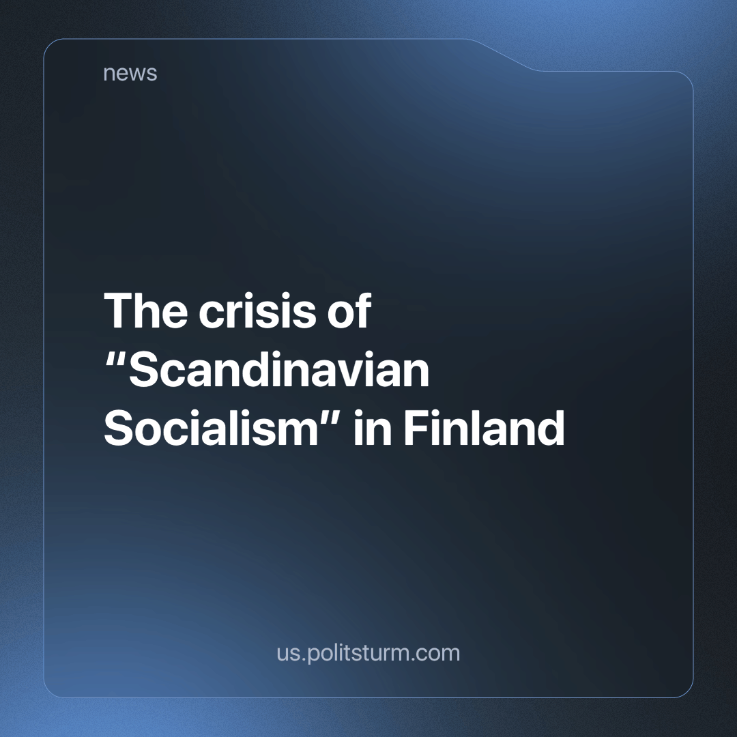

Original article
2023-12-22
3 min read

In the public consciousness, Finland is still often associated with the fruits of the struggle of Finnish workers of the 20th century. These included: adequate labor legislation, observance of workers' rights by corporations, a lot of social benefits, and active state supervision of business abuses. They call it “Scandinavian socialism”.
Nevertheless, despite the successful brand advertising capitalism with a human face, the ruling class of Finland decided to abandon it. On December 14, the country was effectively immobilized by one of the most massive strikes of workers in the railway, transport and other spheres. The total number of strikers approached 100,000, which is quite a lot for a country with a population of 5.5 million people. The economic damage to the capitalists is estimated at 100–130 million euros. [1]
This did not happen suddenly, since September 26, Finland has witnessed days of strikes involving workers from various industries. The nationwide strikes were organized by the Central Organization of Finnish Trade Unions in protest against the antisocial policies of the right-wing conservative government of Petteri Orpo.[2]
In the spring of this year, the right-wing National Coalition Party (NCP) came to power in the country, which formed a bloc with the far-right Party of True Finns. [3]
The policy of the new government is to reduce housing benefits, unemployment benefits, migrant rights, the complete abolition of employment insurance, and the introduction of unpaid sick leave. The workers' movement will also suffer: the courts will have the right to declare strikes illegal, and trade union members will be banned from taking part in solidarity strikes and strikes with political slogans. For this, the unions will face a fine of 10-15 thousand euros and 200 euros for each worker.
These measures will hit both the most vulnerable strata of workers and the labor movement as a whole.
These changes, which aim to eliminate budget deficits, simultaneously increase defense spending by 36%. This is the highest increase in the Finnish military budget since 1962. [4]
Stepping on the workers' throats on the one hand, on the other, the right-wing government is at the same time trying to equate Communism and Nazism and ban communist symbols, which local Communists oppose [5]. It is worth noting that the number of workers in trade unions has been steadily declining in Finland and currently stands at 55%, down from 68% in 2009, which demonstrates the weakening of the labor movement. [6]
At the moment, trade unions demand to take into account the opinion of workers when changing labor legislation, hoping for workers to have a place at the negotiating table. The success of these strikes is not guaranteed and there is a possibility of future protests. The government has not yet shown fear of the protests of workers and does not intend to deviate from its goals of reducing the market price of labor. [7]
According to public polls, 50% of local residents oppose restrictions on political strikes and solidarity strikes, and only 35% are in favor.[8]
At the same time, public opinion is being pressured through the bourgeois press, which serves the interests of business. The strike participants are criticized because they are on strike during the Christmas season. A number of entrepreneurs consider the strike “irresponsible”, as it complicates the conduct of business and the daily lives of citizens. [9]
How will “Scandinavian socialism” end in Finland? Most likely, by the victory of the anti-popular reforms that continue to weaken the position of the working class. In order to oppose the government, the working class needs to present a united front under the leadership of an independent and genuine communist party. The Social Democrats are revealing their anti-worker essence by once again reducing their activities to parliamentary chatter. At this moment, the strike, despite its massive scale, has not convinced the ruling class of Finland of the seriousness of the threat of the workers to their rule, so the right-wing government will continue its course of militarization to the detriment of the public welfare of its citizens.
Sources: 1, 2, 3, 4, 5, 6, 7, 8, 9

Original article

