The Business Veto: Midterm Elections Raise up to $548 Million
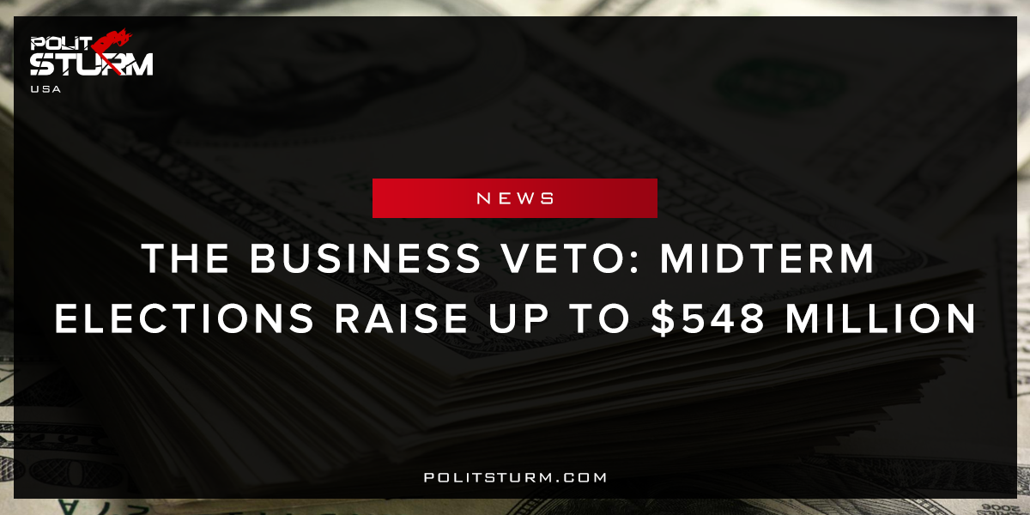

Original article
2018-01-30
2 min read

Candidates running for office in the US Midterm elections have thus far raised a total of $548,006,016 according to the Center for Responsible Politics, and have spent an estimated $245,275,339.
Fundraising efforts for candidates for the House of Representatives, which is widely believed to be safe in Republican hands, is more or less even with Democrats raising $169M to the Republicans’ $180M. Meanwhile, fundraising for Senate candidates, which could swing in the direction of the Democrats, is more lopsided. There, Democratic candidates have the advantage, having raised $135M to the Republicans’ $57M.
The 2018 Midterm elections, named for congressional elections midway through the President’s mandate, are to be held on November 6, 2018. 33 senators, mainly Democrats are up for election as well as the 435 seats in the House of Representatives. This is the first major election following the election of Donald Trump and could result in major wins for the Democratic party if current trends are to continue.
Politsturm: Once again, we watch our politicians get bought off by big business and call ourselves a “democracy”. This self-reinforcing relationship, that weeds out the antagonistic elements to the business elite, overrides any democratic potential the American system can aspire to. Politicians, both liberal conservative, accept corporate money because of the power it has in triumphing over their opponent. Money in bourgeois society has the ability to grant a candidate better strategists, more political advertisements, larger events, a larger campaign team, better marketing campaigns, better, faster and more frequent transportation methods, etc. For example, campaign funds allowed for Hillary Clinton to make a payment to Correct the Record for “research” and Donald Trump to unofficially hire the dark horse political consultant Roger Stone. If this were Vegas, the odds would be stacked incredibly in favor of the gambler. In 91% of the cases where a candidate raised the most money, that candidate went on to win the election, making the corporate world’s relatively small donation a smart investment for the legislation, access, and protection they could receive in the future.
Don’t the people deserve to have a fully democratic process without the “invisible hand” of capital overriding the true will of the people? And aren’t we fully capable of determining for ourselves how our communities should be run without oligarchs like Rupert Murdoch, Bob Mercer, Warren Buffett, and George Soros picking and choosing who does or doesn’t have a vocation for political office? A truly complete rebuke of this kind of corruption cannot be found in small-scale reforms and regulations but in the complete negation of the conditions that led to their rise in the first place. The social relationship which allows these small few characters to accumulate wealth off of the backs of the American workforce must be overturned. The exploitation of man by man must be abolished!
Sources: 1, 2, 3

Original article

