The Bolsheviks vs. the White Guards
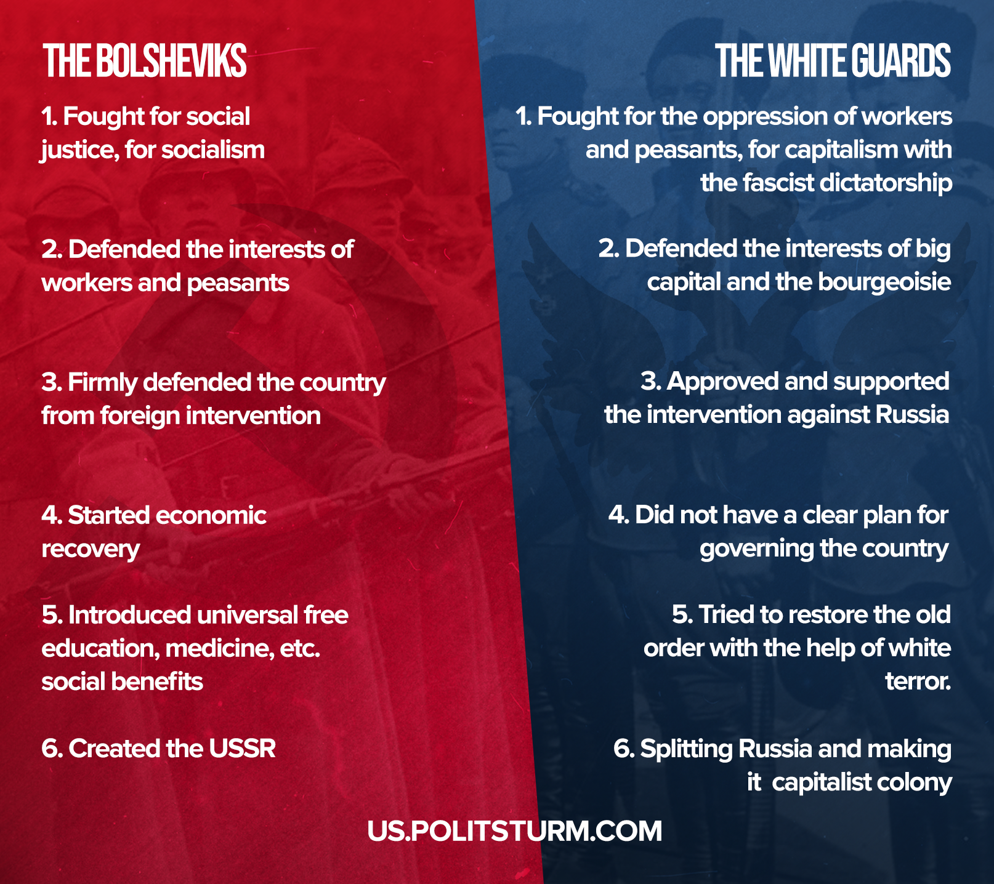

Original article
2021-11-07

What were they fighting for?

Original article

