The Anti-Russian Sanctions Explained. Who Needs To Be Punished?
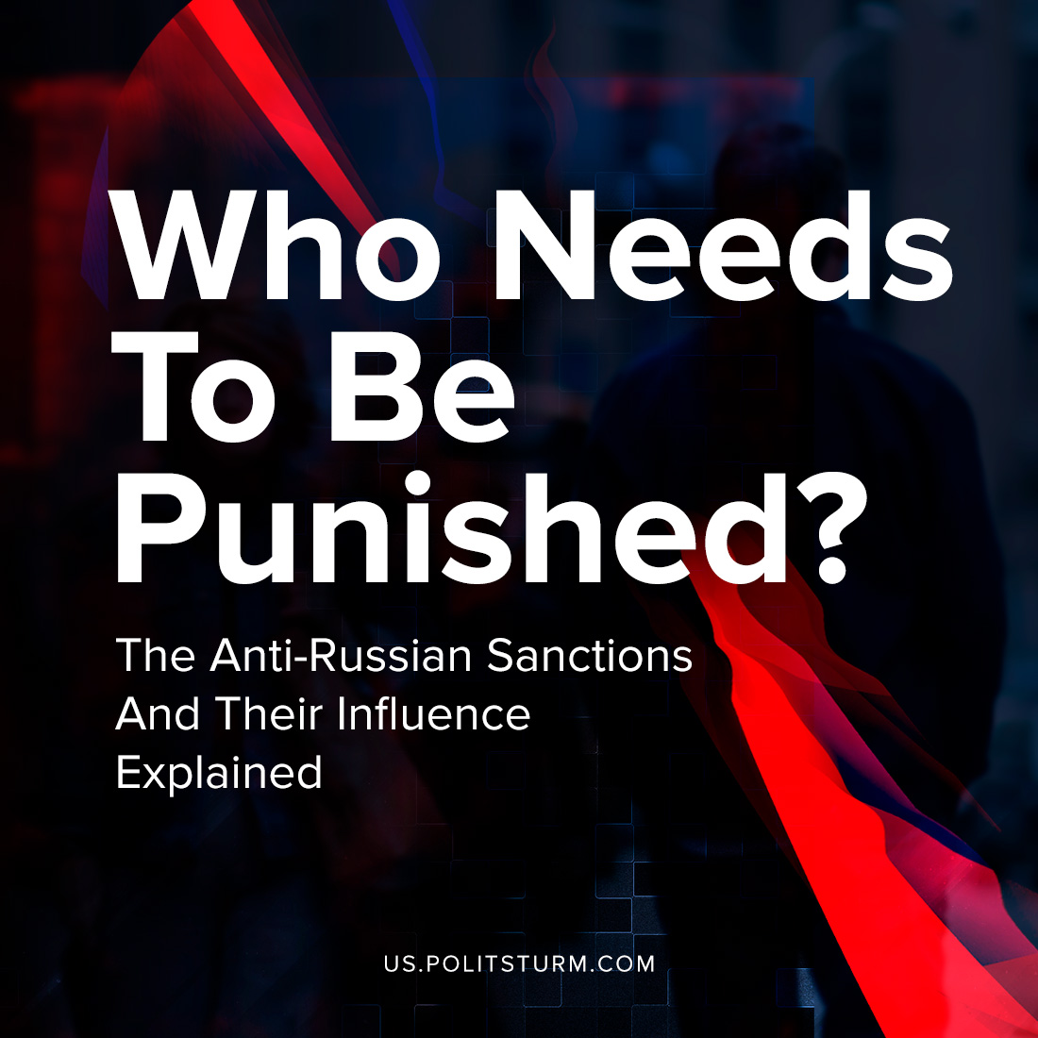

Original article
2022-03-09
4 min read

Since February 24, the “special military operation” of Russian troops in Ukraine continues. The United States, a number of European Union countries, Great Britain, Canada, Australia, Japan, Turkey, South Korea, and Singapore condemned Russia’s policy, after which they imposed a number of economic sanctions.
Formally, most of these sanctions are aimed at companies of large capitalists. However, one should not assume that the broad masses will remain unaffected. At the moment, as in any other crisis, the yoke of economic problems falls on the shoulders of the working people.
The standards of living in Russia have been rapidly deteriorating since the beginning of the “military operation”. The ruble exchange rate against the dollar collapsed almost twice. Drug prices have skyrocketed in recent days, up to 25% in some regions; this is due to disrupted supplies from Europe, as well as purchase prices soaring due to the collapse of the ruble. Food products’ prices have crawled up, and some of them completely disappeared from store shelves. The cost of buying and renting housing has risen, as a result of which it has become much more difficult for workers to keep a roof over their heads.
Error loading image
Exchange rates on the Moscow stock market by 11AM Moscow time.
Regardless of government sanctions, many multinationals and large companies have announced they will stop working in Russia or with Russian citizens. An unprecedented number of foreign companies have stopped working on the territory of the Russian Federation. Among them are eBay, Samsung, IKEA – the list continues to grow.
A number of car manufacturers, such as Volvo, Skoda, Toyota, BMW and Nissan have suspended work in Russia. Toyota cars are among the top five best-selling in the country. The Russian automotive industry is not able to give consolation, as it directly depends on the rapidly rising cost of foreign supplies, which will affect the final price of products.
And if the closure of many traditionally “high-end” brands is unlikely to have any impact (ordinary Russians could not buy expensive clothes, cars or smartphones, and the rich will buy them anyway), then the decisions of large companies affect the lives of many. Just yesterday, McDonalds announced the closure of more than 800 restaurants across the country. Because of this, tens of thousands of people will be left without a livelihood. PayPal has stopped working, as well as Visa and Mastercard. Through these services, many Russian artists, programmers and other freelancers earned their living.
Error loading image
One of the companies blocking all the Russians and stealing their money because of the actions of the Russian government.
Film companies Disney, Paramount, Sony and Warner Bros. withdrew their films. Activision Blizzard, Electronic Arts, Rockstar Games and CD Projekt RED have suspended sales of their games. Booking.com and Airbnb have limited work for Russian users. British-Dutch Shell closes all gas stations in Russia.
At the same time, it is known that despite the most severe sanctions and the collapse of the ruble, some Russian billionaires have increased their wealth since the beginning of 2022. This number includes Arkady Rotenberg, Dmitry Bukhman, Oleg Boyko and many others. Moreover, according to Gazprom, gas supplies through the territory of Ukraine, where these events are unfolding, are proceeding as usual. And some representatives of the big bourgeoisie are removed from the sanctions. Alisher Usmanov – one of the richest people in Russia, the owner of many metallurgical enterprises – was removed from the US sanctions.
Hypocritical are the words of the representatives of the Western bourgeoisie, that sanctions and blockages will allegedly encourage the people of Russia to oppose the military operation and the country’s leadership. Obviously, such actions, on the contrary, play into the hands of the representatives of the Russian authorities, since they confirm their propaganda about “the insidious enemies of Russia in the West”.
Equally important is the use of the special operation to stir up anti-communist sentiment. Thus, despite the fact that Russia has been a capitalist state for more than thirty years, the bourgeoisie does not miss the opportunity to call Russian politics communist. The consequence of this is the growth of Russophobia.
The military operation in Ukraine is carried out in the interests of the ruling class – the bourgeoisie. But the workers are forced to pay for it and for its consequences in the form of rising prices, lack of necessary goods, closing shops, deprivation of the thirteenth salary and many others. The sanctions imposed against Russia will be a heavy burden on the people, and not on the capitalists, who, even in modern conditions, continue to increase their fortunes.
More sources: “TASS” – Gazprom continues regular gas supply for transit to Europe through Ukraine
“BFM.RU” – “Why did the US withdraw Alisher Usmanov’s assets from blocking sanctions?”
“Federal Press” – “How PayPal’s departure will affect the Russians”
“RB.RU” – “List of companies that have limited work in Russia”
“Izvestia” – “Unhealthy interest: wholesalers raised purchase prices for pharmacies”
“New Day” – “South Ural residents are outraged by the continued rise in prices”
“Gazeta.SPb” – “From March 9, food prices in Russia will rise sharply”
“RBC” – “Which Russian businessmen are “getting richer” despite the crisis”

Original article

