“The Amazon of Russia" to Use Prisoners at Warehouses
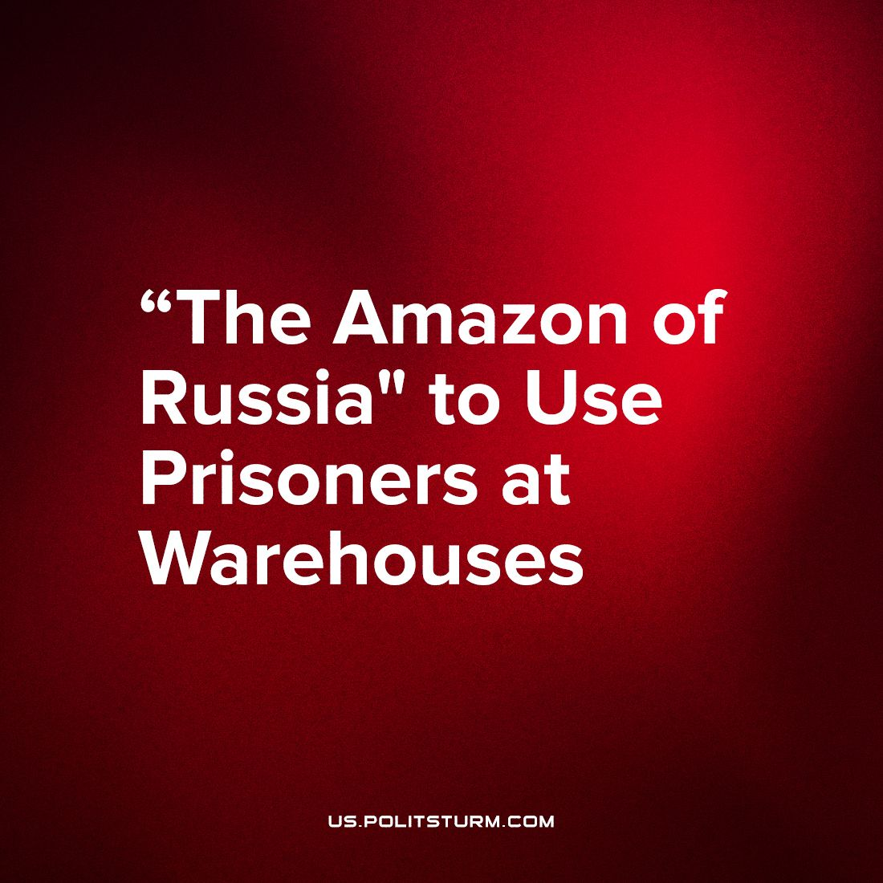

Original article
2023-10-10
1 min read

Convicts have been working at Ozon warehouses in St. Petersburg since the end of last year. They work as storekeepers and packers. They represent 10%, or 180 people out of 2000 warehouse workers.
The "Ozon" company, known for being "Russian Amazon", announced the expansion of its project "Ozon without Conviction": up to 500 convicts will be employed by the end of 2023. AvtoVAZ also announced plans to hire this category of citizens, stating that due to a shortage of personnel by September 2023, the company will need 1100 people, and from January 2024 about 2900 more.
It would seem that the personnel shortage should have made entrepreneurs think about raising wages to attract new workers, but instead they preferred to hire convicts. After all, they can be paid much less than an ordinary employee, and they are unlikely to demand labor improvements. Instead of re-educating a person, making him a decent citizen, he is isolated from society, using his disenfranchised labor to enrich a bunch of rich people.
Under capitalism, with its inherent private property and market economy, this state of affairs is in the order of things. In order to maintain a high level of profit, businessmen use any tools and methods. At the same time, the state in their hands actively contributes to this. That is why the penitentiary system has recently been increasingly involved in this direction by them.
Only under the power of the working people, which destroyed capitalism, every person will be able to find a worthy use for his work. And then the modern absurdity will become impossible - a shortage of workers and at the same time millions of unemployed.
Source: Vedomosti - "Russian companies have begun to actively recruit convicts to forced labor" dated August 01, 2023.

Original article

