Thälmann on World War 1
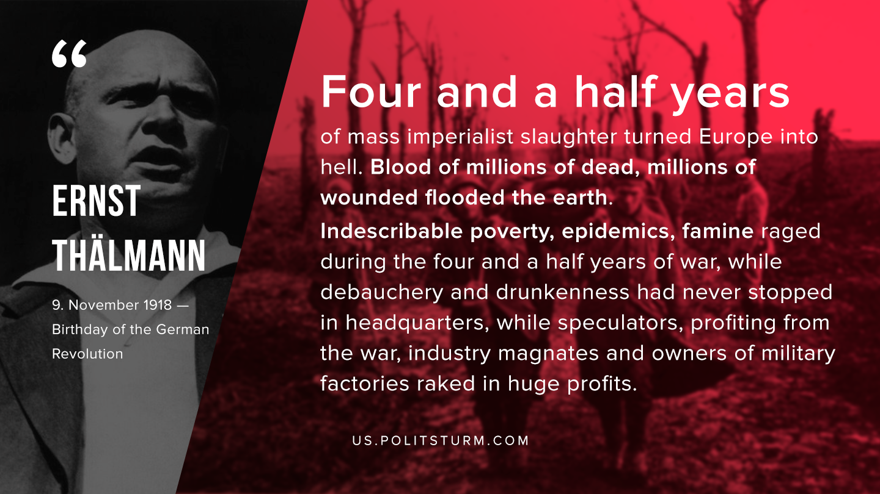

Original article
2019-11-17

Four and a half years of mass imperialist slaughter turned Europe into hell. Blood of millions of dead, millions of wounded flooded the earth. Indescribable poverty, epidemics, famine raged during the four and a half years of war, while debauchery and drunkenness had never stopped in headquarters, while speculators, profiting from the war, industry magnates and owners of military factories raked in huge profits.
Ernst Thälmann, “9. November – Birthday of the German Revolution”

Original article

