Thälmann on the Role of the Communist Party
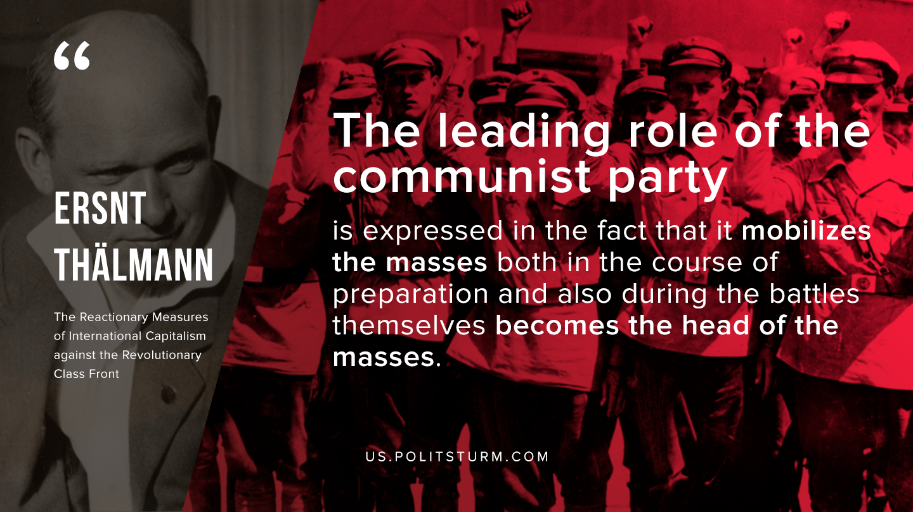

Original article
2019-11-19

The leading role of the communist party is expressed in the fact that it mobilizes the masses both in the course of preparation and also during the battles themselves becomes the head of the masses.

Original article

