Thälmann on Self-Criticism
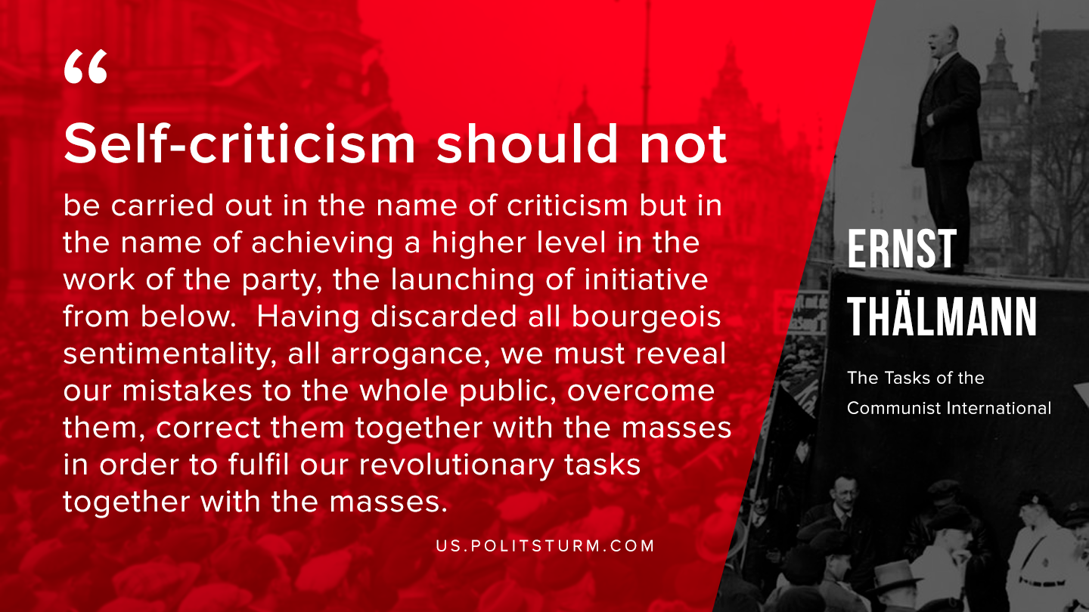

Original article
2019-12-04

Self-criticism should not be carried out in the name of criticism but in the name of achieving a higher level in the work the party, the launching from below. Having discarded all bourgeois sentimentally, all arrogance, we must reveal our mistakes to the whole public, overcome them, correct them together with the masses in order to fulfil our revolutionary tasks together with the masses.
Ernst Thälmann, “The Tasks of the Communist International”.

Original article

