Texas Lt. Governor Urges U.S Back to Work
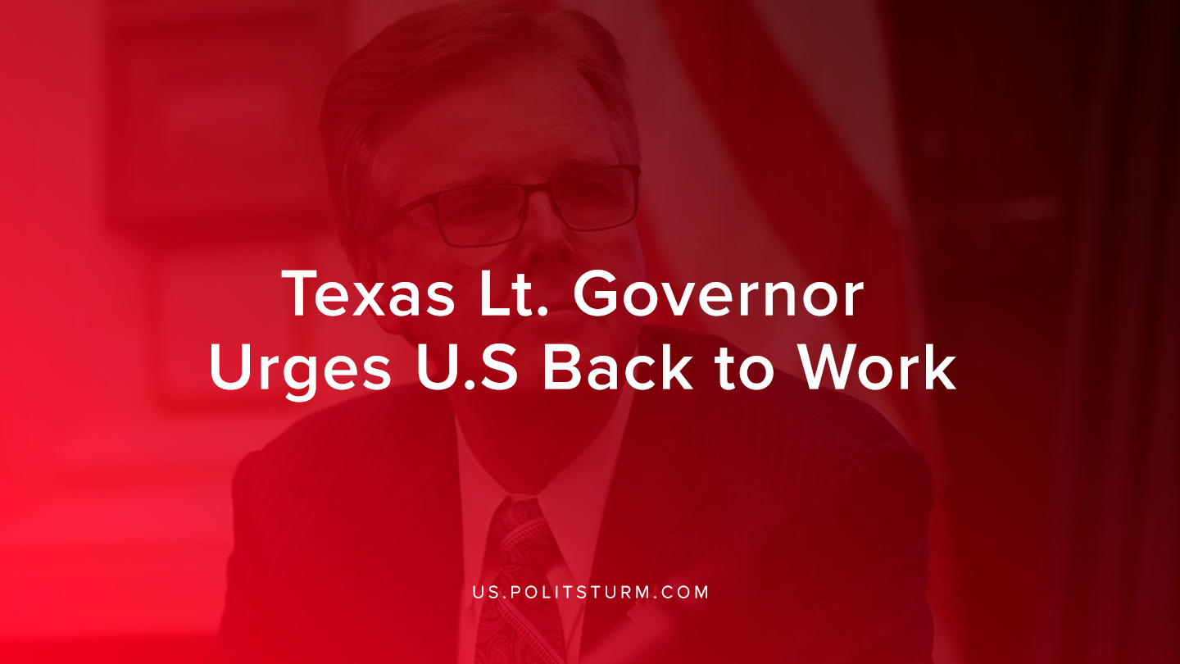

Original article
2020-03-29
1 min read

Texas Lt. Governor Dan Patrick said that the U.S. should get back to work quickly amidst the coronavirus outbreak. Patrick went on to say that there were grandparents like him who would not want “the whole country to be sacrificed.”
These comments come amidst Trump’s comments that it would be a “beautiful” idea to reopen the U.S economy by Easter. Trump also tweeted in reference to the coronavirus and the economy by saying, “WE CANNOT LET THE CURE BE WORSE THAN THE PROBLEM ITSELF.”
Health experts around the world criticized the statement as the number of coronavirus cases spikes to 82,174 with 1,177 deaths in the United States.
Capitalist politicians are very much concerned with the growth of the stock market and the preservation of their wealth. Capitalists can only realize their profits in a monetary form with the expanded reproduction of capitalist political economy. As the stock market has declined and the economy has slowed, the capitalist class clearly has no problem in putting the health and safety of the workers at risk if it serves their economic interests.
With the Trump administration and their legislative counterparts, the realization of profits and the accumulation of profit are more important than public health concerns. The capitalist class has no problem in “sacrificing” the working class who would bear the brunt of their malicious and ill-conceived policies. Only the government that represents the interests of the workers, not the capitalists, can reconcile the interests of the economy and the public health.
Sources: 1 ,2 ,3

Original article

