Texas Law Eliminates Water Breaks for Workers Amid Scorching Temperatures
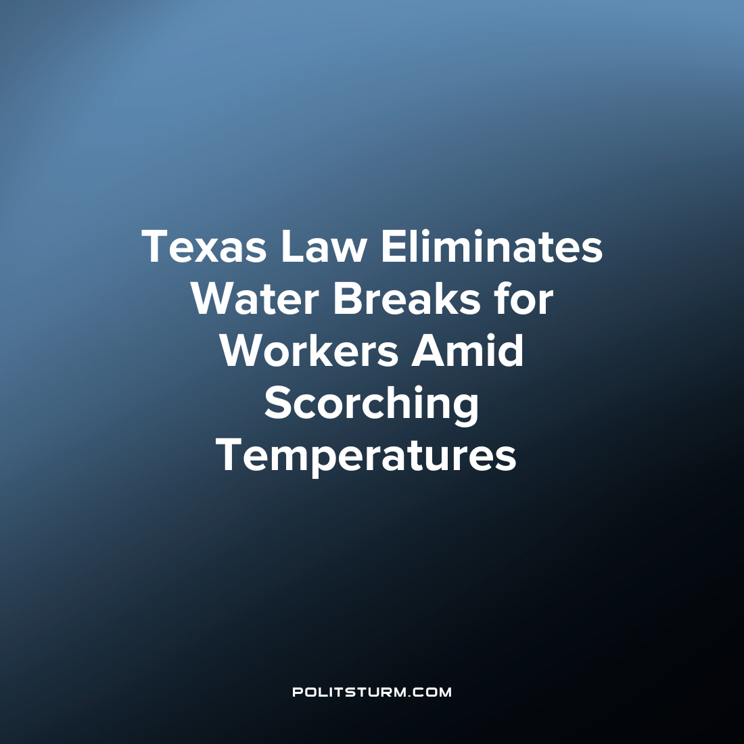

Original article
2023-07-12
1 min read

A new law in Texas, known as the Texas Regulatory Consistency Act, will eliminate mandatory water breaks for construction workers and allow the state to override local government regulations in certain circumstances. The law, signed by Governor Greg Abbott, will take effect on September 1. The new law will nullify municipal codes across Texas, including stricter regulations in cities like Dallas, which require construction workers to take a 10-minute break every four hours.
Texas has a high rate of construction worker fatalities, particularly due to heat-related exposure in the state. Last week, at least 13 people in the state died as a result of the extreme heat. The new law will revert to the water break requirements set by the Occupational Safety and Health Administration (OSHA) which does not have specific minimum water break requirements, as the requirement depends on various factors such as the environment and worker health.
In addition to the impact on water breaks, the Texas law grants the state powers to override local regulations in areas such as agriculture, natural resources, and property. Similar laws exist in other states where state law can trump local regulations if favorable for the employers and at the whim of the state legislators.
The new Texas law shows how the legal system serves the interests of the capitalists, and how “cutting down regulations and red tape” is simply the support of the capitalist class to exploit workers to their heart’s content. Now instead of enforcing mandatory water breaks for construction workers which would amount to 20 minutes over an 8 hour shift, the capitalists can effectively lengthen the working day by 20 minutes per worker. This increases both the relative and absolute exploitation of the workers despite the consequences for worker health which can ultimately mean death under the heat conditions in Texas.
Source: 1

Original article

