Texas Land Seized for Biden Border Wall
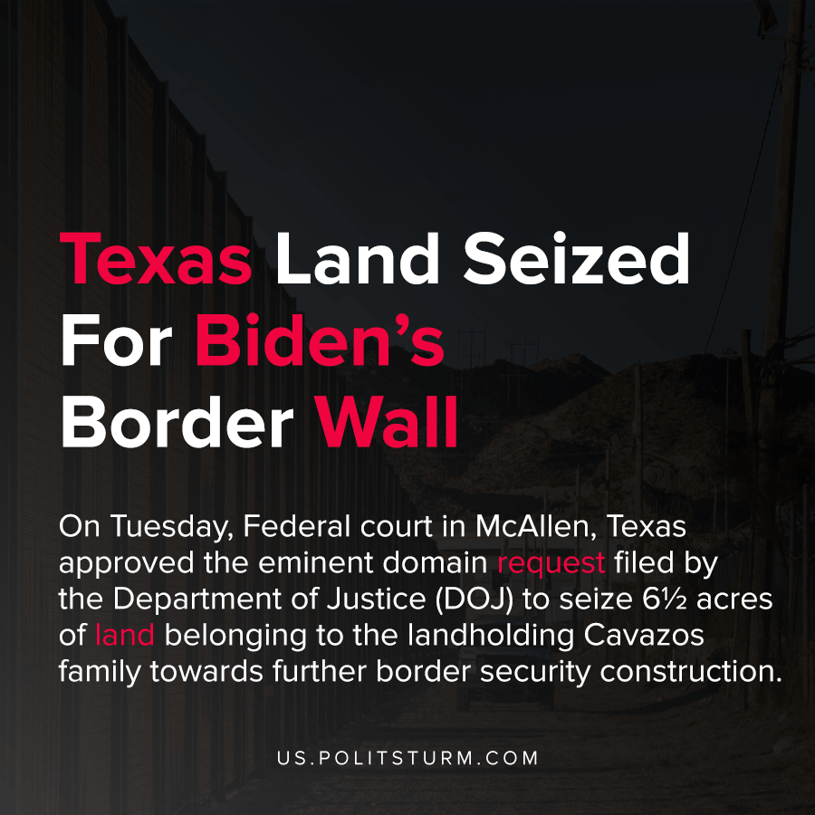

Original article
2021-04-17
1 min read

On Tuesday, Federal court in McAllen, Texas approved the eminent domain request filed by the Department of Justice (DOJ) to seize 6½ acres of land belonging to the landholding Cavazos family towards further border security construction.
In the past few months, complaints by land-owners have grown louder and louder over eminent domain cases that were jammed-in late during the Trump wall expansion project. Many wondered why the appeals for 140 cases of borderland seizures had not been reconsidered in court during Biden’s early order of a 60-day period of review of the DOJ proposals. 23 days after the expiration of this review period, we now see that these borderland seizures will go ahead as usual in Biden’s border policy.

“Taking land from border communities is still a DOJ priority in border wall cases, even in cases where there is no danger, urgent need, or ongoing construction on the tract in question,” said Texas Civil Rights Project attorney Carolyn O’ Connor.
Cases with the wealthy Cavazos family have been a common factor of past presidents, from Trump to Obama to W. Bush, in efforts to consolidate the construction of fortification and surveillance infrastructure across the American border. Since the various Cavazos family holdings control hundreds of acres of land intersecting the border, this minor suit shouldn’t be surprising.
What may also come as little surprise is the fact that Biden is still seeking government land seizure in the process of future border defense construction. Seen in the contexts of earlier border wall expansion proposals indicated by Department of Homeland Security Secretary Anthony Mayorkas, it is clear that the Biden administration’s policy of confirmation for border construction efforts is being led by the recommendations of local border policing agencies.
Source 1, 2

Original article

