Texas Energy Prices Spike During Emergency
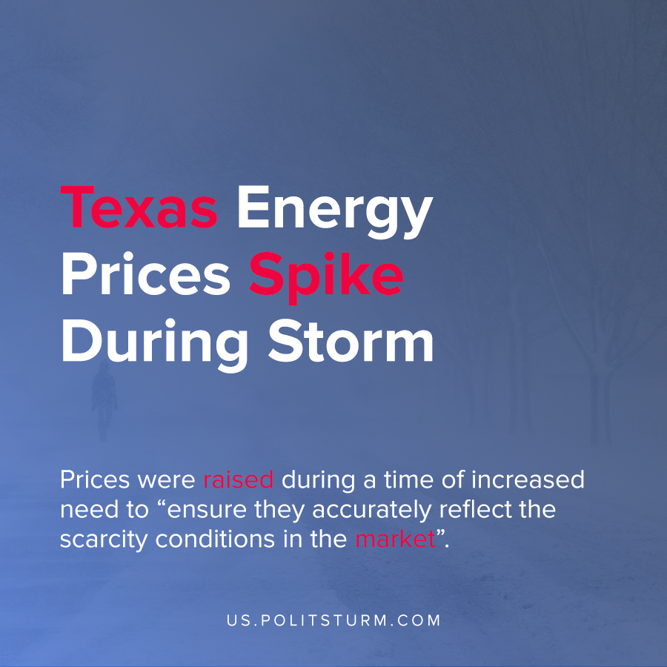

Original article
2021-02-20
1 min read

Texas Governor Greg Abbott recently declared a State of Emergency in response to extreme Winter weather conditions. The cold temperatures triggered an increased need for power consumption.
The Electric Reliability Council of Texas, Inc. (ERCOT) issued an Emergency Energy Alert Level 3, which entailed outages across the state.
In lieu of the extraordinary circumstances, the Public Utilities Commission of Texas convened to discuss what actions should be taken to address the situation. One of the decisions was raising energy prices to reflect the scarcity of the energy supply.
“Energy prices should reflect scarcity of the supply. If customer load is being shed, scarcity is at its maximum, and the market price for the energy needed to serve that load should also be at its highest….adjustments are needed to ERCOT prices to ensure they accurately reflect the scarcity conditions in the market.”
During a time of widespread dysfunction and even loss of life, the logic of the market dictates that energy prices be raised due to the limited supply and large demand. The capitalist system only recognizes the logic of profit maximization and claims that the anarchy of the market will lead to the best results. It is obvious that during freezing temperatures energy is needed to keep warm, yet the logic of the market increases prices and reduces affordability to benefit the private owners of the means of production.
Source: 1 , 2 , 3

Original article

