Tesla Workers Union Files NLRB Complaint as Workers Fired After Unionization Push
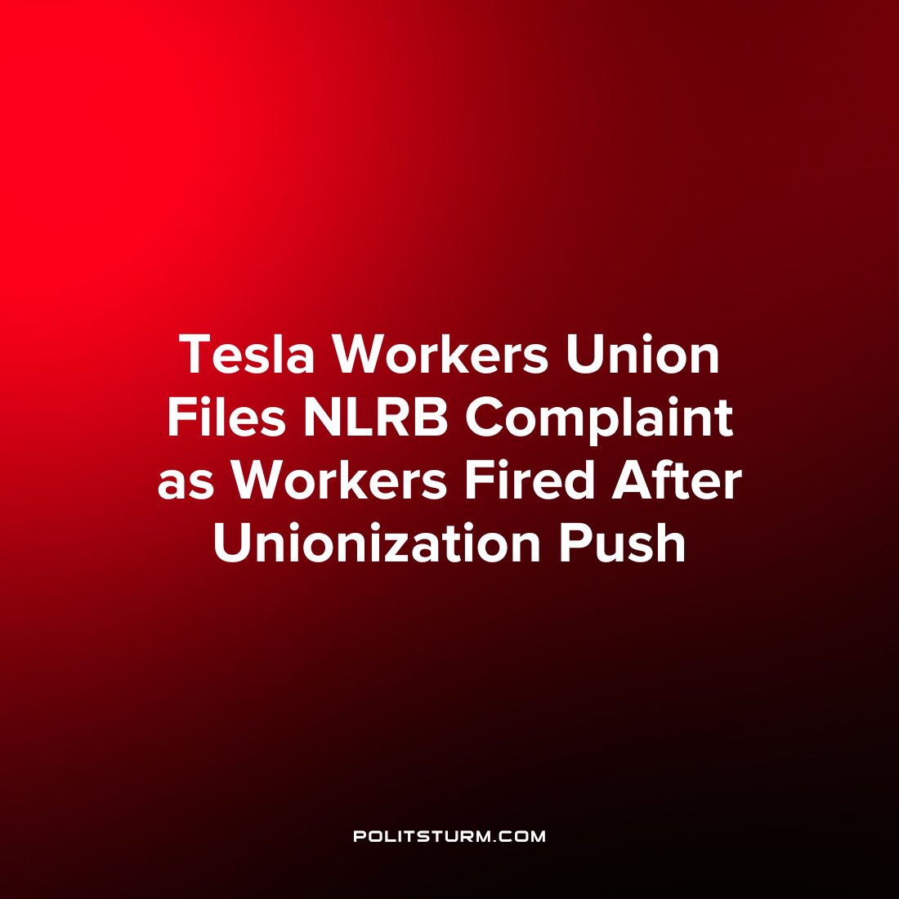

Original article
2023-02-24
1 min read

Employees at the Tesla Gigafactory 2 in Buffalo, New York announced their intentions to unionize citing poor working conditions and a lack of job security. Shortly after the workers announced their intent to form a union, dozens of workers were fired with Tesla citing poor performance reviews as the ultimate cause of the “exits”. Tesla categorized the association with the firings with the unionization campaign as “categorically false”.
“The impacted employees were identified on February 3, 2023, which was well before the union campaign was announced. We became aware of organizing activities approximately 10 days later. We learned in hindsight that one out of the 27 impacted employees officially identified as part of the union campaign. This exercise pre-dated any union campaign’, said Tesla in a related statement.
By contrast, the union has filed a complaint with the National Labor Relations Board alleging that the firings were in retaliation for the unionization drive.
The capitalist class will always push to undermine the unionization of labor or anything that threatens the maximum exploitation of workers and the profit motive. It is commendable that the workers are organizing for the improvement of working conditions. However, in order to truly overcome the exploitation of workers it is necessary for workers to understand Marxism-Leninism to truly understand the essence of the class struggle and ultimately end the exploitation of man by man.
Source: 1 2 3

Original article

