Tesla Plans Mass Layoffs Due to Falling Sales
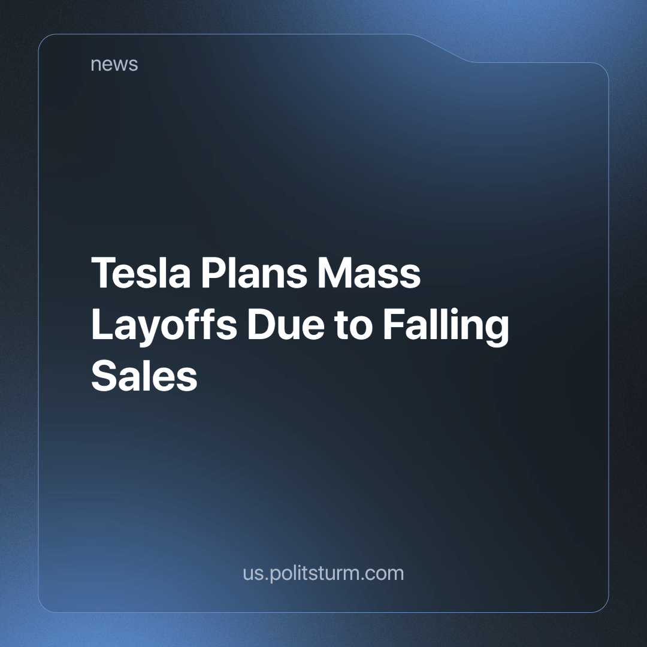

Original article
2024-04-19
2 min read

Tesla plans to reduce its global workforce by 10%, citing "duplication of roles and functions" in certain areas. CEO Elon Musk said in an email to employees that the decision was made after a thorough review of the organisation's performance to improve efficiency, innovation and readiness for the next phase of growth.
The number of employees to be laid off is estimated at 14,000 [1].
In February 2024, managers were asked to assess whether the position of their subordinates was critical. The announcement of the layoffs followed a decline in car sales in the first quarter and a slowdown in demand for electric vehicles. Over the course of the year, Tesla's shares fell 31%, making it the worst performer in the S&P 500 index. Musk decided that the best way to turn things around was to lay off some of the employees [2]. During the last major cut in mid-2022, Tesla also laid off around 10% of its workforce.
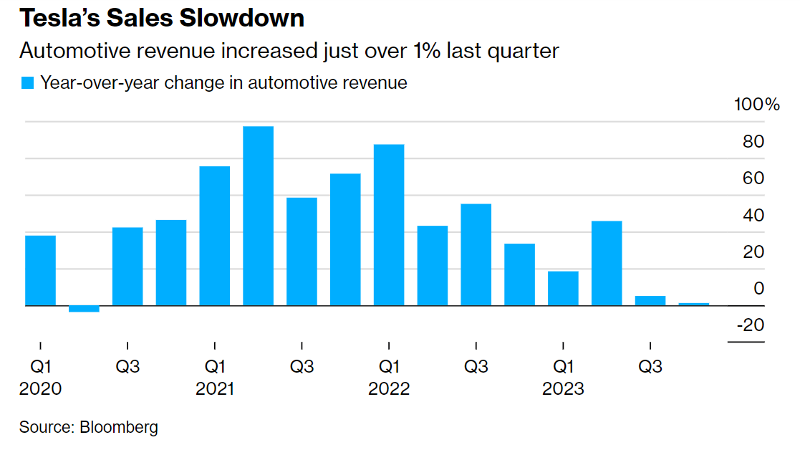
Source: https://www.bloomberg.com/news/articles/2024-02-07/tesla-stokes-layoff-fears-by-asking-whether-jobs-are-critical
The capitalist system clearly shows that even such "geniuses" as Elon Musk and even the biggest corporations do not know what quantity, and what kind of product the market needs at the moment. And capital must grow at all costs, otherwise, a capitalist is doomed to be defeated in the competitive struggle. So they produce whatever they can in the hope of finding a buyer. Because of this anarchy of production, each company in particular, and the world as a whole, experiences crises. These crises mainly affect the poorest sections of the population and the unemployed, to whom the Tesla management is kindly sending ~14,000 new members, depriving them of a stable income. Capitalists easily pass on costs to consumers, and profits are privately owned and spent on luxury goods.
A reasonable alternative to the capitalist mode of production is socialism, where the means of production are owned in common by society and production is planned. Thanks to modern technologies, it is even more possible to calculate the needs of the entire population of the planet and meet the demand for food, housing, education, culture and entertainment for all human beings. But there is a long way to go in the class struggle before this real goal can be achieved. We need to build a communist party to guide the workers to this shared destiny.
Sources: 1, 2

Original article

