Tax Evasion: How Do Capitalists Evade Taxes?
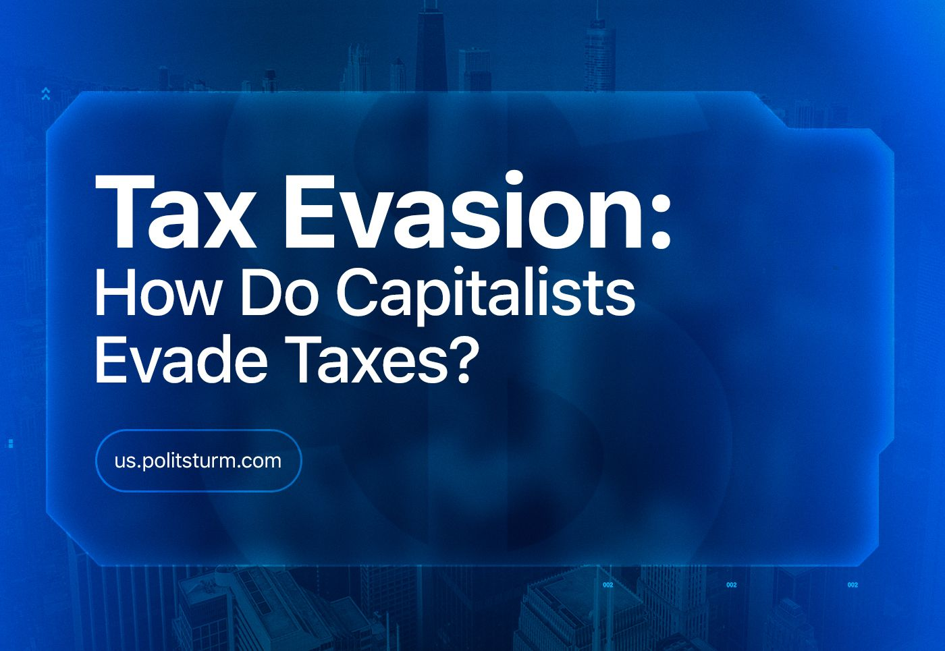

Original article
2024-02-18
14 min read

Tax policy is a fundamental aspect of the capitalist “welfare state”, in particular, taxation of business and the rich stratum of society. The government is often portrayed to workers as a supra-class institution that prioritizes the common good of the society. It involves taxing businesses and wealthy individuals to promote equality and maintain material stability. By redistributing wealth from rich to poor, the state ensures a decent standard of living for the general population.
The reality differs greatly from what is typically described in social science textbooks. Rich and super-rich capitalists, along with the largest transnational corporations, have been evading taxes for decades by hiding billions of dollars in profits from tax authorities.
It is important to consider how much capitalists should pay and how they avoid taxes. What role does the state play in this? And what is the impact it has on society?

I. What should a business pay for?
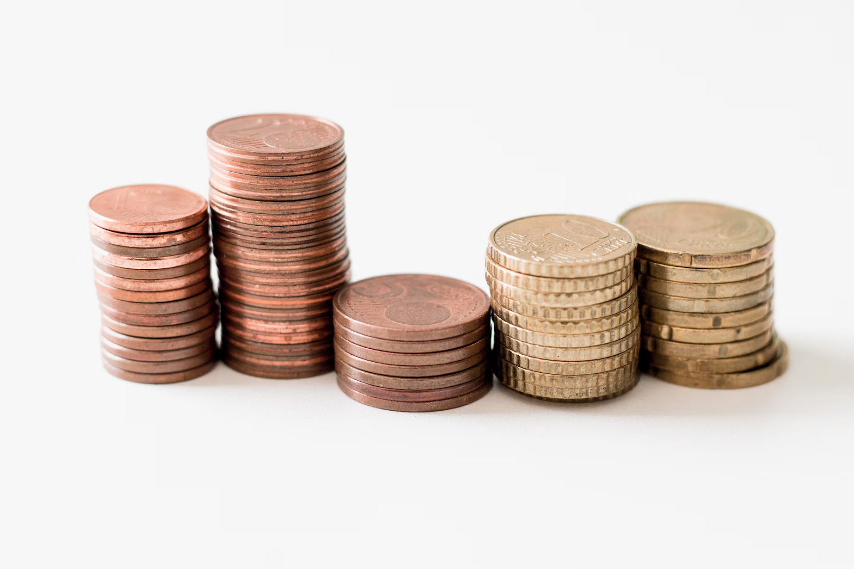
Taxing the wealthy is one of the ways to reduce social tension and class struggle in society.
The taxation system varies between countries as the process of its formation and change has not been the same.Developed capitalist countries, which exploit not only their own workers but also those of other countries, tend to have higher taxes due to their greater wealth. In poorer countries, taxes are often lower, and the taxation system is less efficient. However, it is still possible to identify the main features of taxation and how businesses evade taxes.
In Russia, the corporate income tax rate is 20%, of which 3% goes to the federal budget and 17% to the regional budget. In some cases, the rate paid to the regional budget can be reduced to 12.5%. It turns out that if we take the average and exclude various concessions, a Russian company should pay 15.5 - 20% of its profit [1].
In Germany, the company income tax consists of corporate income tax (15%), solidarity surcharge (5.5%), and trade tax (the rate varies from 7% to 20%). The total tax rate for companies in Germany can range from 22.5% to 35%[2].
In France, the corporate tax rate can vary depending on the company's activity from 15% (small enterprises) to 50% (mining). The basic rate is 33.33% [3].
In Sweden, the basic corporate income tax rate is 21.4%. For non-profit organizations and small enterprises there is a reduced rate, and there are also various exemptions [4].
In the United Kingdom, depending on the amount of profit, a company has to pay from 19% to 30% of its profit. There is also a separate corporate tax on oil production, which amounts to 20% [5].
In China, the corporate income tax is 25%. Low-profit enterprises can pay 20%, and companies in the fields of high technology, biomedicine, and science - 15%. A sole proprietor, depending on income, will have a tax income rate of 5 - 35% [6].
In the United States, the federal corporate income tax is 21% of profits. To this value is also added state corporation tax - depending on the state varies from 2% to 12%. In total, the US corporations must pay from 23 to 33% of the profit (gross income) received on the territory of the USA [7].
To avoid health and social security contributions, Steve Jobs and Larry Page made their official salaries $1. Some, like Carl Icahn, take a $1.2 billion credit, allowing them to reduce their tax rate. Michael Bloomberg, Bill Gates, and Warren Buffett do the same, but through charity activities, which also reduce the taxation rates [8]. The fact that billionaires' charity has a “dark side” is no secret. The media often refers to such activities as "tax evasion competition".
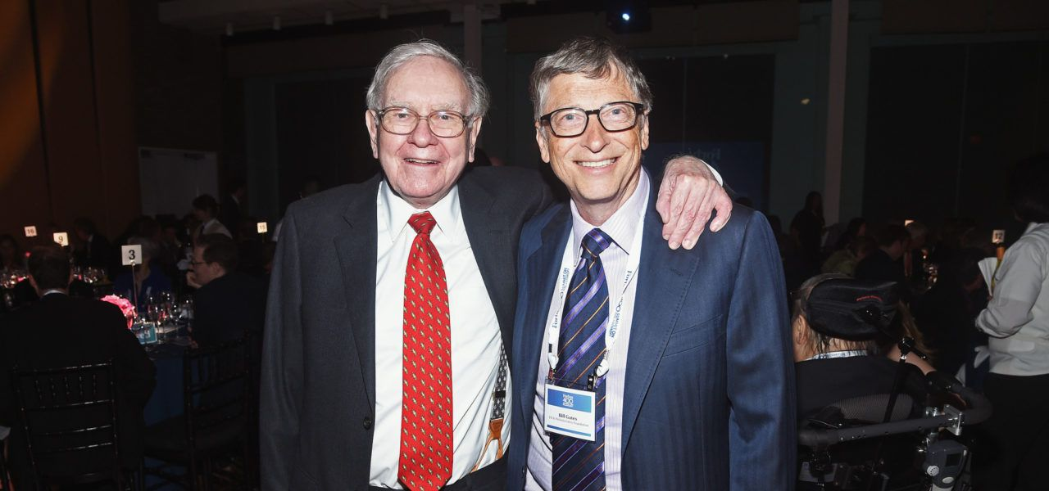
Warren Buffett and Bill Gates
It is clear from the above data that the law obliges capitalists to pay a significant part of their profits in the form of taxes. But from the point of view of capital, this is a cost that it always tries to minimize under the pressure of competition. Not surprisingly, big business has long found ways to avoid or reduce these costs.

ll. How corporations avoid taxes
One of the easiest, most effective, and legal ways for various companies and capitalists to avoid paying taxes is to transfer profits to zones with very low tax rates, the so-called offshore financial center.
“Offshore” is a territory or state with a special preferential tax regime for non-resident companies (with almost zero tax rate), usually provided that their business activities are carried out outside the offshore.
There are more than 80 offshore jurisdictions in the world. In 2010, the total amount of money “invested” in offshore financial centers was between $21 trillion and $32 trillion. Considering that the world's total wealth in that year was $231 trillion, an average of 10% “went offshore” to settle in the accounts of private individuals [9]. By 2021, a quarter of the world's money supply and half of the world's trade was concentrated in offshore financial centers [10].
According to Joe Biden, 91 Fortune 500 companies pay not a dime in federal taxes, while the family of a firefighter or teacher pays 22%. 63% of U.S. corporations' total profits from foreign operations are booked in Bermuda, Ireland, the Netherlands, Switzerland, Singapore, and Luxembourg, with tax rates ranging from 0 to 5% [11].
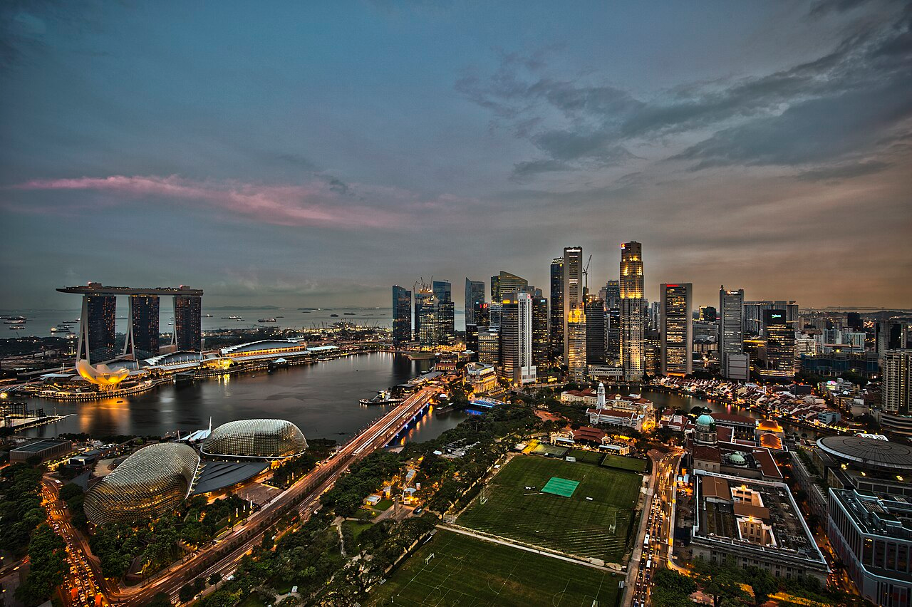
Singapore
Microsoft has 3 regional centers in Ireland, Puerto Rico, and Singapore. The company has an agreement with them to share the costs of research and development in proportion to their share of sales. In fact, these centers are used by Microsoft to avoid taxes in the United States. For example, Microsoft Puerto Rico reported a profit of $4 billion in 2011 and paid a tax of 1.02% on it. In Singapore and Ireland, the tax rate is also significantly lower than in the US - 0.3% and 7.2%, respectively [12].
Microsoft's main competitor, Apple, did a similar thing, transferring the economic rights to use intellectual property to its Irish “subsidiaries” - Apple Sales International and Apple Operations Europe. In this way, the company transferred most of its profits from the US jurisdiction to the Irish one, where in 2009-2011 it received a profit of 38 billion dollars and paid a tax of 21 million dollars, that is, only 0.06%. In total, the American company had $102 billion offshore as of 2013. As CEO Tim Cook pointed out, “We pay all the taxes we owe, to the dollar. We not only comply with the laws, we act in the spirit of the laws,” while omitting details about offshore manipulation [12].
As of 2015, 47% of private companies from the RBC 500 ranking in Russia were registered abroad, of which 75% were registered in Cyprus. The total revenue of companies registered in foreign jurisdictions in 2014 amounted to 23.57 trillion rubles.
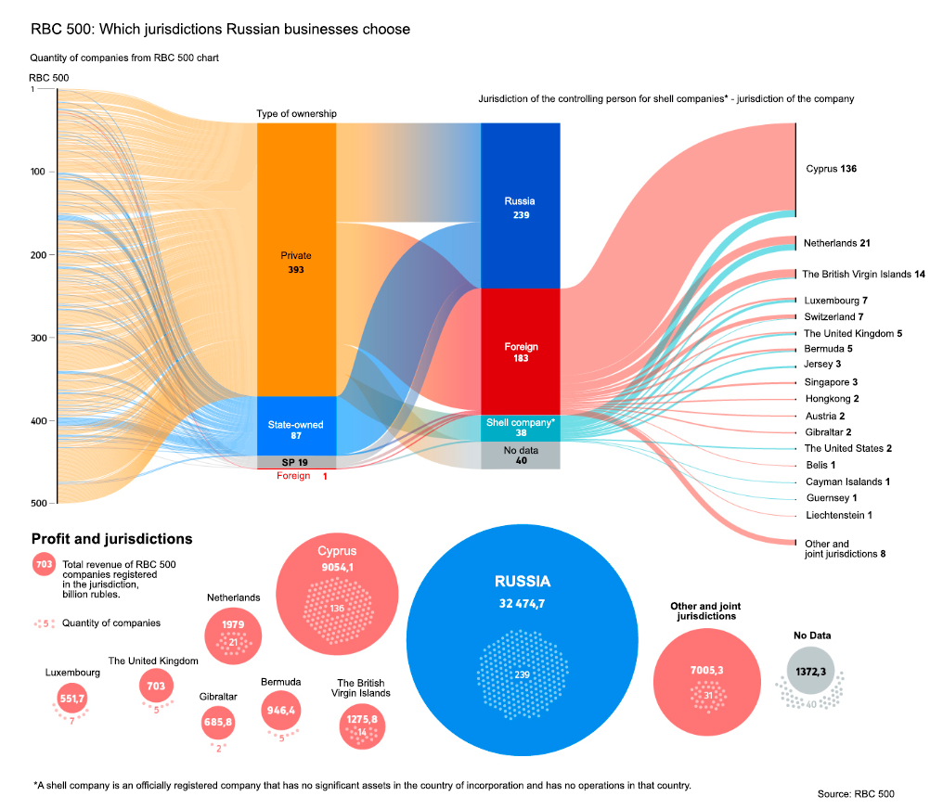
One example is Novolipetsk Steel company, the largest steel plant in Russia. It is owned by the Cypriot company Fletcher Group Holdings Ltd. The Cypriot company Mintha Holding Limited also owns the Magnitogorsk Iron and Steel Works until 2022. UNITED COMPANY RUSAL ALUMINIUM LIMITED, registered in Cyprus, was the owner of Rusal until 2019. For 2021, the Russian company PJSC “MMC Norilsk Nickel” was also registered in Cyprus [10].
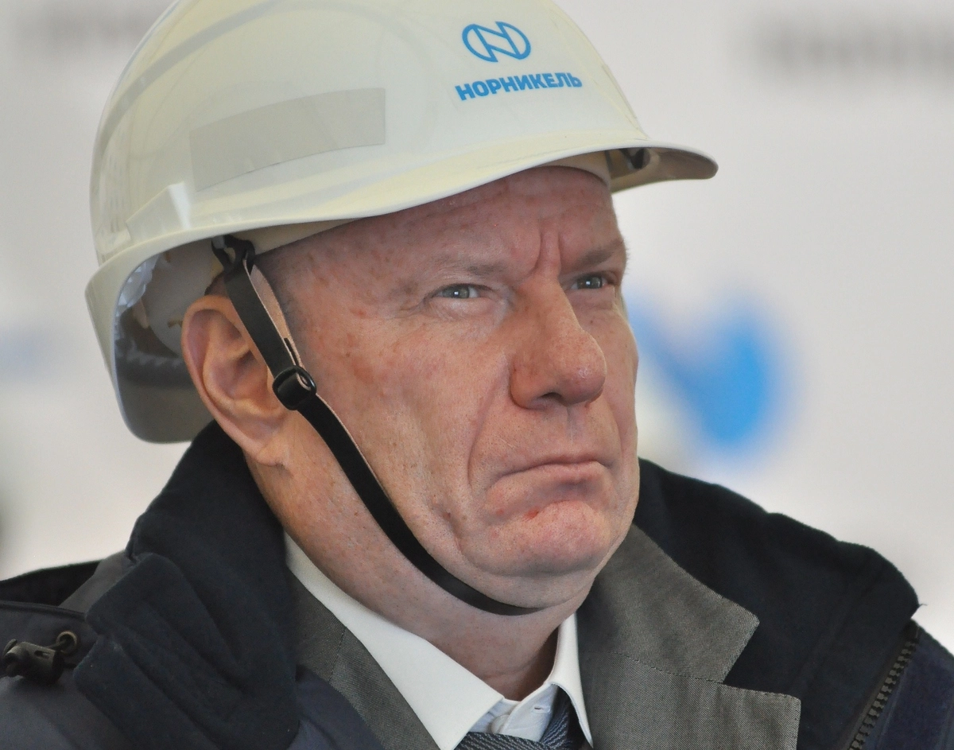
Vladimir Potanin, CEO of “MMC Norilsk NIckel”
The state is well aware of this. A favorite game of politicians aimed at gaining reputation and “political points” is making periodic statements about the irreconcilable struggle against offshorization. Russian President Vladimir Putin is particularly fond of such rhetoric, expressing his readiness to help some oligarchs “entangled in offshore”. But this is nothing more than simple populism.
Chinese companies had $1.2 trillion offshore in 2010 [9]. Such companies as Alibaba, Tencent, and Baidu actively use offshore schemes. 20% of the capital raised by Chinese companies goes offshore, mainly through the Cayman Islands [13]. On the one hand, the PRC fights against Western imperialism; on the other hand, it creates more and more favorable conditions for attracting the same Western capital by creating “free trade ports”. Finally, it pretends to fight against its own big capital.
Formally, the rule of law applies under capitalism. Politicians and bourgeois lawyers hypocritically declare the equality of all citizens before the law, deny the possibility of anyone being above the law, and so on. In fact, we see big business constantly avoiding taxes, bringing assets of billions of dollars into the “shadows”, while government officials just shrug their shoulders at this.
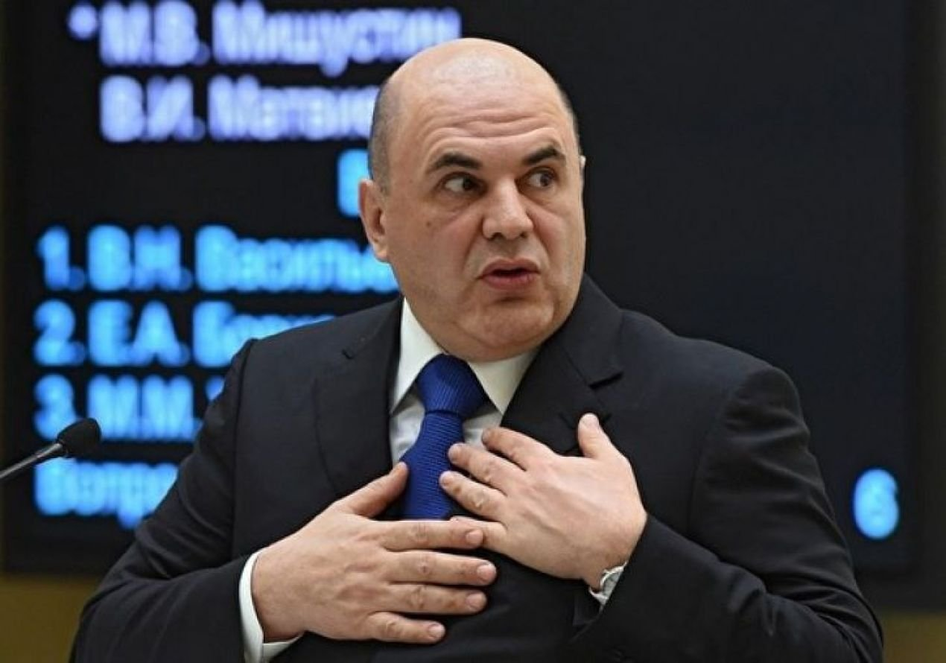
Mikhail Mishustin, Prime Minister of Russia
The state is an instrument of the ruling class, as are the laws it makes. This means that the “rule of law” is, in actuality, the rule of bourgeois law. The entire legal system under capitalism is incredibly harsh on workers, but when it comes to the biggest and most powerful owners, bourgeois laws show astonishing impotence.
Capitalists commit blatant violations of the law. For example, Microsoft owed the state nearly $30 billion between 2004 and 2013. Whether a large transnational corporation, one of the titans of American capitalism, will bear responsibility is a rhetorical question [14]. In the conditions of competition between different capitalist groups, tax evasion is an easy way to gain a competitive advantage in the market, one that is freely used by capitalists.

III. Impact on workers
As was seen in the above statistics, the mass of global capital located offshore has doubled in the last 10 years. This shows that with each passing year, the capitalists are moving away from one of the main principles of the “welfare state” - taxing the rich and super-rich.
The working class creates all of the capitalist's profits with its labor and expects that the state ensures that at least some of those profits go back into society by funding various health and social funds. Instead, the worker gets nothing back because the capitalist took those profits to the notional Canary Islands.
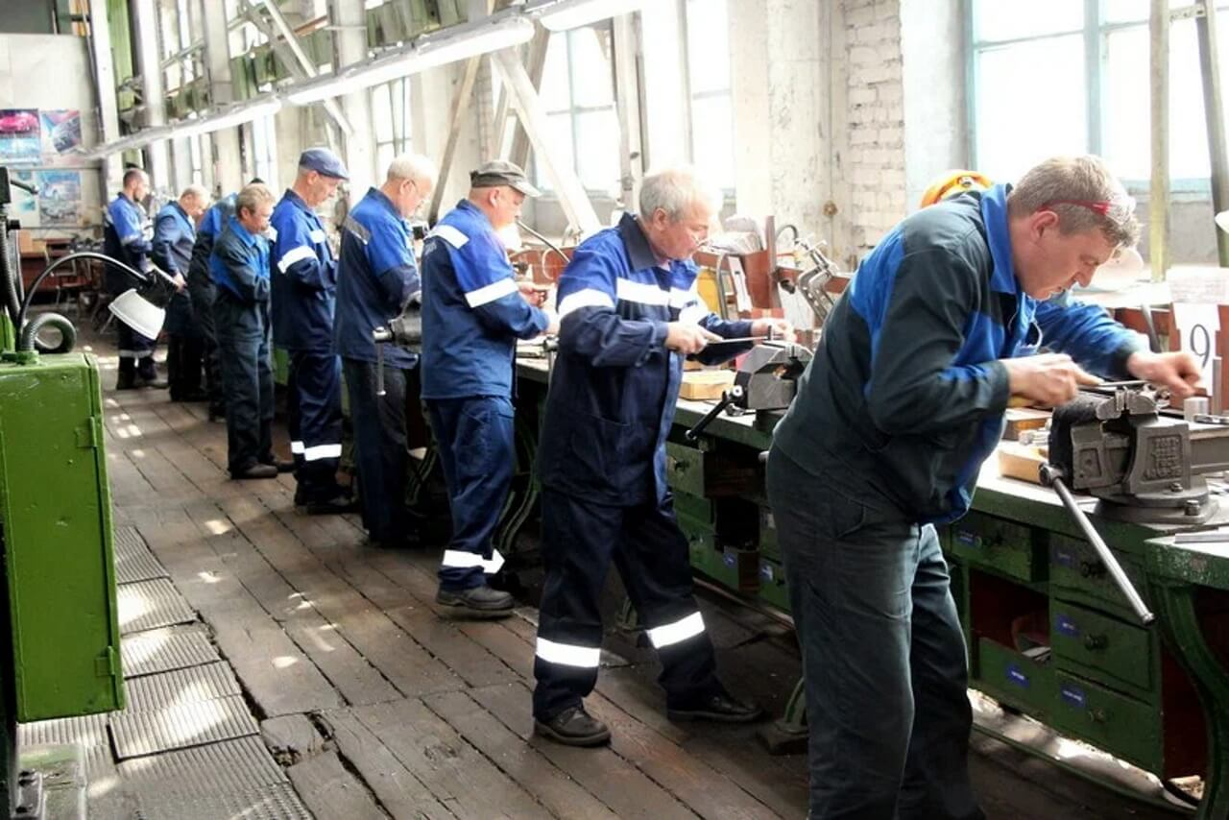
Every year, the concentration of wealth among the rich and super-rich becomes more apparent. Capital is not created out of thin air, but rather the result of thousands of hours of labor by workers worldwide. Unfortunately, workers have not received their fair share. Instead, their access to public goods is shrinking, and their material well-being is declining.
As of 2020, Oxfam reports that the world's richest 1% have accumulated more new wealth than the other 99% of the world's population combined. For every $1 earned by a person from the poorest 90% of the world's population, a billionaire has grown richer by $1.7 million. Only 4% of every dollar of taxes paid is a wealth tax.
Since the start of the pandemic, 1 dollar billionaires have appeared every 26 hours, which is just over 330 per year. Meanwhile, according to UNICEF, before the pandemic, 3.1 million children a year were dying of hunger. One person dies every 4 seconds due to material inequality in the world: from hunger, lack of medical care, or environmental pollution [16].
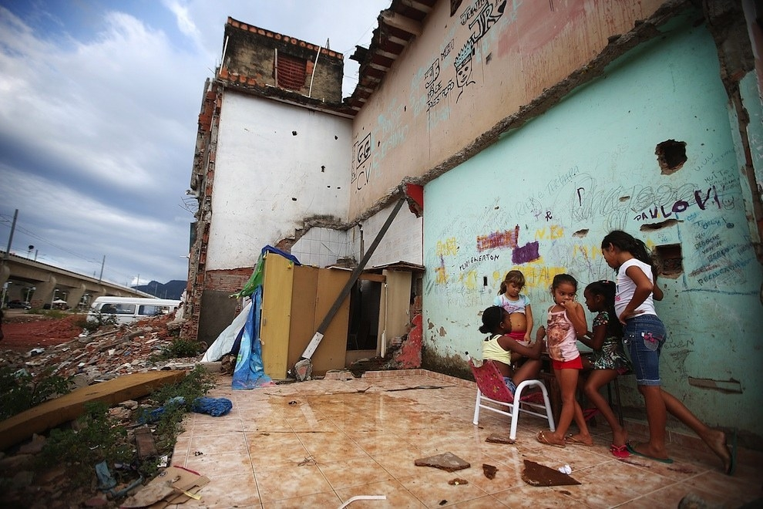
Slums in Brazil, also known as favelas.
Even a 5% increase in the tax rate for billionaires could provide enough funds for the state to lift 2 billion people out of poverty through social subsidies and job creation. It is a quarter of Earth's population.
However, it is clear that such a reform is not feasible under modern capitalism. It is also evident that no tax increase or reformist plan can solve the fundamental contradictions of capitalism. The concentration of wealth in the hands of the largest capitalists is illustrated in this example. As the workers' position deteriorates, the amount of money held by the capitalists continues to grow.
The capitalists' increasing tendency to evade taxes and inflate their offshore accounts demonstrates a steady inclination to dismantle the so-called “welfare state”. The wealth of society, including its material resources and labor, is increasingly concentrated in the hands of millionaires and billionaires. The state, which serves as the executive committee of the ruling class, only feigns opposition to offshoring and tax evasion. While it may occasionally prosecute high-profile cases, the fundamental situation remains unchanged.
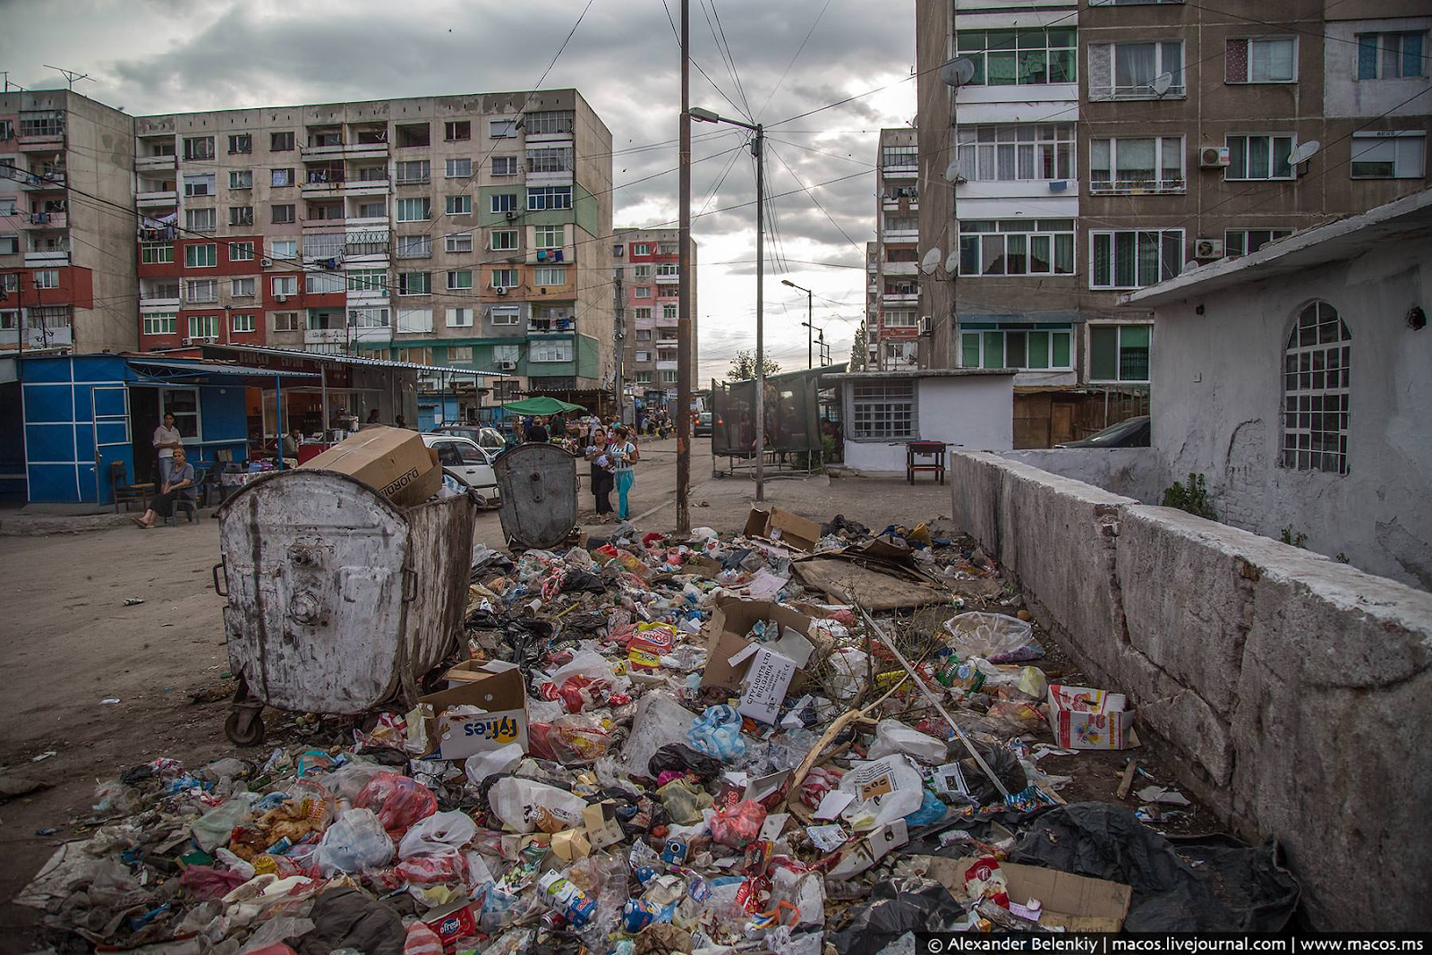
Slums in Russia
The active dismantling of the “welfare state” is evident, and the situation with taxes is just one sign of this phenomenon. As the crisis of capitalism worsens, class contradictions in society will only intensify.

Conclusion
The profit of a capitalist is the result of the workers’ unpaid labor. According to the bourgeois state, a significant portion of this profit must be paid in taxes to fund social policies aimed at reducing class struggle by bribing the working class.
However, it is more profitable for capital to avoid these costs, which it successfully does. A significant portion of society's wealth ends up in the hands of a small group of super-rich individuals.
The increasing trend of tax evasion over the decades highlights the dismantling of the “welfare state” and the deepening crisis of capitalism. The only way to overcome it and build a truly fair society where free labor prevails over corporate interests is through the transition to socialism.

Sources
[1] Official website of Federal Tax Service of Russia
[2] Zakon.ru: Taxation in Germany — dated June 28, 2017.
[3] Klerk.ru: French tax system: how it works — dated November 25, 2022.
[4] JURSITE: Swedish tax system: main taxes and their peculiarities
[5] Vc.ru: Taxes in the UK: benefits for non-resident businesses — dated May 27, 2022.
[6] PRC Tax System — dated 2013.
[7] YB Case: Taxes in the United States — dated March 5, 2023.
[8] ProPublica: The Secret IRS Files: Trove of Never-Before-Seen Records Reveal How the Wealthiest Avoid Income Tax — dated June 8, 2021.
[9] James S. Henry. The price of offshore revisited p. 5, 31 — dated July 2012.
[10] CyberLeninka: Analysis of the global practice of using offshore as an instrument of international tax planning and its impact on the current economic state of Russia — dated 2021.
[11] World Inequality Lab: World inequality report p.264 — dated 2018.
[12] Vedomosti: How Microsoft, Apple and Hewlett-Packard evade taxes — dated May 27, 2013.
[13] Kommersant: Cayman of China — dated February 8, 2023.
[14] RIA Novosti: US authorities count Microsoft $28.9 billion in debt — dated October 12, 2023.
[15] Oxfam: Survival of the richest — dated January 2023.
[16] Oxfam: Inequality kills — dated January 2022.

Original article

