Taiwan: Why China Wants the Island
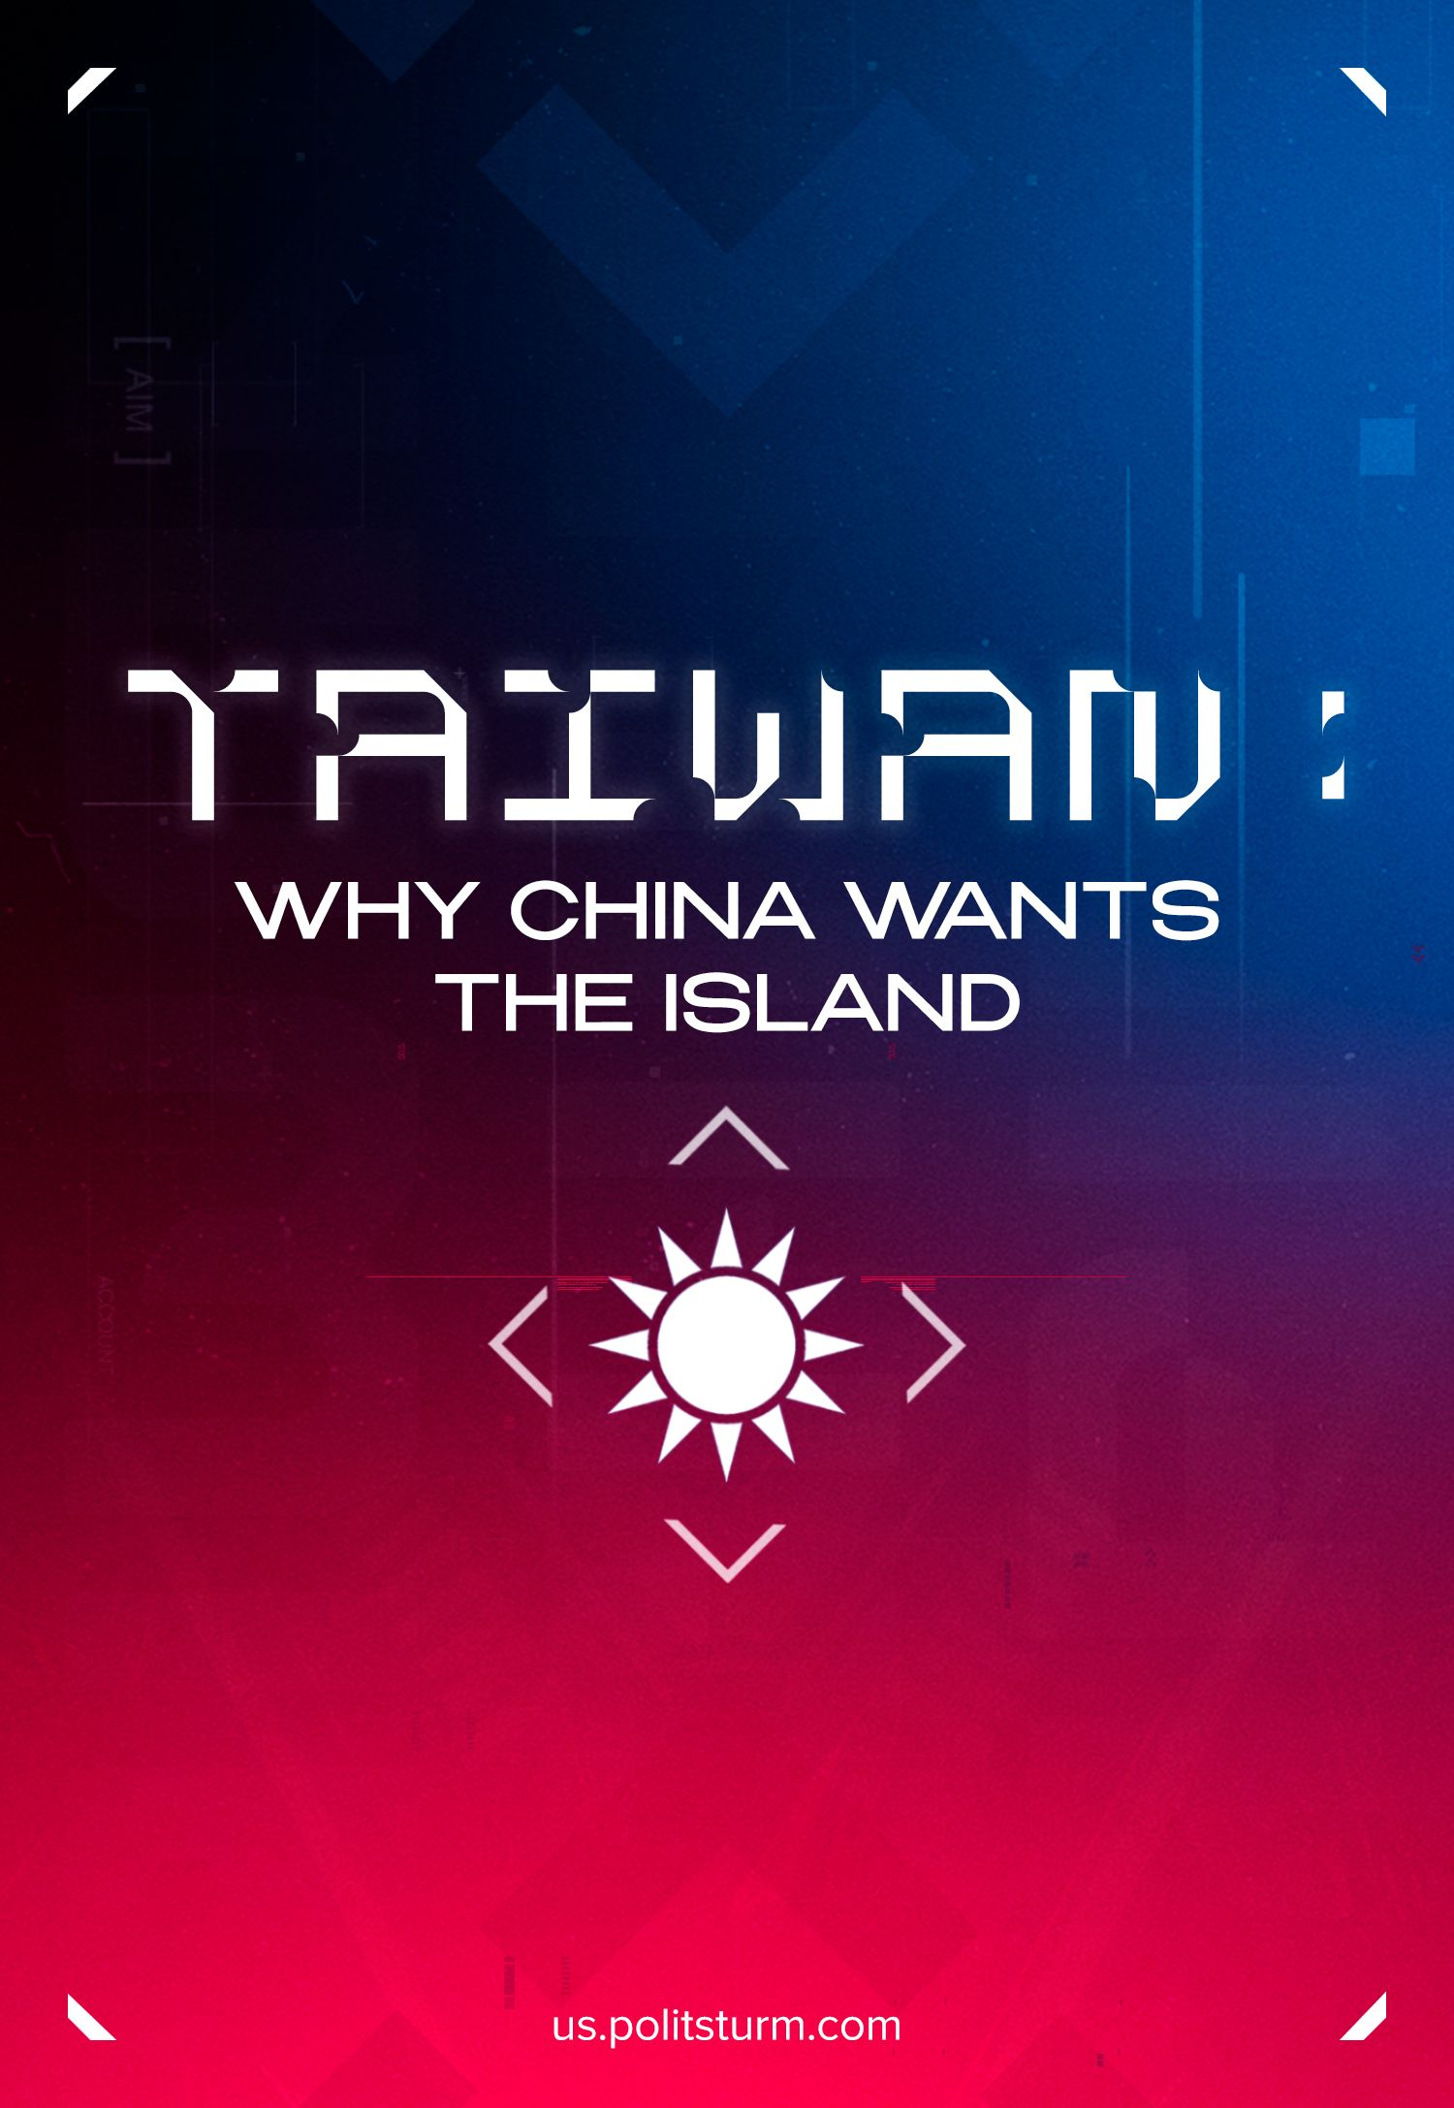

Original article
2024-05-11
23 min read

The debate over Taiwan's ownership has been going on for a long time. Beijing claims ownership of the island, while Taipei insists on its own independence and identity without formally renouncing its rights to own all of China. The "Taiwan issue" has long ceased to be just a territorial dispute between two governments claiming to represent the Chinese nation. Tensions in relations between the PRC and the Republic of China (Taiwan), Nancy Pelosi's visit to the island in 2022, Chinese naval exercises near the island, hostile rhetoric and special attention of Western capital to Taiwan – all this has raised the disputes between Beijing and Taipei to a whole new level. Behind this struggle lies the global competition between Chinese and Western imperialism.
Why is Taiwan so valuable to China and the West? Why does the Chinese capital want to return control of the island, while the US and NATO resist this to the last? Why is the island dispute between the East China Sea and the South China Sea threatening the entire world with a new world war?

History of Division and Confrontation
The PRC and Taiwan (officially the Republic of China) are separate states today. They do not recognize each other, and other great powers take an active part in their confrontation.
The division into mainland China (PRC) and the island government of Taiwan resulted from the Chinese Civil War, which occurred intermittently from 1927 to 1950. The major confrontation was between the right-wing bourgeois party Kuomintang and the Communist Party of China. The long civil war ended in victory for the CPC. By 1950, the Kuomintang armies were defeated, essentially running away in every direction [1] [2].
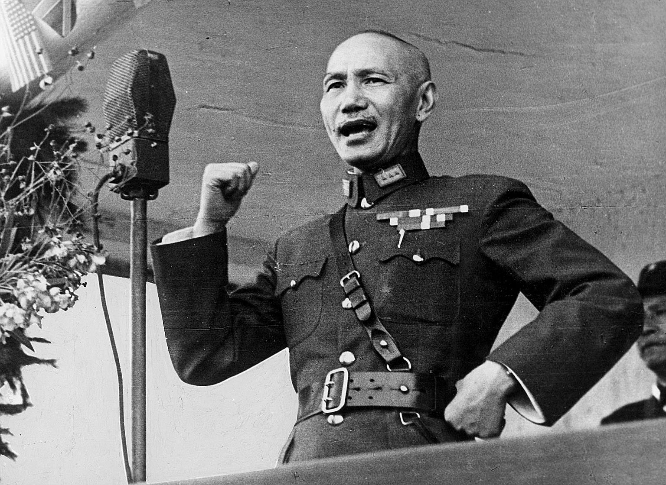
Chiang Kai-shek – President of the Kuomintang from 1925 to 1975.
In April 1949, Kuomintang’s President Chiang Kai-shek ran away to Taiwan, and the remaining Kuomintang troops suffered defeat after defeat. The CPC’s army was rapidly advancing towards Chongqing, where the Kuomintang’s government was. Two days before the Maoists captured Chongqing, the remaining government were evacuated to Taiwan with the help of American planes. In the spring of 1950, the defeat of the Kuomintang’s forces was completed.
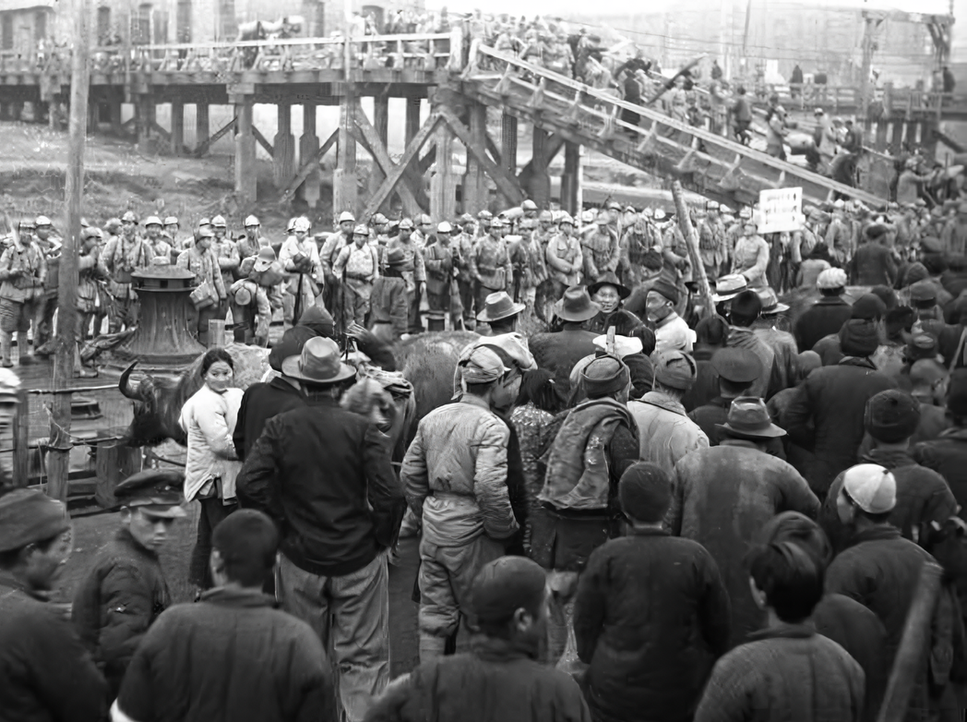
The Kuomintang’s escape
In total, according to current estimates, in the period from 1945 to 1955 from 900 thousand to 1.1 million people migrated to Taiwan – less than 0.2% of the Chinese population in 1955 [3]. The Kuomintang exported more than 100 tons of gold from the continent, which formed the foundation of the Taiwanese economy and government activities. In addition, ancient relics were removed, which are currently located in the Imperial Palace Museum in Taipei. After the retreat to Taiwan, Chiang Kai-shek and other Kuomintang leaders made plans to invade the continent, but the plans never came to fruition.
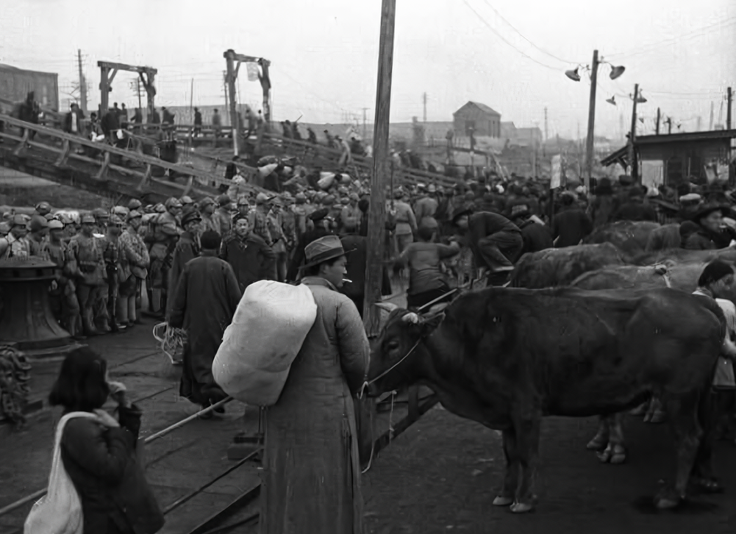
The Kuomintang’s flight
The PRC’s government initially, and to this day, believes that Taiwan is a part of its territory, which must ultimately be annexed to mainland China. The softening of the position and the recognition of Taiwan's special status, which occurred over time, PRC was presented as a temporary measure. At the same time, Taiwan has not given up its rights to mainland China and has long positioned itself as the true government of China.
Until the 1970s The Republic of China (Taiwan) was recognized by the majority of states and international organizations as the legitimate authority of all China, but the republic gradually lost international recognition. In 1971, her place in the UN Security Council was transferred to the PRC. Taiwan maintains official diplomatic relations with only 13 UN member states, and de facto relations with most countries of the world through unofficial representative offices.
Since the separation of Taiwan from mainland China, three serious military and political crises have occurred.
The first Taiwan Strait crisis was 1954-1955. The conflict began when the Kuomintang increased its military presence on the disputed islands: Yijiangshan, Dachen, Jinmen and others.
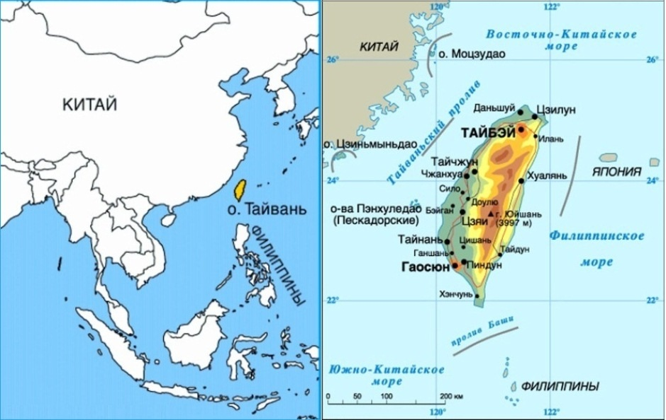
In response to Taiwan's military expansion, the People’s Liberation Army (PLA) launched artillery and air strikes on the Kuomintang’s military infrastructure and even carried out landing operations on several islands. The United States took an active part in the conflict - US and Taiwanese aircraft carried out more than 2 thousand combat flights over the disputed islands. Ultimately, despite US assistance, Kuomintang troops abandoned Dachen Island and its neighbouring islands, which were located close to the mainland and relatively far from Taiwan.
Second Taiwan Strait Crisis 1958.
Three years later, a new conflict broke out, again over disputed island groups located off the coast of mainland China but de facto controlled by Taiwan. The conflict was not large-scale, it consisted of exchanges of artillery strikes and air battles. The conflict has caused renewed tension between the US and China. President Eisenhower warned that the United States would not back down "in the face of armed aggression". After demonstrating the US readiness to enter the conflict, negotiations were resumed and the crisis ended [5].
The third crisis in the Taiwan Strait of 1995–1996.
At the moment in the next and the last time in the region, tension increased sharply at the end of the 20th century. In 1995, the president of Taiwan, Li Denghui, made a private visit to the United States, which was protested by the PRC leadership.
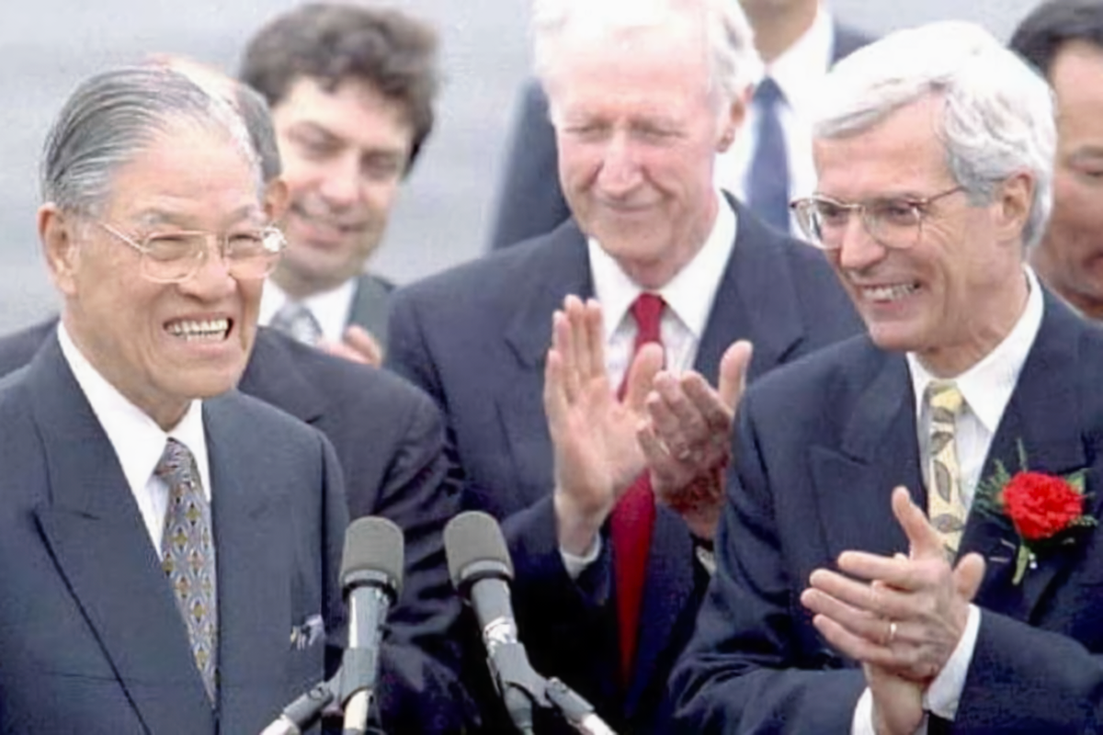
President of Taiwan Li Denghui (left) in the United States, 1995.
The purpose of Li Denghui's trip to the United States was to achieve greater international recognition of Taiwan as an independent country. The leadership of the PRC perceived this policy as a direct challenge to the "One China Policy" and "One country, Two systems" principles, according to which Taiwan is part of the People's Republic of China.
China's armed forces carried out several series of training launches of combat missiles and naval maneuvers in the immediate vicinity of the territory controlled by Taiwan, which was considered by the Kuomintang as pressure from the PRC. In March 1996, US President Bill Clinton decided to send two aircraft carrier groups to the Taiwan Strait area. After their arrival, the Beijing government was forced to take steps to de-escalate the conflict. The leadership of the PRC sent a request through diplomatic channels to the US requesting for them not to enter warships directly into the Taiwan Strait.
The American administration officially responded that it would not accept any obligations that could limit its actions in support of Taiwan. But the American warships did not enter the strait, remaining in the immediate vicinity of it. At the same time, Taiwan's ambitions for international recognition did not meet with support. Tensions over the Taiwan issue have gradually decreased and relations between the PRC and the US have improved. This became the latest outbreak of tension in the region. The situation in the region was pacified for almost 25 years.

Territorial Claims
In the first years after the end of the civil war, the CPC was going to annex Taiwan by any means, even militarily. However, the US support of the island government did not allow this to happen.
In the early 1980s, the de facto leader of the CPC, Deng Xiaoping, put forward the concept of "One Country, Two Systems". According to it, there is only one China – the People's Republic of China. Moreover, territories such as Hong Kong, Macau and Taiwan may have their own economic and political systems (of a capitalist nature), while the rest of China supposedly has a "socialist" system. The "One Country, Two Systems" policy was aimed at reducing tension so that it would not stop the development of China’s economic relations with the capitalist world, paving the way for intensive market transformations during Deng Xiaoping’s administration.
A variation of the "One Country, Two Systems" idea is the so-called "One China Policy", the essence of which is that mainland China and Taiwan are part of a unified China. This principle is supported by some circles of power in both the PRC and Taiwan. But the nuance is that each side sees itself as the only legitimate government of China.
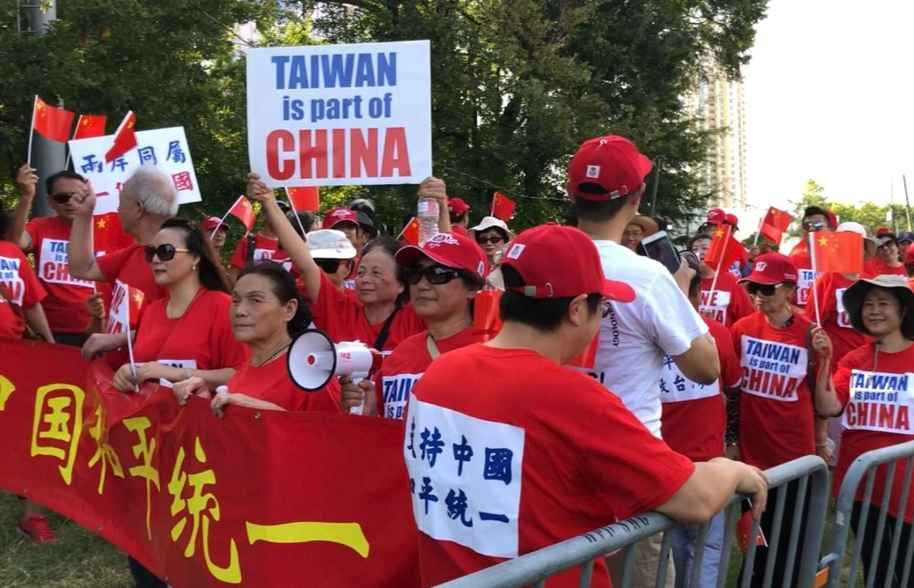
There is also a Taiwan independence movement, which aims to proclaim the "Republic of Taiwan" and develop a separate identity from mainland China through "Taiwanization". This approach contradicts both the "One China Policy" and the principle of "One Country, Two Systems".
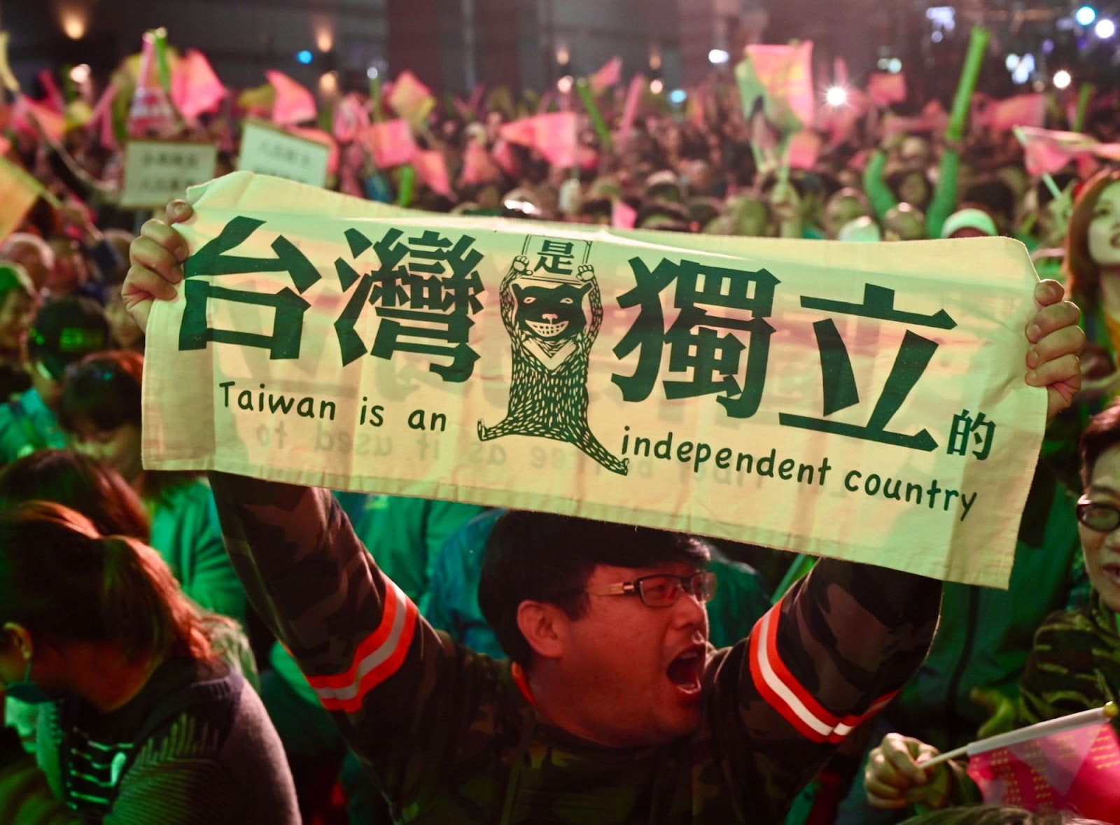
The President of Taiwan from 1988 to 2000, Lee Teng-hui, was a representative of the independence movement. The course pursued by Denghui to internationally recognize Taiwan as a separate country caused a crisis. And in 2008, another Taiwanese president, Ma Ying-jeou, repeated his claims to mainland China.
The "One Country, Two Systems'' and "One China Policy'' approaches do not eliminate the causes of crises and give China a formal reason to escalate the conflict in the future. The situation may develop unpredictably; at any moment, the PRC may try to annex the islands. In this sense, the situation is somewhat similar to the period before WWI and WWII: at that time the opposing sides also had territorial claims to each other, which became the formal reason for the war. For example, WWII in Europe began with Germany's demands for Poland to return part of the former eastern territories of Germany, the so-called "Polish Corridor" and Danzig.
The next round of escalation began in the summer of 2022, when the US speaker, Nancy Pelosi, arrived in Taiwan on an official visit.
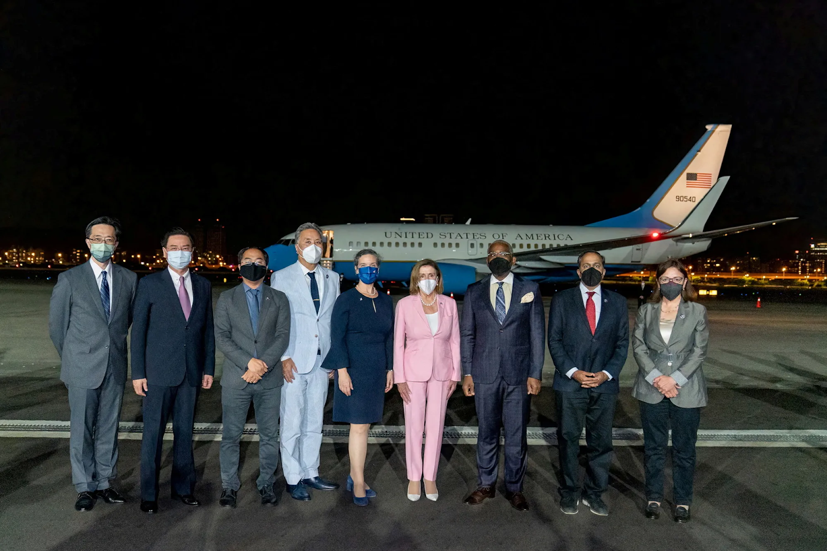
Nancy Pelosi meets with Taiwan's Foreign Minister Joseph Wu
Delegations of US politicians have visited Taiwan before, but it was in private. This time, however, it was done as an official international event. Since the PRC considers Taiwan a part of its territory, the Chinese authorities reacted sharply negatively to the visit.
The PRC perceives the official visit of American politicians as a challenge and a rejection of the restraining approach of "One Country, Two Systems". In this case, Taiwan acts as a separate subject of world politics from China, which causes a reaction from the CPC.
Even before the arrival of Pelosi, the air force and navy of China and Taiwan were put on alert. China carried out missile firing training near Taiwan's territorial waters, and Pelosi's plane was accompanied by combat aircraft and the US Navy.
There were no open military conflicts; the opposite sides limited themselves to a demonstration of armed force. Military activities continued despite the end of Pelosi's visit. China continues to conduct military exercises to close international waterways around Taiwan and potentially occupy other islands. The US has responded by sending officials and military forces to Taiwan – an island that China considers its territory.
Both sides are trying to upset the delicate balance in their favor, but they are still negotiating. In 2023, the tension did not subside, which was facilitated by both sides – the US continues to supply arms to Taiwan, turning the island, as the Chinese Defense Ministry commented, into a "powder keg". China, in turn, regularly conducts military exercises around the island.
In his New Year's address on December 31, 2023, Xi Jinping said:
"The reunification of the motherland is a historical necessity. Compatriots on both sides of the [Taiwan] straits must join hands and share the great glory of national rejuvenation".
The PRC leadership constantly uses the "One China Policy" to oppose and push back against Western influence in Taiwan. An unresolved territorial dispute is a constant, understandable and compelling reason for war with Taiwan and its patrons. As far as the US and the European Union are concerned, this dispute is a clear explanation of why "you can't stand by and watch".

Economic Interests
The wealth and gold exported by the Kuomintang from mainland China provided a strong starting foundation for the development of Taiwan's economy. The 1953 land reform gave a start to industrialization. It was modelled on Japan's 1946 agrarian reform.
As in Japan, the American economist Wolf Ladejinsky played a crucial role in the reforms. The state forcibly bought the land from large landowners and gave it to the peasants in long-term installments. As a result, the former landowners acquired capital, which they invested in the development of industry. US aid played a huge role in the rise of Taiwan's economy, accounting for more than 30% of domestic investment from 1951 to 1962.
As a result of economic growth, American financial support for the island was reduced in 1970. In the 1960–1970s Taiwan's GDP growth averaged about 10% annually, in 1981–1995 the economy grew at an average of 7.5%. By the 1980s Taiwan set a course for “openness” in the economy, and privatization of state-owned enterprises was carried out. This course became possible due to the fact that capital within Taiwan had reached a high level of concentration and was already exploding outside the island.
In the 21st century, the island is fully integrated into the global capitalist system, which was consolidated by Taiwan's accession to the WTO in 2001. The island's economy follows general global trends and does not have outstanding growth rates. In the crisis year of 2008, Taiwan's GDP growth was only 0.7%, and there was a 2.5% decline in 2009. After a recovery growth of 10.6% in 2010, the development rate has fallen to 1-3% per year, which is in line with the global trend.
Taiwan plays a special role in the world economy due to the production of semiconductors and microelectronics – the basis of modern technology. Semiconductors are the key components of electronics – memory chips and microprocessors. They are used everywhere – in computers, smartphones, household appliances, transportation, measuring equipment, construction equipment, industrial equipment, medical equipment, communication equipment, etc. Modern industry, accounting, planning, medicine and science are unthinkable without microelectronics. In fact, it can be said that the entire modern world economy – especially its financial side – is built on this technology. In fact we have previously written about the Microchips Arms Race.
The island is home to the world flagship of the semiconductor industry – TSMC (Taiwan Semiconductor Manufacturing Company). It has a huge share of the global semiconductor market: 52.1%. Another Taiwanese company, UMC (United Microelectronics Corporation), holds another 7%.
Other Taiwanese microelectronics companies include Asus, Gigabyte, Foxconn, HTC, D-Link, Zyxel, Billion Electric, MediaTek, AU Optronics, and Quanta Computer.
The whole world uses high-tech products made in Taiwan and China is no exception. In the structure of Taiwan's imports to China, machinery and electronics occupy first place - 64.7%. In 2023 the PRC imported a total of 479.5 billion chips worth $349.4 billion. For comparison, during the same year, the PRC spent $337.5 billion on crude oil imports.
Since semiconductor chips and microelectronics produced mainly in Taiwan play an important role in modern technology, dependence on them puts the PRC in an extremely precarious position. After all, if a conflict develops or relations with the US escalate, access to the technology will be stopped. Therefore, China seeks to develop its own production of the necessary products.
In pursuit of technological independence, China annually increases its own production and develops new technologies. For example, in 2023, China imported 10.8% fewer chips compared to 2022. However, the volume of imports of high-tech products remains high. Imported equipment is still required for domestic production, and the lag from advanced standards is several years.
Taiwan is also of common economic interest to China. Despite the lack of diplomatic relations and formal confrontation, China is the most important economic partner for Taiwan.
Taiwan’s private investment in China is roughly equal to Taiwan’s investment in the rest of Southeast Asia. Many large Taiwanese companies in high-tech industries, such as TSMC, have factories in China.
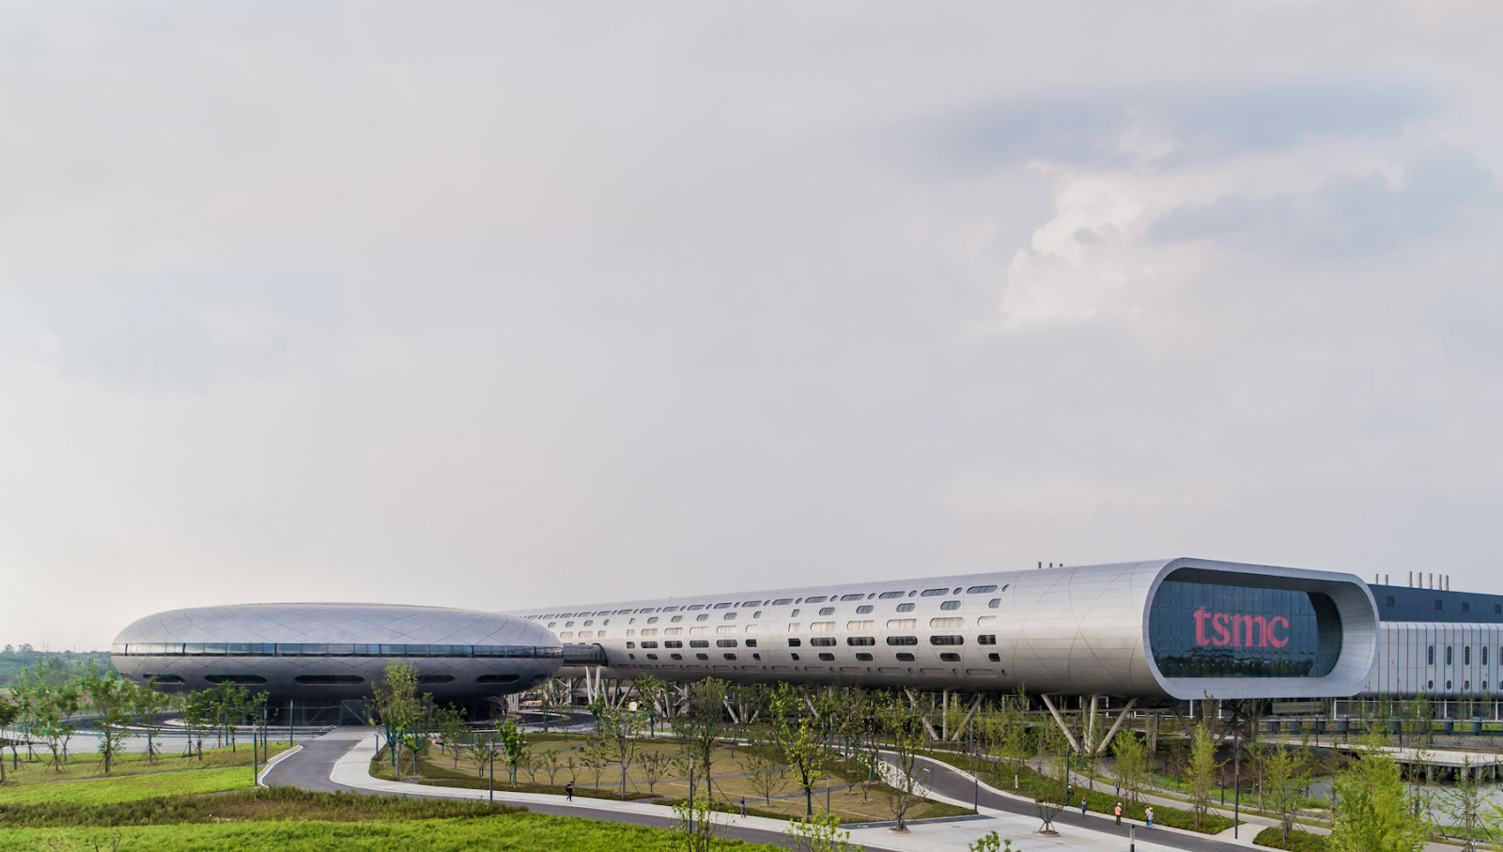
TSMC factory in Nanjing, eastern China
Imports from the PRC to Taiwan rank first with a 22% share in the structure of imports to the island, and Taiwan's exports to Southeast Asia were even greater than to the US - they amounted to $70.25 billion compared to $65.7 billion in 202.
Since 2021, there has been a decline in Taiwanese investments in the economy of mainland China: -1% in 2021 and -14% in 2022, which is in line with the global trend of dividing economies into two camps. After Nancy Pelosi's visit, China decided to reduce trade relations with Taiwan - in particular, the PRC stopped the supply of natural silicon to the island and banned the sale of food products from more than 100 Taiwanese brands.
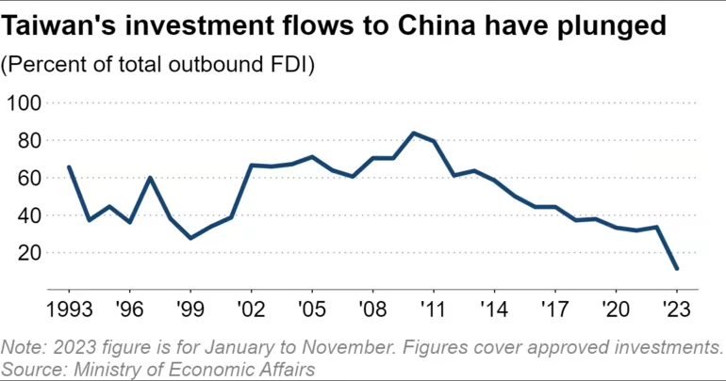
At the same time, Taiwan's exports to China account for 40% of Taiwan's exports to all countries, which indicates mutual dependence. Taiwan cannot declare an embargo on its own. But in case of pressure and support from outside, for example from the US, stopping the export of high-tech products is quite possible, which is what Beijing fears.
Implementation of the "One China Policy", as this principle is interpreted in Beijing, i.e. establishing control over Taiwan, would strengthen its own economy, get rid of dependence and significantly strengthen its own position in the world market and political arena.
Thus, it can be argued that Taiwan is the highest economic priority target for China’s large capital and political elites. The lack of control over the island poses an existential threat to the PRC, as control of the island becomes the key to defeating the US in the struggle for hegemony in the imperialist system.

Political Challenges
Taiwan is located in southeastern China, 160 km from the mainland. The continent and the island divide the Taiwan Strait, 400 km long. China's long coastline allows ships to access the ocean both from the south of Taiwan, through the South China Sea, and from the north, through the East China Sea. However, control of the island and adjacent archipelagos would allow China to move the territorial waters boundary away from much of the continent's coastline and make the strait an internal waters.
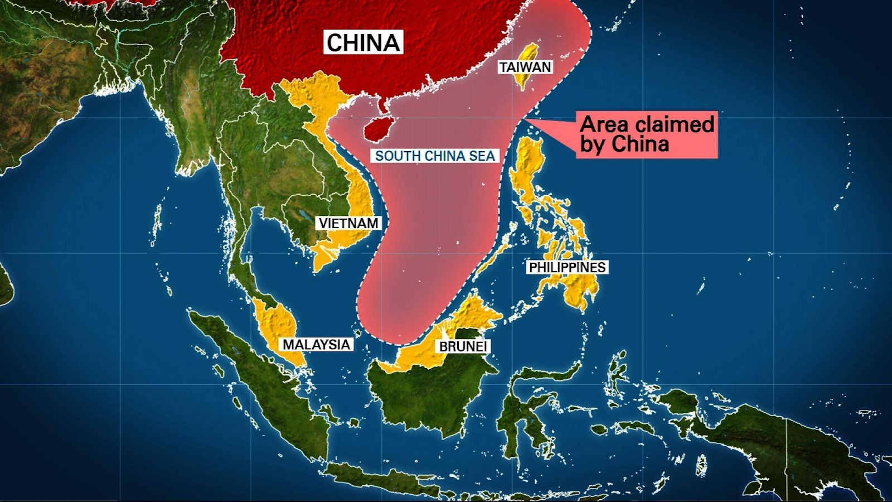
The PRC is particularly concerned about Taiwan's cooperation with the US and military assistance to the island. Taiwan is actually a US ally, an outpost of American capital in close proximity to China. With the support of the American military-industrial complex, the island poses a powerful military threat to mainland China. The close location of Taiwan makes it possible to strike deep into Chinese territory against key military, industrial and infrastructure facilities of China.
A successful missile or air attack could either cause significant damage to China or completely paralyze the country. It would be enough to strike dams and water channels, the destruction of which would provoke a monstrous flooding of the key rivers Huang He and Yangtze. Obviously, such an acute military threat worries the Chinese government.
For the PRC ruling class and political elite, Taiwan's situation is a constant irritant. China considers Taiwan a part of China, but in fact, it is an independent state from China, which is contrary to PRC state propaganda. The return of Taiwan would strengthen the power and reputation of the CPC and specifically Xi Jinping (a representative of the PRC's monopolistic oligarchy) as the "Helmsman of the Chinese Renaissance" who has put into practice the slogan of "One China".
There is reason to believe that in order to establish control over the island, the imperialist groups of the PRC allowed Xi Jinping to break the informal tradition that has been in effect since the time of Deng Xiaoping – the so-called "cishan basia" rule: the age limit of 68 years for party officials which they can hold party positions. Xi’s re-election to a 3rd term as CPC General Secretary occurred when he turned 69 years old and broke a rule that had been in effect for several decades.
China and Xi Jinping are using every possible means to regain control of Taiwan. For many years, the PRC has pursued a policy of developing trade relations with Taiwan, opening up to investment, and increasing imports and exports. Beijing promoted economic integration with Taipei in order to pursue political integration later; reunification with Taiwan, effectively incorporating the island.
Formally, Chinese politicians declare the goal of “peaceful reunification,” but the conduct of military exercises around Taiwan, the general growth of militaristic hysteria and threats of interfering in the island's affairs demonstrate readiness for non-peaceful solutions. In the case of increased US dominance in the region, the loss of the possibility of reunification would be a serious blow to the CPC's authority and would shake the position of the entire current party and official grouping in the PRC.
In turn, the US is obviously not going to give up Taiwan so easily, since a huge amount of capital has been invested in the island. For American capital, Taiwan is an important business project, a key military base that must generate profit, and it cannot be given to its international "partners" from mainland China.
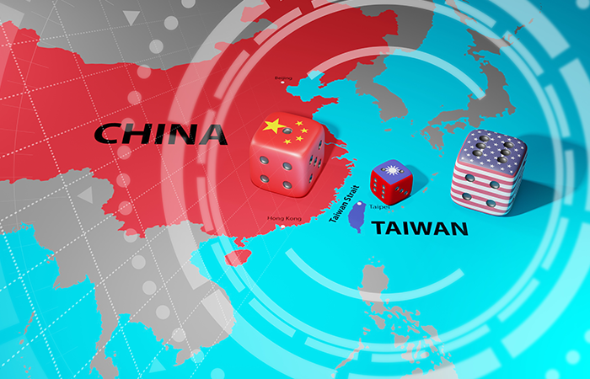
Another reason for the US interest is the possibility of provoking an internal political crisis in China. Taiwan still officially calls itself the Republic of China and claims authority over all of China. If a serious political crisis occurs on the mainland and the position of the dominant capital group in China weakens, the United States can promote the "reunification" of Taiwan with China with the establishment of a loyal government.
At the same time, the transfer of Taiwan to Chinese control would result in serious reputational losses for the US. The loss of such a significant and dependent ally, located near its main competitor, would significantly undermine Washington's authority. When it brings benefits from an economic, military and political point of view, the US and NATO will discourage Chinese aggression against Taiwan, and support the status quo or a formal declaration of independence.
Like Taiwan's economic situation, politically the island has become similarly intertwined with the interests of competing groups of imperialist capital. Control of the island has become the main point of the program of both sides, it provides great political benefits in case of success and terrible losses in case of defeat.
Political and economic value makes Taiwan too desirable a prize to retreat without a fight.

Conclusion
The loud slogan "One China" – the territorial claims by the PRC – is only a pretext for resolving economic and military issues: liberation from technological dependence and getting rid of the threat of a nearby US outpost. Resolving these issues would be very beneficial for the CPC, would strengthen its power and increase its authority.
In the international confrontation, there are many points of tension such as Taiwan, the contradictions of the capitalist system everywhere are constantly pushing governments to redistribute spheres of influence, markets and sources of resources by aggressive economic and military methods.
It should be remembered that the crisis in the Taiwan Strait, which could lead to a major war, is just a pretext. The reason for any new round of military clashes lies in the very essence of the capitalist system. It is not just the struggle for land and political prestige that leads competing parties to war with each other – but the economic goals pursued by different groups of imperialist capital in the PRC and the United States. Taiwan is just one of many keys to unchallenged dominance of the global market and the preservation of profits.
Sources
- James C. Hsiung & Steven I. Levine. "China's Bitter Victory: The War With Japan, 1937–1945", 1992.
- Full History of the Revolutionary War. Liberation war. Volume "North-east", 2004.
- Yang, Meng-Hsuan. "The great exodus: sojourn, nostalgia, return, and identity formation of Chinese mainlanders in Taiwan, 1940s–2000s", 2012.
- A. Larin. "Taiwanese Modernization against Background of Russian and Chinese Ones". World Economy and International Relations, 2011, No. 12.
GlobalSecurity: "Second Taiwan Strait Crisis. Quemoy and Matsu Islands".

Original article

