Massacres, Conflict and Agreements in Syria
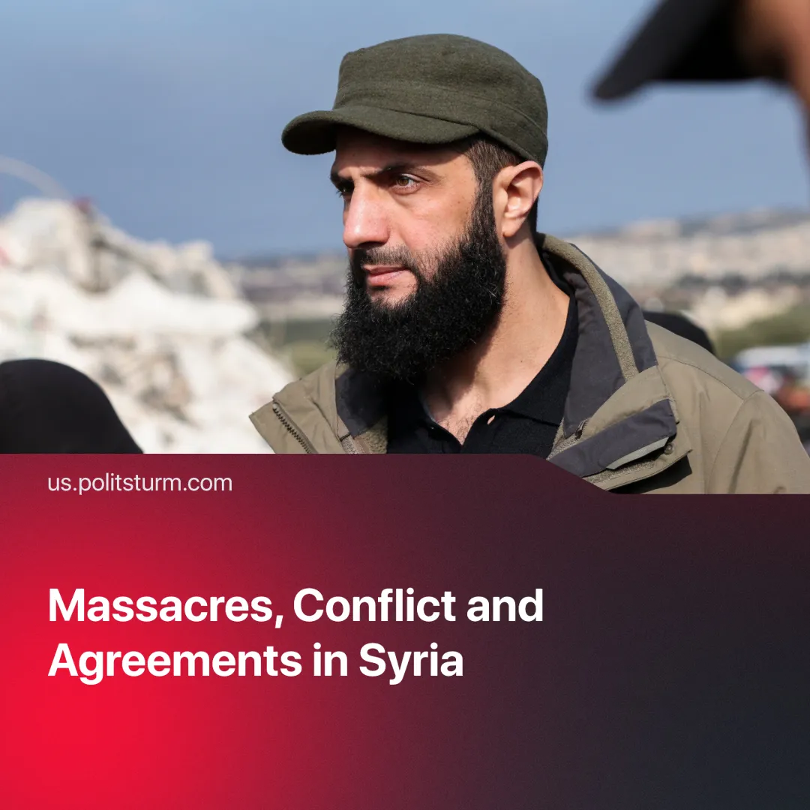

Original article
2025-03-16
2 min read

As the new government consolidates power, Syria remains politically unstable and a battleground for competing imperialist interests. Clashes between alleged "Assad loyalists" and Hay'at Tahrir al-Sham (HTS) government forces have led to violence against civilians.
Details. On March 6, 2025, a “resistance” group ambushed HTS security forces in Latakia. In retaliation, HTS forces carried out revenge killings targeting the Alawite minority. Following this violence, Western allies boosted support for the interim government.
► Brig. Gen. Ghiath Dalla, a former 4th Division officer under Assad, reportedly led the "resistance." The “Military Council for the Liberation of Syria” claimed it sought to "establish a united, sovereign Syria with equal rights for all citizens.” The rebellion ultimately failed.
► The UN stated that 'whole families' were slaughtered by HTS, verifying 111 civilian deaths but noting the toll is likely much higher.
► Interim President Al-Jolani announced an independent national committee to investigate "the events of the Syrian coast on March 6, 2025."
► On the same day, Britain became the first country to unfreeze all assets of the Central Bank of Syria, despite HTS remaining a proscribed terrorist organisation.
► The EU allocated €235 million in humanitarian aid and invited the interim Syrian government to a donor conference in Brussels.
► The U.S.-backed Kurdish SDF and Israeli-backed Druze factions signed agreements integrating into the new Syrian government.
Context. The Assad regime fell on December 8, 2024, after a Turkiye-backed HTS offensive, ending decades of Ba'athist rule. However, Syria remains divided.
► Assad’s government, which lasted over two decades, was closely tied to the Alawite community, an ethnoreligious minority.
► The Syrian war began in 2011 as a “pro-democracy” uprising but quickly escalated into a multi-front war involving the Assad regime, opposition groups, ISIS, Kurdish forces, and international actors.
► Turkiye supported HTS, providing them with weapons, intelligence, and training.
► Israel used this power shift to void the 1974 border agreement and occupied the Golan Heights while backing Druze rebels.
► Russia and Iran supported Assad militarily, while NATO countries and Gulf states backed various opposition factions.
► Syria has a diverse population including Sunnis, Alawites, Kurds, Druze, Christians, and other minorities. Imperialists and various nationalist groups have exacerbated ethnic and sectarian divides for their own gain.
Important to know. Syria has long been a proxy battleground for competing imperialist interests. Each faction is tied to foreign powers while claiming to fight for a "united" Syria.
► Russia maintains two key military bases and initially supported Assad but quickly shifted to building ties with HTS after his fall.
► Israel lobbied the U.S. to tolerate Russia’s presence as a counterbalance to Turkiye’s expansion into Mediterranean gas fields.
► Assad’s fall severed Iran’s supply routes to Hezbollah, especially as U.S.-backed Kurdish forces solidified control. Israel, meanwhile, seeks to weaken Hezbollah and expand its influence over Syria, bolstering its position against Turkish, Iranian, and Russian interests in the region.
► Syria finds itself caught between two imperialist blocs: the U.S.-Israel alliance and Iran-backed forces. With U.S. sanctions nearing expiration and Israel escalating attacks on Iran’s allies, Syrian capitalists are in a vulnerable position. In response, it appears they are aligning with the U.S., as evidenced by the agreement between the Druze, SDF, and HTS groups.
Conclusion. In Syria’s conflict, no faction truly fights for the people—all serve imperialist and capitalist interests. Instead of blindly supporting any so-called "resistance," it is crucial to analyze the class forces behind these groups, as only the independent organization of the working class can break the cycle of imperialist war and exploitation.

Original article

