Swedish Pilots Win Weeks-long Strike
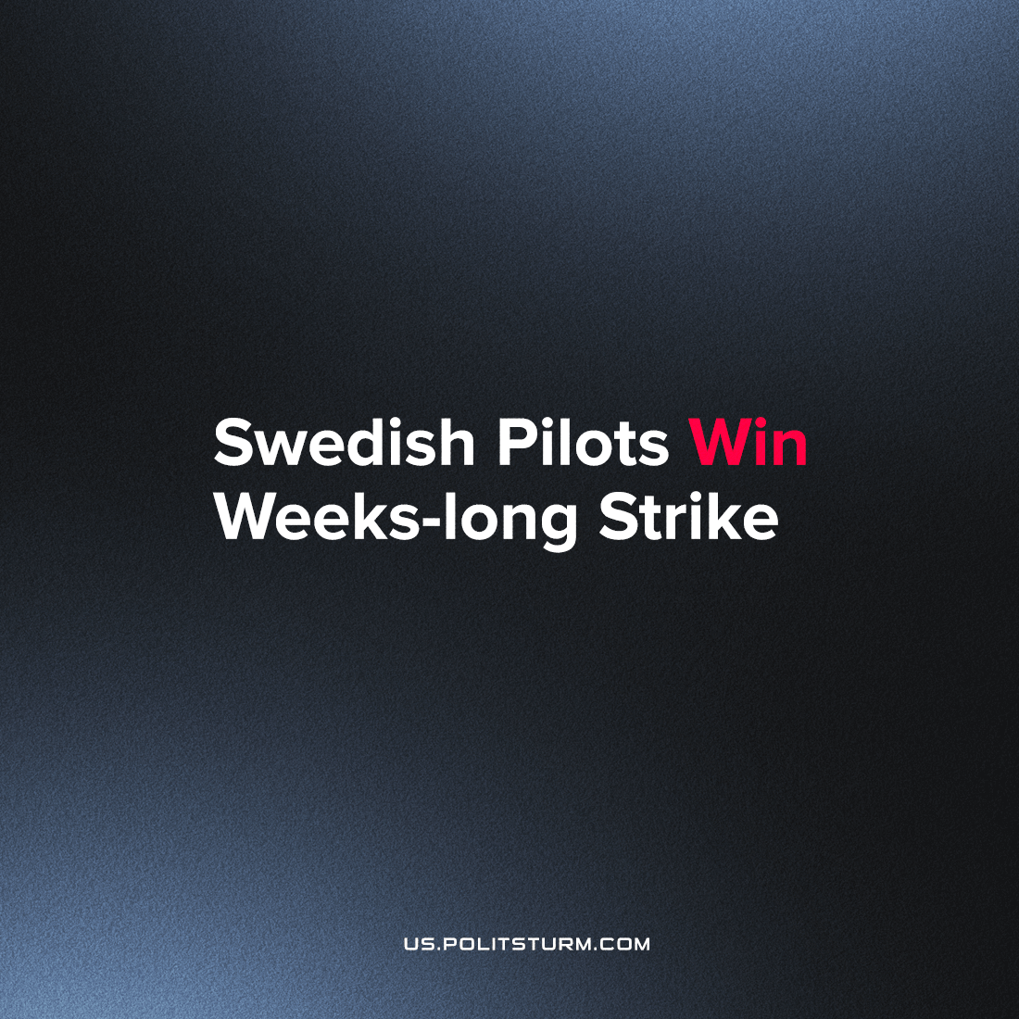

Original article
2022-07-28
2 min read

The pilot strike that lasted for just over two weeks is now over. Overnight today, the Swedish Pilots’ Association and SAS (Scandinavian Airlines System) reached an agreement that will see a collective agreement stretching five and a half years into the future. At the same time, all the laid-off pilots will be rehired.
During the night, SAS published a press release in which they presented the main points of the agreement. All the pilots who were laid off will be gradually rehired on a full-time basis until 2024, transferring them from the company’s own temporary employment agency.
The agreement also involves the pilots agreeing to a series of “cost savings”, as the press release puts it. What these entail, however, is not specified.
It also points out that the agreement now has to be approved by all four unions, but possibly also by a US court, as the company is undergoing a restructuring process in that country.
The strike had a major impact on the company, which lost between 100 and 130 million Swedish Krona ( a day. Although the agreement is a compromise, it shows that it is worth fighting for, because it won a victory on one of the key demands – rehiring the pilots.
Yellow unions attack the pilots
The pilots at “Scandinavian Airlines System” had been striking for over a week with no result. Tens of thousands of passengers stranded and the pressure on SAS to present the pilots who had been let go during the pandemic with sensible work conditions had only increased. Still, the company would not relent, and other unions came to its defense.
In an article from SVT, two representatives from SAS’s miscellaneous unions were interviewed. Middle management, legal advisors, engineers, and academics from the company have their opinions presented by the representatives. The criticisms thrown at the pilots’ strike are scathing, but also very telling.
Union representatives on the employer’s side
The management is trying to make the company economically viable using SAS Forward. To strike now is to undermine the company. We need to bring in money before being able to offer our employees better work conditions. There is, as of today, no money available. Giving better work conditions to some of the staff would necessarily mean taking money from others, says Katarina Johansson, representative for SAS Academics.
The union representatives are thus shifting the focus towards the apparent competition with other air travel corporations, instead of showing solidarity with those fighting for sensible work conditions. At the same time, different employee groups are being pitted against each other – being framed as a zero-sum game where they need to take from each other instead of holding the corporate management responsible.
In their obsession to kiss upwards and kick downwards, they don’t even seem to think the pilots deserve to be rehired. Rather, the company should be evaluating its “realistic needs” and to pick and choose which of the pilots are the most viable for rehiring.
That these groups use this kind of reasoning should not be surprising. They hold vastly different positions (e.g. middle management), and are thus closer to corporate, which informs their loyalties – an observation which the Pilot’s Union has also made.
In contrast to the yellow unions organizing the SAS middle management, Danish flight technicians have chosen to strike in solidarity with the pilots. The flight technicians know that together, they can all win the battle for better work conditions.
Source: https://riktpunkt.nu/2022/07/pilotstrejken-over-piloter-ateranstalls/

Original article

