Swedish Authorities Warn of Power Outages in the Winter
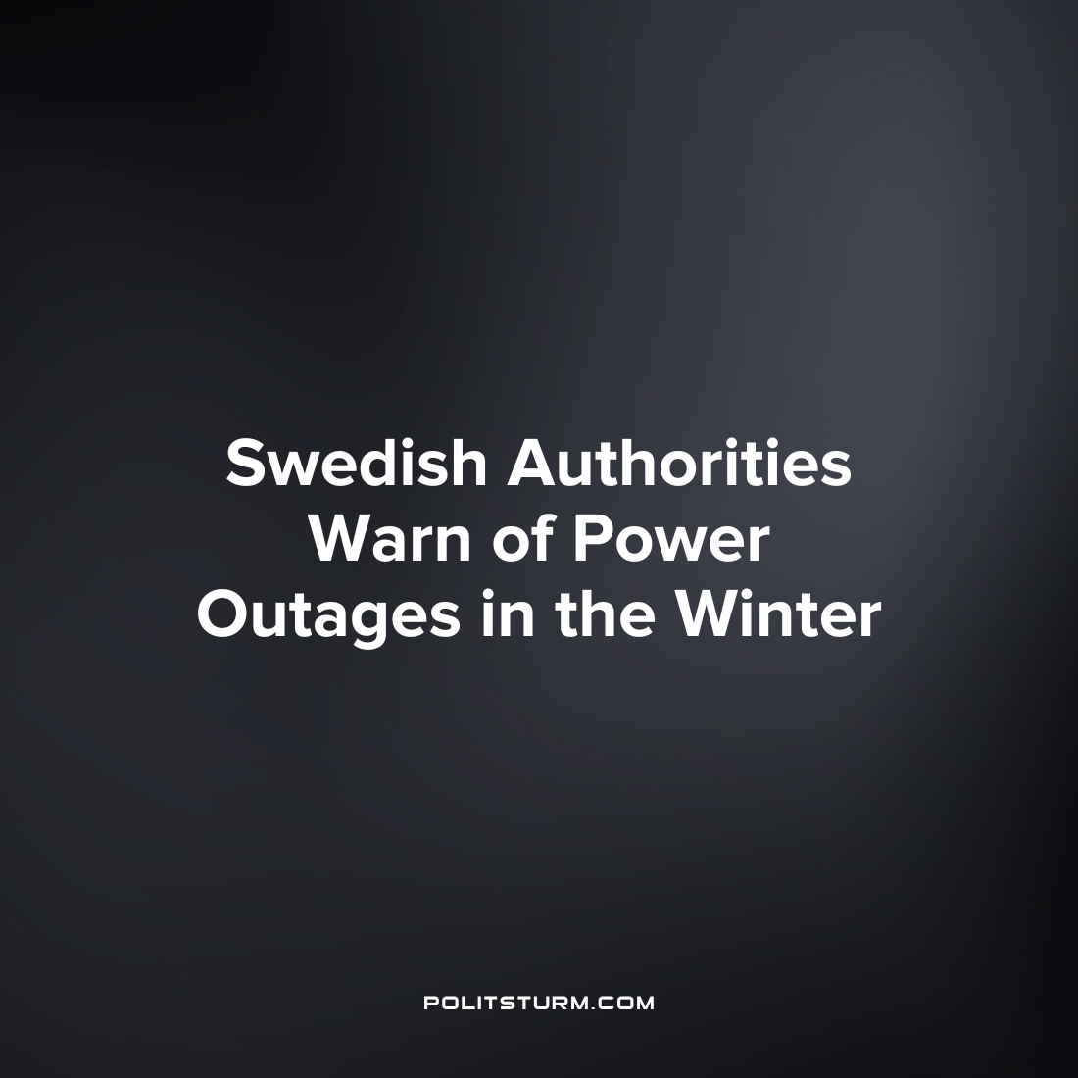

Original article
2022-12-31
2 min read

Against the backdrop of the energy crisis, the electricity supply situation in Sweden is becoming increasingly unstable. The kingdom's government is currently urging the population to prepare for possible power outages in the coming months.
At a press conference on December 21st, Swedish Energy Minister Ebba Busch explained that it's most likely to experience a power outage for several hours, but she also admitted the possibility of longer power failures. To prepare for such an emergency, Bush advised the people to stock up on water and buy cooking methods without electricity. She also hinted that a hand-charged emergency radio could come in handy in case of a prolonged power outage.
"We must be prepared for the worst, but work for the best," Bush concluded.
Civil Defense Minister Carl-Oscar Bolin added that the government is now unable even to foresee the conditions of the coming crisis. Of the coming winter, he said: "This territory is uncharted. We don't know exactly how the power outage will turn out."
Meanwhile, the people of Sweden are facing rising electricity prices. In an attempt to show concern for its citizens, the Swedish government recently launched a support program for electricity prices. However, at the moment the program covers only the two southernmost regions of Sweden, where a large number of profitable enterprises are located. Despite the harsher weather conditions in the northern parts of the country, these regions will remain without direct government assistance in the near future.
Statements by Swedish ministers on the topic of energy supply reveal the inability of the bourgeois state to cope with the current energy crisis. The actions of the Swedish state clearly show that the priority of the authorities is profit, and not the well-being of the inhabitants of the country. As long as the bourgeois class is in power, the working people would vainly hope that the state will provide them with a decent quality of living. Only when power passes into the hands of the working people themselves will it be possible to put the interests of the people in the first place.
Sources:
Aftonbladet – “Regeringen: ‘Viktigt med en plan’ vid strömbortfall och kris” Date: December 21st
SVT – ”Busch: Reel risk för strömavbrott – se över beredskapen” Date: December 22nd
Izvestia – "Swedish authorities urged the population to prepare for a power outage in winter"

Original article

