Sweden Tightens its Political Censorship
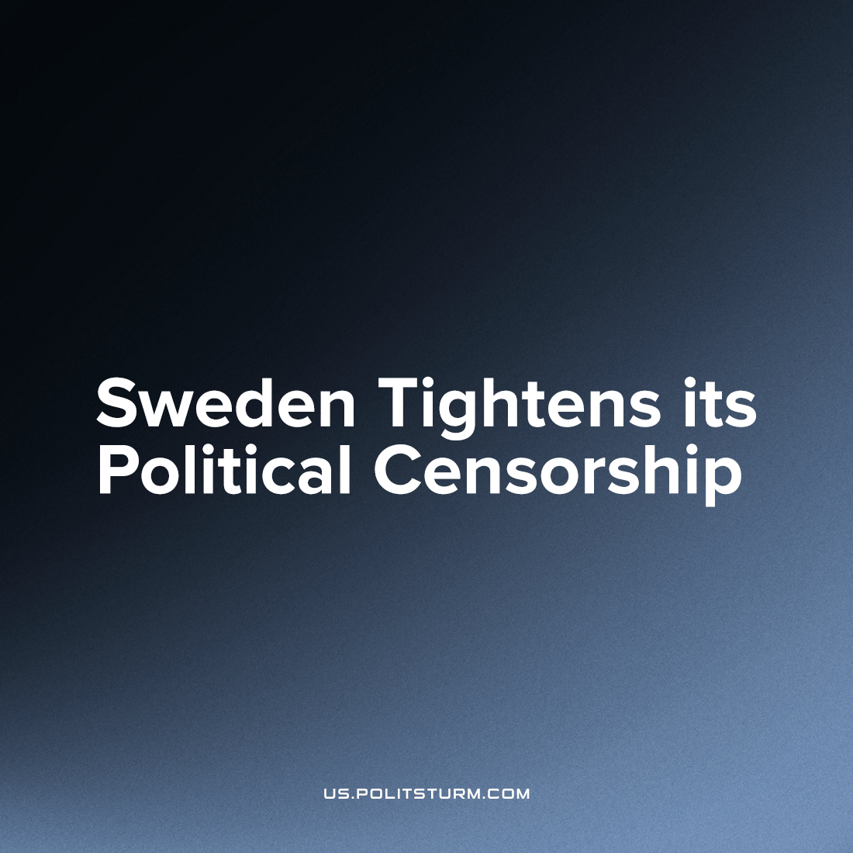

Original article
2022-11-28
1 min read

Sweden is known as one of the countries of 'Scandinavian socialism' and one of the world's most 'free' countries. However, on November 16th, Swedish Parliament introduced a new amendment to the constitution, severely restricting freedom of speech and the press.
Under the new law, the dissemination of information that "may harm Sweden's relations with another state or an international organization" can be considered a criminal offence and will be punished by up to 8 years of imprisonment.
Official Swedish media presents the censorship amendment as ''strengthening the protection of classified information'' to counteract ''spying for a foreign state.'' However, in practice, the new amendment criminalizes criticism of the Swedish government or "friendly states" of the EU and NATO.
For example, covering Sweden's plans to build an arms factory in Saudi Arabia could be classified as a crime and sabotage against the Swedish state. It can also censor information that NATO countries would prefer to keep secret from the Swedish public, such as the persecution of the Kurds by the Turkish government or the US invasion of other countries.
270 deputies of the Swedish parliament voted for the new amendment, and only 37 voted against it. The new law was supported not only by the ruling right-wing coalition but also by the "red" social democrats. "We have a loophole in the law, and we need to cover it again. It's about the security of the kingdom," said Magdalena Andersson, leader of the Social Democratic Party and former Prime Minister of Sweden, defending the censorship amendment.
The new amendment exposes the hypocrisy of liberal regimes about "human rights". When bourgeois politicians speak of freedom of speech and the press, they mean the freedom of the bourgeois class to defend its class interests in public media and not at all the freedom of the proletariat to criticize the existing order. In practice, liberals and social democrats do not hesitate to censor information unfavourable to their government. Real freedom of speech for the proletariat can be acquired only when power passes into the hands of the working people and socialism is established.
Sources: 1, 2, 3, 4

Original article

