Supreme Leader’s Newspaper Admits Oct 7 Failed
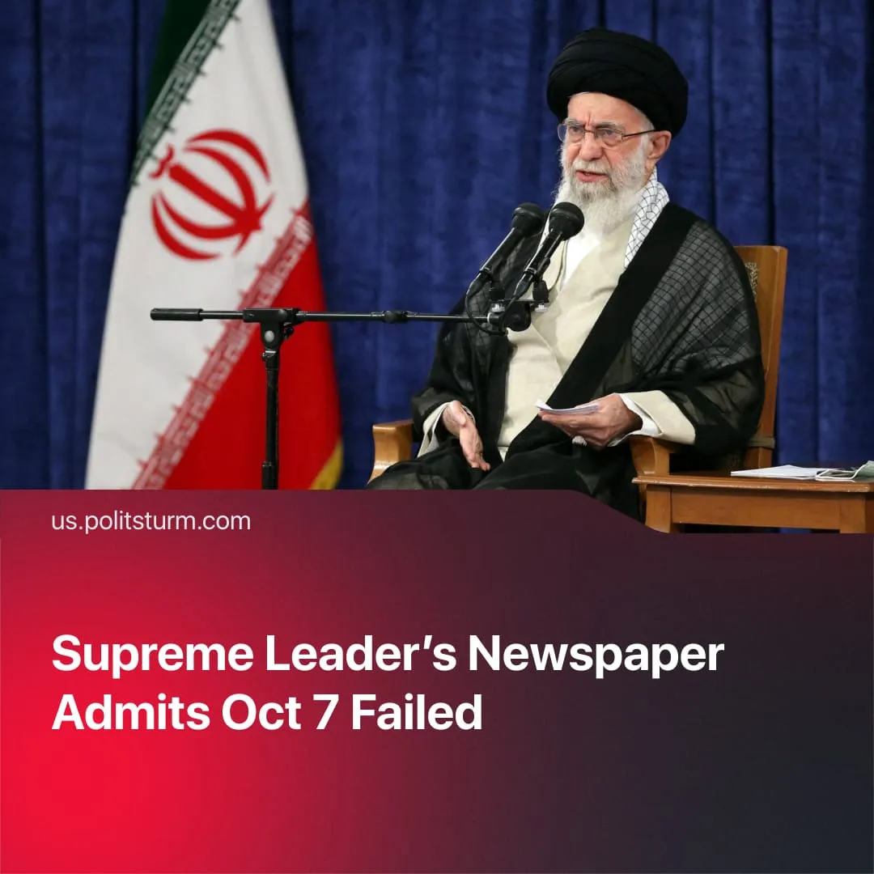

Original article
2025-10-29
1 min read

October 7 was called a grave mistake by a newspaper linked to Iran’s Supreme Leader.
Details. The Jomhouri-e Eslami (Islamic Republican) – a newspaper whose publisher is directly appointed by Iran’s Supreme Leader – published an article on October 11 acknowledging that the Al-Aqsa Flood operation was a mistake.
► The article stated that the destruction of Gaza, the rise of a US-aligned government in Lebanon, and the 12-day war were among the negative consequences of the operation. Above all, it described Syria’s withdrawal from the “anti-Zionist front” as the greatest loss.
Context. On the day of the operation, the Supreme Leader’s top military adviser voiced support for the attack. Khamenei had praised Hamas’s attack, calling it “logical, just and internationally legal action.”
► After US-Israeli strikes hit Iranian nuclear sites and senior commanders, Iran’s bourgeois leadership quickly accepted a ceasefire. Some factions sought full compliance with Western demands to preserve their own position amid economic crisis and growing domestic unrest. The Iranian state’s weakness and the collapse of its so-called “Axis of Resistance” show the failure of its regional imperialist project.
► The “Axis of Resistance” – Iran’s network of regional proxies – has been significantly weakened. Hamas accepted a ceasefire on Western terms after its destruction in Gaza; Yemen’s Houthis lost senior leaders, and their main seaport was struck; Hezbollah’s leader was killed, many rocket depots were destroyed, and it now faces disarmament; and Assad’s regime in Syria – once the logistical bridge between Iran and Hezbollah – has been overthrown.

Original article

