Supreme court upholds public charge restriction on immigration
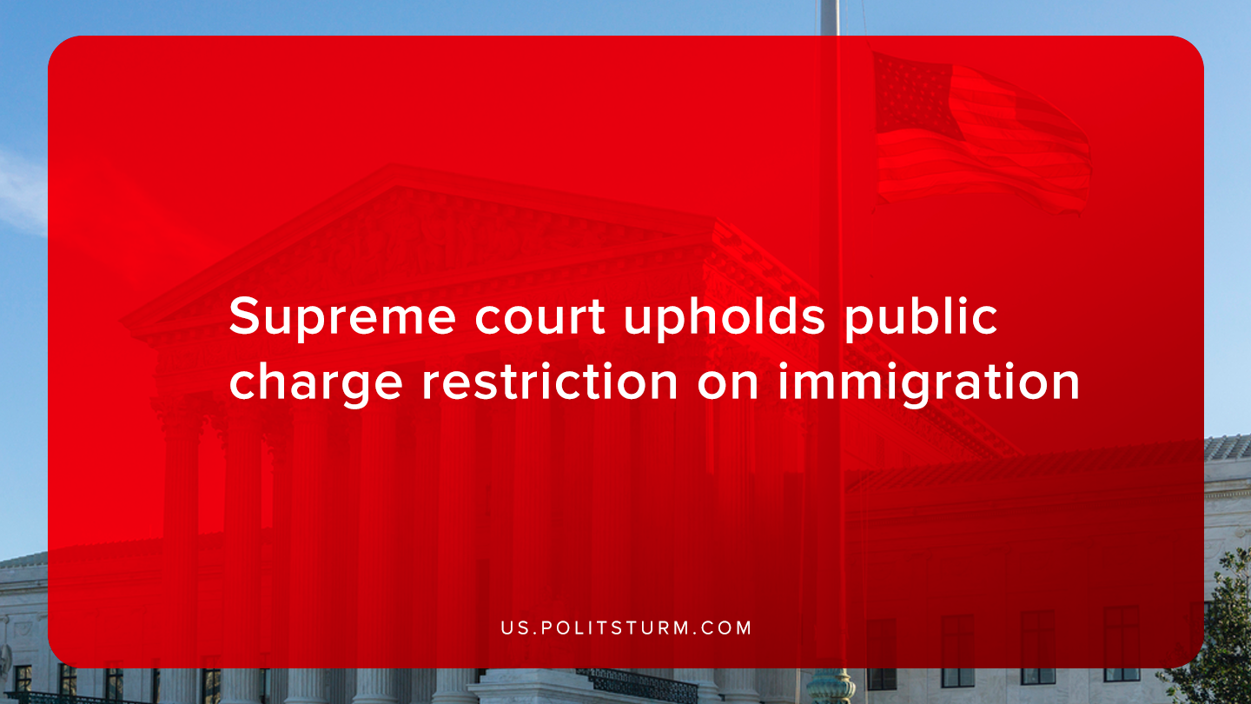

Original article
2020-01-30
1 min read

The Supreme Court lifted a court order that blocked implementation of the Trump administration “public charge” regulation. Public charge refers to immigrants who are applying to immigrate to the United States who would need assistance from the government to survive.
The Trump administration expanded what constituted a public charge by expanding the criteria for determining a public charge, including an individual’s age, credit score and disability status. Also, the ruling includes immigrants who would be recipients of subsidized public housing, Supplemental Nutrition Assistance Program (SNAP), Section 8 Project-Based Rental Assistance, among other benefits.
The Trump administration intends to limit legal immigration by all methods available. This method allows immigration officials to limit immigration based on the prospective immigrants potentially needing public assistance.
The Trump administration has taken various actions to stop immigration from all kinds in the United States. From the construction of a border wall to the tightening of immigration law, the Trump administration is attempting to redirect the frustration of a failing capitalist economic system on immigrants, poor trade deals, etc.
The capitalists in the United States rely on nationalism as a tool to undermine the class unity of the working class. This change to the enforcement of immigration law is just confirmation of this tendency. For the working class to overcome the deception and obfuscation of the capitalists, it is necessary to master the Marxist-Leninist theory to lead the workers to victory.
Sources: 1, 2, 3

Original article

