Supreme Court Strips Worker Protections
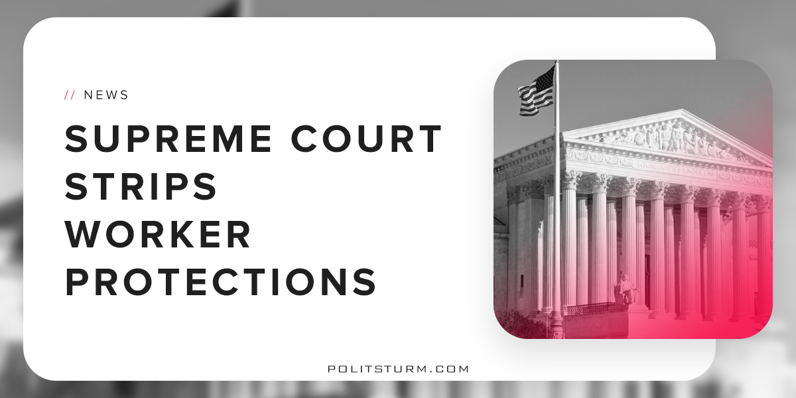

Original article
2018-05-22
2 min read

Should employers be allowed to force employees into behind doors, one-on-one arbitration, or should workers be able to bring their claims into court in class or collective actions? This was the question being asked in one of the most important workers rights cases of the term. There were three cases brought before the Supreme Court by employees of the corporations Ernst & Young LLP, Epic Systems Corporation, and Murphy Oil USA, Inc. Workers claim that they were being illegally forced to challenge violations of federal labor law behind closed doors, in private one-on-one meetings, due to the mandatory individual arbitration procedures under the 1925 Federal Arbitration Act. They contend that a later bill, the 1935 National Labor Relations Act, makes these clauses and provisions illegal, as this bill was passed to protect the right of workers to join together in a class or collective action suit.
On May 21, the US Supreme Court ruled 5-4 in favor of employers. In a decision that will affect more than 25 million private-sector workers, the 1925 bill will trump the protections gained by the 1935 bill. Justice Neil Gorsuch, speaking for the majority, said: “The policy may be debatable but the law is clear: Congress has instructed that arbitration agreements like those before us must be enforced as written.” Now, workers will have to do everything individually and claims of hour and wage violations will have to be done personally and without the intervention of the court.
This ruling is a slap in the face of the working class and will come down especially hard on the already lower paid workers. A study by the Economic Policy Institute shows that 56% of private-sector workers are forced to handle disputes by themselves, alone, and often without the aid of a lawyer. With almost half of Americans in or near poverty, the majority of workers simply do not have the time, money, or know-how to effectively defend themselves alone. Justice Ruth Bader Ginsburg, one of the four dissenters, called the ruling “egregiously wrong.” She points out that the 1925 arbitration law came well before federal labor laws and, therefore, does not cover, as she put it, these “arm-twisted, take-it-or-leave it contracts” which employers can now insist on.
This is the first ruling of its kind. Never before have workers been denied the right to unite and defend themselves in court. However, this should not come as much of a surprise. The Trump administration itself submitted a brief in 2017 to the Supreme Court on the behalf of Murphy Oil, advocating an anti-worker legal theory in favor of so-called “job creators.” The Trump administration has been particularly shameless and open with their anti-worker agenda. The appointment of Friedmanites Betsy DeVos as head of the Department of Education and Scott Pruitt as head of the Environmental Protection Agency can aptly be described as Benito Mussolini described fascism: “the merger of state and corporate power.” The working class can only expect further degradation and declawing in the coming years as more and more fundamental neoliberals are appointed to the highest levels of government under the administration of an actual billionaire.
Sources: 1, 2, 3, 4, 5, 6

Original article

