Supreme Court Strikes Down Roe vs. Wade
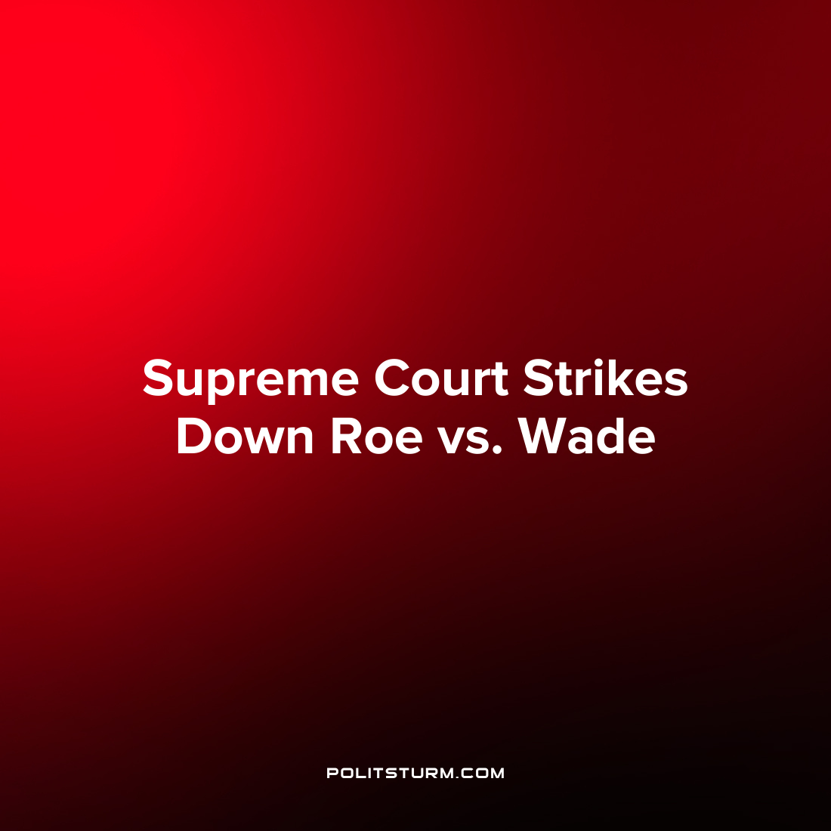

Original article
2022-06-24
1 min read

The Supreme Court of the United States made a landmark decision surrounding abortion in the case Dobbs vs Jackson Women’s Health Organization. The court held that the Constitution does not confer the right to an abortion and overruled the landmark case Roe vs. Wade, opening the door for states to individually ban abortions.
The Supreme Court stated that “The Constitution does not confer a right to abortion; Roe and Casey are overruled; and the authority to regulate abortion is returned to the people and their elected representatives”.
When the court says that the authority to regulate abortion has been return to “the people and their elected representatives”, they do not mean that the masses will have any part in the decision making process. Rather, the people will get to select which member of bourgeois parliament will serve the interests of the oligarchs and reactionary forces.
Despite making grand claims about democracy, America is an oligarchy which serves the interests of the capitalists who will use reactionary religious zealotry to ensure their class dominance. Defenders of the ruling will point to the legality of the ruling as proof of its legitimacy, neglecting to mention that the legalistic rulings of the capitalists are laws of their own creation and design. This is just another demonstration that the legislative, judicial, and executive branches of the U.S. political system serve the interests of the rich and despite claiming to be democratic, in practice limit the freedoms of individuals based on idealistic, religious grounds against the material needs of the masses.
Source: 1

Original article

