Supreme Court Ends Eviction Moratorium
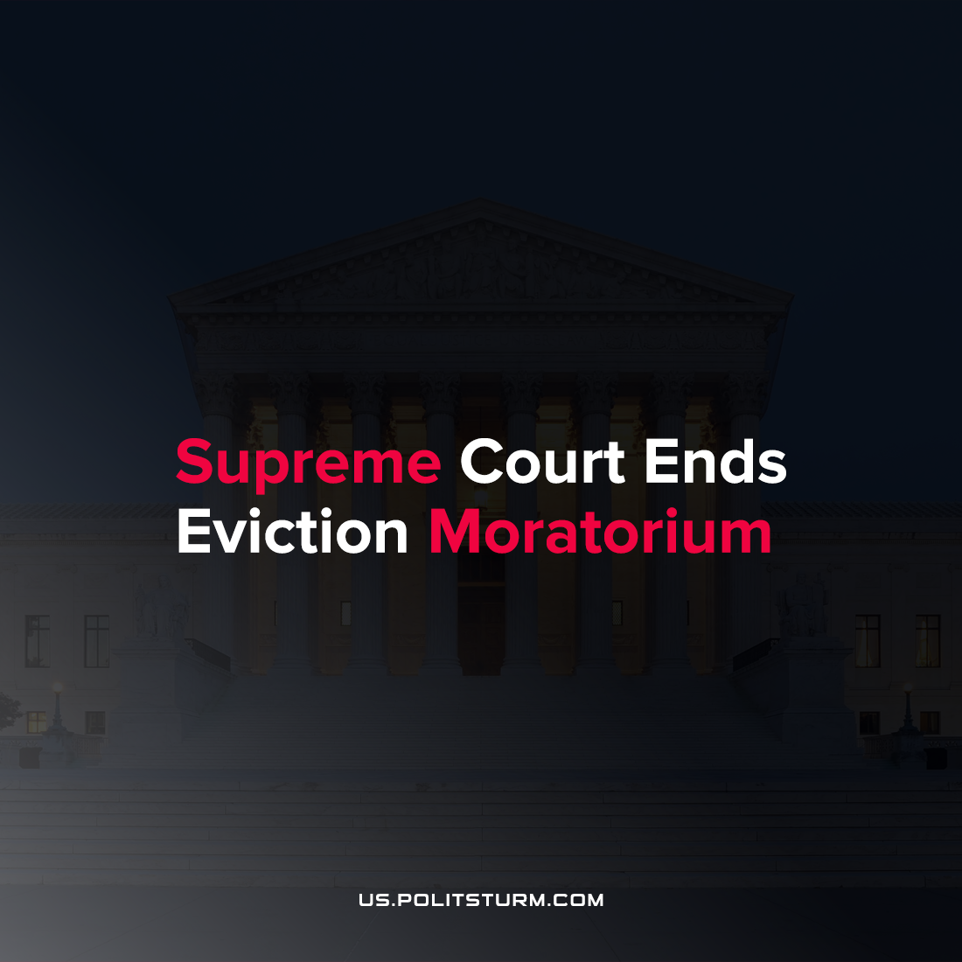

Original article
2021-08-28
1 min read

The Supreme Court ruled in favor of the Alabama Association of Realtors in ending the moratorium on evictions. During the onset of the coronavirus pandemic, the director for the Center for Disease Control (CDC) imposed a moratorium on evictions for tenants who “live in a county that is experiencing substantial or high levels of COVID–19 transmission and who make certain declarations of financial need”.
Realtor associations and rental property managers in the states of Alabama and Georgia swiftly sued to enjoin the CDC’s moratorium, arguing that the CDC lacked the statutory authority to impose the moratorium.
Unsurprisingly, the Supreme Court has most recently sided in favor of the landlords and realtors. The “logic” used by the bourgeois judiciary is that even if the moratorium is highly favorable in preventing the transmission of COVID-19 and will achieve a favorable outcome, the eviction moratorium oversteps the limited authority granted to the CDC.

“It is indisputable that the public has a strong interest in combating the spread of the COVID–19 Delta variant. But our system does not permit agencies to act unlawfully even in pursuit of desirable ends” Supreme Court per Curiam
As such, while the coronavirus continues to spread across the country with the Delta variant surge, the Supreme Court has stricken down the eviction moratorium which will allow landlords to evict tenants from their homes. This act will endanger tenants and the most vulnerable in society to serve the interests of the ruling oligarchy. This is further evidence that the judiciary and other branches of the bourgeois government stand to protect the interests of the capitalists and landlords and their ability to extract rents and profits despite the consequences for the working class.
Source: 1

Original article

