Sunni Bloc Aligns With US–Israel in Iran Conflict
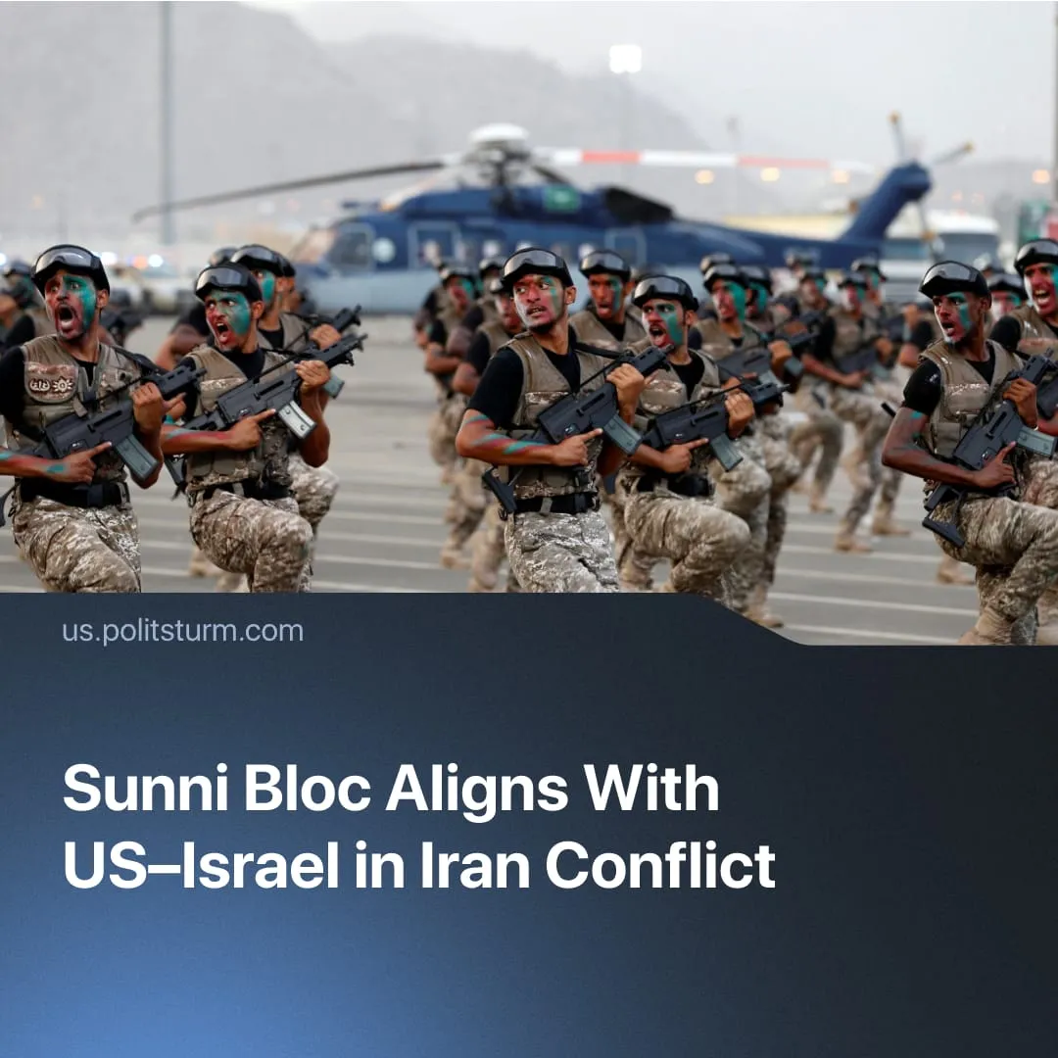

Original article
2026-03-21
1 min read

Saudi Arabia restores alliance with US–Israel in the Iran war, foregoing previous pushes at imperialist independence.
Details. As the Middle East war escalates, Iranian attacks have targeted NATO member state Turkey, multiple Gulf states, and Saudi Arabia, all of which host US troops. These countries’ military forces joined the conflict, shooting down Iranian missiles heading for US bases.
► Saudi Arabia placed its armed forces on full alert and has threatened to respond to Iran’s attacks by fully joining the US-Israeli offensive strikes. The Gulf states issued statements of cooperation since the outbreak of the war, jointly condemning Iran and aligning with the USA and Israel.
Context. Imperialist alliances are in fluid motion in the buildup to global conflict. Driven by desires for “strategic autonomy,” former US partners are struggling to assert independent policy, but their capitalists remain tied to shared interests.
► In 2025, a Saudi-led bloc of Sunni Muslim countries had attempted to form an autonomous imperialist force, reducing dependency on the US and claiming to stand against Israel’s expansion in the Middle East. Saudi Arabia, Turkey, Egypt, and Pakistan – who had long been aligned with the USA – signed a new military alliance of their own to oppose Israeli attacks.
► Israel formed a regional alliance with other countries such as Ethiopia and the United Arab Emirates – a Gulf rival of Saudi Arabia – to counter this emerging Sunni bloc. By early 2026, the contradiction between these two imperialist blocs had escalated to military conflict across multiple proxy fronts in the Middle East and Africa.
► Since the inter-imperialist Iran war started, the conflict between the Saudi-led bloc and Israel has now been frozen, with both powers putting aside their differences to support the USA’s offensive campaign against their mutual enemy: Iran’s Shia Muslim Axis.

Original article

