British Conservative Party Leader to Introduce National Service if Elected
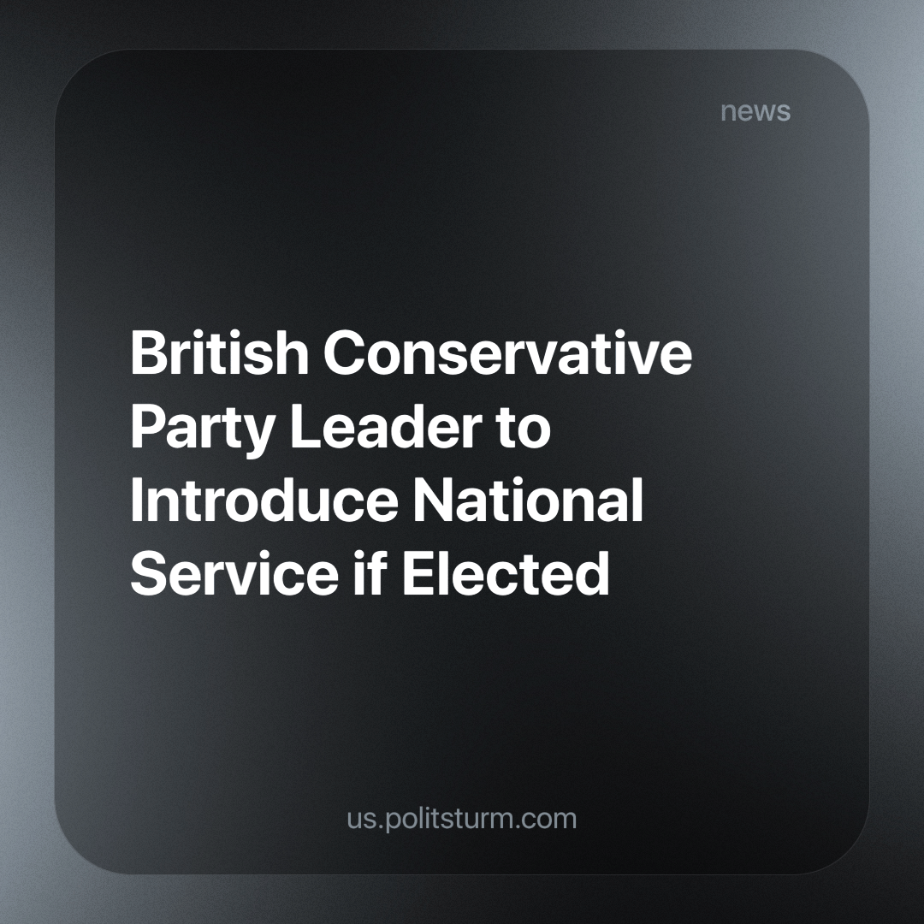

Original article
2024-06-05
4 min read

The Prime Minister of the United Kingdom, Rishi Sunak, has announced that, if elected, he will introduce a £2.5 billion plan (as reported by the BBC) to reintroduce National Service in the UK. This is an attempt to gain support as polls suggest that the Labour Party is likely to win the upcoming election on 4 July.
The plan would require 18-year-olds to either:
- Take part in community programmes for 12 months. This volunteering would take place one weekend a month for a total of 25 days a year, working with a range of essential services such as the National Health Service (NHS), Fire and Rescue, Ambulance and even the Police.
- Do a year-long full-time placement in the British Armed Forces, specialising in areas such as logistics, cyber security, procurement and others. Although this would represent a small proportion of 18-year-olds, as there are up to 30,000 placements available.
This plan differs from the National Service of 1949-1960, which required every male between the ages of 17 and 21 to undergo 18 months of military training and remain on the reserve list for a further four years. This meant that they could be called up at short notice.
Rather, the publicly stated aim is to “keep kids out of trouble” [1] and “get young people out of their bubble” [2]. It tries to present itself as a project that makes people proud of their country and builds a sense of community by supporting vital services.
Opposition leaders such as Labour’s Shadow Chancellor Rachel Reeves, have criticised the proposal saying it is “a desperate gimmick from the Conservative Party with no viable means of it”, while the Scottish Labour leader Anas Sarwar said the money should be spent on “stabilising our economy”.
But the reality is that this bill will be used to further dismantle public services. The NHS in particular has been targeted for privatisation and dismantling by both parties. The NHS was first created in 1948, in the post-war period and at the start of the Cold War, in an attempt to deal with the aftermath of such destruction and to appease revolutionary workers with concessions and pressure from the example of the Soviet Union.
Such concessions are commonly known as the welfare state, and Britain's extensive welfare state was funded by the super-profits of its many colonies and dependent countries. Now that British imperialism is in rapid decline, and the workers and communists are not sufficiently organised to resist the onslaught, the capitalists are trying to roll back all the concessions to the workers in order to keep as much of the social wealth as possible in their own pockets. This is the reality under capitalism, where both parties are merely tools of the ruling class, and the workers are so weak and disorganised as a class that they feel they can roll back this concession.
Margaret Thatcher, a member and leader of the Conservative Party from 1975 to 1990 and Prime Minister of the UK from 1979 to 1990, worked to dismantle and privatise public services such as the railways and the postal service. She (and the capitalists she governed for) had wanted to dismantle the NHS since the 1970s, but it is a hugely popular service among British workers [3]. As a result, they could not do it immediately and completely, but they began the gradual process of killing off the NHS, and we are witnessing the end results of their machinations. However, the policy of privatisation is not exclusive to the Conservatives, as all political parties are subservient to capital, even the Labour Party. We have previously covered how the current leader of Labour has praised Thatcher.
Despite presenting itself as the main opposition party, the Labour Party is no exception to the rule of capital, openly so since the leader of the Labour Party from 1997 to 2007 rebranded the party as pro-capitalist and abandoned all previous nominal commitment to socialism. Their policies have actively promoted the privatisation of the NHS in the past [4] and will continue to do so. They are merely the controlled opposition to the Conservative Party.
This can be plainly seen, in their promises (or lack thereof) for the upcoming election (which the Labour Party is likely to win). Nowhere do they mention a concrete plan for more funding for the NHS besides paying workers overtime for working weekends and evenings, and whatever funding it might give, will come from a “crackdown on tax dodgers” and “abolishing non-dom tax loophole for the very wealthy”[5]. We know, however, that no real harm will come to the wealth of the capitalist, otherwise, business owners wouldn’t be flocking en masse towards the Labour Party [6].
This is a far cry from some of the most basic demands of workers such as junior doctors, who have been on strike demanding an end to poverty wages and are planning to go on strike again during the election period [7].
Sunak's bill, if implemented, will be massively unpopular, as it will further deteriorate the service of the NHS, causing further outcry from the British people. And so the capitalist parties will propose further privatisation as a supposed solution to this problem. Although the Labour Party publicly opposes this bill in particular, its policies and deliberate deafness to the demands of public services, workers and the population will lead down the same road. With the means of production owned by private individuals with the sole intention of making a profit, the state will inevitably reflect the interests of capital, no matter what the face of its representative. Only a truly communist party, fighting for the social ownership of the means of production, can lead the workers to a system that truly represents their interests.
Sources: 1,2,3,4,5,6,7

Original article

